Effects of Planting Population on Yield in Full Season Soybeans
A Final Report to the Maryland Soybean Board, March 11, 2020
Kelly Nichols, Ag Agent Associate, University of Maryland Extension, Frederick County

Soybean population plots were planted on two farms in Frederick County near Thurmont and Tuscarora on June 4 and 7, respectively. Planted populations were 80, 100, 120, 140, and 160 thousand plants per acre (ppa). The Thurmont plots were planted on 30-inch spacing with three replications. The Tuscarora plots were drilled on 7.5-inch spacing with four replications.

On July 1, initial population counts were taken at both farms. At the Thurmont farm, plots ranged from 79 to 88 percent germination. At the Tuscarora farm, plots ranged from 88 to 98 percent germination. (Table 1.) This is consistent with the germination percentage of the seed.

Plots were harvested on October 3 and October 24 at the Tuscarora and Thurmont farms, respectively. Yield ranged from 61 to 70 bu/A (Table 2). Overall, yield differences between the populations were within three bu/A. Each farm was statistically analyzed separately due to the differences in row spacing and variety. There were no significant differences in yield between any of the planting populations on either farm, indicating that on these two farms in 2019, lower populations did not adversely affect yield. Also, those lower planting populations would have resulted in reduced seed costs.

The variety used at the Thurmont farm was Pioneer P37A69, which retails for $71.00 per unit of 140,000 seeds. The variety used at the Tuscarora farm was Hubner 38-27R2X, which retails for $59.00 per unit of 140,000 seeds. (Note that these costs do not include any discounts or seed treatments.) At the time of harvest, soybeans were $9.51/bu on the Chicago Board. The gross amount per acre was calculated by multiplying the price per acre by the number of bushels per acre. The net dollar amount was then calculated by subtracting the seed cost from the gross amount per acre. At the Thurmont farm, the 100,000 planting population had the highest net per acre at $598.19, while the 140,000 and 160,000 populations had the lowest net, around $581/A (Table 3). At the Tuscarora farm, the 120,000 planting population had the highest net per acre at $560.13, while the 160,000 population had the lowest net at $515.76/A.

Shortly before harvest, stem diameter measurements were taken. At higher populations, plant stems tend to be thinner because plants are closer together and there is more competition between plants. At lower populations, plants can branch out, resulting in thicker stems. The Dectes stem borer is a pest of soybeans; after the eggs hatch, the larvae bore into the stem and feed from the inside. Soybeans with thicker stems are theorized to be a more favorable environment for Dectes stem borer larvae. The average stem diameters for the two fields in this study are presented in Figure 1. This data shows the trend that as population increases, stem diameter decreases, indicating that higher populations with thinner stems may be less favorable for Dectes larvae.

In summary, lower soybean populations may still result in optimum yield while reducing seed costs. For fields that have a history of Dectes stem borer, a balance may need to be found between lowering planting population and creating a less suitable environment for Dectes.

Table 1. Initial Population Counts, July 1.
 | Thurmont Farm |  | Tuscarora Farm
Planted Population (thousand plants per acre) | Initial Population (thousand ppa) | % Germination | Initial Population (thousand ppa) | % Germination
80 | 63 | 79 | 71 | 88
100 | 85 | 85 | 88 | 88
120 | 95 | 79 | 117 | 98
140 | 123 | 88 | 124 | 88
160 | 135 | 84 | 153 | 96

Table 2. Average Yield at 13.5% Moisture.
 | Yield (bu/A)
Planted Population (thousand plants per acre) | Thurmont Farm | Tuscarora Farm
80 | 67 a* | 61 a*
100 | 68 a | 63 a
120 | 69 a | 64 a
140 | 69 a | 63 a
160 | 70a | 61 a
*The same letter indicates no significant different between treatments on the individual farm.

Table 3. Net Amount in $/A.
 | Net $/A
Planted Population (thousand plants per acre) | Thurmont Farm | Tuscarora Farm
80 | 596.92 | 548.18
100 | 598.19 | 554.78
120 | 595.33 | 560.13
140 | 581.39 | 542.89
160 | 581.71 | 515.76

Figure 1. Average Stem Diameter.
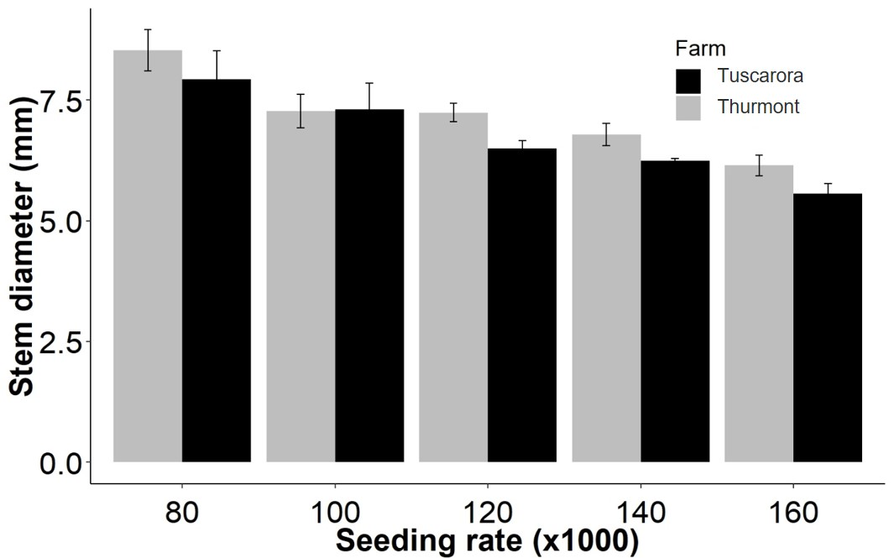
*Data courtesy of Dr. Alan Leslie, Ag Agent in Charles County.

