Increasing Efficiency and Cost Effectiveness in Intensively Managed Soybean.
James H. Long Ph.D.
A report of activity during the first, second, and third year of the 3 year project ending Feb. 29, 2019. All studies unless stated utilized KS5004 a high yielding cyst nematode resistant variety planted in 7 inch rows at 160,000 seed dropped per acre. High management of each study consisted of seed treatment followed by insecticide and fungicide at R3 and then again at R5. All studies were conducted at Columbus, KS, USA. Herbicide was Trifluralin applied at 1.5 pints per acre then followed by post emergent broadleaf herbicide if needed.
Objective 1- Screening for Genetic potential Varieties with varying response to charcoal rot were compared to determine their potential under both conventional (check) and intensive management. Results for 2017-19 indicate that entries with some tolerance to charcoal rot will perform well under intensive management. Data also indicate that MG IV and V will outperform MG III most years. The only time MG III will perform better is when there is adequate August rainfall.
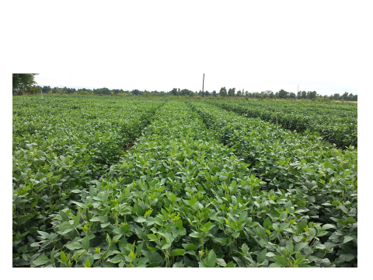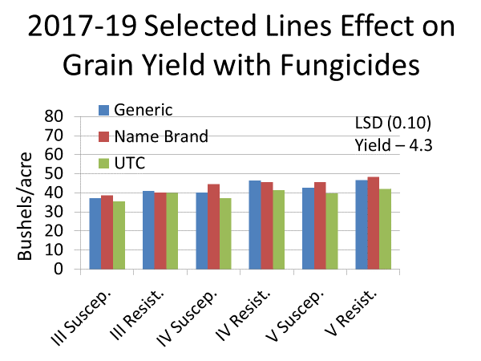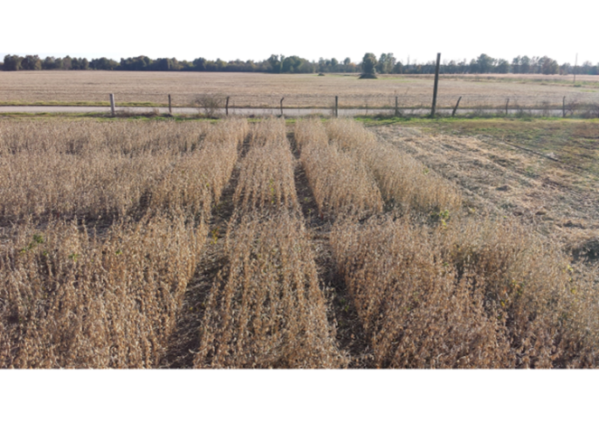
Objective 2 – BMP’s.
A second study to develop best management practices for predicting disease and insect problems and need for crop monitoring or treatment has been set up with insect traps and sentinel plots established in the field. In 2018 Black light and sticky traps started picking up large numbers of Japanese beetle by June 7th, with Pod worms showing up by July 1 in both 2017 and 2019. This was confirmed by field scouts especially in corn fields as well as soybean. Soybean reached treatment levels all three years with treatments applied by R3 all years. This also includes weather data from time of planting to determine the effect of weather fronts, temperature and rainfall on insect and disease infestation in the soybean crop. Small increases in pod worms were seen following rains in late July and August. Sentinel fields and plots were also established in all three years and were scouted for both diseases and insects. In addition to the insects picked up through scouting and traps soybean diseases such as septoria and frogeye leafspot were picked up by mid to late-season in all three years with heavy Cercospera in 2018. Charcoal rot effect was also seen by late season and affected early maturity soybean more than later maturity soybean. Insect control was one of the major needs in IPM of intensively managed soybean.
Objective 3 – PGR use on soybean
Another study was planted and treatments were applied to compare PGR use on soybean to enhance soybean growth and yield especially early in the season. Auxin or auxin like compounds were utilized at PGR rates to determine their effect on growth and grain yield. PGR had little effect on yield across years although there are trends to increase root mass (data not shown) and grain yield. We had no dry weather any of the three years that might allow positive effects of increased toot mass on grain yield. Two of the three years were excessively wet with much above average summer rainfall.
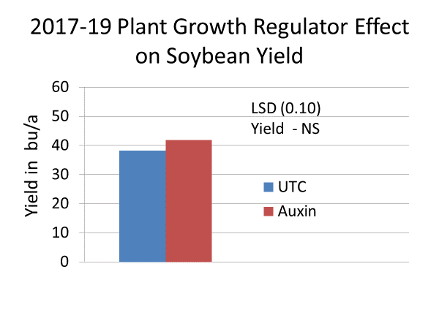
Objective 4. - Nitrogen Rates in High Yield Dryland and Irrigated Soybean.
As a part of the previous objectives study Nitrogen rates and times of application were utilized throughout the growing season. Their effect on grain yield as well as the agronomic characteristics such as lodging have been followed throughout the year. Some N rates have caused lodging of plants. Other plots receiving less N have not lodged. Grain yields have been increased when 40 pounds of N in split applications have been used.
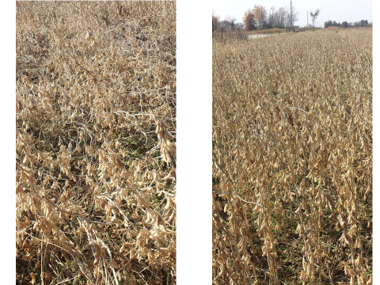
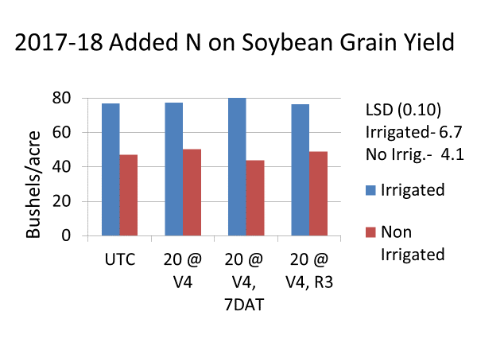
5. - Novel compounds
Treatments were compared in 2017 -19 to compare novels compounds like sugar added to spray components to determine if there is an effect and what that effect might be. Generally there was little effect on grain yield although sugar in a spray component did increase disease control of Septoria and frogeye leaf spot.
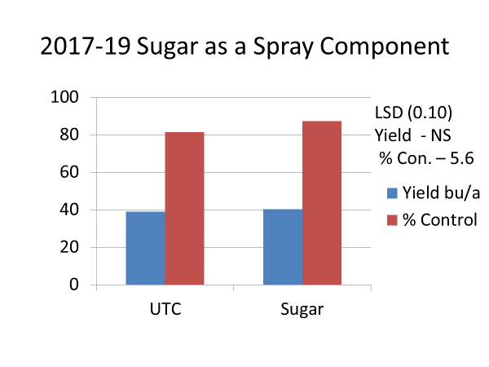
Objective 6. – Incorporation of Generic Compounds into a Cost Effective Package.
Plots were planted that compare untreated checks with generic and standard treatments. If a mixture of treatments was used the first treatment with insecticide went on at R3 with a second treatment at R5 Comparisons of treatments included critical stages of growth as well as specific insect and disease occurrence. All treatments with except UTC were planted with seed treatments. Insecticides and fungicides were applied at R3 and R5. Generally, generic treatments do an adequate job under intensive management but new products such as Trivapro or Priaxor have better canopy management of disease and warrant use late in the season when Frogeye leaf spot and Cercospera spp. Were prevalent.

