Effect of late season management practices on soybean seed filling and yield

Introduction
For soybean (Glycine max [L.] Merr.), final seed yield is primarily explained by modifications in the seed number per unit area. However, changes in individual seed weight can contribute to variations in seed yield. Final seed weight is defined by the amount of biomass accumulated in seeds per day (i.e., rate of seed growth) and the duration of this phase (i.e., number of days for seed filling). During the seed feeling period, the seed growth rate and the duration are sensible to growing conditions. Thus, any limitation on resources availability (e.g., water, radiation, and nutrients) during this period can be translated into reductions in seed weight that ultimately will affect final seed yield. The objective of this study was to identify “late-season” management practices contributing to increase final seed weight and seed yield in soybeans.
Materials and Methods
A field study was conducted at Ashland Bottoms Research Farm, Ashland Bottoms, KS (39.14º North, 96.64⁰ West). The type of soil was quartic Argiudolls (18% clay, 54% silt, and 28% sand). Soil samples were collected before planting at 6-inch soil depth. The pH was 7.6, soil phosphorus (Mehlich) was above the critical threshold (90 mg kg⁻¹), and soil organic matter was 21 mg kg⁻¹. The soybean variety utilized for this study was P38T20X (Dupont Pioneer®), a maturity group 3.8 planted in June 26, 2019 under rainfed conditions and a target plant density of 145,650 plants per acre. Maximum average temperature during the season was 83.1°F and 62.0°F the minimum. Total seasonal precipitation was 15.95 inches from planting to harvest.
Plots were arranged in a complete randomized block design with four replications. Plots were 45 feet long and four rows spaced at 30 inches. Treatments were applied at full pod formation (R4 growth stage) and consisted in different management practices:
- Fungicide protection late-season application
- Insecticide protection late-season application
- Full-foliar protection (fungicides + insecticides late-season application)
- N fixation longevity (inoculant late-season application)
- Plant nutrition -standard- (S late-season application)
- Plant nutrition -complete- (micros plus S late-season application)
- Nutrition -complete- + N fixation (combination of both for improving nutrition)
- Intensified inputs (all practices combined)
- Control condition (Standard practices)

When needed, treatments were sprayed with handheld backpack sprayer.
In each soybean plant within all treatments, seed samples were collected 15 days after the onset of seed filling and every 7 or 10 days until physiological maturity (R7 growth stage). Final seed weight, rate, and duration were determined fitting a bi-linear model to the data collected.

Seed weight (mg/seed) = a + b × d for d < c) [1]
Seed weight (mg/seed) = a + b × c for d > c) [2]

where b is the linear seed growth rate (mg day⁻¹), and c is the duration of the seed filling period in days.
At physiological maturity, an area of 18.75 sq. ft in the two central rows of each plot was manually harvested to determine final seed yield.

Results
Seed yield and seed weight
Seed yield ranged between 34.2 and 52.3 bu ac⁻¹ and seed weight ranged from 132 to 166 mg seed⁻¹, respectively. However, statistical differences among treatments were not detected for neither yield nor seed weight (Figs. 1, 2, 3, 4).

Duration and Rate
Rate and duration of seed filling were not affected by any of the evaluated treatments (Figs. 2, 3). Thus, variation observed in all the investigated variables can be mainly attributed to the spatial variability of the experimental conditions.
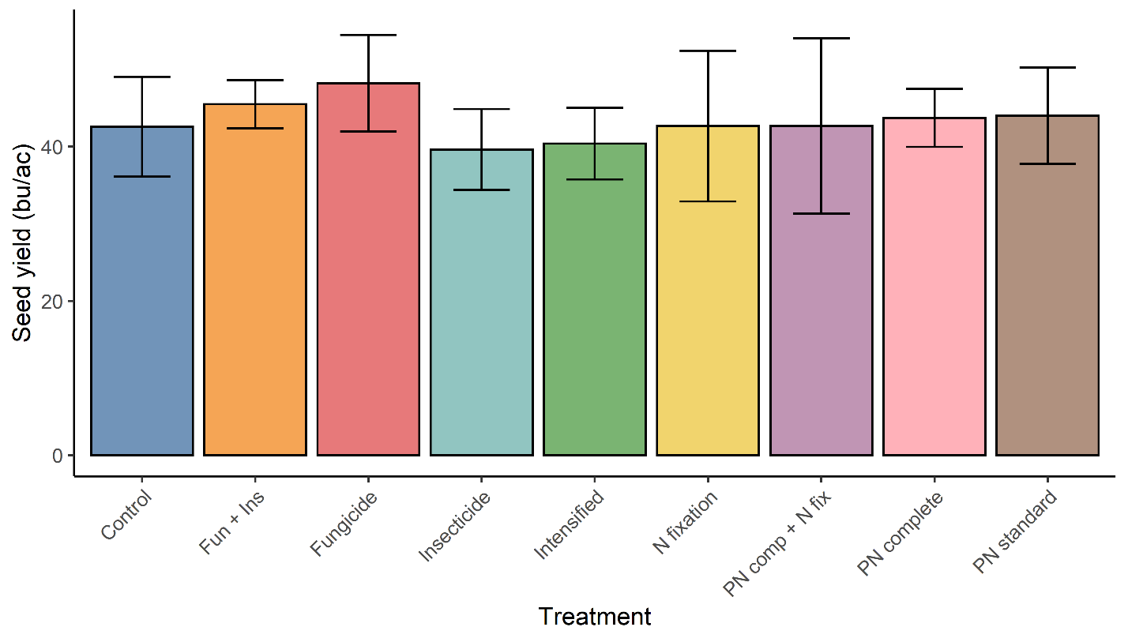
Figure 1: Seed yield (bu/ac) for each treatment. Vertical bars are the 95% CI.
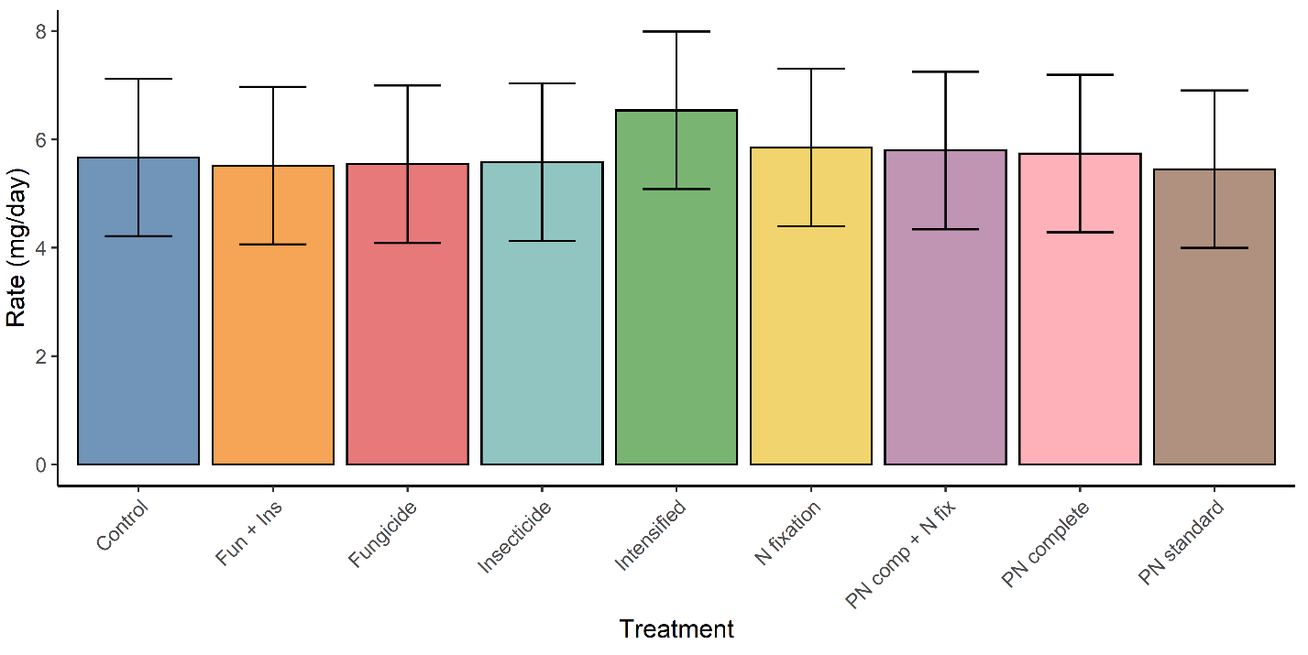 Figure 2: Seed filling rate for each treatment. Vertical bars are the 95% CI.

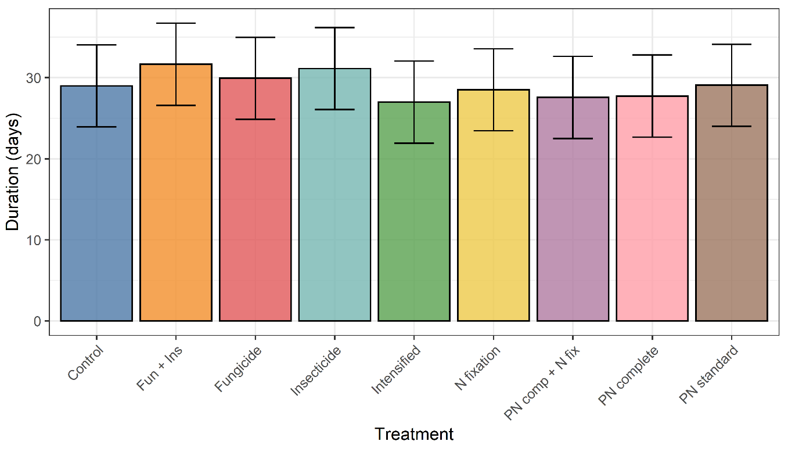
Figure 3: Seed filling duration for each treatment. Vertical bars are the 95% CI.

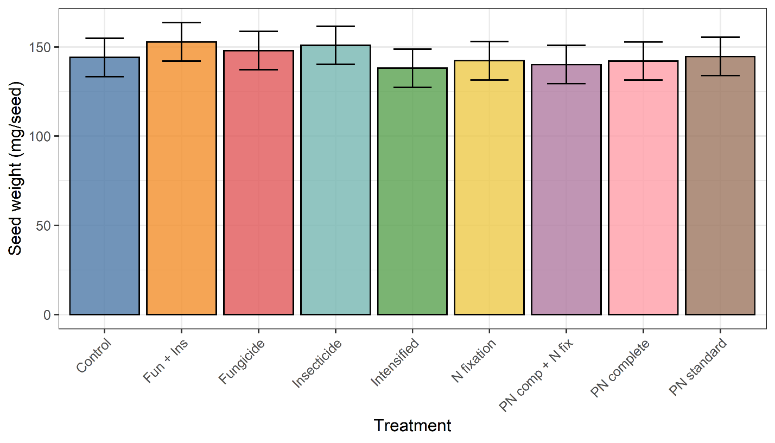Figure 4: Final seed weight rate for each treatment. Vertical bars are the 95% CI.
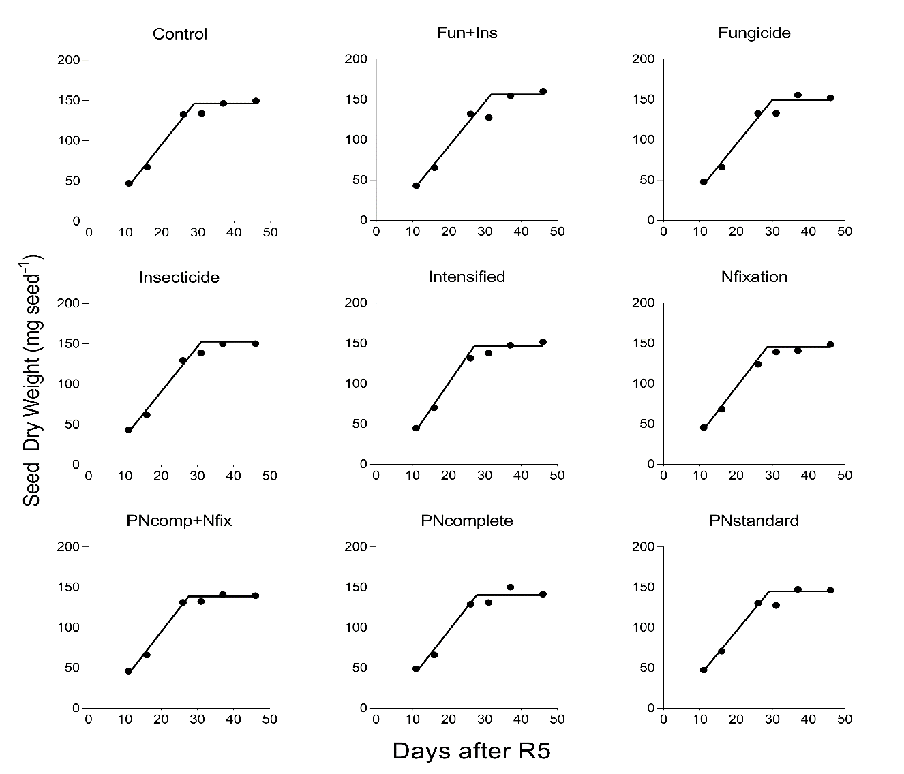
Figure 5: Changes in seed dry weight accumulation from the onset of the seed filling (R5 growth stage) until physiological maturity, end of the season. Each point represents the average of four replications.

Conclusions
Treatments applied neither affect final seed weight nor seed yield. Furthermore, across all treatments similar trends were observed for the seed growth rate and seed filling duration. Future research should consider evaluating the effect of the treatments here tested at different crop growth stages.

