Technical Report to the North Dakota Soybean Council and the State Board of Agricultural Research and Extension

Control Measures for Iron Deficiency Chlorosis in Soybeans

R. Jay Goos, Professor
Department of Soil Science
North Dakota State University
31 December 2020

Summary
Numerous studies were performed at the NDSU AES Greenhouse, to screen plant growth regulators (PGRs) and biostimulants (BSs), in conjunction with the fertilizer FeEDDHA, for the reduction of iron deficiency chlorosis (IDC) of soybeans. Only successful trials are reported here. Many compounds did not have an effect on IDC. Three candidate PGRs and two BSs were identified as having the ability to increase leaf chlorophyll contents, when used in conjunction FeEDDHA. One compound, PGR-3 was given the most scrutiny, as it was effective and is already widely available commercially at reasonable cost for other purposes. PGR-3 was effective as either a seed treatment or foliar spray in greenhouse trials, when used with FeEDDHA. A field trial near Glyndon, MN demonstrated that a combination spray of FeEDDHA and PGR-3 was more effective than a spray of FeEDDHA alone, in reducing IDC in the field.

Introduction
The problem of IDC in soybeans appears to be as bad as ever in North Dakota. The main control measures are well-known: 1. Plant an IDC-resistant variety, 2. Use an in-furrow application of an effective Fe fertilizer, like FeEDDHA, at planting, 3. Wider row spacings and heavier seeding rates can also reduce IDC. Foliar spray "rescue" treatments have been less effective. Control measures for IDC appear to be "stackable," meaning, additive. For example, Goos and Johnson (2001) demonstrated that variety selection, seed treatment with FeEDDHA, and heavier seeding rates worked together to reduce IDC severity and increase yield.
The syndrome of IDC leads to more than a loss of chlorophyll. Certain toxins can accumulate in the leaves. For example, hydrogen peroxide is produced during normal metabolism of plant cells. Normally, the hydrogen peroxide is detoxified by an enzyme called catalase. Catalase is an iron-containing (heme) enzyme, and accumulation of hydrogen peroxide in plant cells has been measured in plant cells suffering from IDC (Sun et al. 2007). The objective of this project was to screen plant growth regulators known to stimulate chlorophyll production or stimulate leaf catalase activity, to determine if their use could be "stacked" with an application of FeEDDHA, to further reduce IDC.

Methods--General
Greenhouse screening methods followed a procedure developed in an earlier NDSC project. Methods followed in all studies were as follows. One kg lots of a chlorosis-producing Glyndon soil were mixed with one kg lots of 20/40 mesh white sand that had been treated with basal nutrients. Basal nutrients were in solution form, and contained 100 mg P as K₂HPO₄, and 5 mg each as Zn, Mn, and Cu as sulfate salts. The nutrient solutions were mixed well with the sand, before being mixed with the soil. The soil was previously air-dried and crushed to pass a 2 mm sieve. Cotton balls were placed into the bottoms of conical "cone-tainer" pots, and filled to within 2 inches of the top. Plastic cups were placed under the pots, and a nitrate, or nitrate-bicarbonate solution, added, and the soil allowed to wet by capillary action. The pots were covered, and the soil allowed to incubate for 5-7 days, to allow the basal nutrients time to react with the soil, and to reestablish microbial growth. Seed was placed on the surface of the moist soil, and covered with ~15 mL of 20/40 sand. The sand was moistened with ~5 mL of water daily until emergence. The water in the cups under the pots was filled daily, typically of a solution of 10 mM sodium nitrate and 5 mM sodium bicarbonate. Plants were grown to the 2nd or 3rd trifoliolate stage. Measurements included the relative chlorophyll content with a Minolta SPAD meter, and the fresh weight of the plant tops, when the stem was severed just below the intersection of the petiole of the first trifoliolate leaf and the main stem.
Compounds being screened for seed-treatment potential were first screened for seedling toxicity, to give guidance as to the rates that could be used in studies as described in the prior paragraph. These preliminary studies consisted of placing individual soybean seeds in test tubes and treating them with 0.2 mL of water containing the PGR or BS of interest. Ten seeds such treated were planted in moist sand, and root growth after 4 or 5 days measured. These studies established relatively safe rates of the compounds being screened for seed treatment potential.
Seed treatment studies were performed either by imbibing the PGR or BS into the seed, as described in the prior paragraph, or by surface application to dry seed, followed by drying. Surface application was accomplished by weighing 100 g of seed into a plastic bag, adding 1 mL of treatment solution to the seed with constant mixing, and air-drying after the seed appeared to be equally "shiny" and treated.
Foliar spray treatments were applied using the research spray booths at the AES greenhouse, using a TeeJet nozzle, 3 mph nozzle speed, and a volume of water of about 18 gpa.

Methods--Experiment Specific
Only the most relevant studies are discussed in this report. Unless stated otherwise, the variety was ND17009GT, and the study had 10 replicates. Experiment 1 was a seed treatment study, where individual seeds were placed in test tubes and treated with 0.1 mL of PGR-1 solution of varying concentration (0, 0.15, 0.3, 0.6 µg/seed), and 0.1 mL of FeEDDHA solution (0, 50 µg Fe as FeEDDHA). The rates of PGR-1 were approximately 1, 2, and 4 mg PGR-1 per kilogram of seed (1, 2, or 4 ppm).
Experiment 2 was a similar study, except that PGR-1 was applied to the seed and air-dried. The rates were 0, 1, 2, or 4 mg PGR-1/kg of seed. Iron was applied to the soil surface at planting at rates of 0, 25, and 50 µg Fe as FeEDDHA.
Experiment 3 evaluated a different compound, PGR-2, after a preliminary seed-imbibition study similar to Experiment 1 showed some promise. The rates were 0, 25, 50 and 100 mg of PGR-2/kg of seed, applied to the surface as a commercial product sold for other purposes. Iron was applied to the soil at rates of 0, 25, and 50 µg Fe as FeEDDHA.
Experiment 4 evaluated a different compound, PGR-3, after a preliminary seed-imbibition study similar to Experiment 1 showed great promise. PGR-3 was applied to the seed surface as a commercial product sold for other purposes at rates of 0, 2, 4, and 8 mg/kg of seed. Iron was applied to the soil at rates of 0, 25, and 50 µg Fe as FeEDDHA.
Experiment 5 evaluated two commercially-available biostimulants, BS-1 and BS-2, received from the manufacturer in powder form. Iron was applied to the soil at a rate of 15 µg Fe as FeEDDHA, and the biostimulants applied as 1 mL of a solution of 5 g/100 mL, or 50 mg of dry product equivalent per pot.
Experiment 6 evaluated the same biostimulants, but this time in the liquid form more commonly sold by the manufacturer. The BS-1 solution was approximately a 15% solution of the dry material in water, and the BS-2 solution was approximately a 30% solution of the dry material in water. The thought was to evaluate BS-1 and BS-2 in practical form, perhaps as a "sticker" for FeEDDHA powder in future studies. One mL of BS-1 or BS-2 was mixed with 100 g of seed, followed by air-drying. The rate of BS-1 and BS-2 were far lower than in the previous study, less than 1 mg/pot of dry product equivalent. The rate of Fe was 25 µg/pot as FeEDDHA.
Experiment 7 examined if there could be synergy between PGR-3 and BS-2 as seed treatments. Seed was treated with 0 or 2 mg/kg of PGR-3 in factorial combination with 0 or 1 mL/100 g of BS-2. The seed was treated first with PGR-3, air-dried, and then treated with BS-2 as appropriate. Iron was added at rates of 0, 25, and 50 µg/pot as FeEDDHA.
Experiment 8 was a foliar spray study. Iron was applied at an equivalent rate of 0 or 1 lb/A as FeEDDHA, and the concentrations of PGR-3 were 0, 50, 100, 200, and 400 mg/L. Spraying occurred when the 1st trifoliolate was fully developed, the second trifoliolate was less than half developed, and the third trifoliolate had not yet appeared. This trial was continued until the 3rd trifoliolate stage, to determine if the treatments provided reduction in IDC in leaves that did not receive spray.
Experiment 9 was a study in a farmer-managed production field, near Glyndon, MN. Soybeans had been planted with 3 lb/A of Soygreen, but the strong greening effect seen early in the season began to fade, and the plants began to yellow at the 4-5 trifoliolate stage. An experiment was established on soybeans that had received Soygreen, with three treatments, and four replications. The treatments were control, 1 lb/A of Soygreen, and 1 lb/A of Soygreen with PGR-3 at a concentration of 400 ppm. The spray was applied as a six-inch-wide band on top of the rows, to focus the treatment on the plants. The spray was applied at about the 5-trifoliolate stage. Ten random plants per plot were taken from each plot at the early pod stage (pods about an inch long), and the upper two fully-developed trifoliolates on the main stem measured for relative chlorophyl content with a SPAD meter. At maturity, soybeans in the plot were cut off at the soil surface, the bundles dried, threshed, and the seed weighed.

Results
The results from Experiment 1 are shown in Table 1 and in Figure 1. It was shown that PGR-1 at all rates (0.15, 0.3, 0.6 µg/seed) increased plant chlorophyll content, especially in combination with 50 µg Fe as FeEDDHA. In the absence of Fe, seed treatment with PGR-1 increased chlorophyll and fresh weight. In the presence of Fe, higher rates of PGR-1 tended to reduce fresh weight. That is consistent with the mode of action of this PGR, as it can slow plant water uptake and growth rate at higher rates.
The results from Experiment 2 are shown in Table 2 and Figure 2. The results were very similar to those observed in Experiment 1. Increasing rate of PGR-1 increased leaf chlorophyll level at all rates of Fe, but at higher rates, growth was somewhat reduced in the presence of Fe.
The results from Experiment 3 are shown in Table 3 and Figure 3. PGR-2 had a weaker effect on chlorophyll levels than PGR-1, but did show a clear greening effect at the 100 mg/kg rate applied to the seed. Unlike PGR-1, the highest rate of PGR-2 increased plant fresh weight, relative to the zero rate of PGR-2. Further studies on PGR-2 are warranted.
The results from Experiment 4 are shown in Table 4 and Figure 4. PGR-3 has a similar mode of action as PGR-1, but appears to be safer to apply to the seed. Application of PGR-3 at the rates of 2 and 4 mg/kg increased chlorophyll levels without significant reduction in fresh weight. The highest rate of PGR-3 had the strongest effect on chlorophyll content, but with some reduction in fresh weight.
It is important to stress how low these rates are. If a farmer plants 50 lb/A of seed, a rate of PGR-3 at 2-4 mg/kg is equivalent to about 0.05-0.1 gram per acre. This compound is commercially-available for other agricultural purposes for about $0.50/gram.
The results for Experiment 5 are shown in Table 5 and Figure 5. The application of BS-1 or BS-2 at an equivalent rate of 50 mg dry material/pot gave a visually-obvious effect on growth and chlorophyll. The rate used, however, was beyond what would be economically practical, but the study did show a possible effect of these two biostimulants.
Experiment 6 tested practical rates of BS-1 and BS-2. In this case, commercial liquid products were used. The undiluted products were applied to the seed at a rate of 1 mL/100 g of seed, followed by air-drying. The amount of dry material equivalent was less than 1 mg/pot. And, as is shown in Table 6. Seed treatment with the two biostimulants increased both chlorophyll levels and fresh weight. BS-2 appeared to be more effective than BS-1, whereas the opposite was shown in Experiment 5. The explanation is that the commercial liquid BS-2 product is about twice as concentrated as the BS-1 liquid product.
After Experiment 6, it was wondered if the effects of seed treatment with PGR-3 and HA-2 were "stackable." The results of Experiment 7 are shown in Table 7 and Figure 6. There was a problem with lighting and temperature control in the greenhouse room, as this experiment was performed in the USDA greenhouse complex, as my reservation in the AES Greenhouse is expiring. The lighting and temperature control problems have been corrected, and this experiment will be repeated. Nevertheless, the combination treatment of 2 mg/kg PGR-3 and 1 mL/100 g BS-2, performed well, and without the growth reduction observed with PGR-1.
Experiment 8 was a foliar spray trial, and was completed in December 2020. The results for the entire experiment are shown in Table 7, and the chlorophyll levels for the plus-iron-only treatments shown in Figure 6. Referring to Figure 6, it is important to note that the highest concentration of PGR-3 applied, 400 mg/L, the chlorophyll levels of the second and third trifoliolate leaves was greater than the control. The third trifoliolate had not developed when the plants were sprayed. This is a confirmation of the field study conducted during the summer of 2020.
Experiment 9 was a field study, where the soybeans had responded well to an application of FeEDDHA at planting, but were yellowing off. Figure 7 shows the striking effect of adding PGR-3 to FeEDDHA, as the effect was visibly obvious in Replicates 1, 2, and 3. The measured chlorophyll levels also documented the increase (Table 9). Iron deficiency chlorosis has a high degree of soil variability, and it was not possible to show a statistically-significant increase in yield because of adding PGR-3 to FeEDDHA, but the trend was promising.

Conclusion
This project discovered new candidate compounds for the reduction of IDC in soybeans. Most promising is PGR-3, either as a seed treatment or as a foliar spray in combination with an iron fertilizer. Also, the two biostimulants also have potential to further reduce IDC, either applied in-furrow with FeEDDHA, or as a seed treatment.

References

Goos, R.J. and B.E. Johnson. 2001. Seed treatment, seeding rate, and cultivar effects on iron deficiency chlorosis of soybean. Journal of Plant Nutrition. 24:1255-1268. DOI: 10.1081/PLN-100106980

Sun, B., Y. Jing, K. Chen, L. Song, F. Chen, and L. Zhang, 2007. Protective effect of nitric oxide on iron deficiency-induced oxidative stress in maize (Zea mays). Journal of Plant Physiology 164:536-543. DOI: 10.1016/j.jplph.2006.02.011

Table 1. Experiment 1. Effect of seed treatment with PGR-1 and FeEDDHA on relative chlorophyll level and fresh weight (1st trifoliolates and above) of ND17009GT soybean. Both PGR-1 and FeEDDHA were applied to individual seeds in test tubes, and allowed to imbibe the treatment overnight.

FeEDDHA | PGR-1 | 1st tri. | 2nd. tri. | Avg. 1+2 | FW
µg Fe/seed | µg/seed | SPAD | SPAD | SPAD | g/pot
0 | 0 | 5.4 | 1.7 | 3.6 | 0.80
50 | 0 | 21.2 | 9.7 | 15.5 | 2.65
0 | 0.15 | 17.6 | 10.0 | 13.8 | 1.68
50 | 0.15 | 28.0 | 18.6 | 23.3 | 2.49
0 | 0.3 | 23.4 | 14.4 | 18.9 | 1.51
50 | 0.3 | 30.8 | 23.7 | 27.2 | 2.09
0 | 0.6 | 21.6 | 15.8 | 18.7 | 1.47
50 | 0.6 | 35.2 | 27.7 | 31.5 | 1.70
Sig. of F | Fe | ** | ** | ** | **
 | PGR | ** | ** | ** | **
 | Fe x PGR | NS | NS | NS | NS
 | SE | 2.3 | 2.5 | 2.3 | 0.21
**, NS, significant at the 0.01 level and not significant, respectively.
SE=Standard error

Figure 1. Experiment 1. Average of the 1st and 2nd trifoliolate SPAD as influenced by FeEDDHA, and PGR-1 applied to the seed.

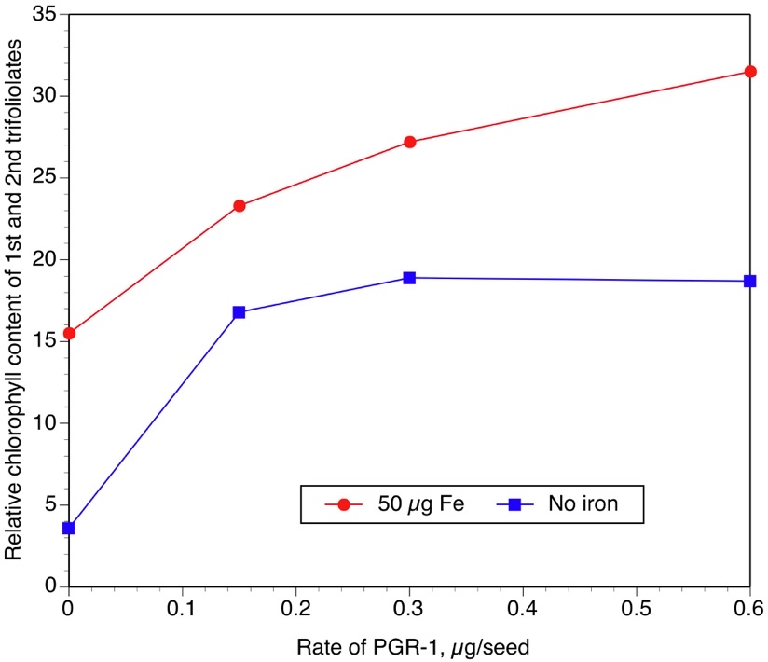
Table 2. Effect of seed treatment with PGR-1 and FeEDDHA on relative chlorophyll level and fresh weight (1st trifoliolates and above) of ND17009GT soybean. PGR-1 was applied to the surface of the seed and dried, and the FeEDDHA was applied to the soil.

FeEDDHA | PGR-1 | 1st tri. | 2nd. tri. | Avg. 1+2nd | Fresh wt.
µg Fe/pot | mg/kg | SPAD | SPAD | SPAD | g
0 | 0 | 5.1 | 2.6 | 3.8 | 1.21
25 | 0 | 12.2 | 7.0 | 9.6 | 1.86
50 | 0 | 22.0 | 15.9 | 18.9 | 2.32
0 | 1 | 9.4 | 2.8 | 6.1 | 1.30
25 | 1 | 15.2 | 9.3 | 12.2 | 2.06
50 | 1 | 22.9 | 15.0 | 18.9 | 2.19
0 | 2 | 12.5 | 6.9 | 9.7 | 1.69
25 | 2 | 19.1 | 12.3 | 15.7 | 2.00
50 | 2 | 30.1 | 23.0 | 26.5 | 1.98
0 | 4 | 21.4 | 11.0 | 16.2 | 1.34
25 | 4 | 30.3 | 21.6 | 25.9 | 1.85
50 | 4 | 36.1 | 30.0 | 33.0 | 1.61
Sig. of F: | Fe | ** | ** | ** | **
 | PGR | ** | ** | ** | **
 | Fe x PGR | NS | NS | NS | NS
 | SE | 2.2 | 1.9 | 1.9 | 0.14
**, NS, significant at the 0.01 level and not significant, respectively.
SE=Standard error

Figure 2. Average of the 1st and 2nd trifoliolate SPAD as influenced by FeEDDHA, and PGR-1 applied to the seed.

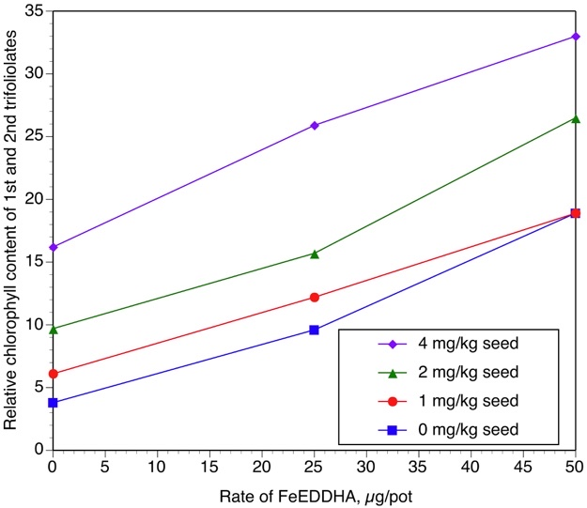

Table 3. Experiment 2. Effect of seed treatment with PGR-2 and FeEDDHA on relative chlorophyll level and fresh weight (1st trifoliolates and above) of ND17009GT soybean. PGR-2 was applied to the surface of the seed and dried, and the FeEDDHA was applied to the soil.

FeEDDHA | PGR-2 | 1st tri. | 2nd tri. | Avg. 1+2 | FW
µg Fe/pot | mg/kg seed | SPAD | SPAD | SPAD | g
0 | 0 | 4.5 | 3.5 | 4.0 | 1.34
25 | 0 | 25.1 | 21.3 | 23.2 | 2.88
50 | 0 | 29.6 | 21.2 | 25.4 | 2.81
0 | 25 | 8.4 | 6.0 | 7.2 | 1.94
25 | 25 | 22.8 | 17.9 | 20.4 | 2.78
50 | 25 | 30.8 | 21.6 | 26.2 | 3.01
0 | 50 | 5.5 | 5.0 | 5.3 | 1.76
25 | 50 | 25.4 | 20.0 | 22.7 | 2.87
50 | 50 | 29.8 | 20.0 | 24.9 | 3.05
0 | 100 | 7.3 | 4.9 | 6.1 | 1.70
25 | 100 | 27.8 | 25.8 | 26.8 | 3.06
50 | 100 | 33.2 | 25.7 | 29.4 | 3.33
Sig of F | Fe | ** | ** | ** | **
 | PGR | NS | + | + | +
 | Fe x PGR | NS | NS | NS | NS
 | SE | 1.7 | 2.0 | 1.7 | 0.15
+, **, NS, significant at the 0.1 level, 0.01 level and not significant, respectively.
SE=Standard error

Figure 3. Experiment 2. Average of the 1st and 2nd trifoliolate SPAD as influenced by Soygreen, and PGR-2 applied to the seed.

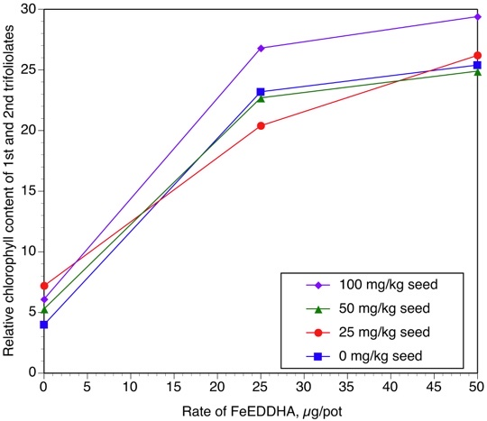
Table 4. Effect of seed treatment with PGR-3 and FeEDDHA on relative chlorophyll level and fresh weight (1st trifoliolates and above) of ND17009GT soybean. PGR-3 was applied to the surface of the seed and dried, and the FeEDDHA was applied to the soil.

FeEDDHA | PGR-3 | 1st tri. | 2nd tri. | Avg. 1+2 | FW
µg Fe/pot | mg/kg seed | SPAD | SPAD | SPAD | g
0 | 0 | 6.1 | 4.6 | 5.3 | 1.15
25 | 0 | 18.2 | 14.8 | 16.5 | 2.14
50 | 0 | 27.4 | 21.9 | 24.6 | 2.59
0 | 2 | 10.2 | 7.3 | 8.7 | 1.78
25 | 2 | 31.6 | 24.4 | 28.0 | 2.58
50 | 2 | 36.6 | 28.7 | 32.7 | 2.76
0 | 4 | 14.5 | 10.2 | 12.3 | 1.65
25 | 4 | 33.5 | 28.5 | 31.0 | 2.47
50 | 4 | 38.3 | 30.9 | 34.6 | 2.43
0 | 8 | 23.1 | 17.3 | 20.2 | 1.37
25 | 8 | 34.1 | 28.3 | 31.2 | 1.53
50 | 8 | 37.2 | 34.7 | 35.9 | 1.61
Sig of F | Fe | ** | ** | ** | **
 | PGR | ** | ** | ** | **
 | Fe x PGR | + | NS | + | **
 | SE | 1.9 | 1.9 | 1.8 | 0.15
+, **, NS, significant at the 0.1 level, 0.01 level and not significant, respectively.
SE=Standard error

Figure 4. Average of the 1st and 2nd trifoliolate SPAD as influenced by FeEDDHA, and PGR-3 applied to the seed.

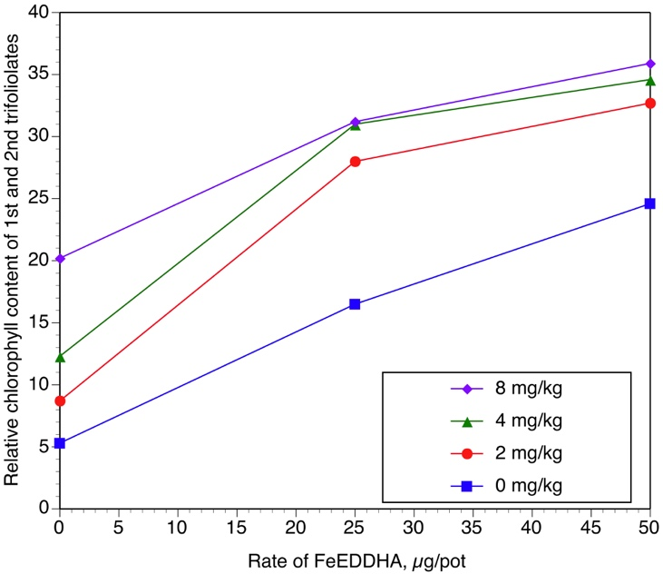

Table 5. Effect of two "biostimulants" (BS1, BS2) on severity of IDC of Glacier and Traill soybean. Rate of FeEDDHA was 25 µg Fe/pot. The biostimulant rate was 50 mg/pot.

 |  | 1st tri. | 2nd tri. | Avg. 1+2 | FW
Variety | Treatment | SPAD | SPAD | SPAD | g
Glacier | Fe | 21.3 | 13.9 | 17.6 | 1.91
Glacier | Fe + BS-1 | 25.0 | 22.8 | 23.9 | 2.31
Glacier | Fe + BS-2 | 22.5 | 21.9 | 22.2 | 2.27
Traill | Fe | 27.7 | 17.9 | 22.8 | 2.07
Traill | Fe + BS-1 | 30.6 | 27.0 | 28.8 | 2.55
Traill | Fe + BS-2 | 27.8 | 20.1 | 24.0 | 2.21
Sig of F | Var | ** | NS | ** | NS
 | Trt | * | ** | ** | *
 | Var x Trt | NS | NS | NS | NS
 | SE | 1.1 | 2.1 | 1.4 | 0.12
SE=Standard error

Figure 5. Glacier soybean, from left to right, 25 µg Fe as FeEDDHA, 25 µg Fe as FeEDDHA plus 50 mg BS-2.

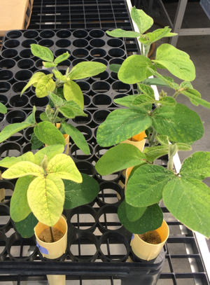
Table 6. Effect of two biostimulants on ND17009GT soybean. FeEDDHA was applied at 25 µg/pot, and the biostimulants applied at a rate of 1 mL/100g of seed, followed by drying.

Seed | 1st trifol. | 2nd tri. | Avg. 1+2 | FW
treatment | SPAD | SPAD | SPAD | g
Control | 18.2 | 14.8 | 16.5 | 2.14
BS-1 ST | 23.7 | 20.6 | 22.2 | 2.51
BS-2 ST | 24.7 | 24.8 | 24.8 | 2.47
Sig. of F | NS | * | * | +
SE | 2.2 | 2.1 | 2.0 | 0.11
SE=standard error

Table 7. Effect of PGR-3, BS-2, and FeEDDHA on severity of IDC of ND17009GT soybean. Both the PGR-3 and BS-2 were applied as seed treatments and dried, the FeEDDHA was applied to the soil.

FeEDDHA | BS-2 | PGR-3 | 1st tri. | 2nd tri. | Avg. 1+2 | FW
µg Fe/pot | mL/100g | mg/kg | SPAD | SPAD | SPAD | g
0 | 0 | 0 | 11.5 | 6.6 | 9.1 | 1.17
25 | 0 | 0 | 18.0 | 13.6 | 15.8 | 1.83
50 | 0 | 0 | 21.5 | 18.9 | 20.2 | 1.95
0 | 1 | 0 | 15.4 | 12.6 | 14.0 | 1.58
25 | 1 | 0 | 15.8 | 12.6 | 14.2 | 1.89
50 | 1 | 0 | 24.3 | 23.8 | 24.1 | 2.16
0 | 0 | 2 | 15.8 | 8.6 | 12.2 | 1.60
25 | 0 | 2 | 21.3 | 14.1 | 17.7 | 1.79
50 | 0 | 2 | 33.6 | 30.0 | 31.8 | 1.98
0 | 1 | 2 | 19.3 | 11.7 | 15.5 | 1.61
25 | 1 | 2 | 26.1 | 20.5 | 23.3 | 1.99
50 | 1 | 2 | 30.8 | 27.0 | 28.9 | 2.11
 | Sig. of F | Fe | ** | ** | * | **
 |  | BS | NS | + | + | *
 |  | PGR | ** | ** | ** | NS
 |  | Fe x BS | NS | NS | NS | NS
 |  | Fe x PGR | NS | + | + | NS
 |  | BS x PGR | NS | NS | NS | NS
 |  | Fe x BS x PGR | NS | * | * | NS
 |  | SE | 1.8 | 1.7 | 1.6 | 0.10

Figure 6. Effect of seed treatment with 1% BS-2, 2 mg/kg PGR-3, and soil application of FeEDDHA on severity of IDC, of ND17009GT soybean, averaged across the 1st and 2nd trifoliolate stages.

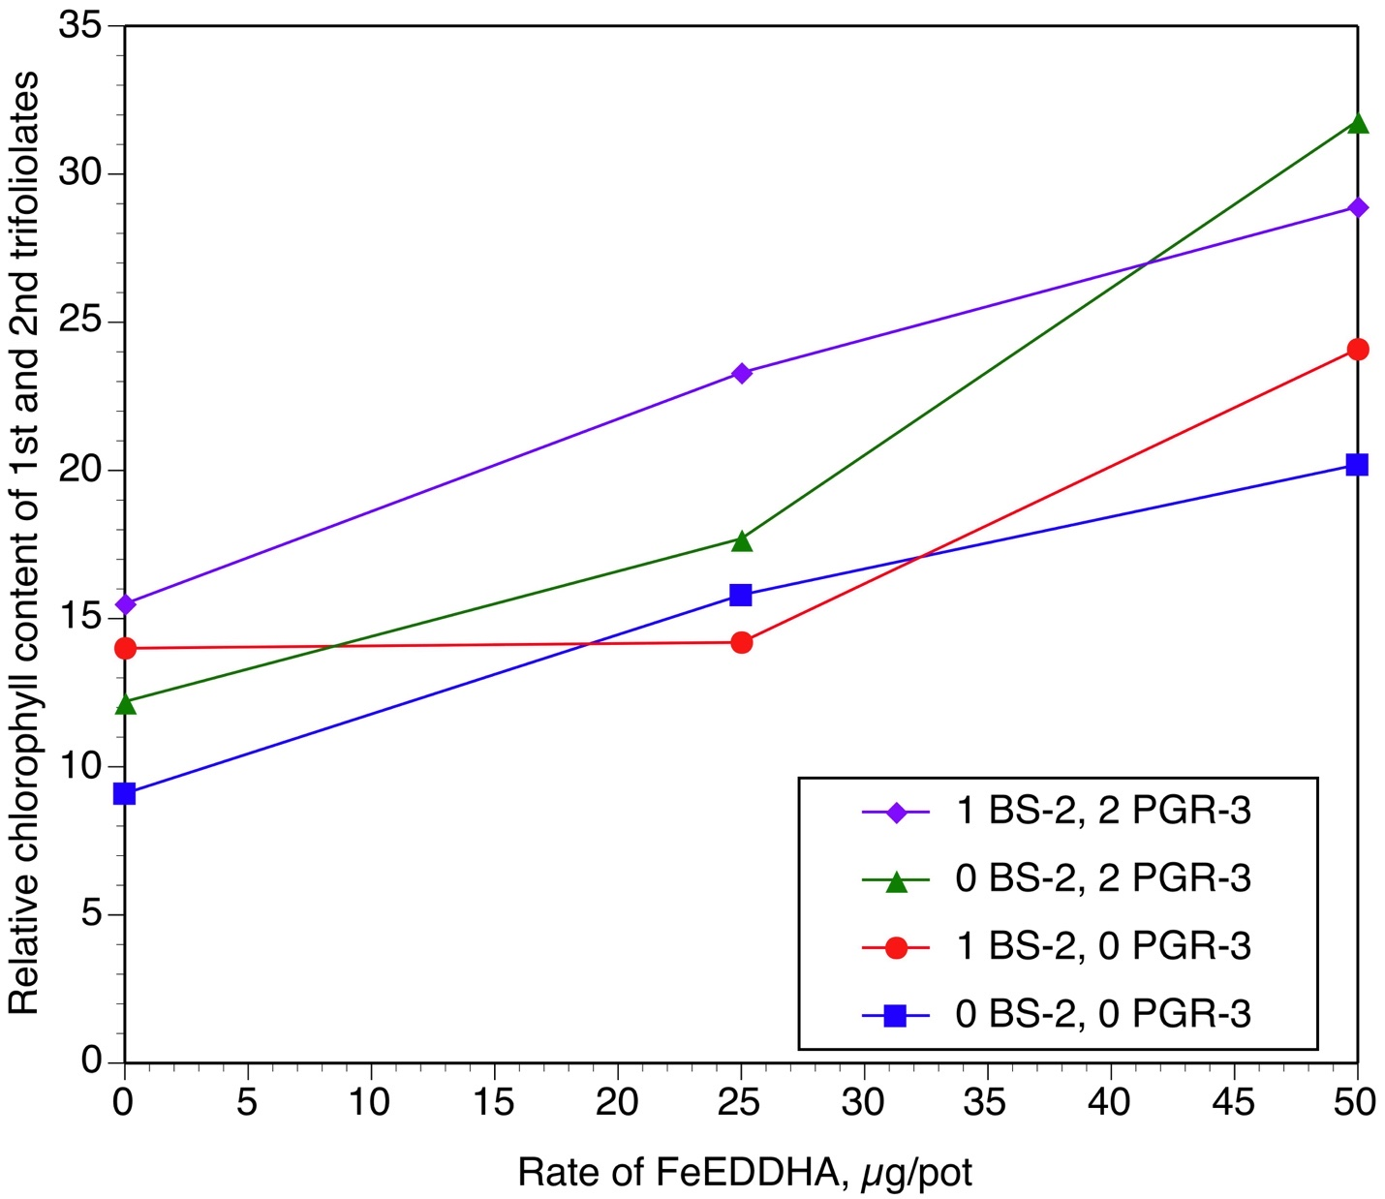

Table 8. Effect of a foliar spray with FeEDDHA and PGR-3 on severity of IDC of ND17009GT soybean. The spray was applied with a research spray booth, using a standard TeeJet nozzle. Statistical analyses were performed on all of the data, and also on those treatments only receiving FeEDDHA.

FeEDDHA | PGR-3 | 1st tri. | 2nd tri. | 3rd tri. | FW
lb/A | mg/L | SPAD | SPAD | SPAD | g
0 | 0 | 18.6 | 10.1 | 3.2 | 2.17
1 | 0 | 30.1 | 31.7 | 14.4 | 2.81
0 | 50 | 19.2 | 11.7 | 2.4 | 2.18
1 | 50 | 31.8 | 31.6 | 16.5 | 2.71
0 | 100 | 19.8 | 12.3 | 2.4 | 1.92
1 | 100 | 29.8 | 36.3 | 17.7 | 2.81
0 | 200 | 19.4 | 9.7 | 2.5 | 1.83
1 | 200 | 31.7 | 33.7 | 17.4 | 2.51
0 | 400 | 20.7 | 11.4 | 2.5 | 1.91
1 | 400 | 31.0 | 38.3 | 23.0 | 2.63
Sig. of F (all treatments)
 | Fe | ** | ** | ** | **
 | PGR-3 | NS | NS | NS | NS
 | Fe x PGR-3 | NS | NS | NS | NS
 | SE | 1.1 | 2.1 | 1.9 | 0.15
Sig of F (plus Fe treatments only)
 | PGR-3 | NS | * | * | NS
 | SE | 0.9 | 1.6 | 1.9 | 0.13

Figure 7. Effect of concentration of PGR-3 in a foliar spray, on severity of IDC of ND17009GT soybean. The figure only shows the chlorophyll levels of pots receiving FeEDDHA.

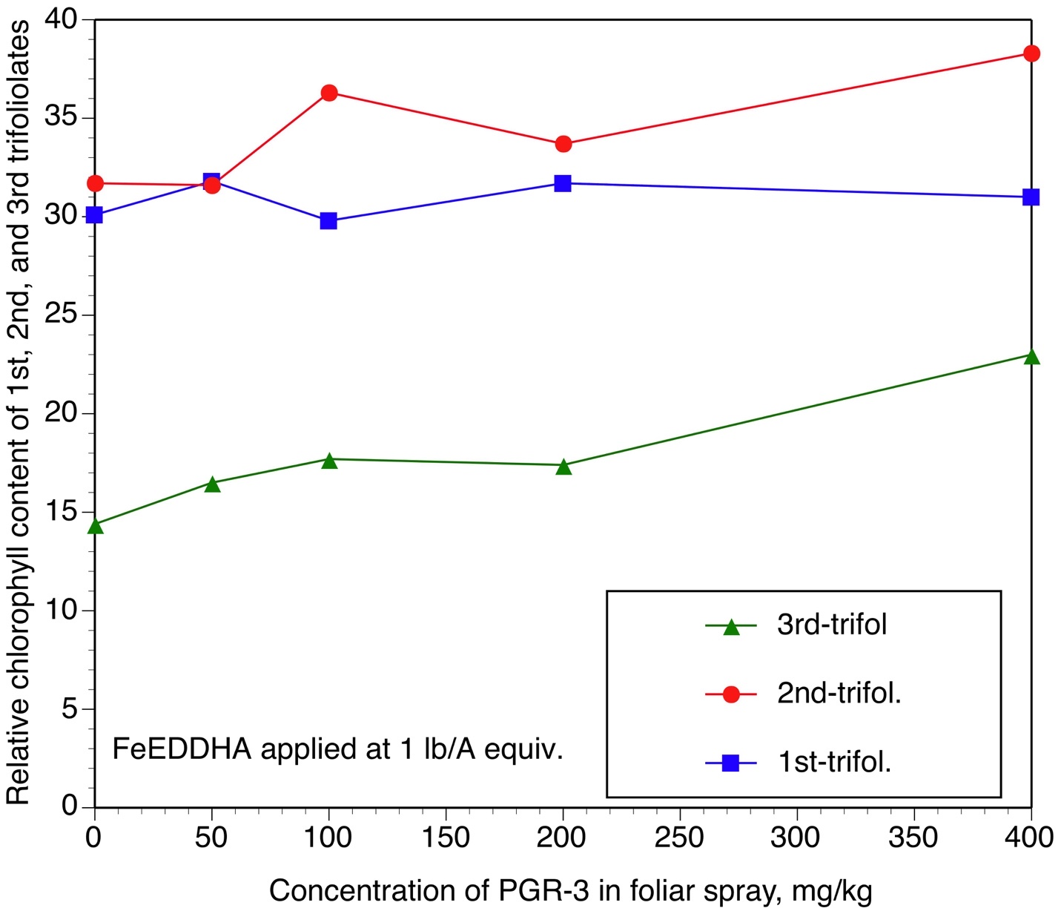
Figure 8. Field picture of soybeans, from left to right, untreated, sprayed with 1 lb/A FeEDDHA, and sprayed with 1 lb/A FeEDDHA and 400 mg/L of PGR-3.

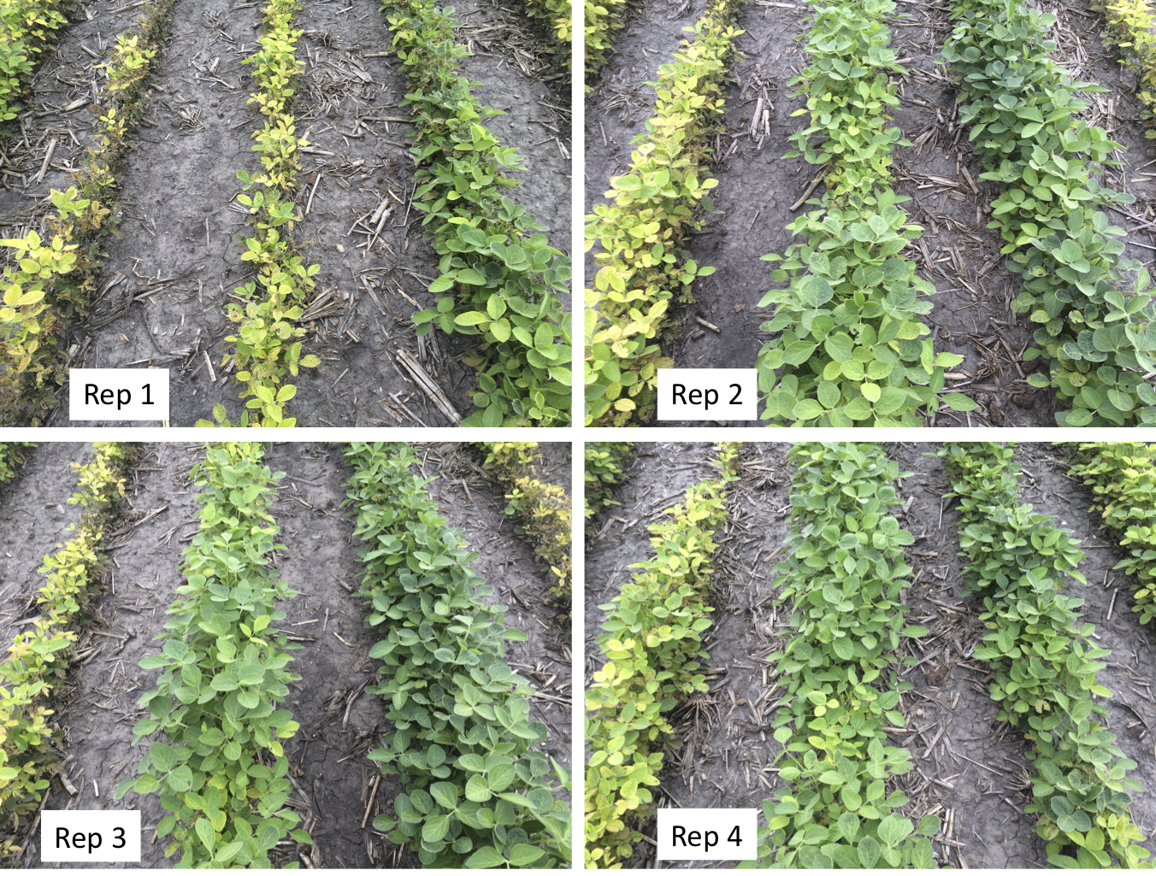

Table 9. Relative chlorophyll levels in the upper two fully-developed trifoliolates, and final seed yield of soybeans, Glyndon, MN, 2020. Spray was applied at the 5-6 trifoliolate stage, and chlorophyll readings taken at the early pod stage. Rate of FeEDDHA was 1 lb/A and the concentration of PGR-3 was 400 ppm. Spray was focused in a 6-inch wide band on top of the rows.

 | Upper trifol. | Seed yield | Seed yield
Treatment | SPAD | bu/A (4 reps) | bu/A (3 reps)
Control | 12.1 | 7.5 | 6.7
FeEDDHA | 26.5 | 39.6 | 31.6
FeEDDHA + PGR-3 | 37.0 | 42.0 | 43.5
LSD (0.05) | 8.8 | 19.3 | 14.0

