Final Report June 30, 2020
Soybean Cyst Nematode Sampling Program: 2019
PI: Sam Markell, Ph.D.
Co-PI’s Guiping Yan, Ph.D.
Collaborators: Berlin Nelson, Ph.D., and NDSU County Extension Agents
Why the Research is Important to ND Soybean Farmers:
Early detection of SCN is critical to avoiding yield loss. Distribution of cost-free SCN sampling has had buy-in among North Dakota growers. This has facilitated a likely detection of new positives and increased active management of SCN. Additionally, secondary benefits of this program have occurred, including the increased talk among growers about SCN, many press interviews and a significant amount of positive press for the North Dakota Soybean Council and its mission to serve the North Dakota growers.
Objectives:
- Provide incentive for growers to sample for SCN by covering the cost of up to three SCN samples (pre-labeled bags) per grower on a first-come first-serve basis (up to 2,000 bags total). Bags will be distributed through Extension County offices, my office, Research Director Nichol’s office, at field days and by any other means appropriate.
- Creation of a SCN distribution map (limited resolution – no farms or growers can be identified) that can be used to determine how widespread SCN is. This map will be widely distributed in an effort to encourage growers to sample and/or manage SCN.
Description of the Research Conducted:
Soybean Cyst Nematode sample bags were obtained from Agvise in June 2019. Bags were labeled with distinct yellow tags containing funding and identification numbers. Bags and accompanying instruction/submission forms were distributed to every Extension County office in early August. The number of bags distributed was roughly proportional to acreage (i.e., Richland and Cass County received more bags than Divide or Williams County). Bags were also distributed though the NDSU Plant Pathology Department, the NDSC Research Directors office, field days, NDSU Research Extension Centers and any other means appropriate. To advertise the availability of the program, multiple radio interviews were delivered, NDSU Crop and Pest Reports were written and other advertising was done.
Soybean growers were encouraged to sample around the time of harvest (before or after) which is when SCN numbers are known to be highest. Growers submitted samples to Agvise directly, or though the NDSU County Extension offices. Upon receipt, Agvise processed the samples and sends results thought the U.S. mail back to the submitter. Dr. Markell received geographic data points and egg levels and construct a map of SCN egg levels and distribution in the state. No additional personal information about submitters was obtained or used.
Findings and Results of the Research Conducted:
By the end of the fall, only 341 total SCN samples were received. This is markedly lower than in previous years, and likely a direct reflection of a very difficult harvest season in 2019. Maps were created with SCN data from 2013 to 2019 (Figures 1 and 2). ‘Heat maps’ were created for the southeast and southcentral counties in 2019 (Figure 3). Heat maps are visually appealing, but should be viewed with a high-level caution, as SCN is very patchy. Consequently, many fields in areas indicating the presence of high egg counts will actually not have SCN, and some fields in areas without SCN eggs will be positive.

Maps were distributed widely throughout winter months. Additionally, reprints of the Extension publication ‘Soybean Disease Diagnostic Series – PP1867’ were reprinted and distributed throughout winter meetings. Whenever possible, these were used as a hands on teaching tool, rather than passively distributed.

An effort was made this spring to provide County agents materials to advertise spring sampling within their counties. The effort was accented by radio interviews and a Crop and Pest Report article. However, due to the response of Covid-19, many county offices remained closed. As a result, it was left up to each county agent on how aggressively to push spring sampling. Notably, there is a lag time between sample submission and data availability, thus, this report may need to be amended within two weeks.

Benefits/Recommendations to the North Dakota Soybean Farmers and Industry:
We continue to recommend that growers actively sample for SCN. For growers who have not detected SCN before, we recommend that they concentrate on areas in the field where SCN is most likely to first be introduced, such as field entrances and frequently flooded areas in fields. In fields where SCN is known to occur, we recommend that growers soil sample to determine if current management strategies are working (i.e. keeping egg levels low).
Acknowledgements:
We express our thanks to the many Extension agents, crop consultants and other agricultural professionals who helped distribute sample bags and sampling instructions, to Michaela Halvorson for map construction, to Agvise for sample processing, and finally to the North Dakota Soybean Council for support.
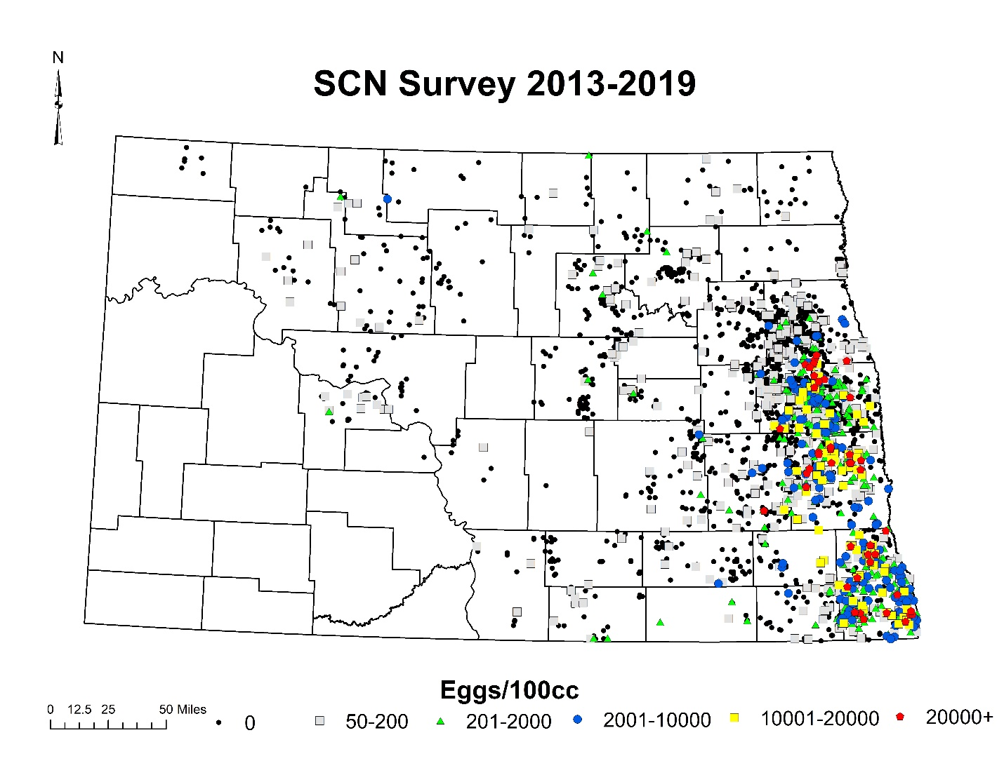
Figure 1. State-wide distribution and egg level of soybean cyst nematode in North Dakota received though the NDSC / NDSU sampling program 2013-2019.
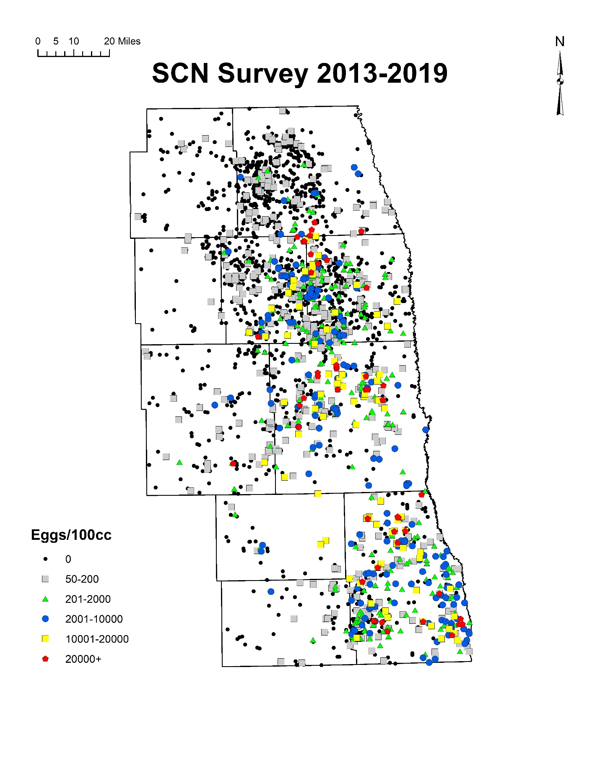
Figure 2. Region-wide distribution and egg level of soybean cyst nematode in southeast North Dakota received though the NDSC / NDSU sampling program in 2013-2019.

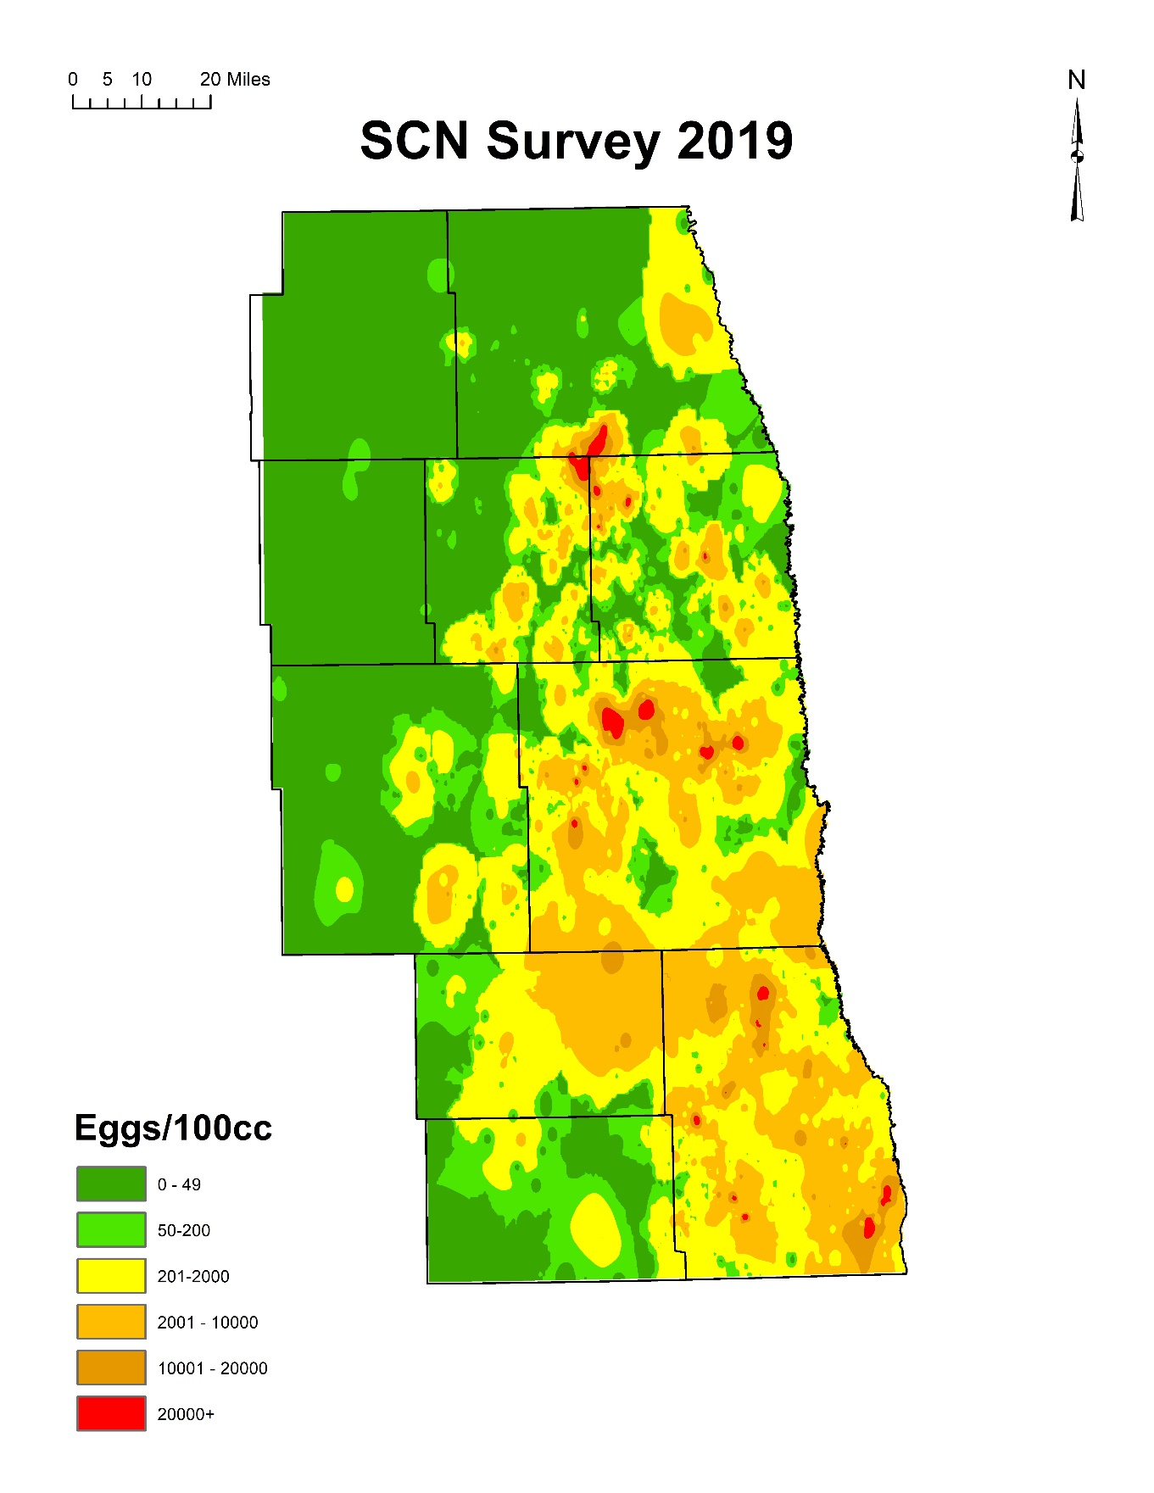
Figure 3. Heat map of distribution and egg level of soybean cyst nematode in southeast North Dakota received though the NDSC / NDSU sampling program in 2019 only.

