EVALUATING SOYBEAN CULTIVARS AND GERMPLASM FOR RESISTANCE TO SOYBEAN CYST NEMATODE

TECHNICAL REPORT

NORTH DAKOTA SOYBEAN COUNCIL
JUNE 2020

Dr. Guiping Yan, Principal Investigator, Dept. Plant Pathology, NDSU
Co-investigators: Dr. Ted Helms, Dept. Plant Sciences, NDSU and Dr. Sam Markell, Dept. Plant Pathology, NDSU

Soybean cyst nematode (SCN; Heterodera glycines) is a major yield-limiting factor of soybean. Annual yield losses in soybean caused by SCN have been estimated to be greater than $1 billion in the United States. Since it was first found in 2003 in North Dakota (ND), infestation of SCN has spread to at least 19 soybean-producing counties. SCN can quickly spread to other counties and become North Dakota soybean growers’ biggest disease problem if it is not detected early and managed proactively. Resistant cultivars combined with crop rotation are the primary methods for controlling SCN. SCN is known to be genetically diverse nematode populations and can develop new virulent forms over time due to continuous use of the same source of resistance. The new forms have higher levels of virulence and can overcome the resistance that is used for control. In ND, the virulent type that had been reported before 2015 was HG type 0 which does not attack PI88788, the major resistance source that has been widely used in ND. However, in 2015 and 2016, a more virulent form (HG type 2.5.7) that reproduced well on PI 88788 was detected in soybean fields in ND. The shift in SCN populations has led to a decrease in resistance in soybean cultivars derived from PI 88788. The overall goal of this research is to sustainably mange SCN by identifying new resistance sources for breeding programs and by identifying and utilizing resistant soybean cultivars. The specific objective of this research was to screen 80 soybean cultivars, germplasm and breeding lines for resistance to the common SCN virulent type (HG type 0) and the new virulent type (HG type 2.5.7) detected in North Dakota.

Eighty soybean lines (66 soybean germplasm lines of maturity group 00 to 1 from USDA-ARS Soybean Germplasm Collection in Illinois and 14 commercial cultivars North Dakota) were screened against the HG type 0. Eighty-one soybean lines (48 soybean germplasm lines of maturity group 00 to 1 from USDA-ARS Soybean Germplasm Collection in Illinois, 19 breeding lines from NDSU soybean breeding program, and 14 commercial cultivars from North Dakota) were screened for HG type 2.5.7. The two SCN populations HG type 2.5.7. and HG type 0 were collected from two soybean fields in ND. Four pre-germinated seeds of each soybean cultivar and line were planted in cone-tainers each containing about 100 cm³ of sterilized river sand soil then inoculated with 2,000 eggs and juveniles of each of the populations. Plants were then kept in a growth chamber maintained at a constant temperature of 27º C with daylight period of 16 hours (Figure 1). After 35 days of growth, SCN white females (cysts) were collected from the roots and soil of individual plants then counted under a microscope. The mean number of white females from four replicates produced on the roots of each soybean cultivar or line was used for calculating the female index by comparing with a susceptible soybean check (Barnes). Female index (FI) was calculated as FI = mean no. of white females produced on a tested soybean line/ mean no. of white females on the susceptible check x 100 %. Resistance response of each of the cultivars and lines was categorized based on the female index described by Schmitt and Shannon (1992) as resistant (R) (FI < 10), moderately resistant (MR) (10% < FI < 30%), moderately susceptible (MS) (30% < FI < 60%), and susceptible (S) (FI > 60%).

Out of the 48 soybean germplasm lines from USDA-ARS Soybean Germplasm Collection tested for HG type 2.5.7, 1 showed resistant reaction (FI: 1.3), 3 showed moderately resistant reaction (FI: 19.6 to 25.6), 16 showed moderately susceptible reaction (FI: 32.1 to 59.6), and 28 showed susceptible reaction (FI: 60.0 to 112.6) (Table 1). For 19 breeding lines from the NDSU soybean breeding program, 1 cultivar showed resistant response (FI: 8.9), 7 showed moderately resistant reaction (FI: 10.6 to 28.9), 7 showed moderately susceptible (FI: 37.6 to 57.5), and 4 showed susceptible (FI: 61.6 to 101.1) (Table 2). Out of 14 commercial soybean cultivars from North Dakota, 4 showed moderately susceptible reaction (FI: 52.3 to 59.6) and 10 showed susceptible reaction (FI: 75.0 to 210.0) but none of them were either resistant or moderately resistant to HG type 2.5.7 (Table 3).

Out of the 66 soybean germplasm lines from USDA-ARS Soybean Germplasm Collection tested for SCN HG type 0, 5 had moderately resistant reaction (FI: 16.1 to 26.4), 36 had moderately susceptible reaction (FI: 30.6 to 58.5), and 25 had susceptible reaction (FI: 60.3 to 90.5), but none of them showed resistance reaction (Table 1). Only a single line out of 14 commercial soybean cultivars from North Dakota had resistant response (FI: 8.9), 1 showed moderately resistant (FI: 28.9), 10 showed moderately susceptible (FI: 30.7 to 58.6), and 2 had susceptible reaction (FI: 69.7 to 109.4) to SCN HG type 0. (Table 3).

Out of all the germplasm, cultivars and breeding lines tested, 91% were susceptible or moderately susceptible and 9% were resistant or moderately resistant to HG type 0, and 85% were susceptible or moderately susceptible and 15% were resistant or moderately resistant to HG type 2.5.7. Importantly, one of them showed resistant response to HG type 0 (Figure 2A) and two of them showed resistant response to HG type 2.5.7. (Figure 2B), but none of them showed resistance to both the populations tested.

The important soybean cultivars and lines identified in this research will be re-tested to confirm their resistance reaction. Further research is necessary to determine if they are new sources of resistance to SCN through molecular analysis such as genome wide association mapping (GWAS) to identify the resistance genes or loci conferring resistance to the common and new SCN virulent types.

Table 1. Resistance responses of soybean germplasm from USDA-ARS Soybean Germplasm Collection to two SCN populations (HG type 0 and HG type 2.5.7) isolated from North Dakota soybean fields, tested in controlled greenhouse conditions.
 |  |  |  |  | HG type 0 |  | HG type 2.5.7
ACID | Province | Country | Cultivar | MG | Female index | Resistance label | Female index | Resistance label
PI597487 | Kyonggi | South Korea | Hwaseongputkong | I | - | - | 63.7 | S
PI612716 | Heilongjiang | China | Harbin 93-6349 | I | 78.0 | S | 80.0 | S
PI612717 | Heilongjiang | China | Harbin 94-2508 | I | 48.7 | MS | 57.7 | MS
PI612718 | Heilongjiang | China | Harbin 92-1062 | I | 75.0 | S | 48.1 | MS
PI612719 | Heilongjiang | China | Harbin 91-6065 | I | 52.3 | MS | - | -
PI612720A | Jilin | China | Jilin 26 | 0 | 38.8 | MS | 76.3 | S
PI612720B | Jilin | China | (Jilin 26) | I | 65.5 | S | 62.8 | S
PI612721A | Jilin | China | Jilin 33 | I | 38.5 | MS | 58.4 | MS
PI612721B | Jilin | China | (Jilin 33) | 0 | 56.3 | MS | 60.0 | S
PI612722 | Jilin | China | Jilin 34 | I | 30.6 | MS | 60.3 | S
PI612723 | Jilin | China | Jilin 35 | I | 35.5 | MS | 41.0 | MS
PI612724 | Jilin | China | Jilin 36 | I | 30.9 | MS | 67.3 | S
PI612725 | Jilin | China | Jilin 37 | I | 54.6 | MS | 47.4 | MS
PI612726 | Jilin | China | Jilin 8966-25 | I | 42.1 | MS | 43.6 | MS
PI612727 | Jilin | China | Jilin 8966-35 | I | 38.5 | MS | - | -
PI612728 | Jilin | China | Jilin 8978-6 | 0 | 37.5 | MS | 55.1 | MS
PI612732 | Beijing | China | Zhao shu 18 | I | 39.1 | MS | 53.8 | MS
PI612734 | Jilin | China | Jihei 45 | I | 38.3 | MS | 112.6 | S
PI612735 | Jilin | China | Jiunong 21 | I | 16.4 | MR | 41.0 | MS
PI612736 | Jilin | China | Yi No. 3 | I | 74.3 | S | 76.9 | S
PI612737 | Jilin | China | Hefeng 21 | I | 37.8 | MS | 32.1 | MS
PI612738 | Jilin | China | 67803 | I | 66.4 | S | 75.6 | S
PI612739 | Jilin | China | 67562 | 0 | 60.3 | S | 59.6 | MS
PI612740 | Jilin | China | CM048 | 0 | 90.5 | S | 81.4 | S
PI612743 | Jilin | China | Bianjing | I | 66.4 | S | 56.8 | MS
PI612744 | Jilin | China | 89445 | I | 54.9 | MS | 92.3 | S
PI612745 | Jilin | China | Bonwand | 0 | 74.3 | S | 1.3 | R
PI612746 | Jilin | China | Fushuali | I | 82.7 | S | 64.7 | S
PI612751 | Jilin | China | Hegi 342 | 0 | 53.4 | MS | - | -
PI613561 | - | North Korea | Nui 2 hu | I | 65.8 | S | 25.6 | MR
PI639539A | - | North Korea | - | I | 16.1 | MR | 94.2 | S
PI639554 | Primorye | Russia | - | 0 | 82.2 | S | 72.4 | S
PI639559A | - | Ukraine | Vytka 2 | 00 | 83.7 | S | 66.0 | S
PI639560A | Primorye | Russia | Koreiskaya mestnaya | I | 76.0 | S | 82.1 | S
PI639560B | Primorye | Russia | (Koreiskaya mestnaya) | I | 52.7 | MS | 74.3 | S
PI639590B | Amur | Russia | (Kz 659) | 00 | 72.9 | S | 53.1 | MS
PI639628 | Krasnodar | Russia | Lada | 00 | 87.6 | S | 56.8 | MS
PI639630A | Krasnodar | Russia | Armavirskaya 2 | 0 | - | - | 27.0 | MR
PI639630B | Krasnodar | Russia | (Armavirskaya 2) | I | 71.3 | S | 49.5 | MS
PI639631 | Krasnodar | Russia | Armavirskaya 4 | 0 | 44.2 | MS | 71.6 | S
PI639632A | Krasnodar | Russia | Renta | 0 | 57.4 | MS | 62.1 | S
PI639632B | Krasnodar | Russia | (Renta) | 0 | 54.3 | MS | 63.1 | S
PI639632C | Krasnodar | Russia | (Renta) | I | 39.5 | MS | 67.5 | S
PI639633A | Amur | Russia | Garmoniya | 00 | 20.2 | MR | 70.0 | S
PI639633B | Amur | Russia | (Garmoniya) | 00 | 35.5 | MS | 81.1 | S
PI639634 | Amur | Russia | Dauriya | 00 | 26.4 | MR | 43.8 | MS
PI675764A | Yen Bai | Vietnam | Dau tuong vang | I | 55.0 | MS | 79.8 | S
PI675764B | Yen Bai | Vietnam | (Dau tuong vang) | I | 12.4 | MR | 19.6 | MR
PI675891 | Ha Noi | Vietnam | Dtrtq8 | I | 72.9 | S | 82.6 | S
PI675914 | Hung Yen | Vietnam | Soybean dal 2 | I | 73.6 | S | 90.1 | S
PI675917 | Hung Yen | Vietnam | SB1 gen | I | 87.6 | S | 82.5 | S
PI612706A | Heilongjiang | China | Bayan 32 | I | 38.0 | MS | - | -
PI612706B | Heilongjiang | China | (Bayan 32) | 0 | 52.5 | MS | - | -
PI612707A | Heilongjiang | China | Bei 8709 | 0 | 35.7 | MS | - | -
PI612707B | Heilongjiang | China | (Bei 8709) | 0 | 58.5 | MS | - | -
PI612708B | Heilongjiang | China | (K 89-9081) | I | 52.0 | MS | - | -
PI612708C | Heilongjiang | China | (K 89-9081) | I | 48.4 | MS | - | -
PI612708D | Heilongjiang | China | (K 89-9081) | I | 51.6 | MS | - | -
PI612709A | Heilongjiang | China | K 87-104 | 0 | 32.0 | MS | - | -
PI612709B | Heilongjiang | China | (K 87-104) | I | 73.6 | S | - | -
PI612709C | Heilongjiang | China | (K 87-104) | I | 85.2 | S | - | -
PI612711A | Heilongjiang | China | K 93-89 | I | 42.6 | MS | - | -
PI612711B | Heilongjiang | China | (K 93-89) | I | 42.6 | MS | - | -
PI612713A | Heilongjiang | China | He feng 910 | I | 87.7 | S | - | -
PI612713B | Heilongjiang | China | (He feng 910) | I | 90.3 | S | - | -
PI612714A | Heilongjiang | China | He feng 1538 | I | 34.3 | MS | - | -
PI612714B | Heilongjiang | China | (He feng 1538) | I | 54.5 | MS | - | -
PI612715 | Heilongjiang | China | Hei nong 40 | I | 77.3 | S | - | -
- not available
MG - maturity group
ACID - Plant introduction accessions

Table 2. Resistance responses of breeding lines from NDSU soybean breeding program to SCN HG type 2.5.7, tested in controlled greenhouse conditions.
Soybean breeding line | Female index | Resistance label
ND16-8064 | 8.9 | R
ND16-6908 | 23.4 | MR
ND16-5820 | 14.7 | MR
ND16-8078 | 11.3 | MR
ND16-7704 | 38.8 | MS
ND16-8909 | 28.9 | MR
ND16-11454(GT) | 75.5 | S
ND16-3035 | 57.5 | MS
ND16-9606 | 101.1 | S
ND16-7896 | 46.2 | MS
ND16-10069(GT) | 61.6 | S
ND14-2678 | 10.6 | MR
ND16-2751 | 19.7 | MR
ND Benson | 42.6 | MS
ND16-9741(GT) | 57.0 | MS
ND16-10485(GT) | 39.1 | MS
ND16-10491(GT) | 37.6 | MS
ND16-8305 | 17.6 | MR
ND Stutsman | 68.8 | S

Table 3. Resistance responses of soybean seed samples from growers and crop consultants in North Dakota to two SCN populations (HG type 0 and HG type 2.5.7) isolated from North Dakota soybean fields, tested in controlled greenhouse conditions.

Seed ID | HG type 0 |  | HG type 2.5.7
 | Female index | Resistance label | Female index | Resistance label
EL80-93 | 39.3 | MS | 57.7 | MS
EL81-13 | 33.6 | MS | 53.1 | MS
EL90-53 | 30.7 | MS | 116.1 | S
G0880GL | 55.8 | MS | 77.2 | S
LEG 08 | 58.6 | MS | 110.8 | S
LG09E054N | 34.1 | MS | 85.3 | S
LG12E053N | 35.2 | MS | 52.3 | MS
LG-LS1172LLN | 8.9 | R | 96.5 | S
NK 06 | 109.4 | S | 210.0 | S
Packer06 | 44.0 | MS | 118.9 | S
Packer11 | 42.3 | MS | 75.0 | S
Packer-G0820L | 32.5 | MS | 101.2 | S
Packer-O5E720 | 28.9 | MR | 77.6 | S
Pio-1.0 | 69.7 | S | 59.6 | MS

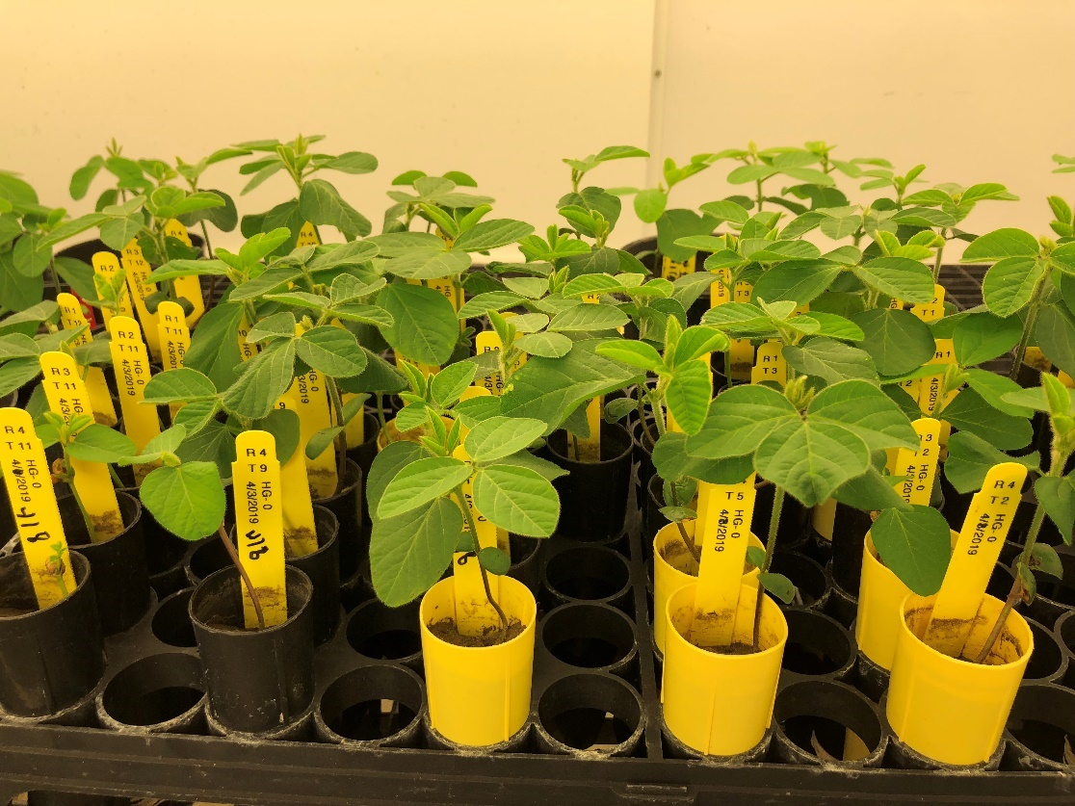

Figure 1. A consistent temperature of 27 °C was maintained in the growth chamber, ensuring soybean cyst nematode resistance tests were performed under the optimum condition.

A:

B:

Figure 2. Classification of the resistance responses of soybean lines (germplasm, breeding lines, and cultivars) to soybean cyst nematode HG type 0 (A) and HG type 2.5.7 (B) isolated from soybean fields in ND.

