Managing salinity with cover crops: A whole system response (year 3)
Caley Gasch, Jason Harmon, Tom DeSutter, Abbey Wick
School of Natural Resource Sciences, North Dakota State University, Fargo, ND

North Dakota Soybean Council – FY2020 final report

Introduction
Soil salinity is a persistent problem across North Dakota and soybeans are particularly susceptible to salinity-caused yield reductions. In 2017, we initiated a project to evaluate the use of cereal rye (Secale cereal) cover crop as a tool for managing soil water to reduce salinity and improve soil health and soybean yields. For three years, we have been monitoring many soil, plant, and insect properties across four field sites that host salinity gradients and cereal rye treatment strips. Ultimately, our goal is to understand the uses and limitations of cereal rye in soybean rotations, particularly as a tool for managing soil water, maximizing soil cover, and reducing effects of salinity. We are also particularly interested in understanding how both beneficial and pest soil organisms and insects are affected by salinity and cereal rye.

This project was intended to span four years, and our final year of data collection will occur during the 2020 growing season. This will help us understand if and how soil properties (especially the distribution of salts in the soil profile) are different with the introduction of cereal rye into the rotation as a winter cover crop. We will continue to monitor the soil, water, and plant properties across our field sites through 2020. To this point, we have not observed differences in crop yield (for either corn or soybean) or soil water content between our cereal rye treatment strips. We also have not observed insect pest threats associated with the cereal rye strips, though we are still analyzing arthropod community data collected in 2018 and 2019. We have learned a great deal about soil microbiological properties across salinity levels. Additionally, we have explored the toll that salinity can have on field-level profitability. These sub-projects will be presented here, according to the following objectives:

Objective 1: characterize soil microbial communities (in terms of abundance and broad-scale community structure) across saline and non-saline soils.

Objective 2: estimate and visualize how cash returns are affected by soil salinity and its variability across a field to provide guidance on potential management actions for saline patches within fields.

Methods
Field site description:
In 2017, we formed cooperative agreements with farmers, on four working farms that host saline patches. These field sites are located near Aneta, Northwood, and Jamestown, North Dakota. In the spring of 2017 and prior to planting, we Veris mapped and ground-truthed each field, which provides a map of apparent electrical conductivity, an indicator of soil salinity. From this map, we located four replicated sets of plots that span saline and non-saline areas in each field.

The Aneta and Northwood sites were planted to corn in 2017, soybean in 2018, and corn in 2019. The two Jamestown sites were planted to soybean in 2017, corn in 2018, and soybean in 2019. Mid-season each year, we broadcast treatment strips of cereal rye into growing corn (early- to mid-July) and soybeans (September) at 45 kg/ha (40 lbs/ac) in 2017 and 2018, and at 90 kg/ha (80 lbs/ac) in 2019. The rye is terminated before, or around planting time the following spring. Thus, across each field, we have four replicates of plots with and without cover crop, and in either low saline soils (electrical conductivity (EC_{1:1}) < 1 mmhos/cm), or moderately saline soils (EC_{1:1}= 2-4 mmhos/cm). As mentioned, we have not observed any difference in shallow soil properties between plots with and without cereal rye, so this report focuses on site characterization across salinity levels.

Objective 1:
To address the first objective, we sampled soils (0- 15 cm) at each plot (n = 16 per field) in mid-season (late June – early August) in 2018 and 2019, when the crops are actively growing. Soils were either immediately processed for microbial biomass carbon (an indicator of total microbial abundance), or frozen and later processed by a commercial laboratory for microbial community structure (abundance of microbial groups, such as bacteria, fungi, mycorrhizal fundi, and protozoans).

Objective 2:
To address the second objective, we applied an economic tool to our salinity maps (Figure 1). The tool was developed by Dr. Dave Ripplinger, NDSU Extension in Agribusiness and Applied Economics (https://www.ag.ndsu.edu/bioeconomics/Library/tools/salinity-economics-tool/view). The tool considers fixed costs and has adjustable inputs for fertilizer costs (if applicable), baseline yields for non-saline soils, and grain prices. We then mapped the returns to identify nonprofitable portions of the field, and to estimate total field-level returns.
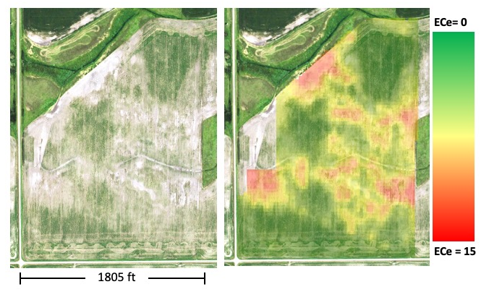
Figure 1: Aerial image of a study site (left) and salinity map (right) collected with a Veris cart and soil samples (ECe = Electrical Conductivity of saturated paste extract in mmhos/cm). Within the 32-hectare (80-acre) field are productive non-saline soils (green) and severely saline soils (red) that prohibit plant growth.
The results presented in this report are based on fertilizer costs and grain prices obtained in November 2019, and we used the appropriate county average soybean yield for each field.

Results
Objective 1:
Based on our knowledge of negative plant responses to salinity, we expected to observe reduced microbial abundance in saline soils. On the contrary, we observed higher microbial biomass carbon in saline soils at the Aneta field (Figure 2) and higher total microbial abundance in the saline soils at three of four fields, as measured by the phospholipid analysis (Figure 3).
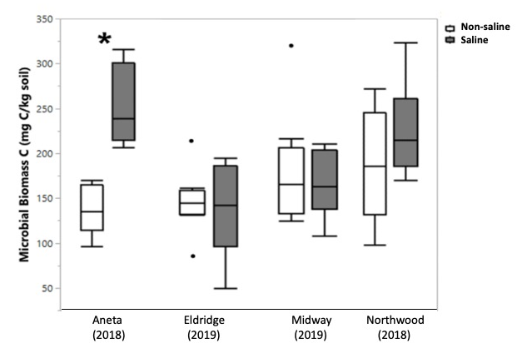
Figure 2: Box-and-whisker plots of microbial biomass carbon across sites and two salinity treatments for 2018 and 2019 for fields with actively-growing soybeans. The asterisk indicates a significant difference between saline (white bars) and non-saline (gray bars) treatments (p ≤ 0.05), which was only observed at the Aneta field.

The breakdown of microbial groups provided by the phospholipid analysis (Figure 3) indicated that bacteria and actinomycetes were particularly elevated in the saline soils, compared to the non-saline soils (statistics confirm this, but are not presented here). Furthermore, we observed that the microbial communities in saline and non-saline soils were between 80 – 93% similar to one another, and the differences were likely due to the elevated bacteria and actinomycete abundances in saline soils.
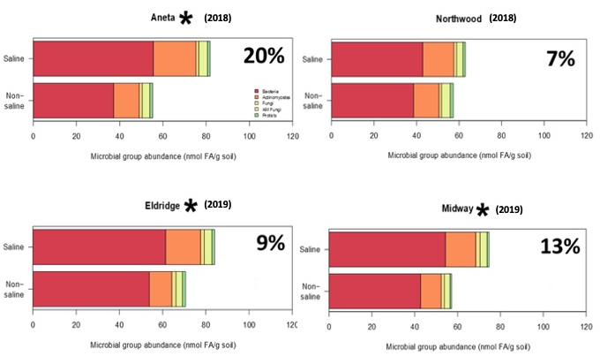
Figure 3: Soil microbial community distribution of broad taxonomic groups in terms of absolute abundance (nmol/g) for fields with actively-growing soybeans. Microbial groups include bacteria (Gram-negative and Gram-positive), actinomycetes, fungi, arbuscular mycorrhizal fungi (AM fungi), and eukaryotes (protists). The values in the upper right corner of each graph represent the Bray-Curtis dissimilarity index, which indicates the percentage of dissimilarity between saline and non-saline soils. Asterisks indicate significant differences in total microbial abundance between saline and non-saline treatments within a field (p ≤ 0.05).

Objective 2:
The application of the salinity-yield tool across salinity maps allows us to quantify areas within a field where soybean yields are so negatively affected by salts that input expenses exceed profit. In all of our study sites, salinity reduced productivity on 22 – 50% of the field area (Table 1), effectively reducing field-level returns.

Table 1: Estimated acreages of gain and loss, along with net return for each field, based on the application of the salinity-yield calculator to the salinity maps.
Field | Profitable area  ---ha, %--- | Loss area  ---ha, %--- | Field net return
Aneta | 16 (50%) | 16 (50%) | $1,895
Northwood | 18 (74%) | 6 (26%) | $3,451
Midway | 18 (62%) | 11 (38%) | $4,559
Eldridge | 15 (78%) | 4 (22%) | $4,100

This approach is also an effective visualization tool. We can produce a map of cash returns for soybeans (Figure 4), which largely aligns with the soil salinity levels (refer to Figure 1). The spatial representation of returns can serve as a decision support tool to assist farmers in making management decisions for fields that have reduced production due to salinity.
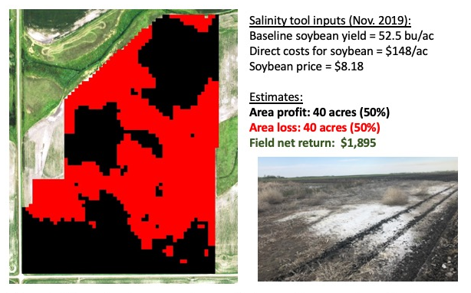
Figure 4: Mapped cash returns, tool inputs, and field-level return estimates due to salinity penalties on soybean for the example field. Black areas are profitable, while red areas have negative returns due to fixed input costs and poor soybean productivity. Note that inputs vary by field.

Discussion & Future Work
We were surprised to find that soil microbial abundance was elevated in saline soils, compared to non-saline soils, at three of our field sites. This difference was confirmed at one site by the microbial biomass carbon measurement, which is not as sensitive of a microbial indicator as the phospholipid method. The community analysis indicated that bacteria and actinomycetes were responsible for the difference across salinity treatments, and these are two groups that are notoriously diverse in their metabolism and functionality. While our methods were limited in characterizing the community, we suspect that the saline soils are occupied by microbial species that are well adapted to the salts.

Furthermore, soil fertility and water data that we have collected over the years indicate that the saline soils hold more water and fertility (particularly labile nitrogen, active carbon, and phosphorous), which would create favorable habitat and substrate conditions for the microbes.

At this time, we do not know what implications this finding may have for soybean production, or the remediation of these saline soils. In 2019, we collected greenhouse gas samples (carbon dioxide, methane, and nitrous oxide) across salinity gradients at the Northwood field, and those data are currently being analyzed. Early results indicate that saline soils are greenhouse gas sources, and this aligns with our microbial and soil chemical observations. Additionally, in 2020, we will be characterizing these soils for more specific microbial species and functions to better understand the microbial roles in saline and non-saline soils.
For our second objective, we were pleased to find that the salinity-yield economic tool was informative in helping us to visualize the spatial variability of cash returns in a field, due to salinity. These maps serve multiple purposes. For example, our cooperating farmers can use the maps to develop a more profitable management plan for unproductive areas within a field, perhaps delineating them as separate zones and planting a more salt-tolerant crop, cover crop, or forage mix. Additionally, the maps are powerful communication tools. Because salinity severity can fluctuate from year-to-year, farmers may be willing to take a risk and plant soybeans in saline portions of the field. Due to the low salt tolerance of soybeans, this approach can result in substantial loss. The maps and profit estimates can help communicate the financial risk associated with farming the saline soils, and help identify more profitable management plans.

Another side-project that has stemmed from this work (currently in progress) is an assessment of cereal rye salt tolerance and water use in a greenhouse setting. This project will help us better identify if cereal rye is an appropriate cover crop to select for managing water and salts in these problem patches.

In our final year of deep soil sampling (in 2020, to 120 cm), we will characterize the salt distribution in the soil profile and compare it to samples taken at the initiation of the project. This four-year project has provided an assessment of the potential risks and benefits of using cereal rye to mitigate soil salinity, but it has also provided the opportunity to learn more about many aspects of saline soils, as demonstrated in this report.

We thank the ND Soybean Council for supporting this research, and the students, research specialists, technicians, and cooperating farmers who make this research possible.

