Technical Report

Why Do Some Soil Practices Make Fields More Resilient To Saline-Prone Years?

Dr. Aaron Daigh, NDSU Soil Science, Principal Investigator
Dr. Caley Gasch, NDSU Soil Science, Co-Investigator
Dr. Thomas DeSutter, NDSU Soil Science, Co-Investigator

Introduction
Soil salinization severely affected a soybean production field near Grand Forks during 2018 due to a persistently high water table. In this field, the southeast corner sustained healthy soybean growth; whereas, most other areas within the field had substantial crop loss (Figure 1). The healthy soybean plants in the southeast corner are the exact outline of a previous research project on cover crops, no-tillage, and tile drainage (previously managed by Co-PI DeSutter; Figure 2) that was decommissioned three years prior to the 2018 soybean crop (Dr. Heather Dose, NDSU dissertation, 2016). This stark observation presented an opportunity for us to evaluate the site’s soil health properties and infer why the older research plots prevented crop loss from salinity. This project evaluated the soil biological community structure, soil aggregation, and soil fertility parameters within the southeast corner’s old research site and compare the soil health to other areas within the field with and without severe impact from soil salinity. This evaluation and comparison of soil health indices is to better understand what aspects of soil health govern soybean field’s resiliency to future soil salinization.

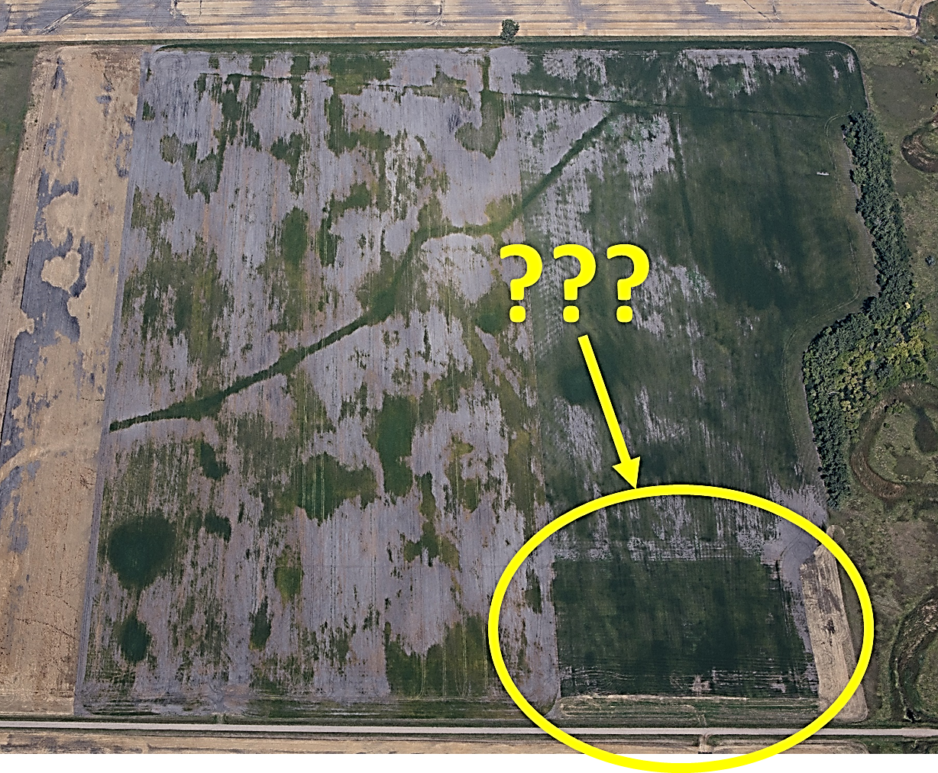
Figure 1. Aerial photo of a soybean field near Grand Forks on August 21st, 2018. The white areas without plants were substantially affected by soil salinization due to a persistent water table within 2-3 feet of the ground surface throughout the growing season. The area highlighted by the yellow circle with healthy soybeans is a previous research site that was decommissioned three years ago.
This project’s goals were to:
1) determine why some soil management practices build a soil’s resiliency to salinization using a case-study site that had stark differences in soybean losses during 2018 (Figure 1), and
2) provide recommendations to soybean growers on management practices to help safeguard fields that may be vulnerable to future soil salinization.

The objectives were to:
1) identify soil health parameters, associated with biological, physical, and fertility aspects, which are strongly linked to soil management areas that have demonstrated resiliency to soil salinization and soybean loss, and
2) disseminate information to soybean producers at established annual field days and local grower meetings.

This type of research will benefit ND soybean farmers by providing information to producers on which soil health parameters aid in limiting soil salinization in future years. Producers will then be able to better align their soil management practices to safeguard their soybean yields in fields that may be prone to future salinization.

Methods
The field site used in this study (Figures 1 and 2) is located southwest of Grand Forks, ND on a producer’s farm. This field, and surrounding areas, has experienced persistently high water tables during 2018 which resulted in substantial soybean losses due to soil salinization (Figure 1). This study was initiated in the summer of 2019 and concluded in spring of 2020.

Transects (N=9) were established and georeferenced for soil sampling in 2019. Three transects were located at the western edge and three transects at the northern edge of the decommissioned research site that had been maintained with no-till practices and underlined with subsurface drainage. Three additional transects were located within the neighboring areas that has been maintained with conventional tillage and no drainage management. Each transect was placed where four consecutive sample points were in an area with dead, damaged, or dying plants, whereas the remaining four consecutive sample points were in an area with living plants (Figure 2). This arrangement of transects allows us to evaluate “pairs” of adjacent areas of contrasting plant performance that may have been controlled by soil management practices (i.e., tillage and drainage) or by natural patches of salinity (i.e., the three transects located in the area neighboring the decommissioned research site) under conventional management practices.

For soil biological community structures and soil fertility evaluations, disturbed soil samples were collected at all transect points. Soil biological community structures were analyzed using phospholipid fatty acid (PLFA) analysis for total microbial biomass, arbuscular mycorrhizal (AM) fungi, remaining fungi, actinomycetes, eukaryotes, gram negative and positive bacteria, G- stress (ratio of cyclopropanes to gram negative bacteria) which can be used as a stress indicator of gram negative bacteria (i.e. bacteria typically associated with the rhizosphere among plant roots), and several other PLFA ratios of interest. Soil fertility parameters included nitrate-N, Olsen P, extractable K, 1:1 pH, 1:1 electrical conductivity (EC), and saturated paste extracts for EC_{e}, Ca, Mg, Na, and sodium adsorption ratio (SAR). Additionally, we analyzed for soil health indicators, including permanganate oxidizable carbon (POXC) and soil protein (an indicator of labile organic N contents). Non-disturbed soil cores were also collected at each point of the nine transects and analyzed for large macroaggregates, macroaggregates, and microaggregate distributions. Intact soil cores were collected at the ends of each transect using PCV collars.

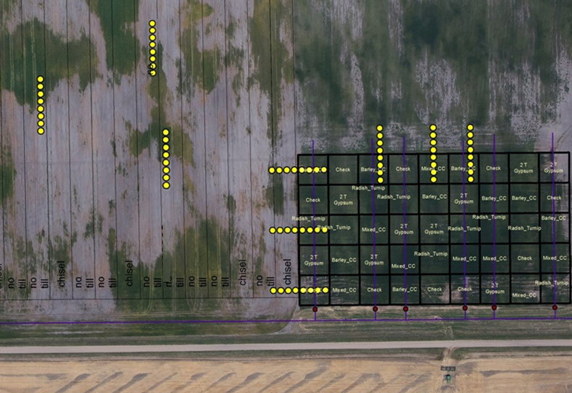
Figure 2. Aerial photograph of soybean field taken in August 2018. Bold lines on the right indicate where the decommissioned research site is located. Light lines on the left indicate a ongoing federally funded project. Yellow circles indicate transects where soil samples were obtained for the current study.

These intact soil cores were then imaged on a GE v|tome|x s microfocus X-ray computed tomography (CT) system at the NDSU Electron Microscopy Center. These CT images provide a 3-dimentional view within the intact soil core to identify and assess macropores, soil structure, pore architecture, and particulate organic matter within the undisturbed soil. The 3-dimentional scans were obtained and will be quantitatively analyzed using a convolution neural network algorithm in the proceeding months after this report.

Originally, we had planned to monitor soybean germination and seedling growth rate/survival in the spring of 2020. Soybean health monitoring would have consisted of weekly measuring plant leaf chlorophyll contents with a SPAD meter, measuring leaf area index with a LP-80 LAI Ceptometer, and measuring stomatal conductance with a SC-1 Leaf Porometer. However, the producer understandably did not want to plant soybeans into this salinized field and decided to plant corn in 2020. Wet field conditions also resulted in late germination of the planted corn crop that would have limited weekly monitoring to only a couple observation dates. Moreover, the pandemic of SARS-CoVD-2 virus (which causes the COVID-19 disease) slowed research efforts during this period. Therefore, the change in crop type and logistical constrained resulted in us forgoing plant monitoring in the spring of 2020.

Data were analyzed using two-tailed, paired t-tests without assuming equal variances and linear and non-linear regression techniques. For the t-test, areas with dead, damaged, or dying plants were compared to the areas with living plants. The four sample points of each transection corresponding to these areas were averaged to obtain a representative mean value prior to the t-test. T-tests were performed with several ways of pooling the data. First all nine transects pooled together (i.e., 8 degrees of freedom). Then, the three general transect types (i.e., western edge, northern edge, neighboring conventional area) were pooled and analyzed individually. For the regression analysis, linear regression was performed for all soil properties against the saturated paste extract EC. One soil property (nitrate-N) showed a non-linear trend and regressed with a simple second-order polynomial.

Findings
The same outcome resulted when all the data were pooled together vs pooled individually by each of the three general locations. This implies that the areas with dead, damaged, or dying plants vs. areas with living plants has soil properties that were consistently affected by soil salinity regardless of prior management practices (i.e., no-till vs. conventional till; subsurface drainage vs. no drainage management). The results of all nine transects pooled together are presented below in Table 1.

Table 1. Summary of paired two-tailed t-test, without assuming equal variances, for soil chemical, physical, and biological properties among areas with 1) dead, damaged, or dying plants and 2) living plants (referred to as treatments). Means were generated from the 9 transects (df = 8) where the 4 transect samples points for each “treatment” area were first averaged to obtain a representative replicate. Highlighted rows indicate soil properties with significant differences among treatment areas.
 |  | Means |  |  |  |  | Means
Soil property | p-value | Dead, damaged, dying plants | Living plants |  | Soil property | p-value | Dead, damaged, dying plants | Living plants
1:1 pH | 0.18 | 8.1 | 8.1 |  | AM fungi (%) | 0.01 | 4.8a | 5.7b
EC_{e} (dS/m) | 0.02 | 3.8a | 1.7b |  | Fungi (%) | 0.80 | 2.0 | 2.1
NO₃-N (ppm) | 0.10 | 14.3 | 6.2 |  | G- bact. (%) | <0.01 | 39.6a | 37.0b
Olsen-P (ppm) | 0.01 | 13.8a | 7.4b |  | G+ bact. (%) | 0.31 | 35.7 | 36.5
K (ppm) | 0.07 | 250 | 278 |  | Eukaryote (%) | 0.32 | 1.7 | 1.5
Ca (meq/L) | 0.01 | 21a | 11b |  | Actino. (%) | 0.51 | 16.3 | 17.1
Mg (meq/L) | 0.04 | 20a | 8b |  | F:B ratio | 0.03 | 0.09a | 0.11b
Na (meq/L) | 0.03 | 13a | 4b |  | Pred:Prey | 0.52 | 0.03 | 0.02
SAR | 0.01 | 2.5a | 1.2b |  | G+:G- | 0.01 | 1.1a | 1.2b
POXC (ppm) | 0.03 | 633a | 675b |  | Sat:Unsat | 0.12 | 0.85 | 0.79
Protein (mg/g) | 0.02 | 3.2a | 4.1b |  | Mono:Poly | 0.91 | 14.4 | 14.2
Macroaggregates (%) | 0.42 | 11.8 | 13.6 |  | G- stress | 0.67 | 2.7 | 2.6
Microaggregates (%) | 0.52 | 32.7 | 34.2

Among the soil properties evaluated, soil chemical properties tended to be more affected than the biological community structures. The highlighted rows in Table 1 indicate soil properties with significant differences among the areas with dead, damaged, or dying plants as compared to areas with living plants. In regards to chemical properties, the values and trends suggest that the soil chemical state of the soil preceded the plant response. That is, the plants likely reacted to the soil salinity as expected. In Table 1 and Figure 3 (regression analysis), we can infer a notable trend of less nitrate-N and Olsen P having been taking up by plants as soil salinity (i.e., saturated paste extract EC) increases. As for the biological community structures, some significant differences were observed, but the scale of influence was minimal to have much of a practical importance. The physical aspect of soil aggregates and their size distribution did not differ among the areas with dead, damaged, or dying plants as compared to areas with living plants. Overall, we observed fewer instances and scale of impacts among the areas than we expected and did not observed evidence that soil properties associated with differences in soil tillage likely had much of a role in this field’s behavior. However, this should not be confused with processes (e.g., evaporation rates due to residue cover and subsequence rise of saline waters) that tillage would have been expected to influence. Instead, these results indicate that standard soil properties, by themselves, may not provide adequate insight into physical processes of saline water management.

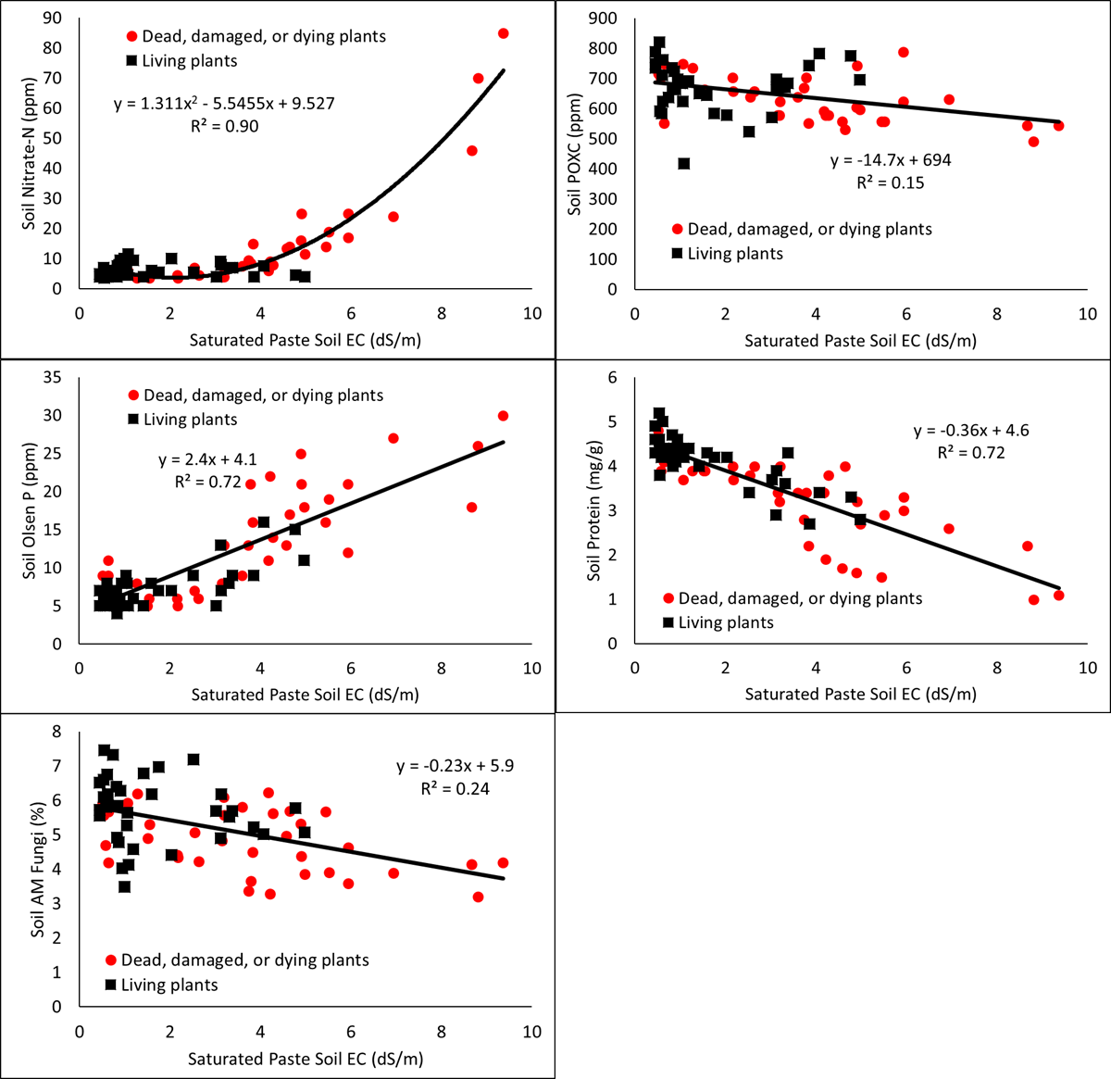
Figure 3. Soil nitrate-N, Olsen P, arbuscular mycorrhizal (AM) fungi, soil permanganate oxidizable carbon (POXC), and soil protein relationships to saturated pasted soil electrical conductivity (EC) for treatment areas with dead, damaged, or dying plants vs. living plants.

The regression analysis showed few soil properties that were strongly associated with soil salinity and mostly corresponded to some of the significant effects also found in the t-test analysis (Figure 3).

The project design and goals were presented in conjunction with other current and previous North Dakota Soybean Council funded projects at the international ASA-CSSA-SSSA conference in San Antonio in November 2019. This research was also presented at several talks at the Dakota Innovation Research Technology (DIRT) Workshop hosted by the NDSU Extension and the Conservation Tillage Conference hosted by the UMN Extension Service. After the end of the grant period, we will continue to disseminate our findings at extension workshops and various spring programs in 2020 and subsequent years. We will continue to monitor crop response at this site in conjunction with a neighboring research site that is supported with federal funds. We will also complete image analysis using a convolution neural network algorithm and make those data publically available in an update report and presentations at stakeholder and extension sponsored events. These data will be combined with the ongoing neighboring field project for future manuscript preparations and submission to a scientific peer-reviewed journal.

In conclusion, none of the soil properties measured in this study appears to provide adequate information to infer if a soil may be prone to future salinization. The outcomes of soil salinization was clearly observed at this site and exhibited distinct boundaries (i.e., within mere inches) between areas with dead, damaged, or dying plants as compared to areas with living and thriving plants. Visually, soil management zones provided stark evidence that tillage and drainage practices (and a prior history of cover crops) can and do make a difference in crop survival in saline-prone fields. However, pairs of areas with the same or contrasting management histories display the same trends in soil properties. Therefore, producers are recommended to focus on how their management practices many change soil processes, such as residue cover effects on soil evaporation rates and subsurface drainage effects on maintaining lower water tables, as opposed to some select suite of soil properties. The most noteworthy take away from this case study is that the combination of reduced tillage with subsurface drainage can and do provide crop protection from salinization due to shallow saline water tables.

