**2019 Final Report to the Tennessee Soybean Promotion Board**

**Project Number:** 19-154-P

**Title:** Economic and environmental impact of dual-use cover crop species in Tennessee no-till soybean/corn rotations

**PI and Collaborator:** Virginia Sykesa, Avat Shekoofaa, Gary Batesa, Frank Yina, Scott Stewartb, Larry Steckela

aDepartment of Plant Sciences, University of Tennessee, Knoxville

bDepartment of Entomology and Plant Pathology, University of Tennessee, Knoxville

**Year and Amount:** 2019 funded amount, $45,000

**Final Report:**

Cover crops provide many ecological benefits to agriculture production systems including reduced soil erosion, reduced nutrient leaching, and enhanced water holding capacity. Another potential benefit is the use of these cover crops as a forage for livestock production. Few cover crop species have been studied for suitability in the Mid-south soybean and corn rotations or under dual-use cover/forage management. The objectives of this study were to 1.) Assess regional adaptation of 17 cover crop species to East, Middle, and West Tennessee under two establishment/termination timings and 2.) Quantify economic and ecological impacts in a conventional cover crop system compared with a dual-use cover crop/forage system.

***Materials and Methods***

Seventeen cover crop species, including brassicas (canola, forage radish, turnip), cereals (barley, cereal rye, oat, triticale, wheat), and legumes (arrowleaf clover, berseem clover, crimson clover, red clover, sunn hemp, common vetch, hairy vetch, woolypod vetch, winter pea), were evaluated under two management systems: single-use and dual-use. Single-use management was defined as a cover crop terminated prior to cash crop planting using a herbicide. Dual-use management was defined as a cover crop harvested for forage and then sprayed with a herbicide prior to cash crop planting. This was repeated under a soybean/corn (SC) and corn/soybean (CS) rotation. Single-use and dual-use plots were no-till drilled in 10 ft x 30 ft plots in a RCBD with three replications at two Tennessee locations: Knoxville and Spring Hill. Single-use plots were also established at Milan in 12 ft x 30 ft plots. Rotation systems were analyzed separately using SAS 9.4. Cover crops in the CS rotation were established in early Oct. and terminated in mid-Apr, while cover crops in the SC rotation were established in mid-Oct and terminated in early May (Table 1).

Table 1. Cover crop and cash crop planting, harvesting, termination, and data collection dates for year 1 (2017/2018) and year 2 (2018/2019).



*Regional Adaptation*

On all plots, monthly percent cover and height were measured. Samples of biomass greater than 1 in. were hand-clipped from a randomly selected 1 ft2 area, dried at 60oC to constant weight, and weighed to estimate total dry matter biomass yield on a monthly basis (forage plots) and immediately prior to termination (all plots).

*Dual-Use Economic Impacts*

Forage plots were harvested using a small plot forage harvester. Percent moisture was determined using a grab sample and yields were converted to a dry matter basis. Forage samples were ground through a 1-mm screen using a Wiley mill. Samples were analyzed for in vitro neutral detergent fiber digestibility (NDFD), crude protein (CP), acid detergent fiber (ADF), and neutral detergent fiber (NDF) using Near Infrared Spectroscopy (NIRS) and for total C and N using dry combustion

The middle two rows of each four-row corn or soybean plot were harvested at maturity using a small plot combine. A grain sample was collected from each plot during harvest and analyzed for protein and oil (corn and soybean), and starch (corn only) using NIRS.

*Dual-Use Ecological Impacts*

Soil samples were collected at the depth interval of 0-6 inches two months after cover crop harvest and analyzed for the following: extractable phosphorus, potassium, calcium, magnesium, sulfur, manganese, zinc, boron, iron, sodium, aluminum, available nitrogen (NO3- + NH4+), and water extractable organic carbon and nitrogen. In addition, samples were analyzed for pH; organic matter, and cation exchange capacity (CEC). Samples were taken in the top 6 inches during the flowering stage of soybean and corn from each plot for the determination of soil moisture content each year. Weed suppression was evaluated visually using a percentage scale at 21 days after cash crop planting. Beer and shingle baits were set in non-forage plots at two locations at cash crop planting. Slugs were counted approximately 24 hrs after baiting.

*Allelopathic effects*

Potential allelopathic effects were further evaluated for seven cover crop species (wheat, cereal rye, hairy vetch, woolypod vetch, crimson clover, winter pea, and canola) under the soybean/corn rotation. Biomass from each species was collected immediately prior to termination and dried at 60oC for five days. Each sample was then chopped, ground, mixed with deionized water, and centrifuged. Finally, the extract received after centrifuging was diluted and added to filter paper within petri dishes containing 10 soybean seeds, and a number of germination properties were measured. For the weed test, goosegrass was considered. Since the goosegrass seeds were small, 30 seeds were placed in each petri dishes for the application of cover crop extract. Germination properties such as germination percentage, germination rate (Ng/day), seedling length, root and shoot length, dry and fresh weights were measured in a controlled environment under 25 C. Data were analyzed using Student’s t-test with JMP Pro 13.2

***Results***

*Regional Adaptation*

Percent cover crop cover was measured monthly, but three critical time points were selected to represent growth over specific periods of time. Fall growth was evaluated in December, winter growth was evaluated in February, and spring growth was evaluated before forage harvest and termination. The CS rotation, which provided a longer cover crop growing season, resulted in higher mean percent cover at each measured timepoint (Figure 1) compared with the SC rotation (Figure 2). Within the CS rotation (Figure 1), all of the cereals, except barley, provided percent cover and biomass at termination higher than the no-cover control. Crimson clover and woolypod vetch stood out among the legumes as providing full season cover and high biomass at termination. Winter pea and hairy vetch did not provide adequate fall cover, but picked up in the winter, spring, and at termination. None of the brassicas provided good full season coverage, although forage radish did provide significant fall cover and canola had biomass at termination greater than the control, though not as high as the top-performing species.

In the SC rotation (Figure 2), only the cereals provided significant fall and winter cover. Cereal rye, oat, triticale, and wheat all performed equally well in this rotation. By spring, some of the legumes were able to provide significant cover, including winter pea, woolypod vetch, hairy vetch, and crimson clover; however, crimson clover was the only legume to provide significant biomass at termination under the SC rotation. The brassicas did not provide significant cover throughout the growing season, though canola did provide significant biomass at termination.

Figure 1. Corn/Soybean rotation percent ground cover by species (A, B, C) and biomass at termination (D). Green bars are significantly higher than the no-cover control.

D.

C.

B.

A.

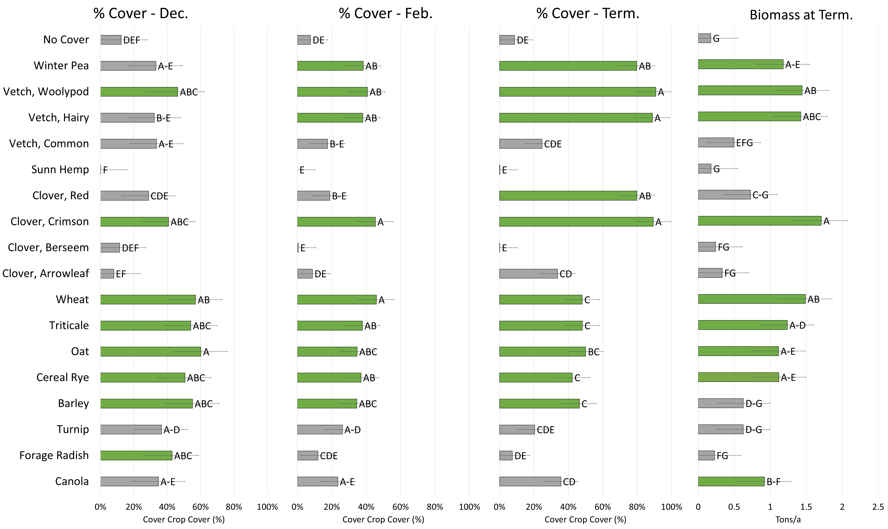

Figure 2. Soybean/Corn rotation percent ground cover by species (A, B, C) and biomass at termination (D). Green bars are significantly higher than the no-cover control.

D.

C.

B.

A.

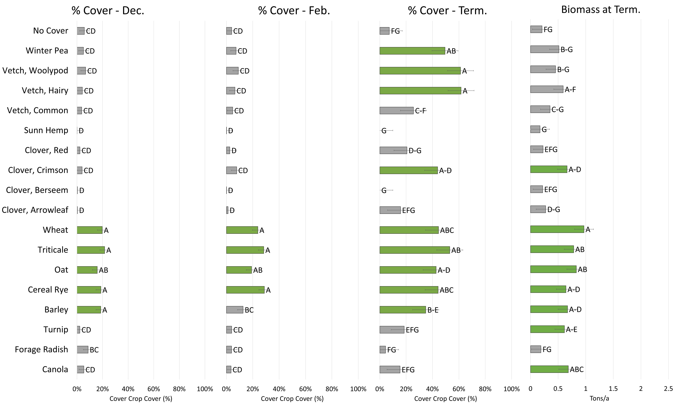

*Dual-Use Economic Impacts*

Forage yields for some species were adequate, resulting in greater than 1 DM ton/ac, in the corn/soybean rotation, but no significant differences among species were observed within either crop rotation (Figure 3). Because significant differences were observed in biomass at termination estimated using 1 ft2 samples, along with similar yield estimates (Figures 1 and 2), it is likely that the forage harvest methods introduced significant error variation into the forage yield estimates resulting in the lack of significant differences. All cover crop species provided adequate forage nutritive values. Forage nutritive value traits, such as crude protein (CP), digested neutral detergent fiber at 48 hours (dNDF48), total digestible nutrients (TDN), and calcium (Ca) showed differences in species in both of the crop rotations (Table 2, 3). Acid detergent fiber (ADF), neutral detergent fiber (NDF), phosphorus (P), potassium (K), magnesium (Mg), and nitrogen (N) had significant differences by species in the CS rotation only (Table 3).

Figure 3. Forage yield by species for Corn/Soybean rotation (A) and Soybean/Corn rotation (B).

A.

~~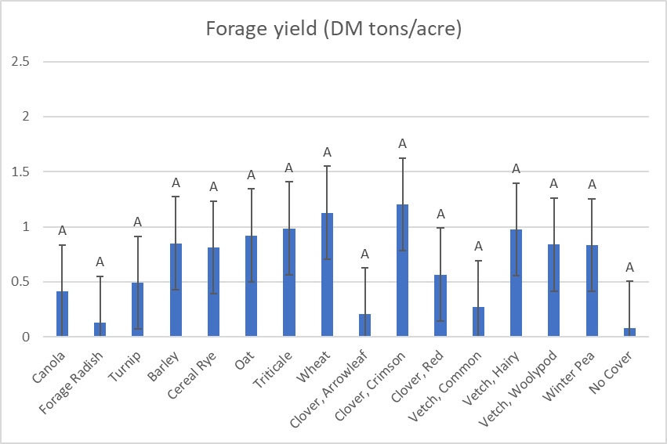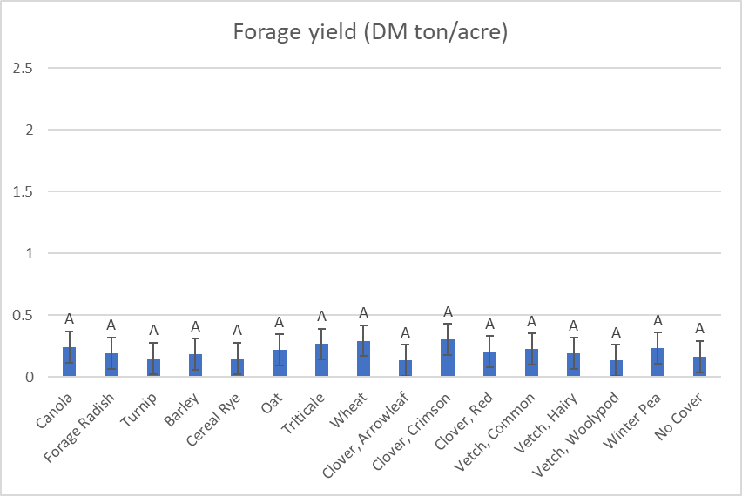~~

B.

Table 3. Mean forage nutritive values that differed significantly by species within the soybean/corn rotation. Means followed by the same MS letter do not differ significantly at the 0.05 level of probability.



Table 4. Mean forage nutritive values that differed significantly by species within the corn/soybean rotation. Means followed by the same MS letter do not differ significantly at P< 0.05.



*Dual-Use Ecological Impacts*

Nitrogen from cover crop biomass differed significantly by species within the longer growing season provided by the CS rotation, but not within the shorter growing season provided by the SC rotation. Nitrogen content differed among groups (cereals, legumes, brassicas), but variation was not seen among species within these broader groups. Percent carbon did not differ among species within either rotation. Although species did contribute differing levels of nitrogen at termination, by two months after termination, no significant differences were observed in soil nutrients among species within either rotation or management system. Likewise, no differences were observed in cash crop yield or quality at harvest, or weed suppression at 21 days post planting. Results for slug data will be presented in the final report for 19-26-R.

Figure 4. Percent nitrogen by species within the corn/soybean rotation.

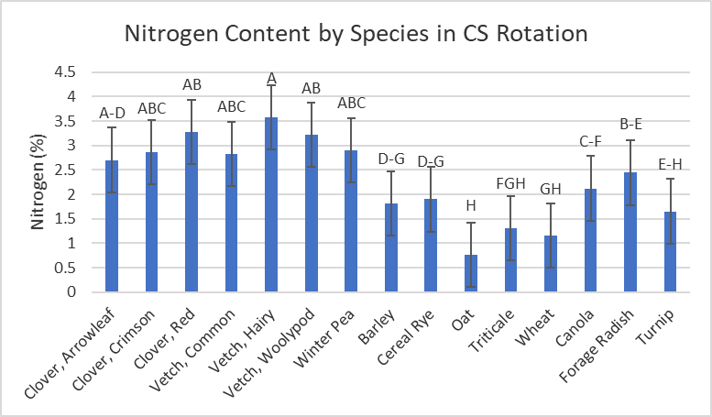

*Allelopathic effects*

Impact on soybean germination by species varied based on collection location. In samples collected from Knoxville, canola (23%), woolypod vetch (22%), and cereal rye (21%) showed the greatest allelopathic effects on soybean germination percentage (Fig. 5). In samples collected from Spring Hill, extracts from all cover crops, except canola, significantly reduced seedling root length (p <0.01). Across both locations, almost all cover crops’ extract significantly reduced germination rate (number of germinated seed/day) (Fig. 6a and b).

Figure 5. In a controlled environmental study, soybean seeds were treated with the extract of each cover crop and water (check). The extract of canola, cereal rye, and woolypod vetch suppressed soybean germination the most. *significant at P<0.05

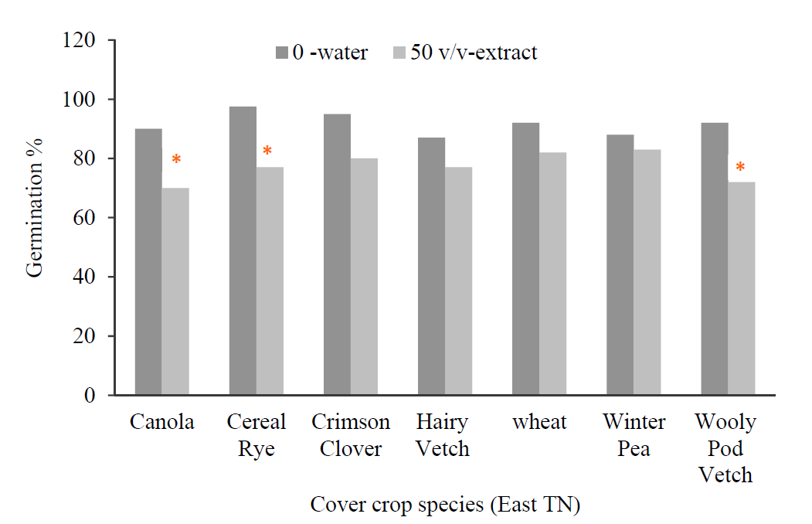

Figure 6. In a controlled environmental study, soybean seeds were treated with the extract of each cover crop and water (check). Application of cover crop extract significantly reduced germination rate (number of germinated seed/day) for soybean at a significant level of P<0.01.

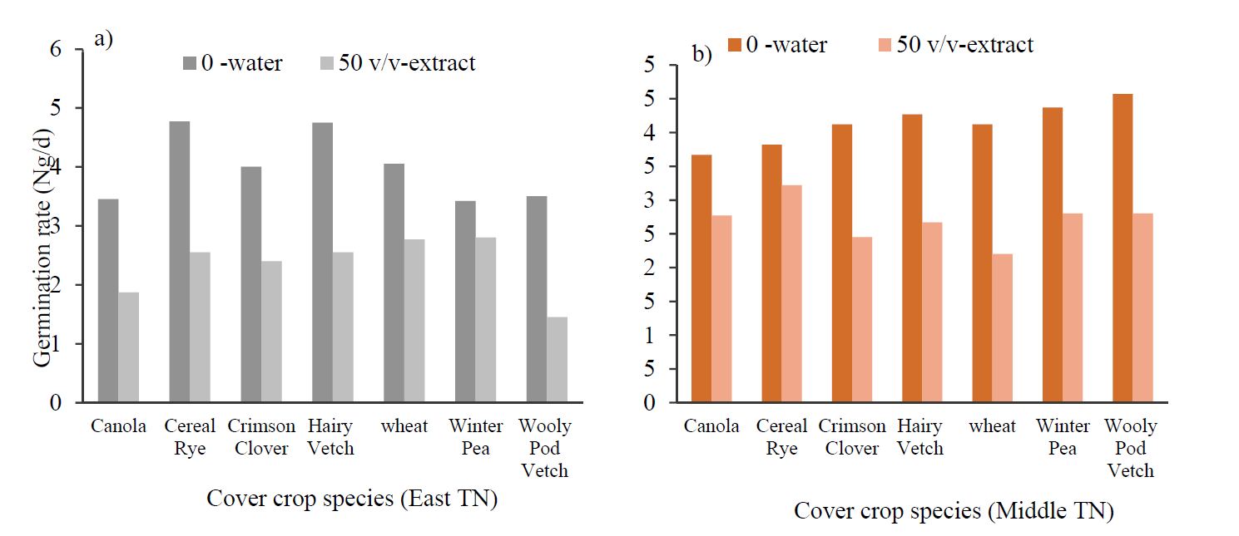

Impact on goosegrass inhibition also varied by location and species. In samples collected from Knoxville, canola and woolypod vetch showed no allelopathic effects on goosegrass germination percentage and rate (Fig. 7a and b). At Spring Hill, cereal rye and crimson clover showed no allelopathic effects on goosegrass germination percentage (Fig. 8a). Both cereal rye and crimson clover plus woolypod vetch showed no significant impact on goosegrass germination rate (Fig. 8b). All cover crops’ extract significantly reduced goosegrass seedling **root length** (p <0.01) in both locations.

Figure 7. In a controlled environmental study, goosegrass seeds were treated with the extract of each cover crop and water (check). Mean values for (a) germination (%) and (b) germination rate (number of germinated seed/day) by species from the Knoxville location are given. NS: not significant at P<0.05.

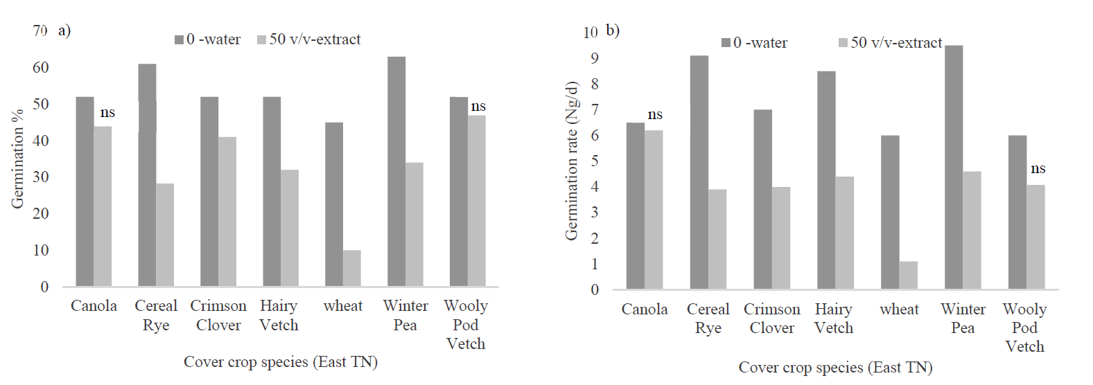

Figure 8. In a controlled environmental study, goosegrass seeds were treated with the extract of each cover crop and water (check). Mean values for (a) germination (%) and (b) germination rate (number of germinated seed/day) by species from the Spring Hill location are given. NS: not significant at P<0.05.

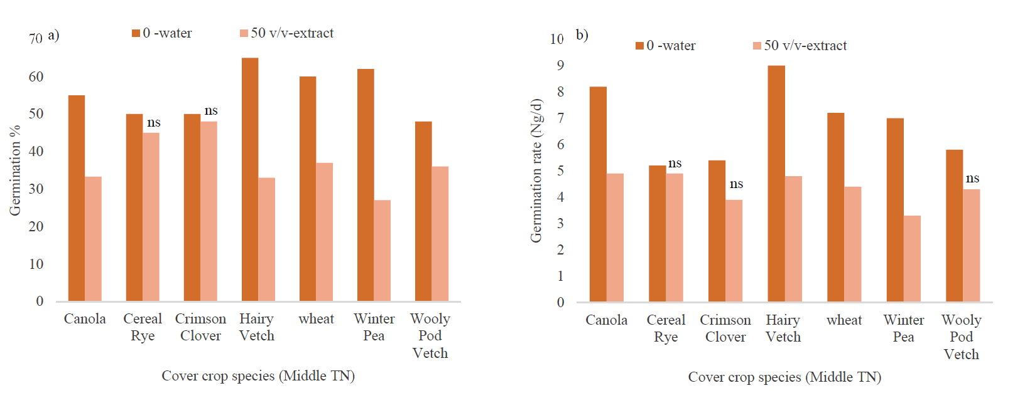

We were called to over a 100 soybean and cotton fields this summer where very poor control of goosegrass, junglerice, barnyardgrass, and Palmer amaranth with glyphosate and dicamba tankmix applications was observed (Fig. 9). As a result, integrated weed management where cover crops can help supplement control from herbicides needs to be explored.  Therefore, seeds of goosegrass were collected and subjected to cover crop allelopathy experiments.

Figure 9. Xtend crop weed failure survey 2019.

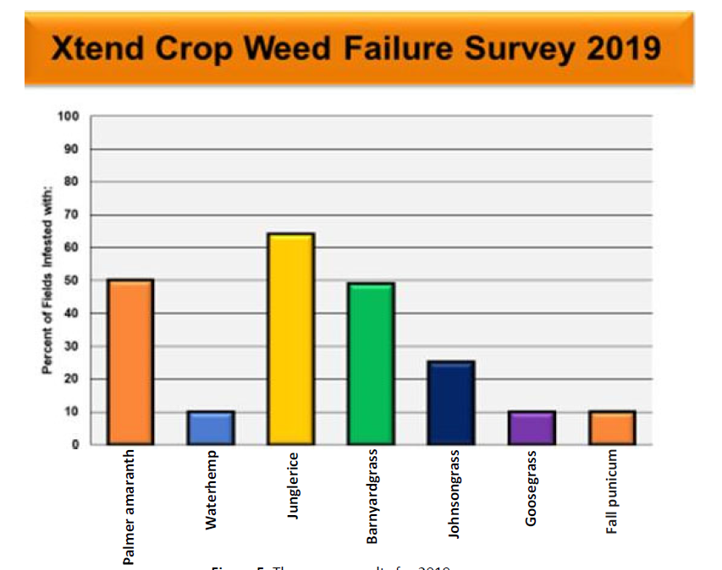

**Conclusions**

Planting cover crops earlier provided more benefits in terms of full-season ground cover and biomass at termination. More species were suited to a corn/soybean rotation than to a soybean/corn rotation due to the longer growing season provided by the former. Regionally adapted species for soybean/corn systems included wheat, triticale, oat, and cereal rye. Crimson clover could also provide significant biomass by termination, but would need to be paired with a cereal in order to achieve full-season ground cover. Species adaptation was broader in a corn/soybean rotation system, including wheat, triticale, oat, cereal rye, crimson clover, and woolypod vetch for full season ground cover and biomass at termination, and winter pea and hairy vetch winter/spring ground cover and biomass at termination. Prior to initiating this study, many cover crop species were available only as “variety not stated” (VNS). Since that time, several varieties within species are now being marketed specifically for use as a cover crop. While our study showed that species such as berseem clover, arrowleaf clover, red clover, barley, canola, forage radish, and turnip were often not well-suited to Tennessee soybean and corn rotation systems, little is known about variation within species. Future work will examine within species variation of cover crop varieties for adaptation to Tennessee soybean systems.

Dual-use forage/cover crop systems produced sufficient yields, with some species exceeding 1 DM ton/ac, of high-quality forage under a corn/soybean rotation. The shorter growing season of a soybean/corn rotation, however, resulted in low yields that likely would not be well-suited to grazing or forage production. Removing forage from the cover crop system did not result in a significant reduction in ecological benefits, resulting in no changes in soil nutrients at two months post termination, early-season weed suppression, and cash crop yield or quality. Nitrogen did vary among species in the corn/soybean rotation, indicating a possible reduction in early season nitrogen from removing forage biomass. These results demonstrate integrated forage/cover crop systems as a potentially beneficial system to offset cover crop seed costs and create additional profit, without reducing ecological benefits.

With increasing herbicide resistant weeds, cover crops offer a further tool for control through allelopathy, chemical root exudates that can inhibit weed seed germination and development. Results showed that among cover crops’ extract; application of hairy vetch, wheat, and winter pea extracts significantly reduced goosegrass germination (%) while having no significant impact on soybean germination (%). However, it is important to note when selecting species, location and environment may change cover crops’ allelopathic potential. Future work will involve collecting more seeds from different weed species including barnyardgrass, pigweed, and junglerice for further weeds germination test under application of cover crops’ extracts, using a new technique to extract cover crop chemical compounds called: ‘Green cover crops product’, and testing varying levels of cover crops’ extract on soybean seeds and monitoring the plant growth and development after application of cover crops’ extract in the greenhouse; a step further than only germination and seedling growth.

**Extension and Outreach**

In 2019, results from this study were shared at eight Extension events and were presented as poster or oral presentations at five scientific meetings. A popular press article was posted to news.utcrops.com and an Extension publication is currently in review. A scientific journal article, targeted towards Agronomy Journal, is in preparation to be submitted in 2020.

|  |  |
| --- | --- |
| **Extension Presentations** | |
| 1 | **Sykes, V.R.** and **W. Bracey\***. Cover Crop Species Selection: Right Time, Right Place. Climate Change Adaptation In-service. Milan, TN. 27 Mar. 2019. |
| 2 | **Sykes, V.R.** and **W. Bracey\***. Cover Crop Species Selection: Right Time, Right Place. Climate Change Adaptation In-service. Spring Hill, TN. 29 Mar. 2019. |
| 3 | **Sykes, V.R.,** Nutrient cycling: the long and short of cover cropping systems, Southern Cover Crops Council Conference, Auburn, AL, 15-17 July 2019**.** |
| 4 | **Sykes, V.R**. Cover Crop Species Selection. Row Crops Hot Topic. 6 Sept. 2019. |
| 5 | **Sykes, V.R.** Call of the Week: The 2019/20 Cover Crop Season. Podcast by UTIAg. 25 Sept. 2019. |
| 6 | **Sykes, V.R.** Grazing Cover Crops. Tennessee Forage and Grassland Council. Murfreesboro, TN. 8 Nov. 2019. |
| 7 | **Sykes, V.R.**, Variety Testing and Agroecology Program Update, Statewide Row Crops In-Service, Jackson, TN, 12-13 Dec. 2019 |
| 8 | **Sykes, V.R.**, Grazing Cover Crops, UT Beef and Forage Center Annual Research and Recommendation Meeting, Knoxville, TN, 17 Dec. 2019 |
|  |  |
| **Papers or extended abstracts published in conference proceedings** | |
| 5 | **Bracey, W.\***, **V.R. Sykes**, G. Bates, X. Yin, L. Steckel, D. Butler, R. Nave. Comparison of dual-use and single-use cover crops in no-till Tennessee production systems. Southern Cover Crops Council Conference. 16-17 July, 2019. Auburn, AL. |
| 2 | **Bracey, W.\***, **V.R. Sykes**, G. Bates, X. Yin, L. Steckel, D. Butler, R. Nave. Comparison of dual-use and single-use cover crops in no-till Tennessee production systems. ACS Annual Meeting. 10-13 Nov. 2019. San Antonio, TX. |
| 3 | Longmire, M., J. Grant, S. Stewart, **V. Sykes**. 2019. Slugs and Bugs: The Thugs of Soybean Communities. Entomology 2019. 17 - 20 Nov 2019. St. Louis, MS. |
| 4 | Longmire, M., J. Grant, S. Stewart, **V. Sykes**. 2019. Dual-Cropping Soybean Systems: Impacts on Pest and Beneficial Arthropods in Tennessee. Entomology 2019. 17 - 20 Nov 2019. St. Louis, MS. |
| 1 | **Bracey, W.\***, **V.R. Sykes**, G. Bates, X. Yin, L. Steckel, D. Butler, R. Nave. Comparison of dual-use and single-use cover crops in no-till Tennessee production systems. UT Beef and Forage Center Annual Research and Recommendation Meeting, Knoxville, TN, 17 Dec. 2019 |
|  |  |
| **Publications** | |
| 1 | **Sykes, V.R.** Cover Crop Species Selection for Tennessee Corn and Soybean Systems. News.Utcrops.com. 12 Sept. 2019. |