Title: "Evaluating the presence of Dectes Stem borer in soybean fields, weeds and assessing the tolerance of cultivars in Kentucky”(UK# 3048114292).
Project Director: Raul T. Villanueva, Extension Entomologist. REC – Princeton, Co-PD: Claire Venard, PhD, CCA, Soybean Research Specialist, Lexington, Univ. of Kentucky
SUMMARY: This study had three major parts, that took place in 2019 and extended to 2020. In 2020 we studied the aggregation of Dectes in the field, an evaluation of Dectes effects on yields using cages, and assessing the tolerance of commercial soybean cultivars to Dectes (data still nont completely collected).
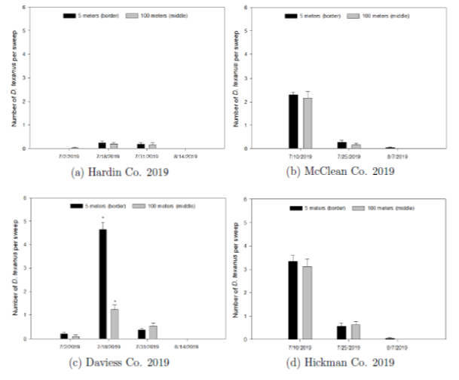
Dectes aggregation on border vs. inner rows in commercial farms of Kentucky: Tallies of Dectes texanus were conducted in four commercial soybean fields located in Hardin, McLean, Hickman and Daviess counties in 2019. Sweep nets were used to conduct this sampling in three different dates in each site. Samples were conducted in edge rows and rows 100 m from the edge. Results showed (Figure 1) that number of D. texanus per sweep in edge rows versus center rows repeatedly demonstrated that location of sampling was irrelevant on samples conducted every two weeks. The 4 commercial soybean fields sampled during three different dates on each field resulted only in one single date in one field where D. texanus was more abundant in the edge. Therefore, based in these results we conclude that sampling can be conducted randomly in a border or inner part of a field throughout the high peak flight or oviposion period of D. texanus. Although previous studies showed edge tallies had larger numbers of Dectes in border rows compared with inner rows; a 2-year study conducted in Nebraska showed that aggregation of D. texanus adults in the field were not consistent in seven scouted fields. The latter finding agrees with our finding. It is hypothesized that the aggregation of high number of D. texanus in border soybean might be due to field facing a weedy area or on fields that had soybeans the precedent year.
Figure 1. Mean No. (± SEM) of D. texanus/sweep in commercial fields in four counties. Data were collected in border and center (100 m inside) of the field. (*) indicates significance after a t-test (p <0.05).
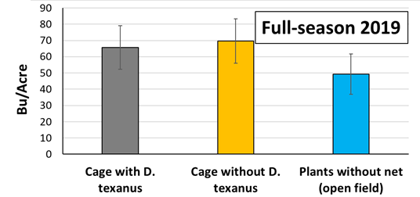
Cages studies with and without Dectes in the field: Full-season soybeans of the cultivar 470 RR/STSn (Caverndale Farms) was planted on 22 May 2019; and double-crop soybeans AG27X7 (Asgrow Seed Co LLC, Bayer Co.) was planted on 8 July 2019. Sixteen outdoor netting cages (1.8 m x 1.8 m x 1.8 m) were constructed using Proteknet Exclusion Insect Netting (Dubois Agrinovation, Quebec, Canada), and two crossed 6-m long steel rebar. These cages were set in experimental plots of soybeans in the University of Kentucky’s Research and Education Center at Princeton. Each full-season and double-crop soybeans had 8 exclusion cages. In 2019, 40 D. texanus adults (1:1 sex ratio) were released into each study cage in full season and double crop at the R2 and V3 stages, respectively. Soybean plants from 2 ft of the middle row were hand-harvested from each cage plus 4 sites outside the cages. Percentages of plants with tunnels caused by D. texanus larvae in plants were tallied. Results in this study showed that mean percentages of plants with tunnels and with D. texanus larva were not significantly different (p>0.05) between the caged plants with D. texanus releases (83.5% tunnels) and plants in the open fields (96.3% tunnels) (p>0.05). Dectes texanus larvae or tunnels were not found in all caged plants where D. texanus was not released. The short-season plants in 2019 escaped the oviposition of D. texanus. Planting of short season soybeans was too late; the pith in the stem had not developed, and D. texanus only oviposits on plants with a well-developed pith for feeding of the larva. Yield in cages with or without D. texanus and open field did not show significant differenced
Figure 2. Mean yields (±SEM) (Bu/A)) for full-season soybeans in 2019 in caged plants with and without D. texanus and plants in the open field. Significant differences were not found after ANOVA and Tukey’s HSD post-hoc test (p ≤ 0.05).
Assessing the tolerance of cultivars in Kentucky.
In 2020, 40 commercial soybean cultivars were planted in the Research and Education Center. Data of this study are being processed and plants have not been harvested yet. By the end of November all this information will be available and analyzed.

