**Potential use of cover crops and green manures for localized or widespread management of Fusarium diseases, white mold and iron deficiency chlorosis on soybean**

Leandro and Mueller

Final report Dec 2, 2020

More growers are utilizing cover crops in the Midwest, but the impact of cover crop practices on plant diseases is poorly understood. Cover crop plantings can alter soil moisture levels and microbial communities, and consequently may influence the development of soil-borne diseases. Sudden death syndrome (SDS), white mold (WM), and iron deficiency chlorosis (IDC) are soil-borne diseases that affect soybean production in Iowa. In the North Central region, fall-sown rye and wheat are two winter-hardy options growers can use for erosion and weed control outside of the growing season. Research in Minnesota has shown that oats, sown as a nurse crop in the spring, can mitigate IDC symptoms in soybean by taking up excess soil moisture and nitrates.

In Fall 2020, we completed a three year study investigating the potential use of cover crops and green manures as tools to manage four soil-associated diseases of soybean: i) SDS, caused by *F.virguliforme*, ii) root rot caused by *F. graminearum*, iii) white mold, caused by *S. sclerotiorum*, and iv) iron deficiency chlorosis (IDC). Over the course of the project, we conducted three years of field trials to evaluate the effects of winter rye, winter wheat, and nurse-crop oat cover crops on development of SDS, WM, IDC, and soybean yield in Iowa. We also conducted greenhouse and lab experiments to determine how cover crops affect disease development and pathogen growth. In addition, we sampled grower fields with tile drainage system to determine if disease pressure is affected by the location of the tile lines and establish a baseline for potential use of cover crops to manage disease in a localized manner.

This report presents the results from the third year of this study, and discusses the main conclusions based on all years of the study.

**Objective 1. Evaluate the effect of cover crops and green manures on SDS, Fusarium root rot, white mold and iron deficiency chlorosis in field conditions**

In the 2020 season, cover crop trials were established at six field locations, three in central Iowa and three in northern Iowa. SDS and IDC fields were located at Kanawha, IA; one SDS and two IDC fields in the Ames area; and a white mold study in Nashua, IA. Fall cover crops included oats (broadcast into standing crops), winter rye and winter wheat (drilled). In Fall 2019, rye and wheat cover crops were drilled but did not germinate until March 2020. The first week of April, the spring cover crops of rye and oats were planted at each location. Cover crop biomass and soil moisture were measured in each plot. Cover crops were terminated the first week of May. Planting began the fourth week of April and was finished at all locations on May 1st. Agronomic data such as cover crop biomass, stand count, and soil moisture were collected.

At termination, fall rye had the largest amount of biomass ahead of fall wheat, spring rye, and spring wheat. The fall-established rye and wheat were 6-10” in height, while the spring rye and oats were about 1” tall. There were no differences in soybean stand count, however plots with fall sown cover crops had slightly less soil moisture than spring sown plots and the non-treated control. Disease notes on IDC, SDS, frogeye leaf spot, and Septoria brown spot were taken throughout August and into September.

Weather conditions throughout July and into August 2020 were dry and not conducive for disease development. As a result, disease levels never reached more than 5% severity in any of the locations. Soybeans were harvested during the last week of September. Analyses conducted on data pooled for the six field locations showed there was no significant difference between cover crop treatments for either soybean variety (susceptible *P*=0.927) and (resistant *P*=0.309) (Fig. 1). When analyzed for each location separately, two locations showed significantly lower soybean yield in the Fall rye and Fall wheat treatments, and one locations showed lower yield with the spring rye treatment. The reason for these reduced yields is likely associated with delayed termination of the cover crops at those locations. With the Covid pandemic, there was limited availability in field crew and some problems with spray nozzles, which made termination less effective. The excess cover crop biomass in the fields resulted in more competition with soybeans in the first weeks after soybean germination.

Figure 1 – Mean yield for soybeans grown following Fall or Spring cover crops across Iowa. Data shown is mean year averaged over the six locations of the study in 2020.

General conclusion for field trials

In the three years of field trials, we never observed an effect of cover crops on soybean diseases. Although this suggests that cover crops are not useful for managing soybean soilborne diseases, it is important to remember that the weather conditions in Iowa from 2018-2020 were not conducive to disease development, and therefore not ideal to test if cover crops can suppress disease. In addition, 2018 was a very challenging season for crop growth, and was not a representative year for soybean production and disease development. Since the field trials were conducted in fields with a history of the diseases, our results do suggest that the cover crops did not increase the risk of disease, at least under the conditions of these trials.

For most of the field trials, we also found that cover cropping prior to soybean did not cause a detrimental effect on soybean, when cover crops are terminated prior to or soon after planting the crop. However, we did find that if the cover crop termination is delayed by several weeks, soybean yield can be significantly reduced, especially in years with low soil moisture like 2020.

**Objective 2. Identify simple, rapid, and cost-effective bioassays to test efficacy of additional cover crop species on disease suppression in controlled environment conditions**

In this objective, we conducted greenhouse experiments to test the ability of different cover crop amendments (rye, oat, alfalfa, clover and corn) to suppress SDS and other soilborne diseases in controlled environment conditions. First, we developed an assay and optimized the conditions to best detect any treatment effects. In the assay, soil is amended with chopped fresh roots and leaves of the cover crop plants, and infested with the pathogen of interest. The soil is then incubated for three weeks, before soybeans are planted. Disease is then rated on the soybeans starting two weeks after planting.

We conducted several experiments with *F. virguliforme*, and found a consistent reduction in root rot in soybeans grown in soil amended with all the green manure treatments compared to the un-amended control. Suppression with oat and rye amendments tended to be more evident that some suppression observed with alfalfa. These results confirm preliminary results we had obtained suggesting that soil amendment with green crop residues reduces the risk of infection by *F. virguliforme*, and that the level of suppression may vary across cover crop species. We then started using the assay to test if green manures suppress other soilborne pathogens. We conducted an experiment with Fusarium acuminatum but could not make further progress due to restrictions imposed by the Covid pandemic. We are now in the process of restarting the experiments.

General conclusion for greenhouse assays:

We were able to show that incorporation of green manures into soil infested by *F. virguliforme* suppresses the development of SDS in greenhouse conditions. Although the mechanisms are unknown, these are interesting results that are worth further investigation in field conditions. In the future, we plan to test if the incorporation of oat and rye green manures in field conditions has the same suppressive effect, to determine its potential as a management option against SDS. With the greenhouse assay that we developed, we also plan to continue testing if green manures have the potential to suppress other soilborne pathogens of soybean.

**Objective 3. Identify cover crops with the most potential for inhibiting pathogen growth and sporulation in vitro and survival in soil.**

We conducted several *in-vitro* assays to test how cover crop extracts affect growth and sporulation of *F.* *virguliforme, F. graminearum, P. sylvaticum and S. sclerotiorum*. The assays used fungal culture media amended with cover crop slurries, and showed primarily that the pathogens benefited from the food source provided by the crops by increasing pathogen growth rate. We obtained no evidence for a strong inhibitory effect on the pathogen. To overcome this effect of excess nutrients provided by the crop slurries, we started developing assays that test how root exudates affect fungal spore germination. The root exudates are prepared by placing root tips in water and incubating in the presence of pathogen spores. These are then observed under the microscope to test effects of germination rate. Unfortunately this work had to be interrupted due to restrictions to lab access during the Covid pandemic and could not be completed before the end of the project.

General conclusions for effects of cover crops on pathogens

The work conducted to date has not provided evidence of direct suppression of pathogen growth by direct contact with cover crops. However, it is possible that any inhibitory effects were masked by the excess nutrient availability provided by the crop extracts. Further work needs to be conducted using other assays to determine the mechanisms that lead to SDS suppression by green manure observed in the greenhouse assays.

**Objective 4. Establish soilborne pathogen baseline data for testing the use of cover crops for precision**

**management of soil health.**

In this objective, we compared risk of SDS in areas of the field located over drainage tile lines and between tile lines. In 2019, we collected soil and plant samples from four grower fields in Iowa. Frequency of root infection by *F. virguliforme* and SCN population density in soil were assessed. Soil was also submitted to Pattern Ag for nutrient and microbial profiling. Consistent with the previous year, we found higher frequency of *F. virguliforme* in roots from areas over the tile lines than between soil lines. In addition, data obtained from Pattern Ag showed that *F. virguliforme* density in soil over tile lines was higher than between tile lines (Fig 2) for the field soil submitted for processing (Cline farm). Finally, SCN counts were also numerically higher over tile lines than between tile lines in three of the four fields tested. In the 2020 season, we were unable to work on this objective due to the absence of SDS symptoms in grower fields. We plan to collect another year of data for this objective in 2021.

Table 1 – Frequency of *F. virguliforme* isolations from roots, and SCN eggs/cc soil, for samples obtained over and between soil tile lines in three grower fields.

|  |  |  |  |
| --- | --- | --- | --- |
| Field/tile area  (2019 data) | Fv colonies/ total root pieces | % roots with FV | SCN eggs/ 100cc soil |
| Cline 3/ over tile | 14/15 | 93 | 1900 |
| Cline 3/ between tile | 8/14 | 57 | 150 |
| Cline 2/ over tile | 1/5 | 20 | 4400 |
| Cline 2/ between tile | 4/5 | 80 | 350 |
| Peterson/ over tile | 4/5 | 80 | 600 |
| Peterson/ between tile | 3/5 | 60 | 1500 |

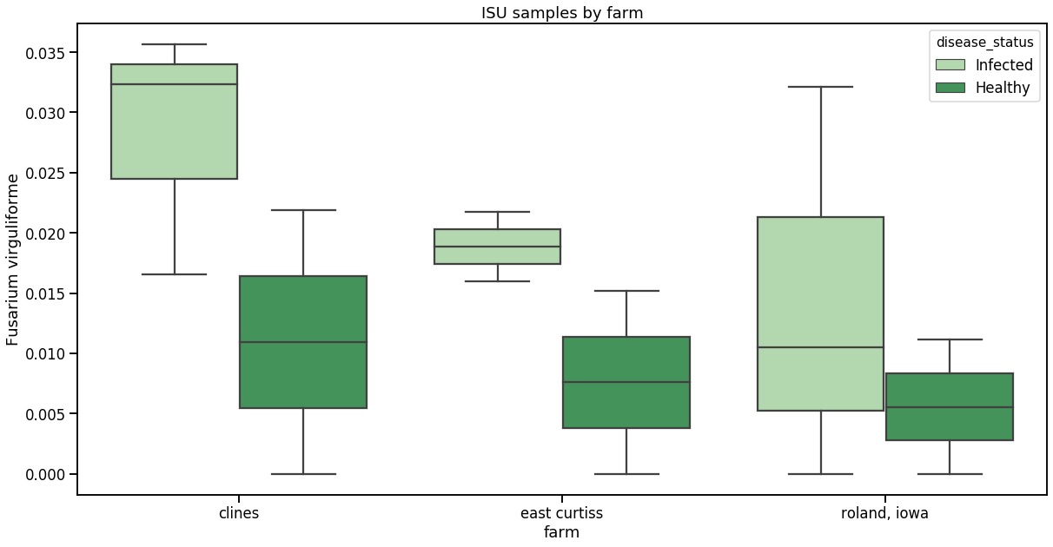

Fig. 2. *F. virguliforme* DNA quantity in soil in areas of a grower field (D. Cline) over tile line (light green) and between tile lines (dark green). Data collected by AgPattern.

General conclusion for tile line effects on spatial distribution of soilborne diseases:

The results obtained from two years of this study suggests that the location of tile drainage lines may affect the distribution of soilborne pathogens in the field, namely SCN and *F. virguliforme*. Even though sample size does not allow for statistical analysis, the numeric data suggests that areas of soil over tile lines tend to have higher SCN egg counts and higher density of F. virguliforme. We were also able to observe patterns of higher SDS severity and earlier maturing of soybeans grown over the tile lines.

**General conclusions for this project**

In the field work conducted under this project, we obtained no evidence that cover crops, whether they were spring or fall planted, affect the risk of soilborne diseases. In addition, when cover crops are terminated before or right after soybean planting, we observed no detrimental effects of the cover crops on soybean yield. Therefore, even though cover crops may not be useful as a disease management tool, our findings suggest that cover crops can be safely used for their many benefits, including reducing soil erosion and nutrient loss.

We also showed that incorporation of green manures of grasses, especially oats, into infested soil has consistently reduced SDS development in soybean plant under greenhouse conditions. Although the mechanisms is not known, these findings suggest it is worth testing if green manures can provide similar suppression in field conditions.

Work to determine the mechanisms that lead to SDS suppression by green manure were inconclusive and need to be further investigated.

Finally, we obtained evidence that the location of soil drainage tile lines may create zones of greater pathogen density in soil, which has the potential to increase disease risk and reduce yield in those zones. Further work is needed to determine to what extent these observations are applicable to other fields that have tile drainage and if localized disease management is justifiable.