General project for Year 1:
Spring planting conditions throughout Iowa were excellent and ahead of historical planting records. In general, drought conditions were evident and field in western Iowa, in particular, were stressed. Abnormally dry or moderate drought conditions persisted throughout the entire growing season. On August 10, a derecho moved through central Iowa and caused plant damage to commercial soybean.
Population fluctuations between locations and years is typical soybean aphid dynamics for Iowa. Soybean aphids arrived on soybean in July, which is average for Iowa. Soybean aphid colonization was initially patchy and continued to grow at a slow pace. Some commercial fields experienced exponential growth of soybean aphid after bloom, especially in northern Iowa. Several fields in northwestern and northcentral counties had soybean aphid exceed the economic threshold. Some populations did persist until after seed set (R5–R6), but very quickly crashed at most locations by mid-September. When applications had sufficient coverage and applied at the labeled rate, efficacy for soybean was good (i.e., >95% knockdown within three days after application) throughout most of Iowa. I was able to complete proposed work, including research and extension related to soybean aphid management. I established a foliar insecticide efficacy evaluation at one location in 2019 (ISU Northwest Research Farm). I had 25+ treatments at this location where aphids exceeded the economic threshold. The complete 2020 summary will be available in December.
Soybean gall midge continues to emerge as an economic pest in Iowa. Five new counties were confirmed with infestations (total of 31 counties), and expanded to 114 total counties in five states (IA, MN, MO, NE, SD). I dedicated many extension programs to soybean gall midge and spoke about the limited information on biology, life cycle and management. Overall, severity of commercial fields was less than in 2019 and infestations tended to be more scattered within fields. I established efficacy evaluations at two locations in 2020. Multiple chemistries and sites of application were used, but emphasis was placed on suppressing overwintering adult establishment. Our 25+ treatments did not appear to delay or effectively suppress larval feeding.
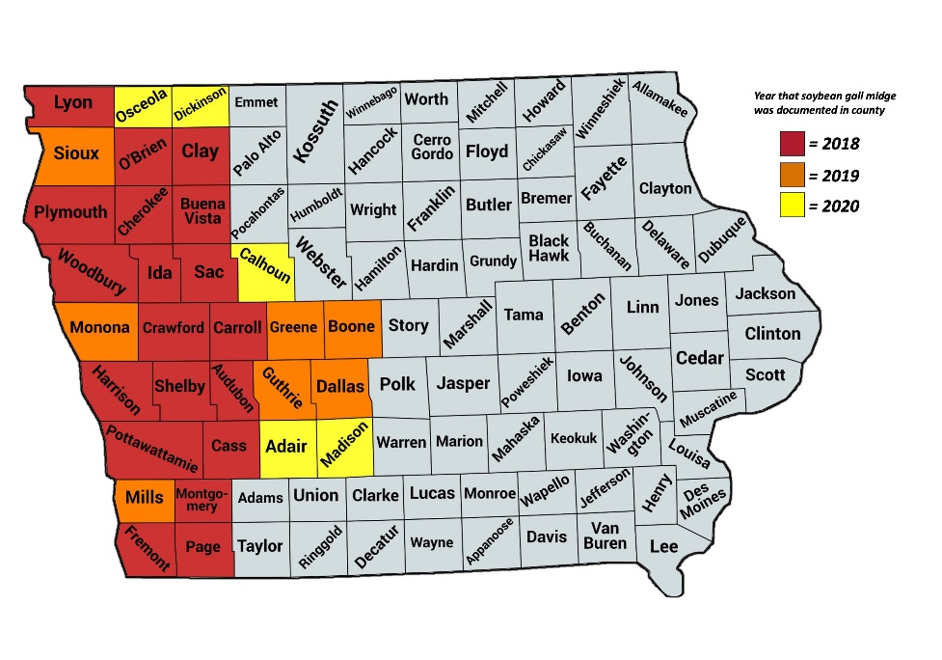
In addition, there were a variety of caterpillar species present in soybean in 2020. Thistle caterpillar was not as abundant as in 2020 but the first generation in Iowa was higher than normal. Japanese beetle and bean leaf beetle populations were typical and spotty in commercial fields. Twospotted spider mites were obvious and sometimes an economic issue later in the season and is attributed to drought-stressed crops.

My extension efforts are summarized here:

Peer-Reviewed Extension Publications and Proceedings: 6
Hodgson, E. W., A. N. Dean, and Z. Wang. 2020. Using immediate feedback cards in extension. Journal of Extension. v58-4rb4.
Hodgson, E. W., and G. VanNostrand. 2020. Soybean aphid efficacy screening program, 2019. Entomological Society of America Arthropod Management Tests. DOI: 10.1093/amt/tsaa053.
Lagos-Kutz, D., D. J. Voegtlin, D. Onstand, D. Hogg, D. Ragsdale, K. Tilmon, E. Hodgson, C. DiFonzo, R. Groves, C. Krupke, J. LaForest, N. J. Seiter, E. Duerr, B. Bradford, and G. L. Hartman. 2020. The soybean aphid suction trap network: sampling the aerobiologcal “soup.” American Entomologist. DOI: 10.1093/ae/tmaa009.
Hodgson, E. W. Field crop pest management updates from 2019, p. 23. In Proceedings: Iowa State University Crop Advantage Series, Ames, IA, January 2020.
McMechan, J. and E. Hodgson. Soybean gall midge: ecology and potential management strategies, pp. 89-93. In Proceedings: 31st Annual Iowa State University Integrated Crop Management Conference, Ames, IA, 4-5 December 2019.
Dean, A., M. O’Neal, E. Hodgson, I. Valmorbida, J. Hohenstein, and B. Coates. Building a budget for pest resistance, pp. 69-73. In Proceedings: 31st Annual Iowa State University Integrated Crop Management Conference, Ames, IA, 4-5 December 2019.

Other Extension Publications: 17
Hodgson, E. W., G. VanNostrand, A. Dean, and M. Helton. 2019. 2019 Yellow Book Report of insecticide evaluation for soybean pests, 36 pp. Department of Entomology, Iowa State University, Publication CROP 3197.
Hodgson, E. “Scouting reminders for spider mites.” In ICM News. 20 July 2020.
Dean, A., and E. Hodgson. “Potato leafhoppers abundant in soybean and alfalfa.” In ICM News. 10 July 2020.
Dean, A., E. Hodgson, and. M. Helton. “Soybean gall midge larvae active in Iowa.” In ICM News. 2 July 2020.
Hodgson, E. “Watch for Japanese beetle emergence.” In ICM News. 11 June 2020.
Hodgson, E., and A. Dean. “Mild winter favors bean leaf beetle.” In ICM News. 24 April 2020.
Dean, A., and E. Hodgson. “Survival effects of fluctuating temperatures on insects.” In ICM News. 22 April 2020.
Dean, A., and E. Hodgson. “Cold hardiness of insects and the impact of fluctuating temperatures.” In ICM Encyclopedia Article. 17 April 2020.
Corona, C., A. Dean, and E. Hodgson. “Getting to know popular insecticides used in Iowa field crops.” In ICM Encyclopedia Article. 14 April 2020.
Dean, A., and E. Hodgson. “Corteva™ to End Chlorpyrifos Production: What Does this Mean for Iowa Farmers?” In ICM News. 21 February 2020.
Dean, A., and E. Hodgson. “Summary of 2019 insecticide evaluations for soybean pests.” In ICM News. 13 January 2020.
Hodgson, E. “The boys are back in town.” In ICM Blog. 6 May 2020
Hodgson, E. “Soybean aphid egg hatch complete in northern Iowa.” In ICM Blog. 12 May 2020
Hodgson, E. “Soybean gall midge detected in Iowa.” In ICM Blog. 12 June 2020
Hodgson, E. “Caterpillars noted in soybean.” In ICM Blog. 2 July 2020
Hodgson, E. “Have you spotted this skipper?” In ICM Blog. 16 July 2020
Hodgson, E. “Update on soybean gall midge.” In ICM Blog. 21 August 2020

Extension presentations: 19
Hodgson, E. W., and B. D. Potter. Understanding insect defoliation and management in field crops. Advanced Crop Advisers Annual Workshop, Fargo, ND [2 sessions; 95 people] 12 February 2020
Hodgson, E., and A. Dean. Soybean insect pests updates. ANR Extension Crops Team Fall In-Service, Field Extension Education Laboratory, Ames, IA. [25 people] 24 September 2020.
Hodgson, E. W., and A. Dean. Insect identification, sampling and management. Iowa State University Extension and Outreach Crop Scout School, Ames, IA. [2 sessions; 48 people] 7 March 2020
Hodgson, E. W. Soybean gall midge and thistle caterpillar management. Jacobsen Annual Seed Meeting, Wall Lake, IA. [35 people] 19 February 2020
Hodgson, E. W. Midges, rootworms and corn borer management. MaxYield Cooperative Annual Winter Meeting, West Bend, IA. [35 people] 13 February 2020
Hodgson, E. W. Mashup of field crops insects from 2019. 2020 Iowa State University Extension and Outreach Crop Advantage Series Workshops.
- Burlington, IA. [20 people] 3 January 202019
- Sheldon, IA. [2 sessions; 43 people] 6 January 2020
- Storm Lake, IA. [40 people] 7 January 2020
- Ames, IA. [2 sessions; 45 people] 9 January 2020
- Honey Creek, IA. [2 sessions; 28 people] 9 January 2020
- Mason City, IA. [50 people] 10 January 2020
- Okoboji, IA. [45 people] 14 January 2020
- Fort Dodge, IA. [2 sessions; 95 people] 15 January 2020
- Waterloo, IA. [2 sessions; 135 people] 16 January 2020
- Davenport, IA. [2 sessions; 100 people] 17 January 2020
- Atlantic, IA. [60 people] 23 January 2020
- Iowa City, IA. [2 sessions; 95 people] 28 January 2020
- Le Mars, IA. [85 people] 29 January 2020
- Denison, IA. [80 people] 30 January 2020

Extension Field Days:
2018: 7 events and 245 contacts
2019: 10 events and 600 contacts
2020: 0 events and 0 contacts

Extension Videos: 8
Hodgson, E. W. Video: Soybean aphid IPM, Iowa State University. July 2020
Hodgson, E. W., and A. Dean. Video: Adult corn rootworm trapping, Iowa State University. July 2020
Hodgson, E. W. Video: Using a sweep net in field crops, Iowa State University. July 2020
Hodgson, E. W. Webinar: Soybean aphid IPM, Essential Row Crop Management, Summer Series, University of Minnesota and Iowa State University. [70 people] 16 July 2020
Hodgson, E. W. Webinar: Insect identification, scouting and management. Scouting basics, Field Extension Education Laboratory, Iowa State University, Ames, IA. [375 people] 14 May 2020
Hodgson, E. W. Video: Thistle caterpillar. PSEP Program, Iowa State University. January - December 2020.
Hodgson, E. W. Video: Thistle caterpillar and soybean gall midge updates. Nationwide Insurance Pesticide Applicator Training Program. January - December 2020.
Hodgson, E. W. Video: Thistle caterpillar. Nationwide Insurance Pesticide Applicator Training Program. January - December 2020.

