SCSB Final Report

General Information
Principal Investigator(s) Name(s): Michael Plumblee
Organization: Clemson University – Edisto REC
Date: January 4, 2020
Quarter: Final

Proposal Information
Title: Determining the Optimum Soil Moisture Sensor Threshold in Soybean
Amount Expended to Date: $6,000 ~ 100%

Progress Assessment
Wendy Buchanan, the M.S. graduate student has been working on this project and started in January 2020. Overall, this trial went well and as expected. Unfortunately, due to timely rainfall events no significant differences were observed between irrigation treatments where rain-fed, non-irrigated, plots made similar yields. Continued research on defining soil moisture sensor thresholds for irrigated soybean in South Carolina is needed.

On-Station Location
Soybean plots were harvested on November 3, 2020. In Blackville, SC during the 2020 growing season annual rainfall resulted in 26.5 inches from May through October. Above average rainfall occurred in August during late bloom and pod fill resulting in good yields even in rain-fed plots. During the growing season approximately 4.5 inches of irrigation were applied to the -15 kPa threshold plots, 3.2 inches of irrigation were applied to the -30 kPa threshold plots, and 1.65 inches of irrigation were applied to the -60 kPa threshold plots. Overall, soybean yields were very good regardless of irrigation treatment and no significant differences were observed between irrigation threshold treatments in 2020. No differences in test weight were observed in 2020.

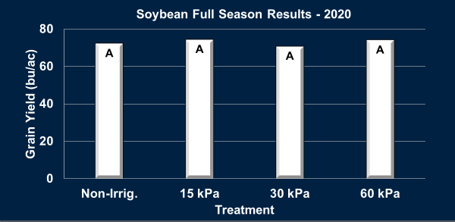
Figure 1. Soybean Yield (bu/ac) corrected to 13% by irrigation threshold/treatment.

Plant heights and total nodes were collected mid-season and at harvest. No significant differences were observed among irrigation treatments for total plant height or total plant nodes at either measurement timing.
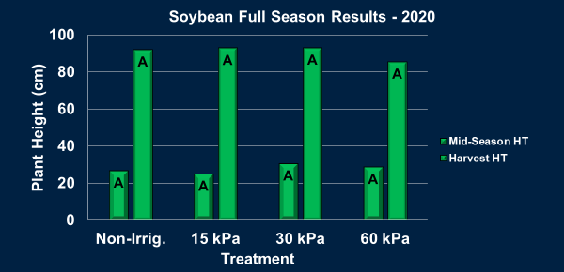
Figure 2. Plant Height Measurements by Treatment

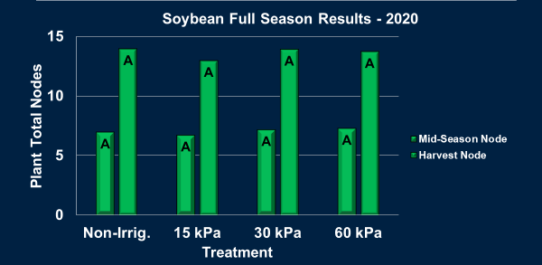
Figure 3. Total Plant Nodes by Treatment

With agricultural water and irrigation becoming a hot topic throughout the Southeast improving our irrigation water use efficiency using soil moisture sensors is imperative. Irrigation water use efficiency is defined as yield produced for every given amount of irrigation water applied. Irrigation water use efficiency was significantly different among treatments even though grain yields were similar. This is in part due to no additional yield being produced even though additional irrigation was applied based on sensor readings for some treatments.
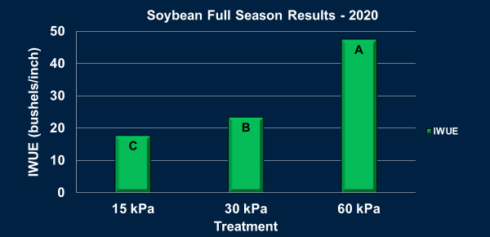
Figure 4. Irrigation Water Use Efficiency by Irrigation Treatment.

Based on these results and the rainfall that we had during the 2020 growing season, our best option would have been to utilize a threshold of -60 kPa (least aggressive) where 47 bushels were produced for every inch of irrigation applied compared to the -30 and -15 kPa threshold at 23 and 17 bushels per inch, respectively. In order to fully understand the best irrigation threshold recommendation evaluating IWUE and net returns above irrigation cost is beneficial. This comparison will provide the most profitable and water efficient threshold value. Based on the 2020 trial, the best irrigation threshold for soybean would have been the -60 kPa threshold. Ideally, before making a recommendation however, additional site-years of data would be obtained to account for year-to-year weather variability before doing so. With this being said, Watermark 200SS soil moisture sensors appeared to have accurately and simply scheduled irrigation in soybean in South Carolina coastal plain soils. Further investigation of sensor thresholds among different weather years is needed to determine the optimum threshold for irrigated soybean production in SC.

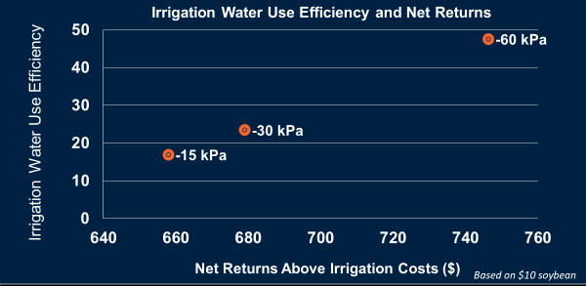
Figure 5. IWUE by Net Return Above Irrigation Costs based on $10/bu Soybean Price.

Key Performance Indicators
Key performance indicators for this study were determined at harvest (to determine if irrigation treatment and threshold value had any direct yield benefit). The water use efficiency data and yield data from this trial helps determine if there is an optimum soil moisture threshold that can be utilized for irrigated soybean. This research will help develop irrigation scheduling recommendations where soil moistures sensors are incorporated. Furthermore, this research allows for a threshold to be selected that maximizes yield and water use efficiency. As of now key circumstances impacting this research are rainfall or lack thereof.

Next Steps
Continue irrigation research in additional years to develop a robust dataset that can be used to base soil moisture sensor threshold recommendations for irrigation soybean in South Carolina that maximize IWUE and net returns. Continued work on analyzing data and sharing results with stakeholders will take place over the next few months at regional, local, and national meetings.

