Nitrogen Management is Not All About the Corn Crop:
Understanding Direct and Indirect Effects of Nitrogen on Soybean
2018 REPORT

Seth Naeve and Fabián Fernández

Introduction
The MSR&PC-funded Minnesota Lake research site was established in 2011 and continues to demonstrate its value to the soybean community by hosting research studies that provide real-world, relevant information & production guidelines that Minnesota farmers can use to increase crop yields and profit and minimize environmental impacts.

We recently completed an MSR&PC study, “Nitrogen Mineralization and Nitrous Oxide Emissions in a Soybean-Corn Cropping System With and Without Tile Drainage”, the findings of which are relevant to soybean. Although N fertilization is often the focus of research dealing with grass crops like corn, soybeans require substantial amounts of N. For example, a 50 bu/acre soybean crop takes up over 250 lb N/acre but only about half of that comes from symbiotic fixation; the rest is assumed to come mostly from mineralization of soil organic N and this mineralized soil N is critical for maximizing both yield and quality of soybean seed. As we observed in this earlier study, the amount of N made available to soybeans through mineralization is largely influenced by what happened in the previous and current growing seasons, including drainage, N fertilization management in the corn year, and crop residue impact.

In addition to soil drainage characteristics and N management, we know that tillage management can also have a substantial effect on soil N availability because of the impact tillage has on soil temperature, aeration, and crop residue decomposition, which in turn influence soil N mineralization and crop N availability. While the effect of drainage, N fertilization, and tillage on N availability have been studied separately (mostly for corn), the interaction of these important variables had not been investigated in soybean. Furthermore, soil drainage conditions and tillage practices can have an important role in affecting soybean insects and fungal diseases, and the effectiveness of insecticide and fungicide treatments. Therefore, part of our research plan was to evaluate the effectiveness of soybean seed treatments and foliar fungicide applications across the three tillage systems, two drainage regimes, and combinations of the two factors.

In the fall of 2016, the eight drainage blocks at the Minnesota Lake, MN research site were split by tillage (no till, strip till, or conventional till). Then in 2017, nitrogen and soybean management plots were established. Our overall plan was:

Objective 1: Evaluate the effect that soil drainage, tillage, and N management have on soybean productivity.
Goal 1: Improve soybean production by tailoring N management in corn to also benefit soybean productivity
Goal 2: Improve soybean production by better understanding how soil drainage and tillage influence soybean’s response to N management in corn
Goal 3: Incorporate the information generated in this research project into guidelines that soybean growers can use to enhance their profitability and productivity while protecting natural resources and the environment

Objective 2: Evaluate the effect that soil drainage, tillage, and soybean seed treatments have on soybean productivity.
Goal 1: Improve soybean production by tailoring seed treatment utilization to benefit soybean productivity
Goal 2: Improve soybean production by better understanding how soil drainage and tillage can influence the soybean’s response to seed treatments
Goal 3: Incorporate the information generated in this research project into guidelines that soybean growers can use to enhance their profitability and productivity while protecting natural resources and the environment

Objective 3: Train the next generation of scientists by involving a graduate student in this project. Specifically, we sought to train one PhD student to meet the ever-increasing demand for scientists that understand how to design and conduct rigorous basic research and then are capable of translating information into knowledge that can be used by farmers to enhance agricultural production.

Materials and Methods
As stated earlier, the eight blocks (four drained, four undrained) at this site were subdivided in 2016 to accommodate three tillage systems: no-till, strip till, and conventional till. In each of these drainage-tillage combinations, the 15 treatments listed in Table 1 were established in the spring of 2017. There were 10 treatments in the corn phase of the rotation designed to evaluate N management on the following soybean crop, where the soybean crop was managed uniformly (standard practice for the region) to avoid any confounding effects. Similarly, there were five treatments evaluating insecticides and fungicides on soybean where the previous year corn was managed uniformly, again to avoid any confounding effects.

In treatments 1 through 6 in the corn phase we measured soil N (ammonium and nitrate) at the 0-12" and 12-24" depths at V4, conducted canopy sensing measurements with the RapidScan sensor at V8. We collected whole-plant samples at R6 from corn treatments 1-10 to determine total N and total C, and to calculate C:N ratios of the plant material to determine the amount of N in crop residue for the subsequent year’s soybean crop. All corn plots were harvested to measure seed yield. We measured soil N (ammonium and nitrate) at the 0-12", 12-24", and 24-36" depths after harvest in treatments 1-10 of the corn conventional tillage system to determine residual N availability for soybean.

Starting in 2018 (after the 2017 setup year), we measured the effects of the previous year’s corn treatments in the soybean phase. We measured soil N (ammonium and nitrate) at the 0-12", 12-24", and 24-36" depths in treatments 1, 4, 6, 8, and 10 in the soybean conventional tillage plots in the spring to determine residual N availability for soybean. In soybean treatments 1, 4, 6, 8, 10, and 15, we collected canopy sensing measurements with the RapidScan sensor at R1 and collected whole-plant samples at R6 to determine total N and total C to calculate C:N ratios of the plant material. In all plots we measured seed yield. In soybean treatments 4 and 15 we measured soil N (ammonium and nitrate) at the 0-12", 12-24", and 24-36" depths after harvest.

In addition to an evaluation of corn management effects on soybean, we evaluated soybean management effects on the soybean crop directly (treatments 11-15). We believe that soybean seed treatments offer tremendous potential to reduce risk of poor stands and reduced yields under poor drainage or reduced tillage situations; therefore, we examined soybean responses to seed treatments at this site. We tested a complete fungicide, insecticide, and combination seed treatments, as well as the effects of a foliar fungicide at R3. We also included an N treatment on the soybean crop directly. This treatment allowed us to not only examine the direct N effect, but it also served as a check for the N treatments on the previous crop. We followed these plots into the corn year to examine the corn yield effects from the supplemental N on soybean.

This is a three-year study, and 2018 was the second of the three years. We will conduct this study in 2019 in order to compile three years of valuable field data.

Table 1 Treatment list for drained and undrained soil conditions under three different tillage systems (no till, strip till, and conventional).
Treatment | Applications to corn-phase plots in the rotation with soybean | Applications to soybean-phase plots  in the rotation with corn
1 | 0 pre-plant (PPT) | Untreated
2 | 40 pre-plant | Untreated
3 | 80 pre-plant | Untreated
4 | 120 pre-plant | Untreated (UTC)
5 | 160 pre-plant | Untreated
6 | 200 pre-plant | Untreated
7 | 40 pre-plant/40 @ V6 | Untreated
8 | 40 pre-plant/80 @ V6 | Untreated
9 | 40 pre-plant/120 @ V6 | Untreated
10 | 40 pre-plant/160 @ V6 | Untreated
11 | 120 pre-plant | Vibrance TRIO
12 | 120 pre-plant | Cruiser 5RS
13 | 120 pre-plant | CruiserMaxx Vibrance + 7.5G ApronXL
14 | 120 pre-plant | CruiserMaxx Vibrance + 7.5G ApronXL + Priaxor @ R3
15 | 120 pre-plant | 120 lb N/acre split @ V4, R1, R3

Results
For this annual year-end report, we will provide highlights of results from the previous two years of this study. We will provide a complete and comprehensive report summarizing all phases of this multi-year project when complete in 2020 or 2021. Here, results will be formatted as summaries of key figures and tables that depict the most important findings from this work over the past two cropping seasons.

Figure 1 Shows the site in early summer by drone. Note the eight drained and undrained blocks, each split by corn and soybean. Each crop is further split by tillage.

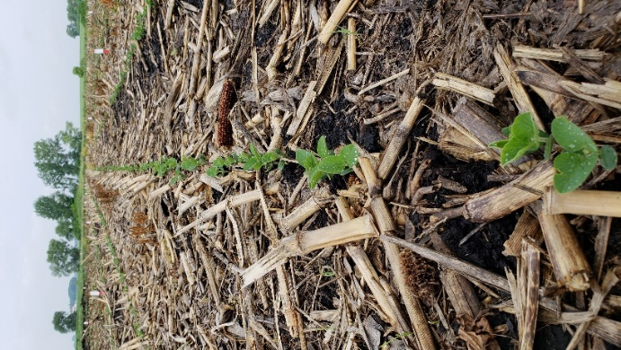
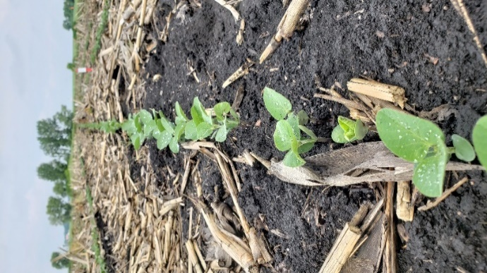
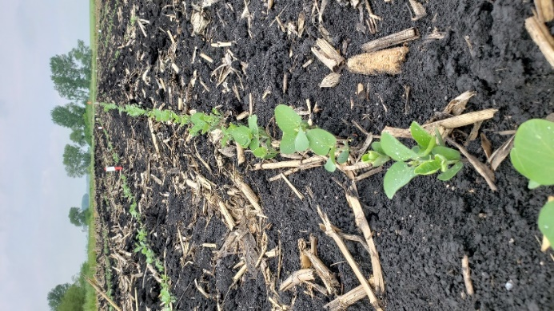

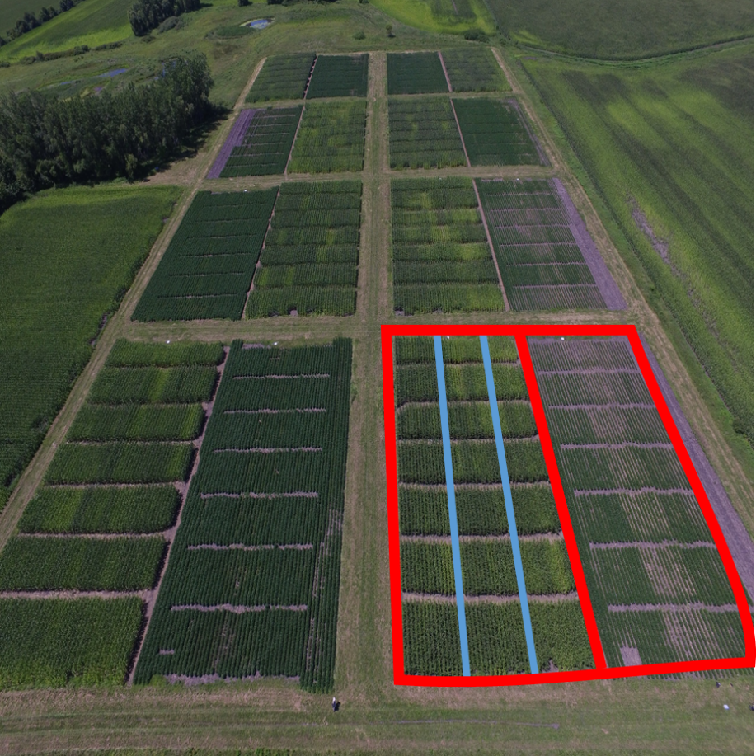
Figure 2 Provides an example of early season soybean stands in conventional till (CT), strip till (ST), and no till (NT) from left to right.
Treatment | Grain Yield (bu/acre)
 | 2017 | 2018
Drained | 190 a | 192 a
Undrained | 175 a | 166 a
CT | 185 a | 185 a
NT | 178 a | 173 b
ST | 185 a | 178 b
PPT | 199 a | 189 b
PPT/V6 | 195 a | 200 a
Table 2 Shows the main effects of drainage and tillage on corn yields in 2017 and 2018. Large numerical differences in corn yields were noted by drainage (15 and 26 bu/acre), but these differences were not determined to be statistically significant due to variation in yields across blocks. Likewise, conventional tillage (CT) tended to yield more than no till (NT), but this was found to be significant only in 2018. Strip till did not yield significantly more than no till in either year, but numerical yields were about 6 bu/acre more in the two years. Split applications (pre-plant [PPT] and at V6) of N yielded more in 2018, but not in 2017.

Figure 3 Shows corn yields across drainage and tillage in 2017 and 2018. The lack of interactions is evident in the similar response to tillage in both drained and undrained scenarios. No till tended to yield less than either conventional till or strip till in most years and drainage regimes.

Figure 4 Shows that split applications (SPT) of N to corn tended to yield the same as pre-plant applications (PPT) except in the undrained areas in a wet year like 2018. Here, early losses of N were greater in the pre-plant treatment which reduced yields.

Figure 5 Shows the interactions between tillage and N timing in corn. Similar to the drainage figure (Figure 4), there were no interactions in 2017. Yield differences were noted in each tillage regime in 2018, but conventional till losses of pre-plant N appeared to be larger and the split application yielded more.
 | EONR (lb/acre)
Treatment | 2017 |  | 2018
 | PPT | PPT/V6 | PPT | PPT/V8
Drained CT | 154 | 197 | 200 | 174
Drained NT | 171 | 200 | 200 | 156
Drained ST | 147 | 158 | 200 | 184
Undrained CT | 200 | 200 | 200 | 167
Undrained NT | 187 | 171 | 200 | 200
Undrained ST | 173 | 200 | 200 | 189

Table 3 Shows the Economic Optimum N Rate (EONR) across both drainage and tillage. Note that these rates are higher in the wet year. Also note that in 2017 undrained EONRs were higher than in the drained plots and were similar to those in 2018.

Figure 6 Shows the residual N in the fall of 2017. While not significant, a split application resulted in numerically greater residual N for the largest N rate applied. This likely reflects early-season N losses with a single pre-plant application, but this excess N is subject to losses before the next growing season. It is also important to remember that there were no differences in grain yield between PPT or SPT applications in 2017. Therefore, it is not necessarily true that residual levels were lower with a pre-plant application, because plants yielded more and used more nitrogen.

Figure 7 Shows the main effect of drainage on soybean yields in 2017 and 2018. Notice the large yield penalty (7 bu/acre) to soybean yields in the wet year of 2018.

69
68
67
62
63
59

Figure 8 Shows that tillage has little effect on soybean yields. No till tended to produce lower yields but differences were not statistically significant.

Figure 9 Shows that in the one year of rotational data, 2018, there were not large carryover N effects on soybean yields. The only significant yield decrease was found in higher N rates in undrained plots. This is a curious finding but we do not have a good explanation for this at this time.

Figure 10 Shows soybean seed treatment and foliar fungicide (R3) responses across drainage and tillage treatments in 2017 and 2018. No interactions were identified indicating that soybean seed treatments and foliar fungicides do not appear to behave differently across drainage or tillage at this site. Moreover, fungicide, insecticide, or fungicide + insecticide seed treatments did not improve yields. However, foliar fungicide did increase yields by about 6 bu/acre across the two years of this study.
Summary
- Drainage consistently resulted in numerically greater grain yield in 2017 and 2018 for both corn and soybeans. In most cases, no statistical differences were observed, but the results show a clear trend of lower yields under undrained conditions.

- In general, corn and soybean grain yields were numerically greater under conventional tillage (CT) and strip tillage (ST). No till (NT) treatments resulted in lower grain yields but the differences were not statistically significant for soybeans in 2017 and 2018, or for corn in 2017.

- Soybeans grown in drained conditions with either conventional tillage or strip tillage resulted in the highest grain yields in 2017 and 2018. For corn, the combination of drainage and conventional tillage resulted in the greatest grain yields in both seasons. The lowest yields for both crops were obtained with the combination of no till and no artificial drainage.

- We observed an interaction between drainage and the nitrogen rates applied to corn in 2017 on soybean grain yields in 2018. Under drained conditions, soybean yield did not differ with respect to the nitrogen rates applied the previous year to corn, but under undrained conditions, the highest nitrogen rates applied to corn (200 lb/acre) were associated with the lowest soybean yields.

- Residual total inorganic nitrogen (ammonium-N + nitrate-N) measured in the spring of 2018 was higher in conventional tillage compared to strip tillage and no till conditions.

- In-season nitrogen application to soybeans (120 lb/acre split at V4, R1 and R3) resulted greater in grain yield (4 bushels/acre) compared to the check treatment in both 2017 and 2018. The differences were statistically significant.

- Split-applications (SPT) of nitrogen at pre-plant and V8 resulted in greater corn grain yield under undrained conditions in 2018. This was likely because of greater nitrogen losses through denitrification.

- For corn, EONRs were generally greater under undrained conditions, likely because of greater potential for nitrogen losses.

- Greater fall residual nitrogen values were observed with split-applications of nitrogen in 2017, even though there were no statistical differences in grain yield. This likely reflects early-season nitrogen loss with pre-plant nitrogen applications.

- Soybean seed treatments of fungicide, insecticide, or a combination did not increase yields in either 2017 or 2018. There were no interactions for seed treatments across drainage or tillage.

- In both 2017 and 2018, the soybean crop responded to an application of foliar fungicide at R3; yields were increased by about 5 bu/acre. Since no interactions were noted, this treatment effect appears to be stable across drainage and tillage.

