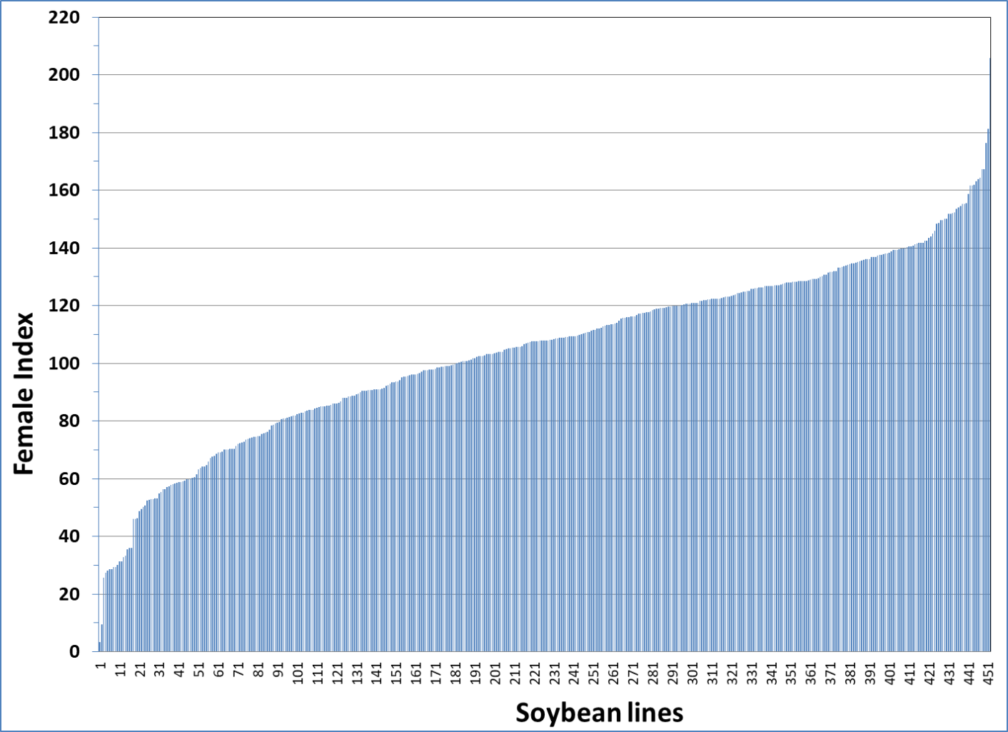
Fig. 1. Female Index of soybean cyst nematode race 3 on the soybean germplasms lines from the USDA Germplasm Collection.

