Final Progress Report for “Soybean Breeding and Genetics”
Aaron Lorenz
Objectives

- Develop commodity and food-type soybean varieties adapted to Minnesota, and new sources of pest and disease resistance for application to Minnesota-adapted varieties.
- Continue testing public and private soybean varieties available to Minnesota soybean producers.
- Discover and develop new sources of resistance to soybean pests and diseases.
- Develop and expand use of UAV-enabled high-throughput phenotyping for IDC resistance ratings and maturity notes.

Progress report
Objective 1
This project forms the core support of our breeding program, which is used to leverage many other funds from diverse sources, and for many projects. This final report will describe the progress made at each stage of the breeding pipeline, and end with a summary of materials transferred, licensed varieties, presentations, and publications.
- All breeding nurseries and yield trial plots were successfully planted during May and early June.
  - 101 unique parents (88 conventional, 13 RR) were planted in the crossing block and 174 crosses were designed between breeding lines selected for high yield, early maturity, high protein, small seed (natto), large seed/high protein (tofu), aphid resistance, SCN resistance, high oleic, among other traits. All crosses were successfully made, and ample F1 seed of 174 crosses was sent to the Chile winter nursery for generational advancement. The winter nursery was successful and F2 seed was successfully sent back from planting in May 2019.
  - The breeding nursery, where generational advancement occurs, consisted of the following numbers for each generation during the summer of 2018: 149 F2 populations (137 conv, 12 RR); 14 conv F3 populations; 108 F4 populations. Pod picks on all F2 populations were successfully conducted and populations were advanced to the F3 generation for planting in the Chile winter nursery. The F3 plants were pod picked in Chile and advanced to the F4 generation for planting in Saint Paul in 2019. These will form plant rows next year, and include breeding populations formed for purposes of aphid resistance, genetic diversity research, early maturity, high sucrose, SCN resistance, high oleic, high protein, and specialty seed traits such as small or large seeds.
  - F3 and F4 breeding nurseries were successfully advanced via plant pulls for planting into plant rows in 2019. Approximately 10,700 plant rows were planted in 2019 resulting from plant pulls in 2018. The reasons attached to breeding populations in 2018 F4/F3 nurseries included disease resistance (SDS, white mold, SCN, IDC), small/large seeds, high protein, aphid resistance, genetic diversity, and high oleic.
  - 1961 breeding lines were planted in preliminary yield trials (PYTs) at two locations. Lines were placed according to the maturity score in the plant row stage. Early maturing lines were planted at Crookston and Moorhead; intermediate lines were planted at Rosemount and Morris; and late lines were planted at Lamberton and Waseca. Yield, maturity, and quality data were successfully collected. A total of 355 lines (307 conventional; 48 RR) performed well enough to be advanced to second year yield testing in 2019.
  - 520 breeding lines were planted in advanced yield trials at three MN locations. Early lines were planted at Crookston, Moorhead, and Shelly; intermediate lines were planted at Rosemount, Danvers, and Becker; late lines were planted at Lamberton, Westbrook, and Waseca. Data on yield, maturity, and quality were all successfully collected. 170 lines performed well enough to advance to general regional trials and third year of testing for food-type trials in MN; All regional and advanced tests were successfully packaged and planted in 2019.
  - The 2018 regional tests were successfully conducted, including our lines and lines from regional co-operators were planted. The regional trials included 89 lines from the MN breeding program, plus many others from co-operators. Several lines performed well enough to be advanced to another year of regional testing. A couple highlights from the most advanced lines include:
    - M10-207102 – Early maturity a combination of high protein and good yield. Protein is 3 percentage points higher than the check cultivars, yet this variety yields within 97% of these checks. It’s RM is approximately 0.0. It also carries Rps1c. This variety will enter its fourth year of regional testing in 2019 and breeder’s is being created in 2019.
    - M10-238-2036 – A RM 1.6 variety with oleic acid levels about 70%. It has Rps1k phyto resistance but is SCN susceptible. Ten environments of data suggest it yields within 95% of commercial check cultivars. A large purified seed increase is being conducted in 2019.
    - M09-285149: M09-285149 is a high yielding, SCN-resistant variety of mid MG I with strong Phytophthora resistance. It has a light buff hilum and average protein content. This variety has displayed high yield in the past, and will be tested again in 2019.
Below is table of lines currently being purified and which are available through MTAs for company evaluation:
Line | Traits | MG (approx.) | FL/PUB/HIL
M10-207102 | Protein | 0.0 | P-G-I
M11-320-1018 | Small | 0.0 | P-G-Y
M12-331013 | Small | 0.5 | P-T-M
M11-244139 | SCN | 0.1 | W-G-F
M11-337015 | SDS | 1.3 | P-M-F
M11-297035 | Large | 1.3 | W-G-Y
M11-245026 | SCN | 0.0 | P-T-Y
M11-314020 | Protein | 1.7 | P-T-Y
M11-314106 | Protein | 1.8 | P-T-Y
M10-159-2022 | Small | 0.5 | W-G-Y
M10-159-3002 | Small | 0.8 | W-G-Y
M11-105060 | Small | 1.0 | M-T-M
M10-159-4011 | Small | 0.3 | W-G-Y
M10-159-4007 | Small | 0.5 | W-G-Y
M11-314101 | Protein | 2.0 | P-G-Y
M10-159-1007 | Small | 0.2 | W-G-Y
M10-238-2036 | High oleic | 1.5 | P-T-G

It’s difficult to document the impact of the breeding program in terms of acres planted and value of seed harvested because this information is proprietary to our licensees. One way we can document impact is through examination of seed transfers and agreements signed. Below is a summary of those signed in 2018. The information of the requestor is kept confidential.
- 12 lines were transferred to private seed companies for use as parents.
- 2 lines were transferred to 2 public universities for use as parents.
- 31 lines were transferred to private companies for testing of quality and yield preceding possible licensure.
- 9 lines were transferred to public universities for testing of quality and yield.
- 54 lines were transferred to other university research projects to serve as experimental materials for studies on pathology, entomology, and genetics.
- Invention disclosures were filled out for 17 varieties to begin the process of licensing, or transferring lines to companies as parental stock: M08-455029, M10-218105, M08-332003, M13-236028, M13-236029, M13-262005, M10-194097, M10-242042, M10-249002, MSC10-562014, M12-354012, M12-373033, M12-386012, MCH13-104091, M10-207102, M11-314101, M10-159-1007.

I spoke at a few events relevant to the breeding program:
- Lorenz, A.J. 2019. Enhancing resistance to iron deficiency chlorosis in soybean, and other stuff. University of Guelph, Jan. 7. Guelph, ON, CA.
- Lorenz, A.J., and R. Stupar. 2018. Modifying soybean meal composition through advances in plant breeding technology. Minnesota Nutrition Conference, September 19. Mankato, MN.
- Lorenz, A.J., A. Dobbels, R. Merry, R. Stupar, J. O’Rourke. 2018. Enhancing resistance to iron deficiency chlorosis: Fine mapping and high-throughput phenotyping. Molecular and Cellular Biology of the Soybean Conference, Aug. 26 – 29. Athens, GA.
- Lorenz, A.J. 2018. Breeding soybeans for quality. Soybean Symposium, March 28. Chanhassen, MN.

Objective 2
- An announcement was sent out to commercial seed representatives. We received 110 unique varieties that were entered into at least one of the four tests.
- Plots were planted at each of the three locations within each type of test. Staking, flower/pubescence notes, weeding, harvest, compositional analysis were all successfully completed.
- The report was created on time in November and can be found here at this link:
https://www.maes.umn.edu/sites/maes.umn.edu/files/2018_soybean_final.pdf
Objective 3
- A main activity related to this objective this last summer was again to collaborate with Dr. Dean Malvick on Rhizoctonia resistance. Screening was expanded this year relative to 2017. We provided Dr. Malvick with two panels of soybean varieties, one being a set of 20 for screening in Crookston, and another being a set of 30 for screening at Waseca, MN. In 2018 the disease pressure from Rhizoctonia in the inoculated nurseries was too great, and therefore very little variation was observed. These tests are being conducted again in 2019.
- Additionally, we have transferred seed to Malvick for a wintertime brownstem rot study, and to Kathryn Bushley for a study on the interaction between SDS and SCN.

Objective 4: Develop and expand use of UAV-enabled high-throughput phenotyping for IDC resistance ratings and maturity notes.
Thanks to USB Fellow Austin Dobbels, this objective has gone quite well. We have developed an UAV image collection and image analysis pipeline that can be used to image our IDC nursery, extract percentages of green, yellow, and brown pixels from plots, and predict IDC ratings computationally. We have found that the accuracy of this, which is around 77%, is acceptable enough for routine use in the breeding program. Implementation of this is being considered for 2019. A manuscript on this has been accepted at Plant Methods.
- Dobbels, A., and A. Lorenz. 2019. Soybean iron deficiency chlorosis high throughput phenotyping using an unmanned aircraft system. Plant Methods (in press).
This platform has been expanded to predicting maturity date via UAV image analysis. Using a method published by Corteva in 2019, we tested out our ability to predict maturity among our small plots in Waseca, MN. We found that we could explain 91% of the variation in observed maturity with UAV-predicted maturity date using this method. Moreover, the precision of these UAV-based predictions (as indicated by the Entry-mean H^2) was as high as ground dating. We are looking at implementing this technology in 2020 for maturity dating, and could result in a significant savings of effort.
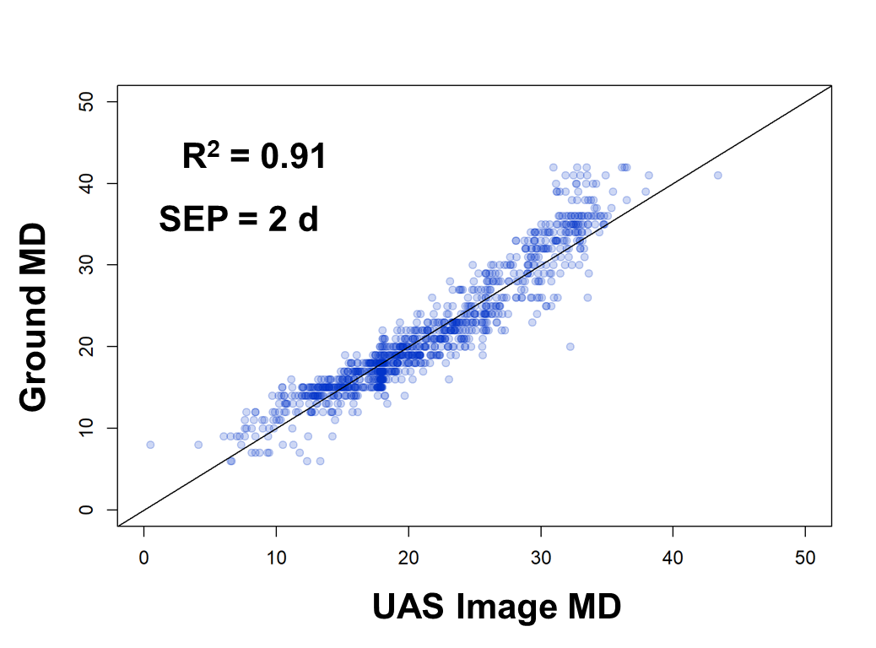

 | Entry-mean H²
Test | Ground dates | UAS-predicted dates
48 | 0.87 | 0.90
49 | 0.69 | 0.80
65 | 0.92 | 0.95
66 | 0.94 | 0.93
67 | 0.97 | 0.96
83 | 0.84 | 0.87
89 | 0.97 | 0.94
105 | 0.96 | 0.95
110 | 0.91 | 0.93
116 | 0.72 | 0.84
117 | 0.96 | 0.96
242 | 0.98 | 0.93
264 | 0.86 | 0.71

