Variable Rate Seeding: Impacts on Yield, Weeds, and White Mold
Leanna Leverich and Seth Naeve

Optimal Soybean Seeding Densities?
Soybean seeding density has often been evaluated to maximize grower returns. Data indicate that 100K seeds per acre is fully sufficient for reaching yield goals, but growers often plant 120-190K seeds per acre to ensure a 100% yield goal is achieved.

The development of precision planting and variable rate technology (VRT) has introduced a new opportunity for growers to have even greater control over their seeding densities. However, few recommendations exist to help guide growers in their variable rate seeding decisions, and few studies have been conducted to evaluate which field factors most greatly influence optimum seeding rate.
Furthermore, Minnesota has yet to identify if variable rate seeding is a profitable venture. Farmers constantly balance volatile market prices against seed costs and pest control for weeds and diseases; variable rate seeding provides another avenue for growers to tighten costs and increase profits.
Our objectives for this study were to 1) determine the magnitude of spatial variation in soybean’s yield response to seeding rate within commercial soybean fields, 2) determine whether VRT could practically be deployed in Minnesota to increase soybean returns, and 3) develop criteria on which VRT prescriptions might be based.

What we did…
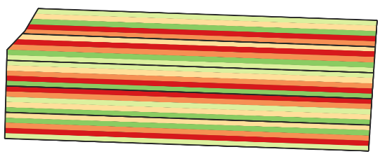
In 2018, two farmer fields were planted with a novel strip-trial design to assess the viability of various soybean seeding densities. The strips were randomized and replicated, and then subdivided and sampled to assess within-field variability for each seeding rate. Five seeding densities were used to assess performance: 75K, 100K, 125K, 150K, or 175K seeds per acre, each replicated four (20-ac field) or five times (50-ac field) (Figure 1). After seeding, stand counts were collected for each seeding rate and soil samples were collected on a 1-acre grid. Weed and white mold (caused by Sclerotinia sclerotiorum) pressure was assessed at R3. Lidar data were obtained through the MNTopo organization for a digital elevation model (DEM) and other topography derivatives. Drone and satellite multispectral imagery was also obtained to derive the normalized vegetation index (NDVI). Yield data were collected with calibrated yield monitors at both sites.
Figure 1. Example of the seeding density trial design with five seeding rates replicated five times.

What we found…
Data from the 2018 growing season indicated that there is a substantial amount of within-field variability that can be managed using by optimizing seeding rates throughout the field. At both sites there was clearly differences in the optimum seeding density (OSD) within the fields, and the ODS for both sites included all seeding rates, with optimums anywhere between the 75K to 175K range (Figure 2). At Site 1, the most common OSD was 175K, which covered 38% of the field. In contrast to this, the most common OSD at Site 2 was 75K, and this rate accounted for 45% of the field. This indicates that seeding rate can be optimized and is highly dependent on each grower.

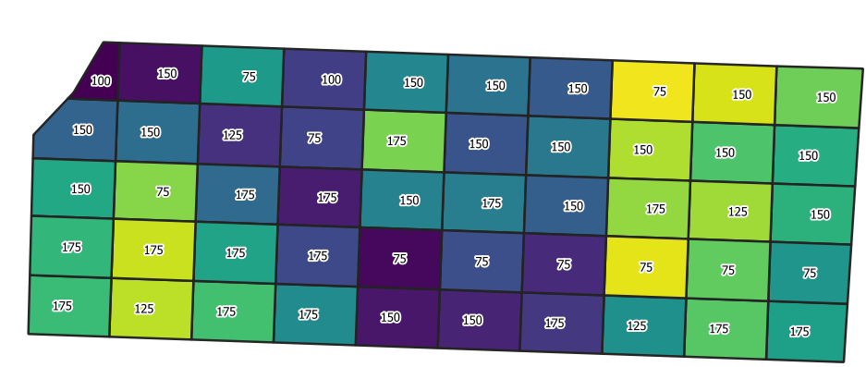
Figure 2. The variation of optimal seeding density (1,000 seed per acre) for each subplot, outlined in white. Color of the plot indicated the average yield.

Yield-stable areas may be a starting point for lowering seeding rates where is a clear economic incentive to lower seeding rates. Areas arbitrarily receiving suboptimal seeding rates in this experiment resulted in economic gains for growers. The seed savings at Site 1 resulted in net economic gain of approximately $77, and more than a $250 economic gain at Site 2. Refining how we place seeding rates based on field features can open the door for even greater economic gain than our two farmers saw in seed savings.

As far as general yield performance across seeding densities for each field, there was no significant differences. However, Site 1 had the highest average yield at the higher seeding rates, while Site 2 had its highest yields in lowest seeding rate (Figure 3).
Figure 3. Whole-field yield averages for five seeding densities of soybean for two sites in Minnesota. No statistical significance was found between seeding rates (P < 0.05). Middle bars indicate the median, top and bottom borders of the box indicate the 25th and 75th percentiles. Lines and points indicate the spread in the yield data.
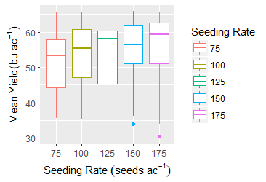
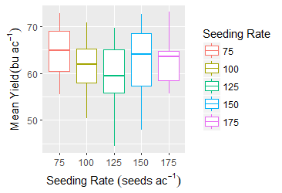
Site 1 Site 2
To best assign variable seeding densities we need to better understand with field factors are influencing optimal seeding density. Yield stability, topography, and organic matter all showed a spatial relationship to yield. These factors, and others, will be further assessed in the 2019 growing season with the goal of developing recommendations for devising VRT seeding prescriptions.

