The Minnesota Challenge: Interactions between SCN and IDC
Austin Dobbels and Seth Naeve

Background
Soybean cyst nematode (SCN) and soybean iron deficiency chlorosis (IDC) are two major soil-borne stresses that cause significant soybean yield reduction in the Midwest. In the case of SCN, the nematodes penetrate and feed on the roots causing the roots, as well as above-ground plant parts, to become dwarfed and stunted. IDC, on the other hand, is caused by a lack of available iron [Fe(II)] to the plant. While iron is abundant in almost all soils, deficiencies are caused by several factors and their interactions that change the solubility of iron in the soil. It is very likely that these two stresses are co-occurring in farmer’s fields.

Research Goals
There are three major project goals
- Identify in-field treatments that differentially affect IDC and SCN
- Investigate how IDC and SCN stress affects yield losses and SCN reproduction
  - Individually and together
- Quantify plant stress using remote sensing tools

Results – Impact of IDC application treatments on yield
The impact of the IDC treatments on yield was analyzed. On average, Soygreen treated plots yielded 66 bu/ac, control plots 54 bu/ac, and N treated plots 45 bu/ac. This can be seen on Figure 2 (left) where the colored bars represent the three IDC treatments We also showed the importance of genetic tolerance to IDC. The IDC tolerant varieties yielded 2 more bu/ac on Soygreen treated plots, 15 more bu/ac on control plots, and 21 more bu/ac on N treated plots compared to the IDC susceptible varieties.

Results – Impact of SCN treatments on yield and nematode reproduction
The impact of SCN treatments on yield and nematode reproduction also was analyzed. SCN resistant varieties out-yielded SCN susceptible varieties in 3 of 6 locations over the two years of data collection. In addition, SCN resistant varieties had less nematode reproduction than SCN susceptible varieties in all locations.

Results – IDC x SCN interactions
There were no statistically significant interactions found between our IDC treatments and our SCN treatments (Figure 2). In other words, yield penalty from the IDC treatments was the same over levels of SCN varieties. In addition, nematodes were found to reproduce on SCN susceptible plots regardless of IDC stress.

Results – In season data collection
Greenness scores as measured by the human eye, a ground-based active sensor, as well as an unmanned aircraft system were taken weekly throughout the growing season. Drone-based imagery was able to capture plot treatment effects and was highly correlated with yield (r= 0.92), and resulted in a similar correlation as that found from the ground-based active sensor. For greenness scores, a 1-point change in the greenness score resulted in ~12-15 bu/ac change in yield.

Recommendations
From our study, it appears that we can manage IDC and SCN independently, but we need to start by identifying the problem. For SCN, soil sampling for SCN numbers is a required first step. Be certain of low SCN numbers before planting a susceptible line. Medium to high populations (2,000 – 10,000 eggs) require action, and beyond 10,000 eggs, one should consider corn or other alternatives.

For IDC, it is known to be found on high-pH soils (>7.5) and is commonly found in shallow depressions. Wet soils and nitrates will worsen IDC. Variety tolerance remains the best solution to IDC-prone areas and additional iron chelates may be added if necessary. Growers should consider variable rate applications of iron chelates if variable rate is available to them.

For more detailed results please contact Seth Naeve at naeve002@umn.edu

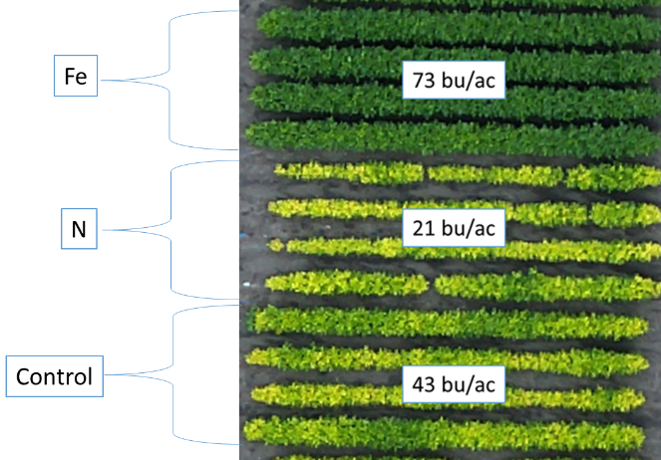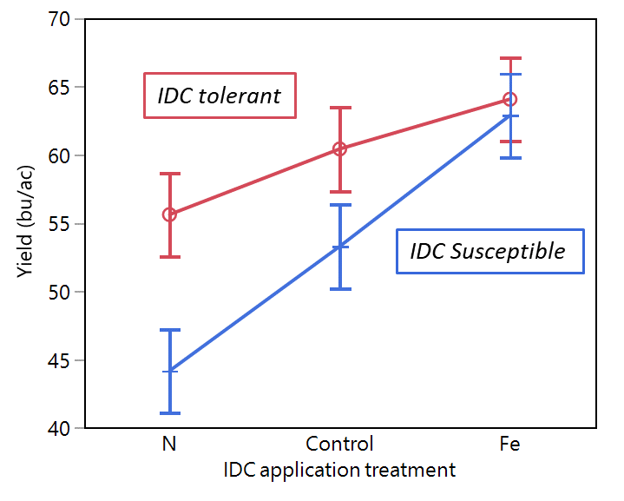
Figure 1. Impact of IDC application treatments on yield. The three treatments banded at planting to create a range in iron deficiency chlorosis (IDC) were urea (N), no treatment control (Control), and Soygreen (Fe). Clear visual symptoms (left) as well as significant yield differences (right) were observed.

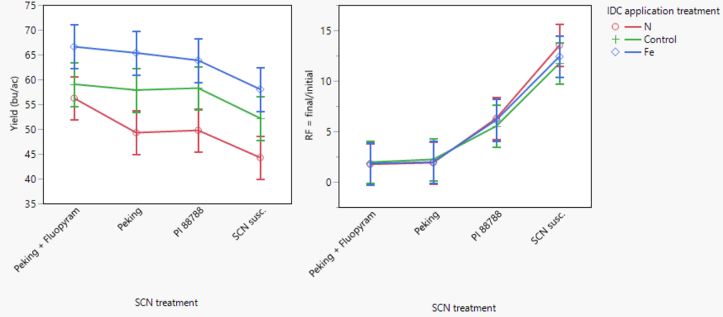
Figure 2. IDC x SCN interactions. Yield (left) and nematode reproduction (right) plotted across the range of IDC treatments and SCN varieties. Yield penalty from IDC is the same over levels of SCN. Nematodes reproduce on SCN susceptible plots regardless of IDC stress.

