Wells Project – 2019 Growing Season Results Summary

Weather Conditions – Temperature and Precipitation

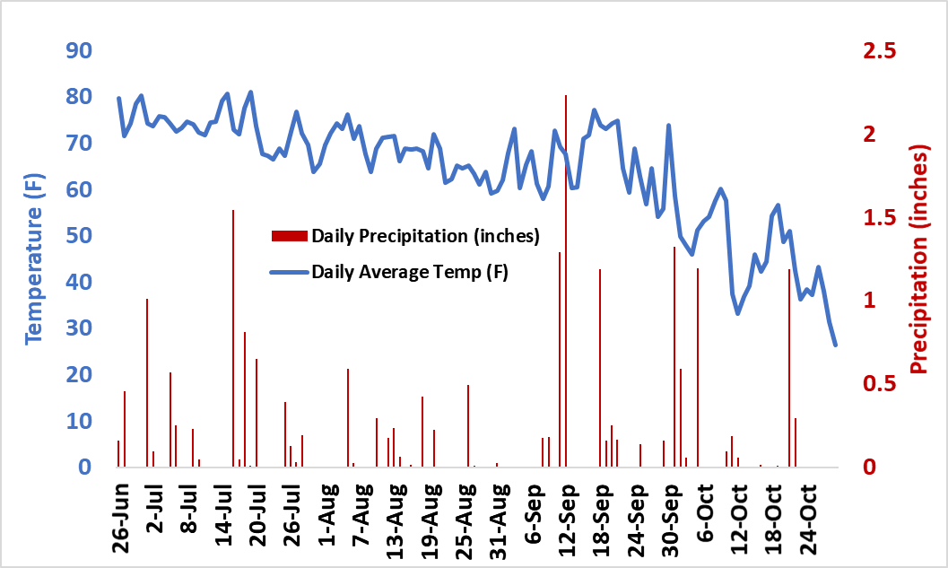

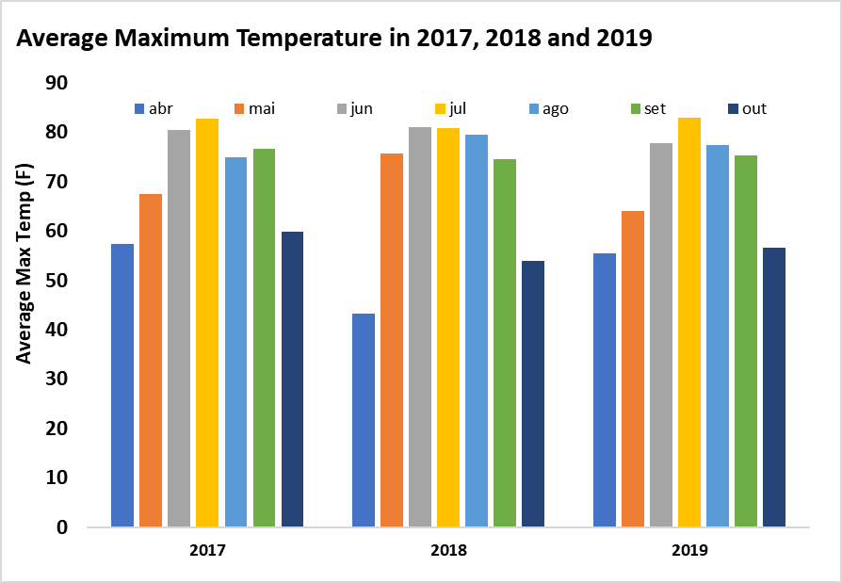

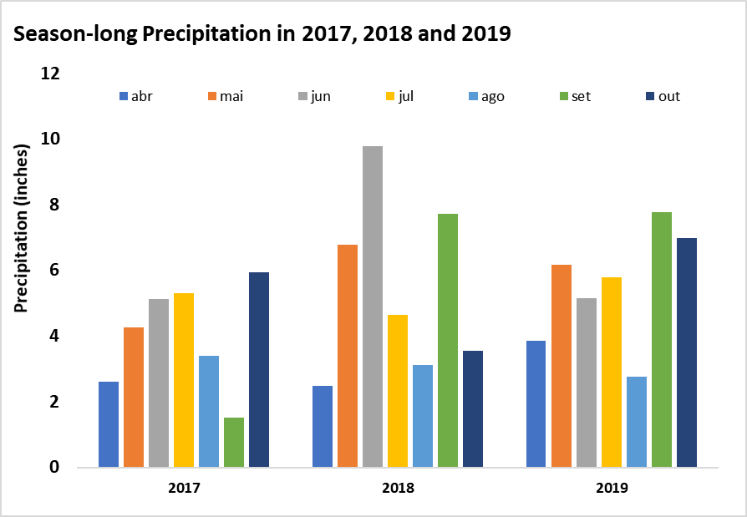

Table 1. Treatment list applied in drained and undrained soil conditions in three different tillage systems: no-till, strip-till, and conventional. Each of these 15 treatments is apple to all six combinations of drainage and tillage.

Applications to CORN phase plots Applications to SOYBEAN phase plots
Trt in the rotation with soybean in the rotation with corn
1 0 pre-plant Untreated
2 40 pre-plant Untreated
3 80 pre-plant Untreated
4 120 pre-plant Untreated (UTC)
5 160 pre-plant Untreated
6 200 pre-plant Untreated
7 40 pre-plant/40 @ V6 Untreated
8 40 pre-plant/80 @ V6 Untreated
9 40 pre-plant/120 @ V6 Untreated
10 40 pre-plant/160 @ V6 Untreated
11 120 pre-plant Vibrance TRIO
12 120 pre-plant Cruiser 5RS
13 120 pre-plant CruiserMaxx Vibrance + 7.5G ApronXL
14 120 pre-plant CruiserMaxx Vibrance + 7.5G ApronXL
+ Priaxor @ R3
15 120 pre-plant 120 lb N/A split applied at V4, R1, R3

Grain Yield – Drainage and Tillage – Soybean

The following analysis was done considering corn treatments 1 through 10. There were no significant effects of drainage or tillage on soybean yield (ANOVA table below).
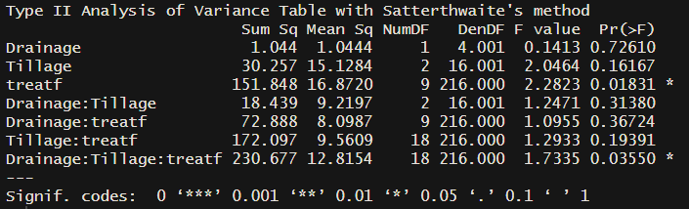

Drainage grain yield means (as ‘emmeans’ in the table)
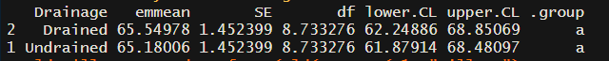

Tillage grain yield means (as ‘emmeans’ in the table)
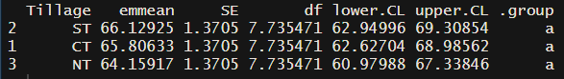

Treatment 6 which received 200 lb N/acre at PPT in the corn rotation was the only treatment to yield significantly lower (figure below). These results are consistent with previous years and might suggest that high corn yields (and high crop residue) might reduce soybean yield the following year. There was not an interaction effect indicating that the performance of treatment 6 was further hindered under NT plots.

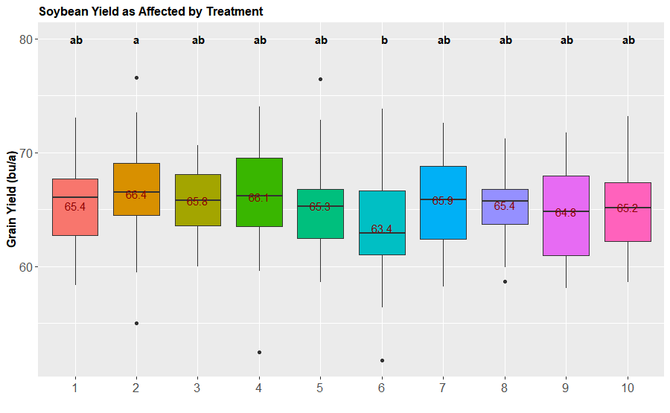
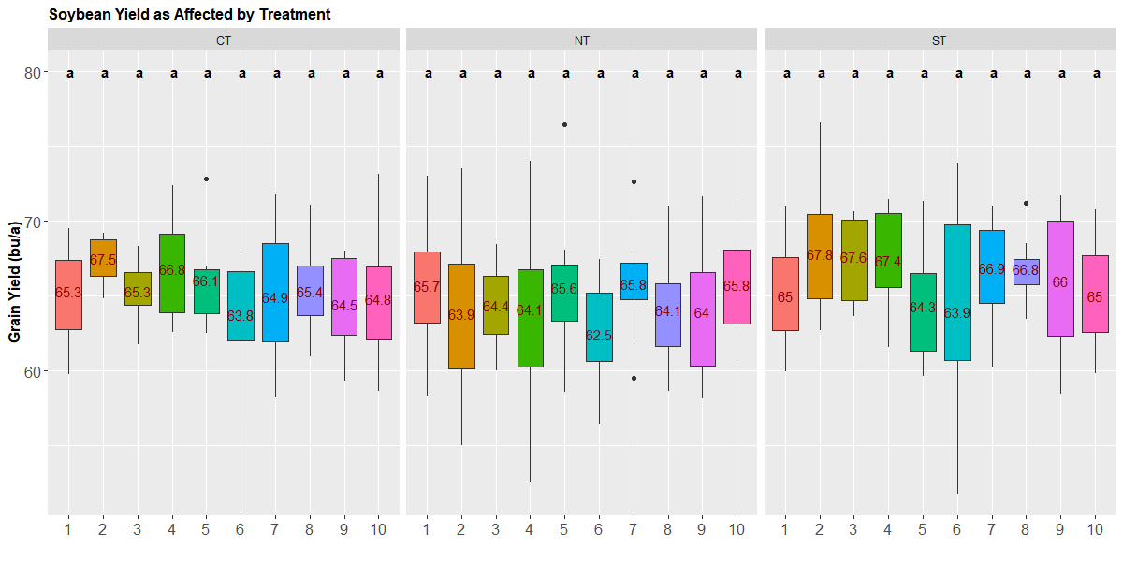

Grain Yield – Nitrogen Application – Soybean

In 2019, nitrogen application to the soybean crop (120 lb N/a split at V4, R1, and R3) did not result in statistically higher yields (figure below).

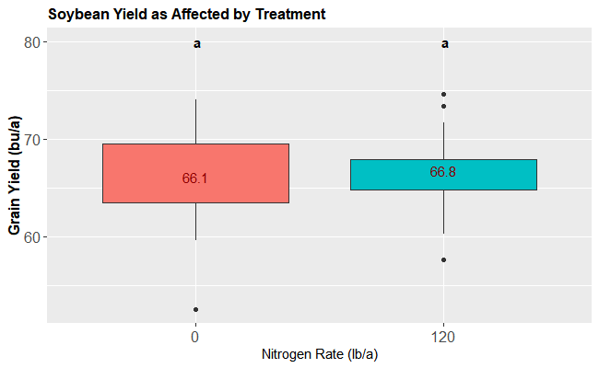

Grain Yield – Seed treatments – Soybean

There were no differences in yield with regards to the seed treatments (figure below).

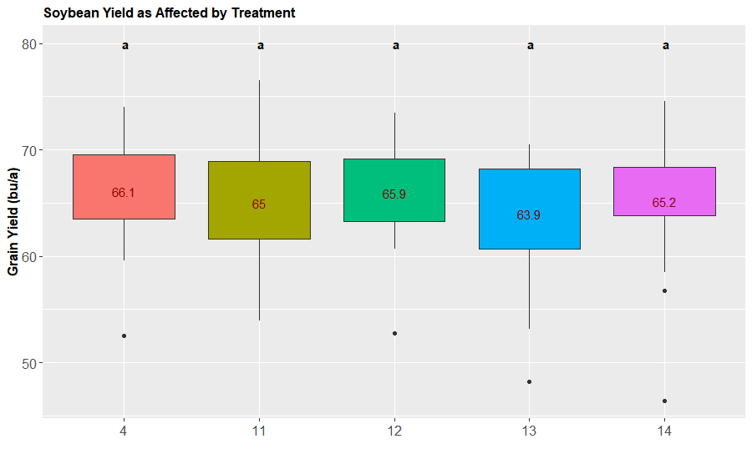
Grain Yield – Drainage and Tillage – Corn

The following analysis was done considering corn treatments 1 through 10. We can see a significant effect of tillage but no effect of drainage. ‘treatf’ indicates the different N rate and application timings.

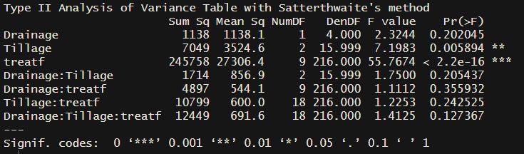

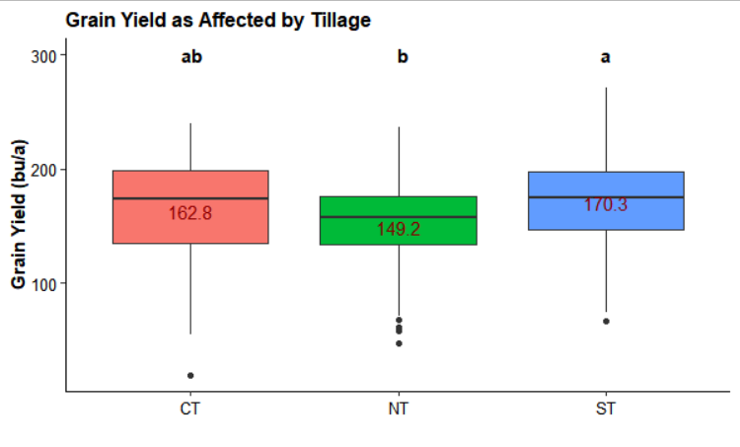
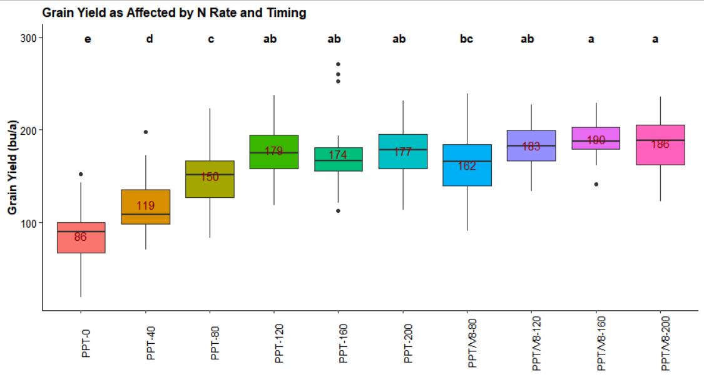

Grain Yield – N Application Timing – Corn

The timing of nitrogen application was significant but there were no interactions with the different drainage and tillage conditions. Higher yields were obtained with split PPT/V8 applications.
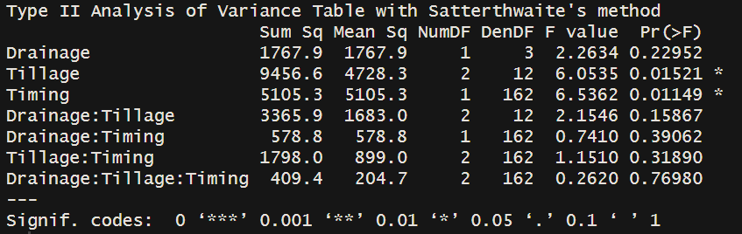

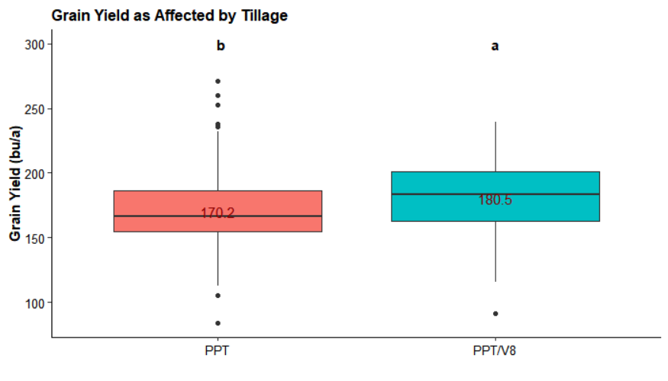

Optimal Nitrogen Rate – PPT vs PPT/V8 – Corn

In general, optimal N rates were lower with a full PP application compared to a split application. Nonetheless, corn responded to in-season N application and that resulted in greater yields (preceding figure). Even though we adjusted the grain yields for the greensnap damage, there might still be some confounding effect of lower yields with PPT treatments, as those were the tallest and most damaged plants at the time the wind storm hit the site.

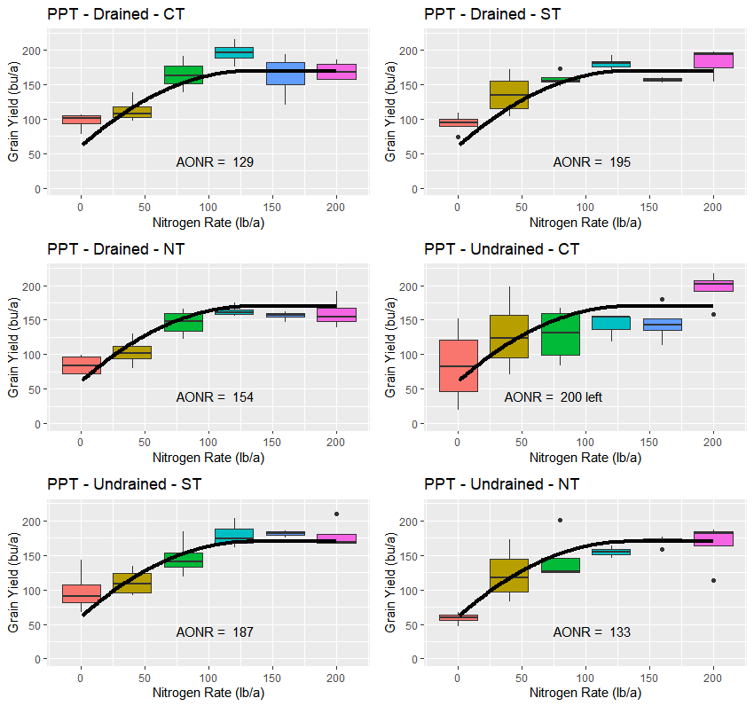

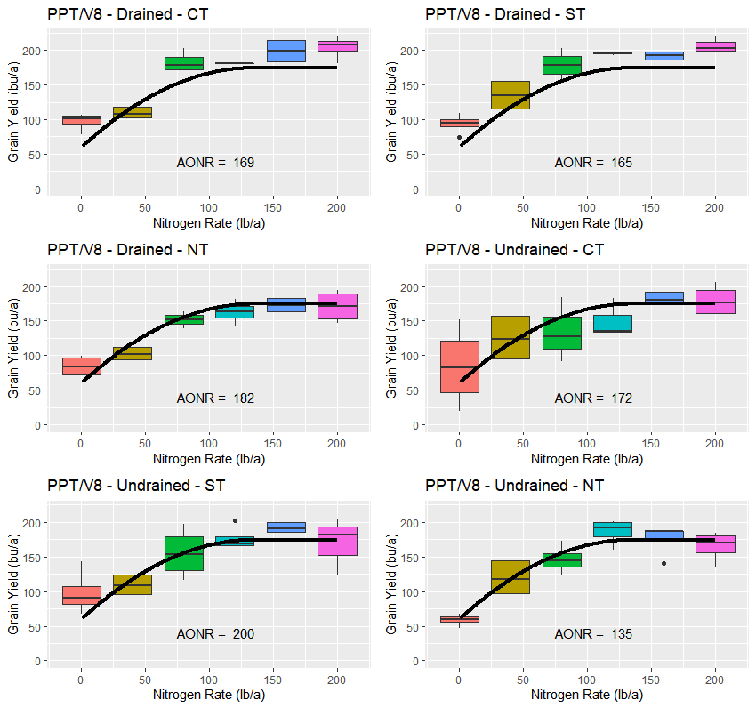

Green Snap Damage – Corn

The figure below shows a clear linear relationship between percent plant breakage (green snap) and percent yield loss across all the treatments.
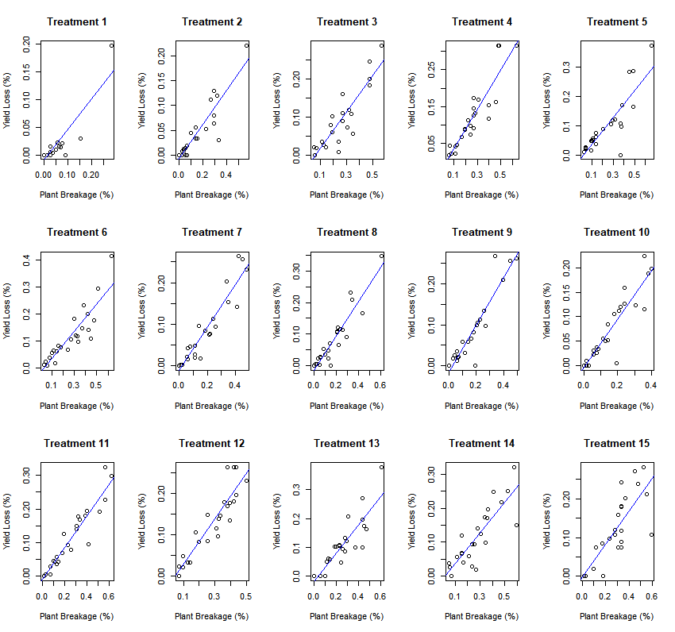

As a side project we investigated the utility of crop canopy reflectance as a predictor of green snap damage. The figure below shows the relationship between percent plant breakage (or yield loss on the following page) and change in canopy NDRE measurement 12 days before and 2 days after the storm. The results are promising and show a clear negative linear relationship, indicating that the greater the change in crop canopy reflectance, the greater the percent plant breakage and yield loss.

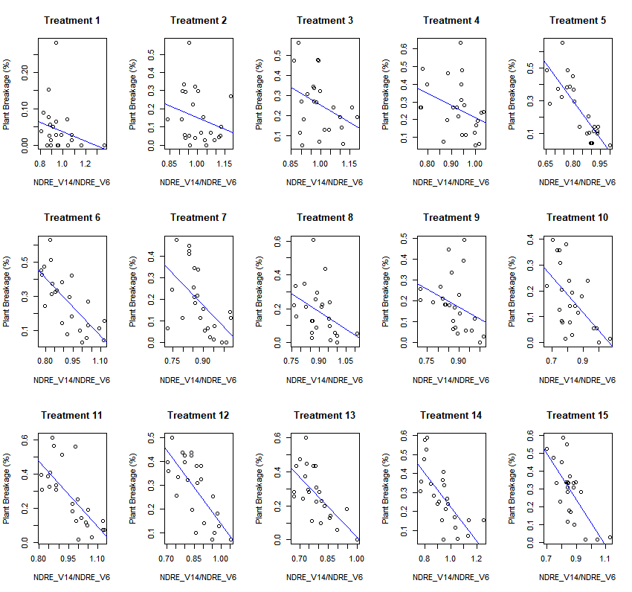

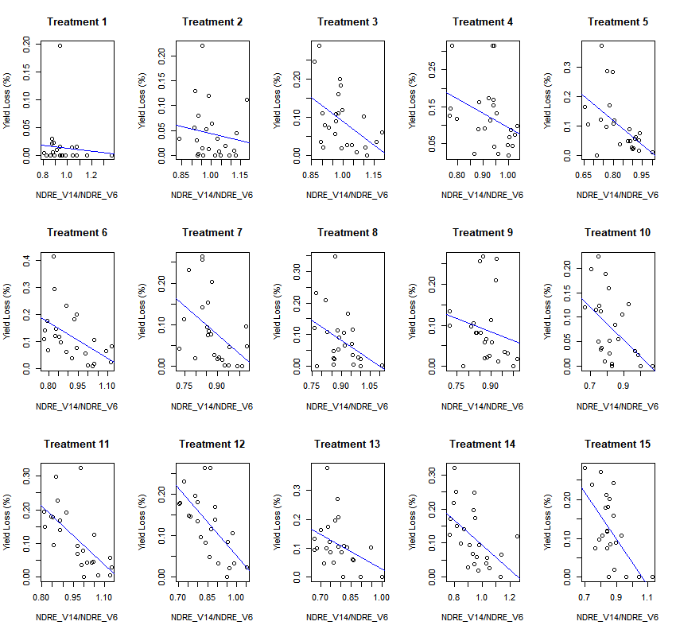

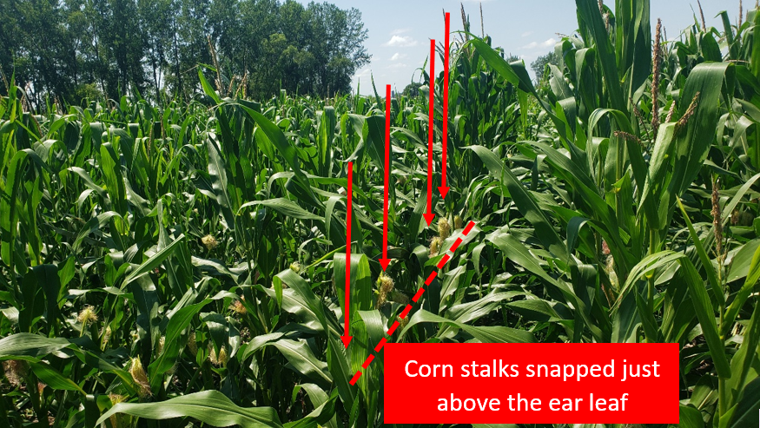

Plant Emergence

There was a significant effect of drainage on corn emergence, with significantly higher plant population under drained conditions.

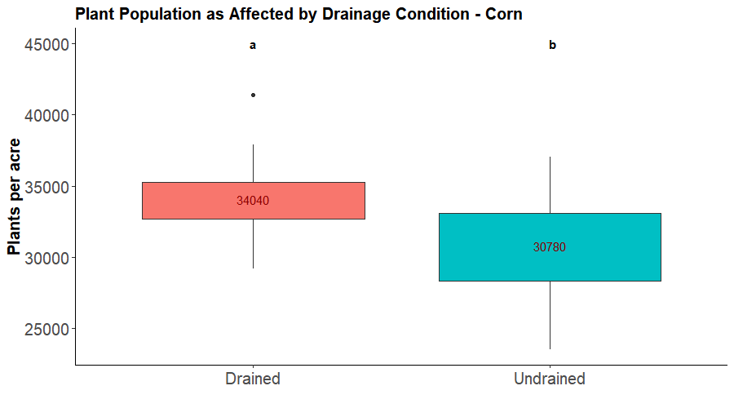

For soybeans drainage did not have a significant effect on plant population.

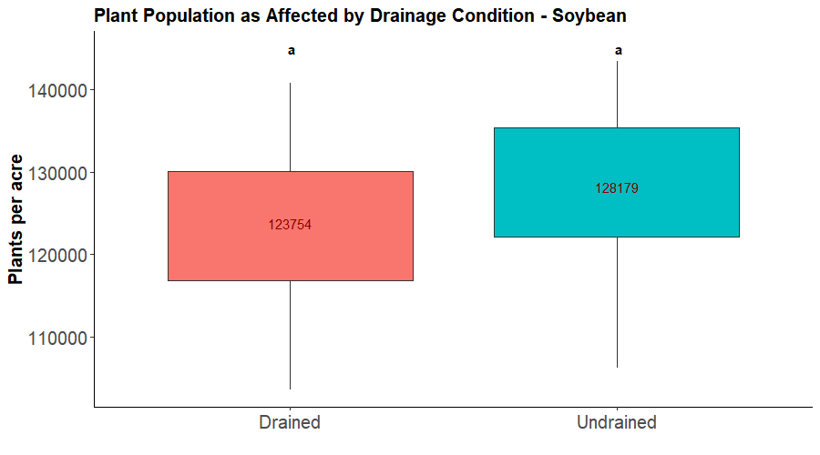

The soybean seed treatments interacted with tillage practice and drainage condition, resulting in significantly different plant emergence values.
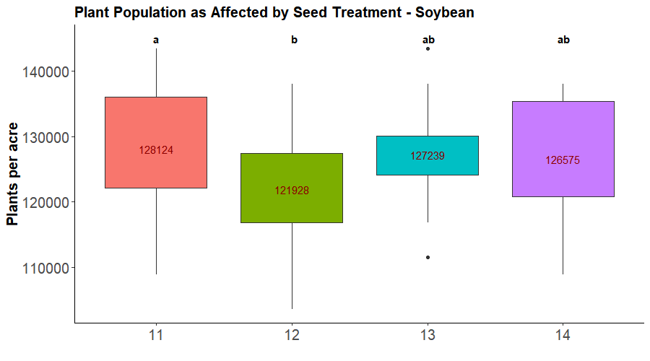

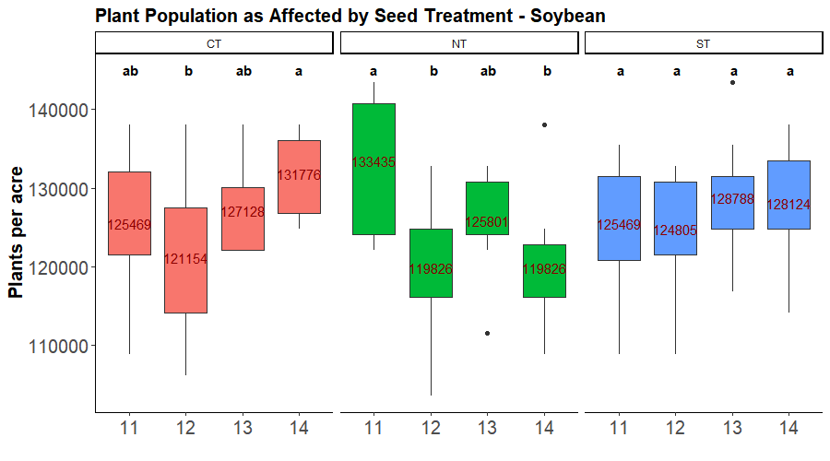

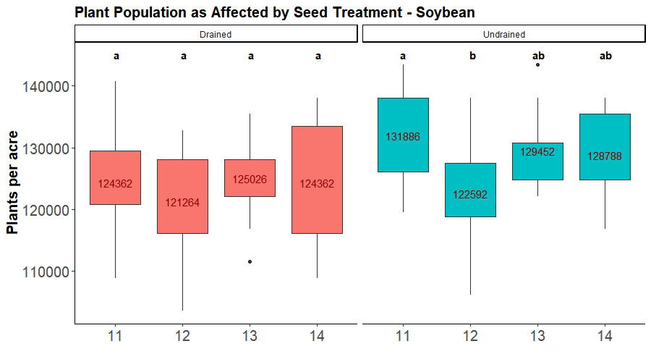

Post-Harvest Soil Nitrogen – Corn

Neither drainage nor tillage had a significant effect of residual soil N (ammonium + nitrate @ 0-3 ft).
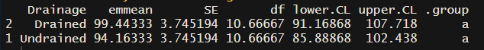

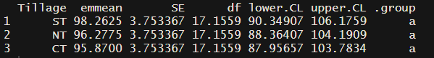

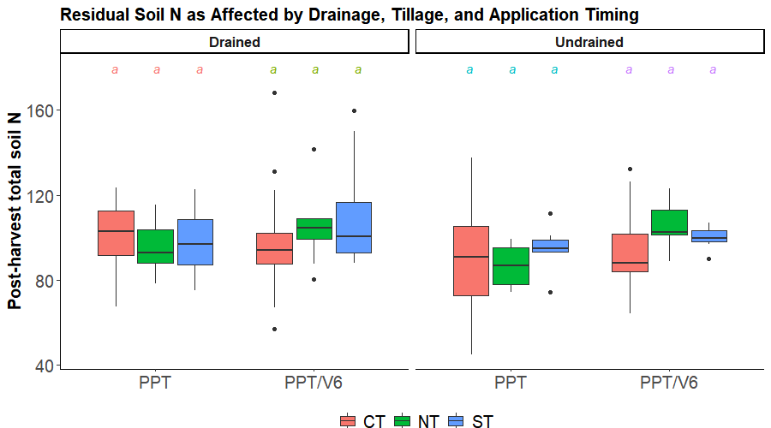

While there as a significant effect of N rate on residual soil N (greater soil N with the largest N rates), those patterns were not affected by drainage and tillage.
It is also worth noting that timing of N application did not affect residual N, as can be observed by comparing treatments 5 and 9, and 6 and 10.
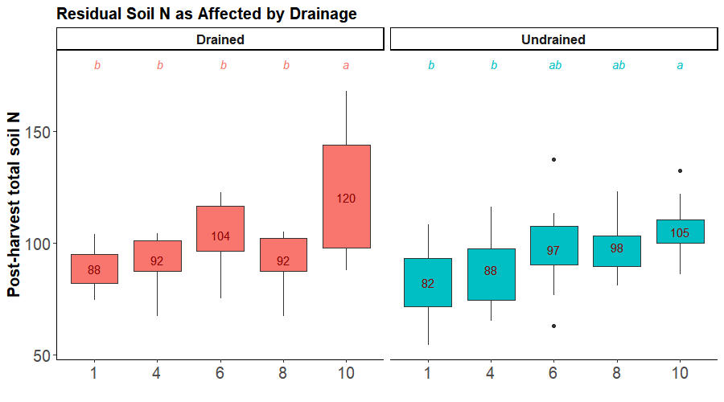

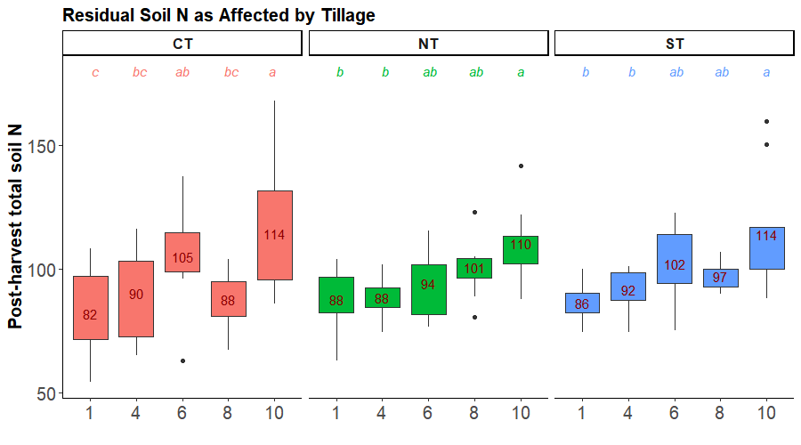

In-season soil N – Corn

Even though differences were numerically large (tables below), drainage and tillage did not affect in-season soil N measured at V6 stage as ammonium + nitrate at 0-3 ft.

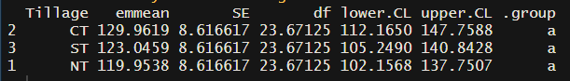

As expected, significantly higher soil N was measured with higher N application rates.
