Q4 Progress Report – Contract 10-15-48-19-153-7527 MWRPC
Feb 1 – Apr 30, 2020
Green-Seeding soybean into rye in a wheat-soybean rotation in NW MN
Objectives:
List the project objectives as submitted in the final proposal. Describe any activity for each objective during this reporting period.

OBJ 1. Establish cereal rye after wheat to evaluate growth of rye and its effects on the environment and planting conditions for the following soybean crop.
Goal 1. Demonstrate that rye can be successfully established following wheat.
Goal 2. Quantify potential biomass accumulation and N uptake in fall and spring, and changes in soil conditions for soybean planting the following spring.
OBJ 2. Evaluate the effect of green seeding soybean into rye on soybean establishment, yield, and overall field management.
Goal 1. Demonstrate that soybean can be successfully seeded into a living rye cover crop.
Goal 2. Quantify effect on soybean establishment and yield.
Goal 3. Quantify rye effects on weed pressure and soil conditions during the growing season.
Achievements:

- Several new participant to begin the trial following wheat harvest in 2020 have been identified.

- Plots were sampled for soil moisture and temperature, weed stand count, cover crop biomass, and soil NO3 prior to soybean planting (Table 1)

- Plots were planted to soybean May 24th and 25th

Challenges:
- Cold, wet conditions delayed cover crop emergence and growth into late April/May
- One cover crop trial by Drayton was lost because the farmer had to change his cropping plans in order to get his crops planted

Publication(s)/Symposium:
NA
Tech Transfer:
General audience identification (EG: growers, consultants) and approximate number attending:
NA this quarter

Table 1. Mean soil nitrate, moisture, temperature, cover crop biomass, and weed stand count for each treatment prior to planting at Dorothy and Warren, MN, May 2020.
Location | Trt. | NO3 0-6" | NO3 6-24" | NO3 0-24" | Biomass (ton/acre) | Soil Temp (C°) | Soil Moisture (%) | Weed/ft2
Dorothy | None | 9 | 24 | 33 |  | 20.0 | 23.2% | 2.5
 | Rye | 6.75 | 21.75 | 28.5 | 78.8 | 20.2 | 22.2% | 0.7
Warren | None | 9.25 | 18 | 27.25 |  | 16.2 | 26.2% | 0.4
 | Rye | 6.5 | 15 | 21.5 | 55.6 | 16.7 | 27.2% | 0.1

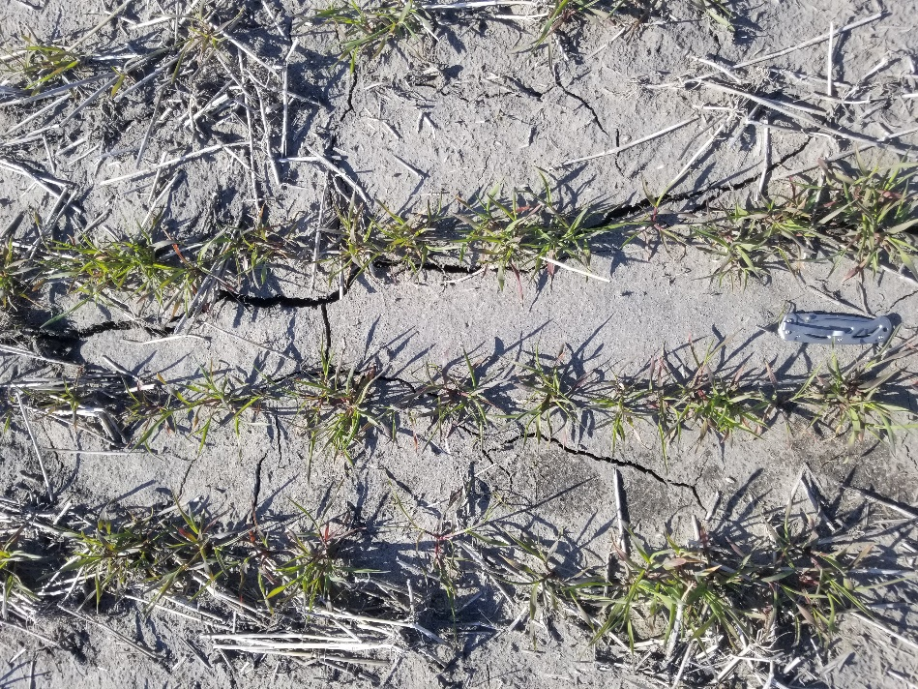
Rye cover crop near Warren, MN, 5-11-20.

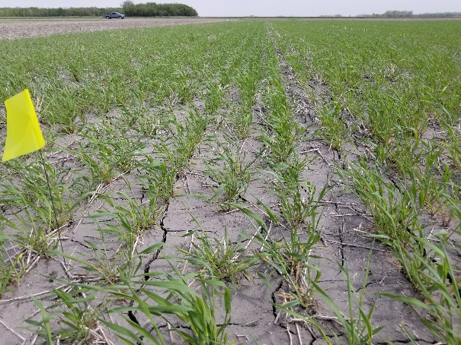
Rye cover crop near Warren, MN, 5-22-20
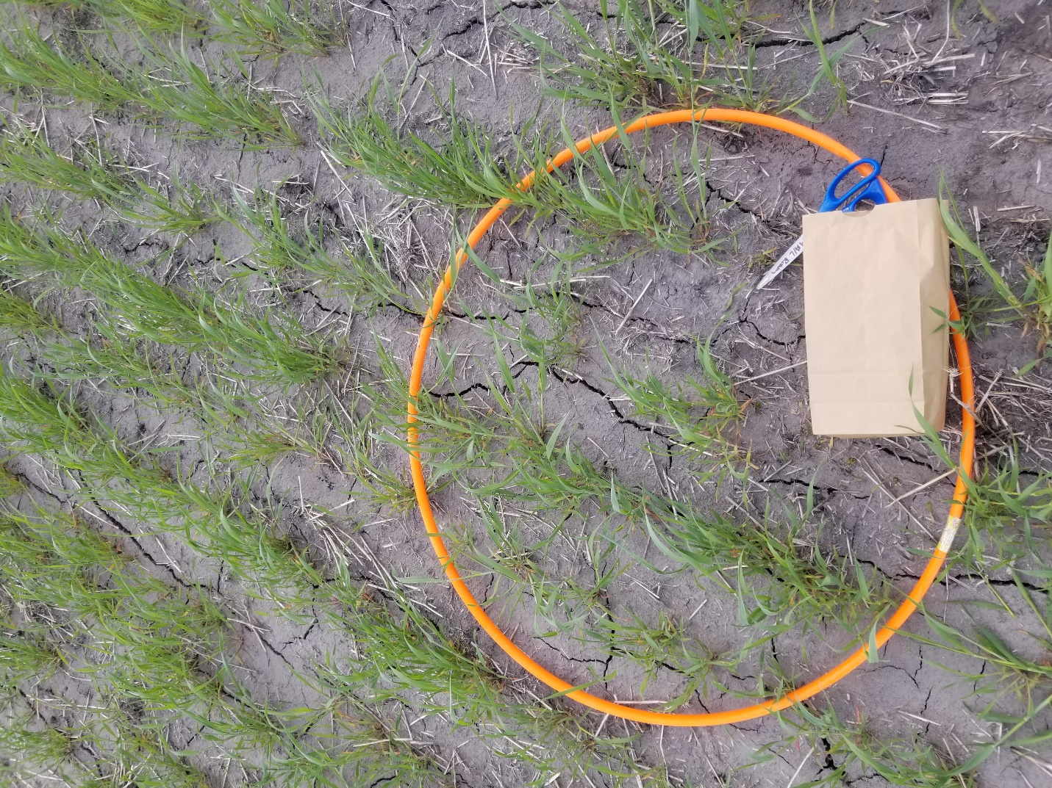
Rye biomass sampling, Warren, MN, 5-22-20.
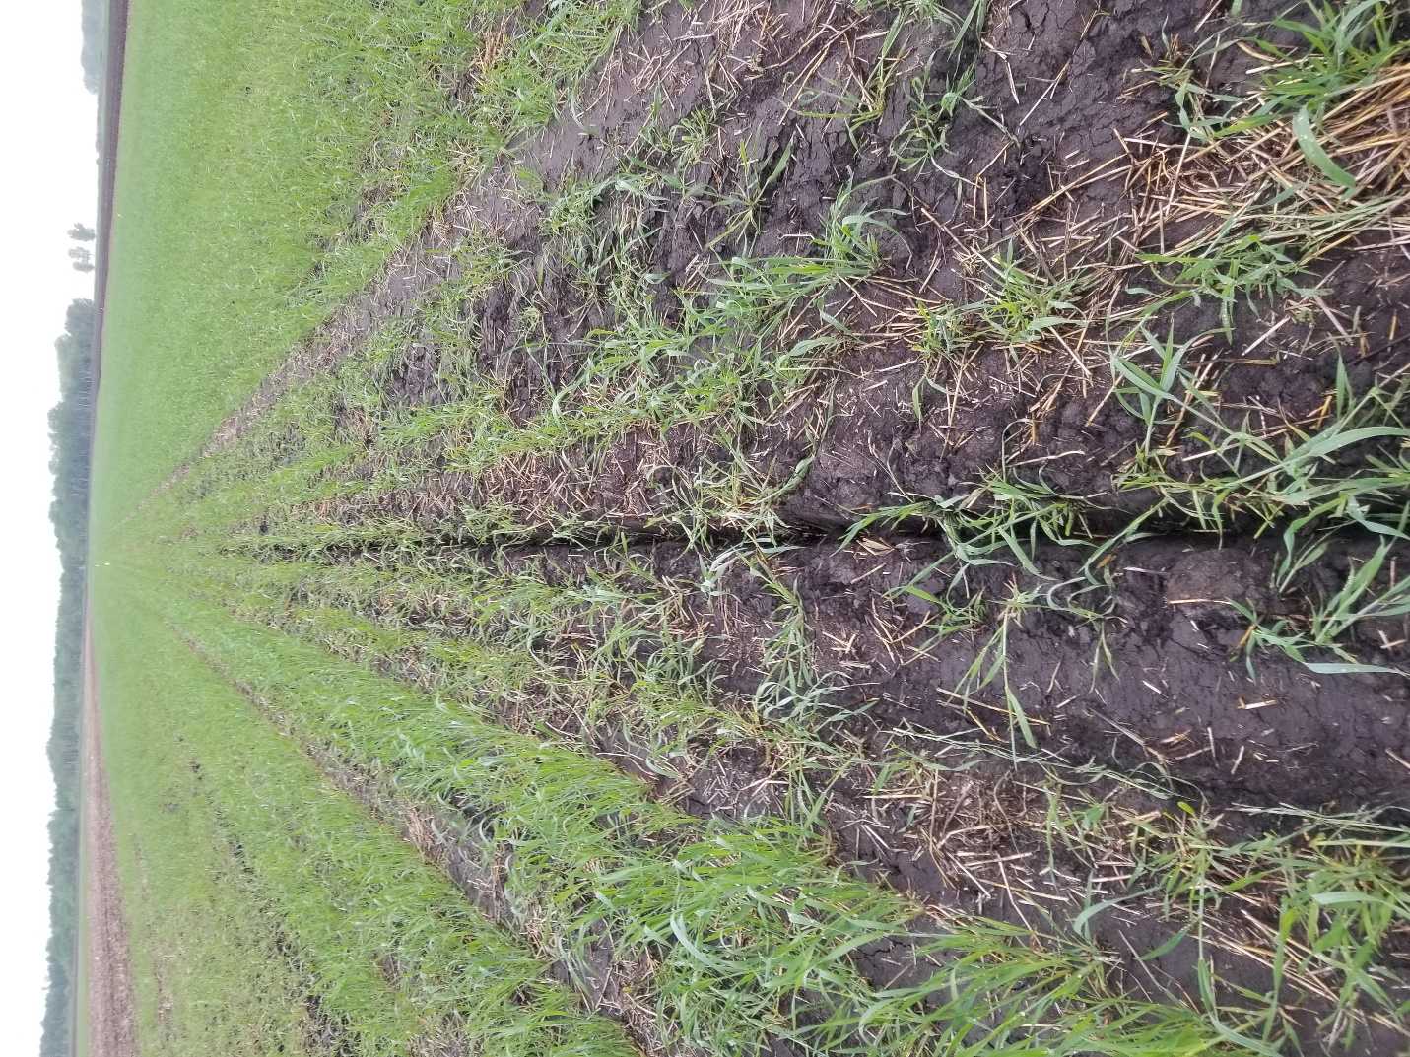
Rye cover crop after planting with 22” disc drill, Warren, MN, 5-26-20.

