The Minnesota Challenge: Interactions between Soybean Cyst Nematode and Iron Deficiency Chlorosis

Abstract
Soybean cyst nematode (SCN) and iron deficiency chlorosis (IDC) are major yield limiting factors to soybean production. In the case of SCN, the nematodes reduce yield by penetrating and feeding on the roots and robbing the plant of energy, whereas with IDC, the plants become stressed due to a lack of available iron. These two stresses are difficult to manage, are dynamic, are likely acting together in the field, and a better understanding of their interaction would allow for a more comprehensive management plan for farmers with IDC and SCN stresses. The goals of this study were to use in-field treatments to differentially affect IDC and SCN, investigate how IDC and SCN stress affects yield losses and SCN reproduction individually and together, and quantify plant stress development using remote-sensing tools. In 2017, 2018, and 2019, a total of nine fields were identified that had documented histories of both IDC and SCN. Results from this three-year study showed that the treatments independently created IDC and SCN severity symptoms and associated yield differences. Nematode reproduction was significantly impacted by varietal resistance and was not impacted by IDC treatment. An interaction between IDC and SCN treatments was not found for yield, nematode reproduction, or severity symptoms suggesting these stresses act additively.

Introduction
Soybean cyst nematode and iron deficiency chlorosis are two soil-borne stresses that have a major economic impact on soybean [Glycine max (L.) Merr.] production Management practices for reducing the yield-limiting effects of IDC and SCN have been studied previously. Options for managing IDC include growing tolerant soybean cultivars, planting companion crops, reducing other forms of plant stress, and supplementing the soil with iron chelates. It has been shown in many studies, however, that the best option for managing IDC is to grow a tolerant soybean cultivar. Soybean cyst nematode has been managed primarily by growing resistant cultivars and by using a crop rotation; however, the control of SCN remains a problem with growing numbers of virulence phenotypes of nematodes.

A soil with high pH is a major factor that leads to unavailability of iron to the soybean plant, thereby causing to IDC. In addition, it has been shown that nematodes are often more prevalent in high-pH soil and are currently widespread across soybean growing regions. It is very likely that these two stresses are co-occurring in farmers' fields.

Many factors will alter the levels of both IDC and SCN in a given environment. Some of these factors can be controlled by the grower including the decision of what cultivar to plant, nutrient application to the soil, and many others. Other factors such as the inherent soil chemical properties and initial nematode egg counts cannot be controlled. A better understanding of the interaction between both IDC and SCN will help farmers and researchers develop more comprehensive management plans. The objectives of this study, therefore, were to alter IDC and SCN stress in a factorial combination to i) investigate how IDC and SCN stress affects yield losses and SCN reproduction individually and together, and ii) quantify plant stress using a modified camera equipped to an unmanned aircraft system in order to compare results to traditional field notes of severity symptoms and ground-based active sensors.

Materials and Methods

Research Environments
On-farm experiments were conducted in western Minnesota at three locations in 2017, three locations in 2018, and three locations in 2019 within the counties of Redwood, Swift, Renville, Chippewa, and Yellow Medicine. Locations were determined based on previous IDC and SCN pressure, information provided by farmer cooperators, and available satellite and soil sampling data.

Research plots were planted with a precision research planter on the following dates for each environment (env): env1: June 02, 2017; env2: June 02, 2017; env3: May 16, 2017; env4: May 22, 2018; env5: May 24, 2018; env6: May16, 2018; env7: June 08, 2019; env8: June 04, 2019; env9: June02, 2019. Cultivars were seeded in four-row plots with 30” spacing between each row and were 26’ long. The soybeans were planted at 165,000 seeds per acre.

Experimental Treatments and Design
The experimental design for this study was a randomized complete block design with four replications in each environment. The goal of the experiment was to create a range in IDC stress as well as a range in SCN damage so that the main effects and the interaction effects of these two stresses could be studied.

A total of twenty-four treatment combinations was used based on a factorial combination of “IDC tolerance, (2 levels)” “SCN resistance, (4 levels)” and “IDC application (3 levels).” Six commercial soybean cultivars, ‘S14-J7,’ ‘PB-1611R2,’ ‘AG1733,’ ‘AG14X7,’ ‘7169,’ ‘7186,’ were used in this study (Supplemental Table 1). These cultivars were specifically chosen based on both IDC tolerance and SCN resistance as well as having similar maturity group ranges. A description of each cultivar including IDC tolerance level rated on a 1-9 scale according to the seed company, IDC tolerance category (tolerant or susceptible), source of resistance to SCN (‘Peking’, ‘PI 88788’, Susceptible), and relative maturity can be found in Table 1.

The IDC application treatments were created by applying nitrogen fertilizer, iron chelate, or no application on the furrow directly following planting. Fertilizer nitrogen was supplied as granular urea (46–0-0) (Loveland Products, Inc., CO) at 200 lb urea/ac (91 lbs N/ac), ortho-ortho Fe EDDHA was supplied as liquid Soygreen® (West Central, INC, Wilmar, MN) at 0.4 gal/ac (0.07 lbs chelated iron/ac), and Fluopyram was supplied as Velum Prime (Bayer Crop Science, St. Louis, MO) at 0.05 gal/ha (0.22 lbs Fluopyram/ac).

Data Collection
Normalized difference vegetation index (NDVI) measurements were collected on plots in each environment every week during the growing season. These measurements were collected using an active sensor on the ground and NDVI collected from an unmanned aircraft system (UAS). Ground-based NDVI was collected from the second row of each plot using a crop circle model ACS-430 (for the publication, you'll probably need the manufacturer's info. here). A UAS was flown to collect passively sensed NDVI data. Visual IDC ratings were collected weekly from the center two rows of every plot by an experienced rater who understands IDC conditions according to Supplemental Figure 1.

Yield was collected by harvesting the center two rows of each plot with a small-plot combine. Grain mass and moisture content were collected in-field, and a one-pound subsample was retained for compositional analysis. Protein and oil were analyzed using near-infrared (NIR) spectroscopy at the University of Minnesota NIR Spectroscopy Laboratory (St. Paul, MN) using a Perten DA7200 diode array instrument.

Soil sampling for SCN was conducted both at the beginning and end of the season to determine the reproduction factor (RF) on each plot, as well as the sample HG type. Prior to planting, a composite soil sample made up of at least 100 cores was collected from each of the 4 blocks in each environment. At harvest, composite soil samples consisting of ten cores each were collected from the center two rows of every four-row plot in each environment. The RF was calculated by dividing the final SCN eggs/100cc count by the initial SCN egg/100cc count. A partial HG test was conducted by calculating the female index (FI) on three differentials [PI 88788, PI 548402 (Peking), and Williams 82 (susceptible)] in a lab test by dividing the mean number of females that developed on each indicator line by the mean number of females on the susceptible check and multiplying by 100.

Results and Discussion

Research Environments
Nine environments (three locations in each of three years) were included in this study. Soil sampling was conducted prior to planting to confirm the presence of SCN eggs in the soil and to measure soil chemical properties. While sites with high levels of IDC and large populations of SCN were targeted, a range in yield and nematode reproduction across environments was observed (Figure 1). Table 2 summarizes the research environments in terms of location, soil type, soil chemical properties, initial soybean cyst nematode counts, and HG type test results including the FI on both Peking and PI 88788 indicator lines.

Soybean IDC is associated with soil pH, carbonates, ionic strength in the soil measured using electrical conductivity (EC), abundance of extractable iron, soluble salts, and water content. In our study, soil pH averaged 7.6 (range 7.1 – 7.9) across the nine environments tested, calcium carbonate equivalent (CCE) averaged 10% (range 7.5 – 14.3%), EC averaged 1.02 mmhos/cm (range 0.5- 1.38mmhos/cm), and abundance of DTPA-iron averaged 22.3 mg/ kg soil (range 7.8 – 35.3 mg/kg soil). Based on these soil analysis results, we expected moderate to high IDC symptoms in all environments excluding environment three. Compared to all other environments, environment three had the lowest soil pH (7.1), the lowest EC value (0.5 mmhos/cm), and the highest amount of plant available iron (35.3 mg/kg soil). Our results confirmed the lack of IDC stress in environment three by observing no visible IDC symptoms throughout the entire growing season and no yield differences between our IDC treatments in this environment.

Initial SCN egg densities at planting, SCN reproduction, and HG-type testing values were collected and are shown in Table 2 and Figure 2. The average SCN egg density at planting was 1,885 eggs/100cc soil (range 422 - 4,753 eggs/100cc soil). The FI on indicator line PI 88788 averaged 19.1 (range 6.3 – 58.5) and the FI on indicator line Peking averaged 4.2 (range 0.6 – 14.8). The average RF from the nine environments was 4.3 (range 1.0 – 11.5). While the field conditions did not have extreme levels of SCN population densities at planting, damage can occur with as low as 10 to 50 eggs/100cc soil. The FI on indicator line PI 88788 and Peking was used to determine the HGtype of nematodes present. It was determined that environments 1, 4, 6, 7, 8, and 9 were HG type 2, environments 2 and 5 were HG type 0, and environment 3 was HG type 1.2 according to the 10% rule previously described.

Factorial Combination of Treatment Effects on Yield and Nematode Reproduction
For yield, the main effect of IDC treatment, SCN resistance, and IDC tolerance was significant in six, five, and three of the nine environments, respectively. For nematode reproduction, the genetic source of SCN resistance treatment was highly significant, on average, across all environments tested with nematode reproduction significantly increased on susceptible genotypes.

Urea and Iron Chelates Effect on IDC Severity Symptoms and Yield
Soybean iron deficiency chlorosis is caused by several soil chemical factors that reduce the amount of ferrous iron (Fe II) to the plant. An increased amount of nitrate in the soil has been shown to be associated with an increased level of IDC. When the soybean plant takes up nitrate from the soil, it does so in exchange for a bicarbonate ion, which buffers soil pH changes. By adding urea on the furrow at planting, it was hypothesized that the level of chlorosis symptoms would increase, and the resulting yield would significantly decrease. The effect of adding urea and iron chelates on yield was significant in six of nine environments (Table 3). These treatments had only a slight effect on nematode reproduction in a single environment (Table 4). A post-hoc test was performed to test mean differences of each of the three treatments (Figure 3). The Soygreen® treatment was the highest yielding treatment, followed by no application control, followed by the application of urea.

Visual severity symptoms of yellowing and stunting of plant growth were significantly impacted by the IDC treatments across the range of dates (Figure 4). The Soygreen® application resulted in significantly lower severity symptoms compared to the control and urea applications. Environment three showed no signs of yellowing throughout the entire season and notes were thus only taken on the first three dates. Additionally, there was a general trend for severity symptoms to decrease over time for all treatments.

Genetic Tolerance to IDC Impact on Yield and Severity Symptoms
Cultivars with varying levels of IDC tolerance were tested in this study in addition to the application treatments of urea and Soygreen®. The main effect of IDC genetic tolerance on yield was significant in 3 of the 9 environments (Table 3). The IDC tolerant lines yielded, on average, greater than IDC susceptible lines. Under severe IDC conditions induced by the urea application, the IDC tolerant lines yielded greater than IDC susceptible lines in all nine environments tested (Figure 5). The interaction between IDC tolerance and IDC application treatment was significant in environments 6,7 and 9 and can be seen in Figure 5.

Influence of SCN Sources of Resistance on Yield and Nematode Reproduction
Three sources of genetic resistance to SCN significantly impacted both yield and nematode reproduction. For yield and RF, SCN resistance had a significant effect in five and nine of the environments, respectively (Table 3, Table 4, Figure 6). In four of the nine environments, a significant difference was found for nematode reproduction with no significant difference in yield. In all nine environments, the application of the active ingredient Fluopyram, had no significant improvement on yield or nematode reproduction when added in combination with the Peking source of resistance. However, there is no evidence in this study to support whether that same application would alter levels when applied to a susceptible or PI 88788 source of resistance.

Environment three had the highest difference between susceptible and resistant genotypes; however, in terms of initial egg counts, it was ranked fifth. The environment with the highest initial egg counts (environment eight) showed the fourth largest difference between resistant and susceptible cultivars. Our study did not show a strong correlation between initial egg counts and perceived yield damage (Supplemental table 4).

Based on the female index value from greenhouse studies of field soils, six environments were HG type 2, two environments were HG type 0, and one environment was HG type 1.2. Looking at RF results from the field, 3 of the 4 environments that were HG type 2 from the lab showed significant reproduction differences between Peking and PI88788 in the field. Environment 5 was determined to be HG type 0 in the lab; however, it still showed significant differences in RF between Peking and PI 88788 in the field.

It has also been shown in other research that yield losses from SCN could occur without any visible symptoms in the field. Our study agrees, as there were no significant differences among SCN treatments for visual symptom scores, crop circle NDVI, or UAS-based NDVI in any of the environments or time points tested; however, there were significant yield differences in five environments.

IDC Treatments and SCN Resistance Interactions
No interaction was found between IDC treatment and SCN treatment in any of the nine environments or averaged across all environments for both yield and nematode reproduction (Table 3 and Table 4, respectively). Based on this finding, the two stresses appear to act independently to alter yield and nematode reproduction. In other words, the nematodes reproduce on SCN susceptible soybean plots regardless of the amount of IDC stress occurring on those plots. Figure 8 graphically represents the lack of an interaction between the IDC and SCN treatments on both yield and RF.

A lack of interaction between SCN and IDC levels suggests that farmers can manage IDC and SCN independently. We recommend to start by identifying the problem. Soybean IDC will be caused by soil chemical properties including pH, soluble salts, EC, and plant-available iron. Previous monitoring of soybean fields will also indicate likely problematic areas for IDC symptoms to occur. Soil sampling for SCN is a required first step. Based on the results of this study, the nematodes are reproducing on susceptible plots even when yield losses are not occurring. For managing IDC, genetic tolerance is the first step, and adding iron chelates will also increase yield in severe IDC environments. Variable rate application of iron chelates would be recommended if available. UAS-based NDVI from previous seasons could be used to identify regions of the field that are more likely to have IDC stress conditions. For SCN, identification of good SCN-resistant varieties based on public variety trial reports, on seed company advise, or through evaluation of varieties on-farm, is necessary. Finally, continual monitoring of SCN levels is highly recommended.

Comparison of Different Methods to Quantify IDC Stress
Data were collected weekly for ten weeks during the growing season in each environment using three different methods including visual severity scores, crop circle NDVI, and NDVI collected from a UAS. Pairwise correlation analysis was performed between yield and data collected from each of these three methods on each of the ten dates of data collection (Figure 9). Pearson correlation to yield averaged 0.72 for UAS, 0.57 for crop circle, and 0.59 for visual score, on average, across all 9 environments and all 10 dates of data collection. The UAS-collected data provided the highest correlation to yield and can thus be considered as a faster alternative to traditional methods of collecting symptom severity data. Compared to the visual severity score notes, the UAS is completely objective and provides an average value collected among the center two rows in every plot. Compared to the crop circle, the UAS-collected data is capturing both center rows and is less variable based on height of sensor, field of view, and the frequency of measurements captured over a given plot on a given date. Finally, the UAS-collected data is the most efficient method for collecting large amounts of remote sensing data over the shortest period of time and can be expanded to larger research trials and may have applications for precision agriculture. In addition, the UAS-based NDVI data was able to capture significant treatment differences among the three IDC application treatments used in this study.

For every one point increase in IDC severity score, there was a resulting average decrease in overall plot yield (Table 5). Across the range of nine environments and ten sampling dates, there was an average 8.5 bu/ac decrease in yield for every one point increase in visual severity rating recorded on a 1-5 scale. This is similar to previous reports that suggest an approximate 20% reduction in grain yield per unit change in severity symptoms.

Supplemental Material
Supplemental table 1. 24 treatment combinations used to create the factorial arrangement of IDC application treatment, SCN resistance, and IDC tolerance.
Treatment # | Variety | IDC application | IDC Tolerance | SCN Treatment
1 | S14-J7 | Urea | R | SCN susc.
2 | S14-J7 | None | R | SCN susc.
3 | S14-J7 | Soygreen | R | SCN susc.
4 | PB-1611R2 | Urea | S | SCN susc.
5 | PB-1611R2 | None | S | SCN susc.
6 | PB-1611R2 | Soygreen | S | SCN susc.
7 | AG1733 | Urea | R | PI 88788
8 | AG1733 | None | R | PI 88788
9 | AG1733 | Soygreen | R | PI 88788
10 | AG14X7 | Urea | S | PI 88788
11 | AG14X7 | None | S | PI 88788
12 | AG14X7 | Soygreen | S | PI 88788
13 | NuTech 7169 | Urea | R | Peking
14 | NuTech 7169 | None | R | Peking
15 | NuTech 7169 | Soygreen | R | Peking
16 | NuTech7186 | Urea | S | Peking
17 | NuTech7186 | None | S | Peking
18 | NuTech7186 | Soygreen | S | Peking
19 | NuTech 7169 | Urea | R | Peking + Fluopyram
20 | NuTech 7169 | None | R | Peking + Fluopyram
21 | NuTech 7169 | Soygreen | R | Peking + Fluopyram
22 | NuTech7186 | Urea | S | Peking + Fluopyram
23 | NuTech7186 | None | S | Peking + Fluopyram
24 | NuTech7186 | Soygreen | S | Peking + Fluopyram

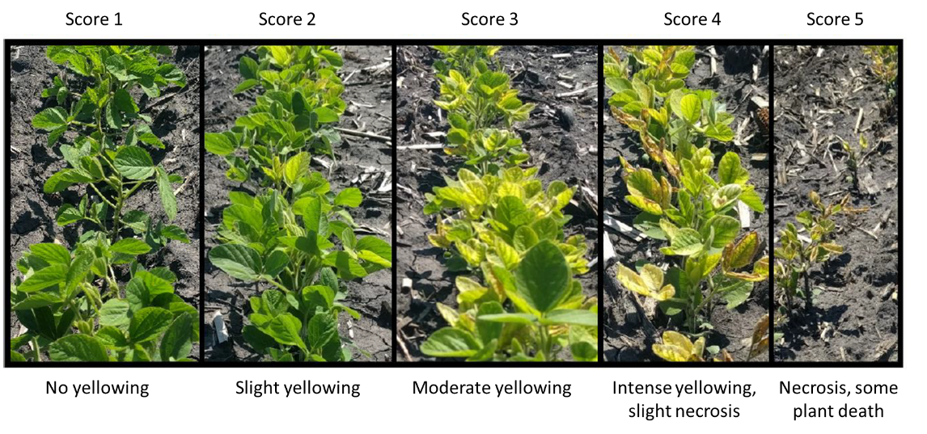
Supplemental Figure 1. Severity rating protocol for visual chlorosis scoring. Visual scores were based on a 1-5 scale. A score of one is given to plots showing no signs of yellowing, a score of two is given to plots with slight yellowing, a score of three is given to plots with moderate yellowing, a score of four is given to plots with intense yellowing and some necrosis, and a score of five is given to plots with severe necrosis and some plant death.

Supplemental Table 2. IDC application treatment effect on yield, RF, P, O, P+O
Treatment |  | Yield (kg/ha | SCN reproduction | Protein (db) | Oil | P+O
 | Environment 1
Soygreen |  | 3846.3 a | 9.24 a | 36.7 b | 21.5 a | 58.3 b
Control |  | 3787.2 a | 8.59 a | 37.0 b | 21.6 a | 58.6 b
Urea |  | 3642.2 a | 9.08 a | 37.6 a | 21.5 a | 59.1 a
P>F |  | 0.264 | 0.95 | <0.0001 | 0.0814 | 0.0002
 | Environment 2
Soygreen |  | 4554.5 a | 5.31 a | 37.5 ab | 21.5 a | 59.0 b
Control |  | 4462 a | 5.93 a | 37.4 b | 21.6 a | 59.0 b
Urea |  | 3741.4 b | 4.54 a | 37.9 a | 21.6 a | 59.4 a
P>F |  | <0.0001 | 0.32 | 0.0204 | 0.65 | 0.0029
 | Environment 3
Soygreen |  | 3824.6 a | 9.75 a | 40.2 b | 20.9 a | 61.1 b
Control |  | 3797.5 a | 10.92 a | 40.3 b | 20.9 a | 61.2 ab
Urea |  | 3742.9 a | 13.7 a | 40.7 a | 20.8 a | 61.5 a
P>F |  | 0.8 | 0.08 | 0.0071 | 0.66 | 0.0082
 | Environment 4
Soygreen |  | 4309.9 a | 1.78 a | 38.1 a | 21.8 a | 59.9 a
Control |  | 3389.7 b | 1.49 a | 35.6 a | 20.6 a | 56.2 a
Urea |  | 3200.4 b | 1.31 a | 36.1 a | 20.3 a | 56.4 a
P>F |  | 0.0005 | 0.087 | 0.36 | 0.29 | 0.34
 | Environment 5
Soygreen |  | 4643.4 a | 4.44 a | 37.7 b | 21.5 a | 59.2 b
Control |  | 4008.0 b | 4.35 a | 37.8 b | 21.3 a | 59.1 b
Urea |  | 3741.1 b | 2.30 a | 38.6 a | 21.2 a | 59.8 a
P>F |  | 0.001 | 0.031 | 0.0005 | 0.15 | <0.0001
 | Environment 6
Soygreen |  | 4428.8 a | 2.96 a | 37.2 a | 21.0 a | 58.2 a
Control |  | 3493.4 b | 2.94 a | 39.0 a | 21.5 a | 60.5 a
Urea |  | 2060.3 c | 2.23 a | 32.1 b | 17.3 b | 49.4 b
P>F |  | <0.0001 | 0.37 | 0.0043 | 0.0004 | <.0001
 | Environment 7
Soygreen |  | 2847.1 a | 2.94 a | 38.0 b | 21.3 a | 59.3 ab
Control |  | 2746.4 a | 3.02 a | 37.9 b | 21.2 ab | 59.1 b
Urea |  | 1977.0 b | 2.23 a | 38.6 a | 20.9 b | 59.6 a
P>F |  | <0.0001 | 0.066 | <0.0001 | 0.012 | 0.031
 | Environment 8
Soygreen |  | 3700.7 a | 1.06 a | 37.8 b | 20.8 a | 58.6 ab
Control |  | 3607.1 ab | 1.05 a | 37.8 b | 21.0 a | 58.8 a
Urea |  | 3358.3 b | 0.93 a | 38.4 a | 20.7 a | 59.2 b
P>F |  | 0.0067 | 0.43 | <0.0001 | 0.083 | 0.0004
 | Environment 9
Soygreen |  | 3840.1 a | 1.04 a | 38.4 a | 21.0 a | 59.5 a
Control |  | 3807.0 a | 0.88 a | 38.4 a | 21.1 a | 59.5 ab
Urea |  | 3714.1 a | 1.23 a | 38.1 b | 21.1 a | 59.2 b
P>F |  | 0.58 | 0.19 | 0.008 | 0.82 | 0.023

Supplemental Table 3. SCN treatment effect on yield, RF, P, O, P+O
Treatment |  |  | Yield (kg/ha | SCN reproduction |  |  | Protein (db) |  |  | Oil | P+O
 |  | Environment 1
Peking + Ilevo |  |  | 3726.2 a | 3.47 c |  |  | 36.4 b |  |  | 21.9 a | 58.4 b
Peking |  |  | 3776.6 a | 3.26 c |  |  | 36.3 b |  |  | 21.8 a | 58.2 b
PI 88788 |  |  | 3679.7 a | 10.1 b |  |  | 37.7 a |  |  | 21.3 b | 59.0 a
Susceptible |  |  | 3851.7 a | 19.0 a |  |  | 38.1 a |  |  | 21.0 c | 59.2 a
P>F |  |  | 0.68 | <0.0001 |  |  | <0.0001 |  |  | <0.0001 | <0.0001
 |  | Environment 2
Peking + Ilevo |  |  | 4476.0 a | 1.73 c |  |  | 37.2 b |  |  | 21.9 a | 59.1 a
Peking |  |  | 4227.2 a | 2.60 c |  |  | 37.0 b |  |  | 21.9 a | 59.0 a
PI 88788 |  |  | 4126.9 a | 5.68 b |  |  | 38.1 a |  |  | 21.3 b | 59.4 a
Susceptible |  |  | 4180.4 a | 11.0 a |  |  | 38.0 a |  |  | 21.0 c | 59.0 a
P>F |  |  | 0.28 | <0.0001 |  |  | <0.0001 |  |  | <0.0001 | 0.066
 |  | Environment 3
Peking + Ilevo |  |  | 4601.0 a | 3.74 c |  |  | 39.1 b |  |  | 21.4 a | 60.5 b
Peking |  |  | 4384.4 a | 4.13 c |  |  | 39.2 b |  |  | 21.4 a | 60.6 b
PI 88788 |  |  | 3592.6 b | 15.7 b |  |  | 41.7 a |  |  | 20.3 b | 62.1 a
Susceptible |  |  | 2575.4 c | 22.3 a |  |  | 41.3 a |  |  | 20.3 b | 61.7 a
P>F |  |  | <0.0001 | <0.0001 |  |  | <0.0001 |  |  | <0.0001 | <0.0001
 |  | Environment 4
Peking + Ilevo |  |  | 3693.5 ab | 1.11 b |  |  | 36.1 a |  |  | 21.2 ab | 57.3 a
Peking |  |  | 3656.8 ab | 1.35 b |  |  | 37.7 a |  |  | 22.2 a | 59.9 a
PI 88788 |  |  | 4134.8 a | 1.15 b |  |  | 38.9 a |  |  | 21.5 ab | 60.4 a
Susceptible |  |  | 3048.5 b | 2.50 a |  |  | 33.6 a |  |  | 18.7 b | 52.2 a
P>F |  |  | 0.0179 | <0.0001 |  |  | 0.073 |  |  | 0.015 | 0.052
 |  | Environment 5
Peking + Ilevo |  |  | 4494.7 a | 0.508 b |  |  | 37.0 b |  |  | 22.0 a | 59.0 bc
Peking |  |  | 4017.6 ab | 0.326 b |  |  | 37.3 b |  |  | 21.6 a | 58.9 c
PI 88788 |  |  | 4432.4 a | 1.60 b |  |  | 39.2 a |  |  | 20.9 b | 60.2 a
Susceptible |  |  | 3578.7 b | 12.4 a |  |  | 38.5 a |  |  | 20.8 b | 59.3 b
P>F |  |  | 0.0042 | <0.0001 |  |  | <0.0001 |  |  | <0.0001 | <0.0001
 |  | Environment 6
Peking + Ilevo |  |  | 3473.7 a | 0.49 b |  |  | 36.3 ab |  |  | 21.1 a | 57.5 a
Peking |  |  | 3141.5 a | 0.51 b |  |  | 35.0 ab |  |  | 20.0 ab | 55.0 a
PI 88788 |  |  | 3152.1 a | 1.71 b |  |  | 33.2 b |  |  | 17.7 b | 50.9 a
Susceptible |  |  | 3542.6 a | 8.13 a |  |  | 39.7 a |  |  | 20.8 ab | 60.5 a
P>F |  |  | 0.27 | <0.0001 |  |  | 0.063 |  |  | 0.037 | 0.072
 |  | Environment 7
Peking + Ilevo |  |  | 2652.3 a | 1.26 bc |  |  | 37.8 b |  |  | 21.4 a | 59.2 b
Peking |  |  | 2425.6 a | 1.08 c |  |  | 37.9 b |  |  | 21.3 a | 59.2 b
PI 88788 |  |  | 2636.4 a | 2.32 b |  |  | 39.1 a |  |  | 20.9 b | 60.0 a
Susceptible |  |  | 2379.9 a | 6.25 a |  |  | 37.9 b |  |  | 20.9 b | 58.9 b
P>F |  |  | 0.043 | <0.0001 |  |  | <0.0001 |  |  | 0.0005 | <0.0001
 |  | Environment 8
Peking + Ilevo |  |  | 3769.2 a | 0.33 c |  |  | 37.5 c |  |  | 21.1 a | 58.7 b
Peking |  |  | 3608.2 a | 0.44 c |  |  | 37.6 c |  |  | 21.1 a | 58.7 b
PI 88788 |  |  | 3655.0 a | 1.39 b |  |  | 38.7 a |  |  | 20.6 b | 59.3 a
Susceptible |  |  | 3189.0 b | 1.89 a |  |  | 38.1 b |  |  | 20.6 b | 58.7 b
P>F |  |  | <0.0001 | <0.0001 |  |  | <0.0001 |  |  | <0.0001 | <0.0001
 |  | Environment 9
Peking + Ilevo |  |  | 3871.4 a | 0.40 c |  |  | 37.4 c |  |  | 21.6 a | 58.9 c
Peking |  |  | 3762.7 a | 0.38 c |  |  | 37.9 b |  |  | 21.4 a | 59.4 b
PI 88788 |  |  | 3810.0 a | 1.31 b |  |  | 38.9 a |  |  | 20.8 b | 59.8 a
Susceptible |  |  | 3704.2 a | 2.10 a |  |  | 38.9 a |  |  | 20.4 c | 59.3 b
P>F |  |  | 0.7 | <0.0001 |  |  | <0.0001 |  |  | <0.0001 | <0.0001
Supplemental table 4. Yield differences between Peking and Susceptible along with initial SCN egg counts.
Environment | Nematodes (eggs/100CC) |  |  |  | Peking yield | Susc. Yield |  | Dif
1 | 422 |  |  |  | 3776.6 | 3851.7 |  | -75.1
5 | 756 |  |  |  | 4017.6 | 3578.7 |  | 438.9
7 | 935 |  |  |  | 2425.6 | 2379.9 |  | 45.7
6 | 1269 |  |  |  | 3473.7 | 3542.6 |  | -68.9
3 | 1619 |  |  |  | 4384.4 | 2575.4 |  | 1809
2 | 1700 |  |  |  | 4227.2 | 4180.4 |  | 46.8
4 | 2169 |  |  |  | 3656.8 | 3048.5 |  | 608.3
9 | 3338 |  |  |  | 3762.7 | 3704.2 |  | 58.5
8 | 4753 |  |  |  | 3608.2 | 3189 |  | 419.2

Figures
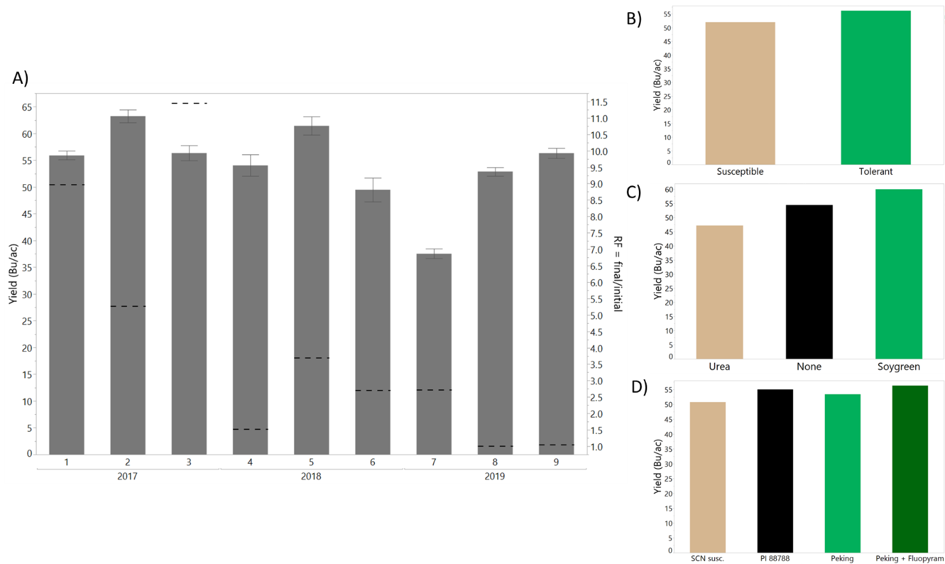
Figure 1. A) Yield (left) and initial nematode egg counts (right) across 9 environments. The mean yield (kg/ha) is represented by bars with corresponding standard error bars. The dashed line for each environment is the initial soybean cyst nematode (SCN) egg count from soil collected in the spring. B) Yield by IDC tolerance classes of tolerant and susceptible averaged across all environments. C) Yield by IDC application treatments of urea, no application, and Soygreen averaged across all environments. D) Yield by SCN treatment of SCN susceptible, Peking resistance, PI 88788 resistance, and Peking resistance plus Ilevo treatment.
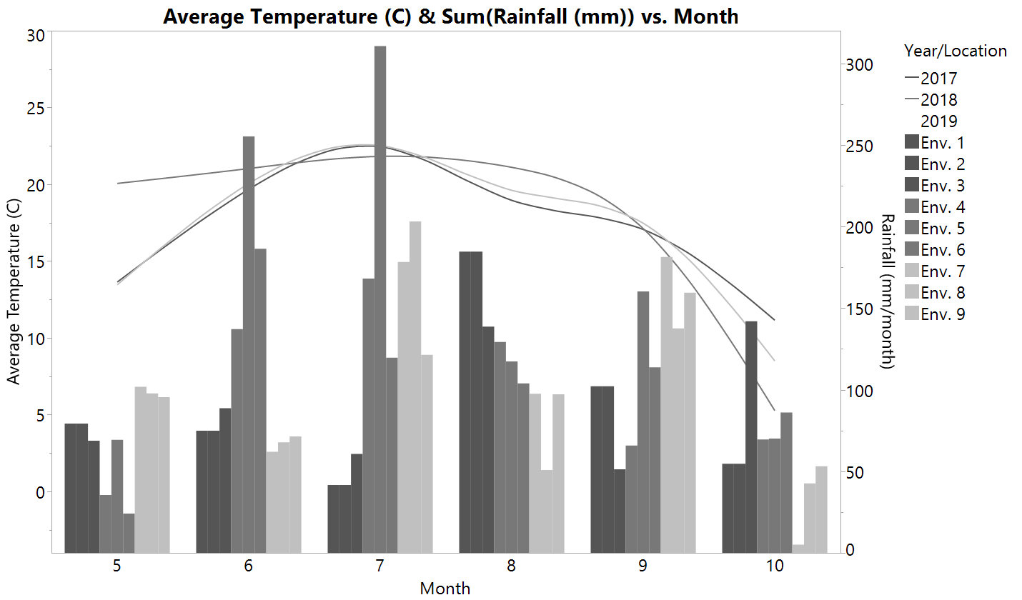
Figure 2. Rainfall and daily average temperatures for nine environments. Rainfall is represented as a sum of daily rainfall for each month (May – October, 5-10) for each of the nine environments signified by the bar charts. Daily mean temperature is represented for each of the three years as a smooth line fit across the same time period.

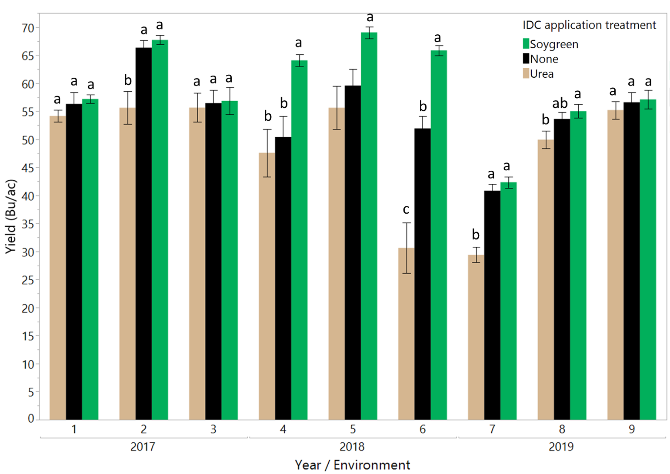
Figure 3. Yield differences by IDC application treatment across 9 environments. The three treatments of urea, no application, and Soygreen.

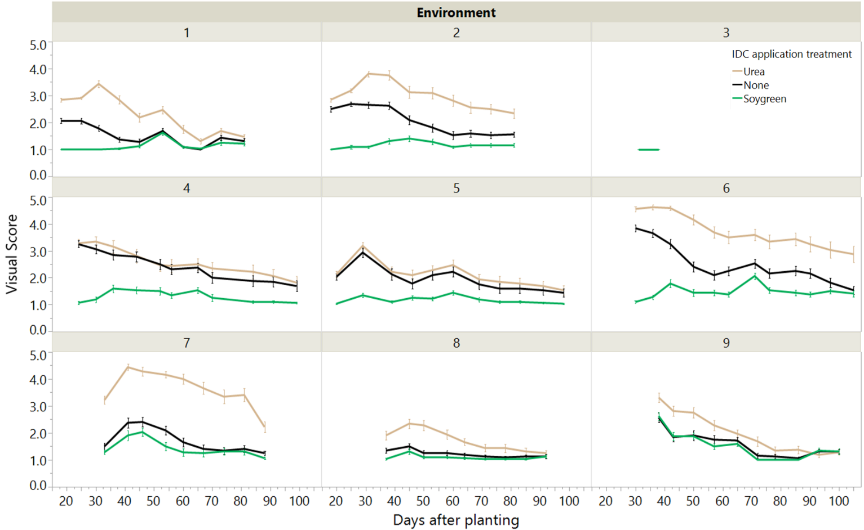
Figure 4. Visual score differences across 10 weeks of data collection. Urea, Soygreen, and a no application control were added on the furrow at planting to test for differences in the severity of iron deficiency chlorosis. Severity was rated using a 1-5 visual score across 10 weeks of data collection.

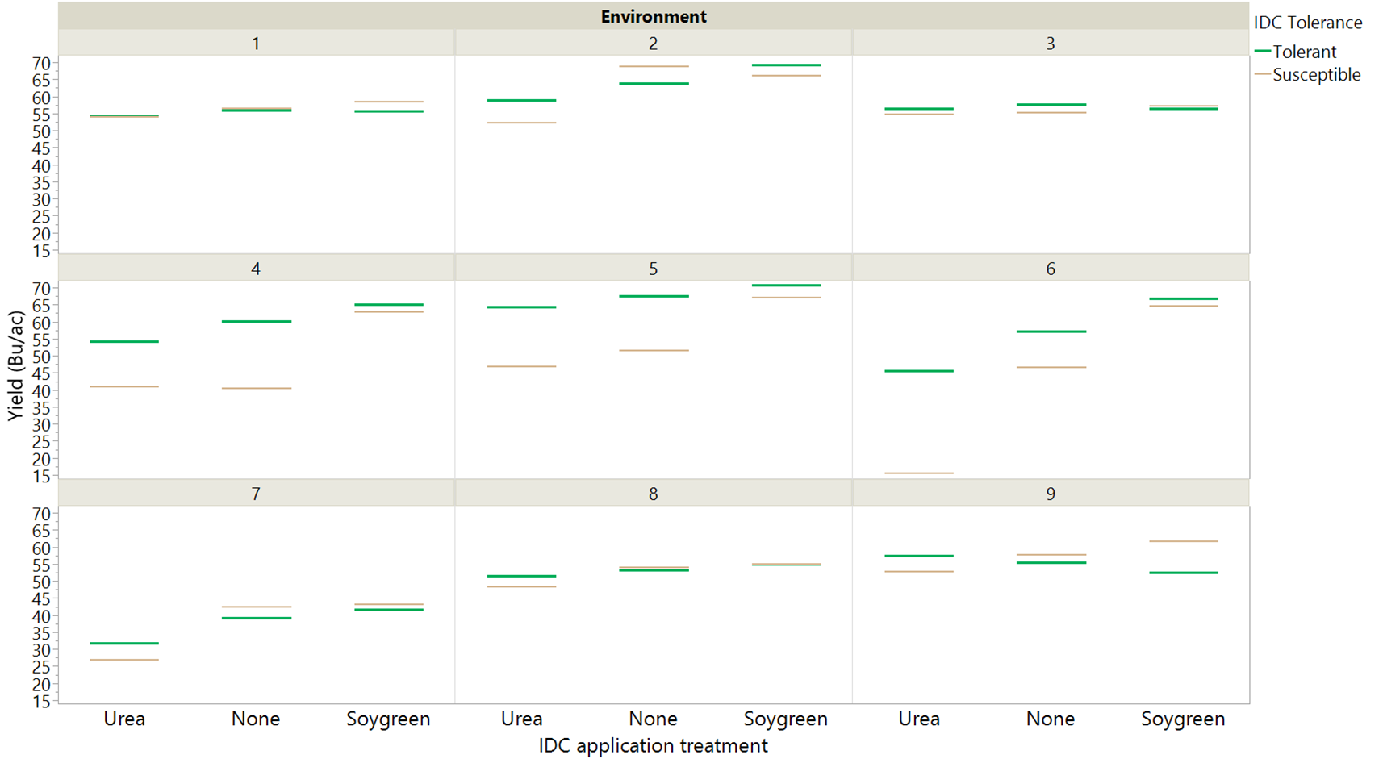
Figure 5. Iron deficiency chlorosis (IDC) genetic tolerance to IDC impact on yield.

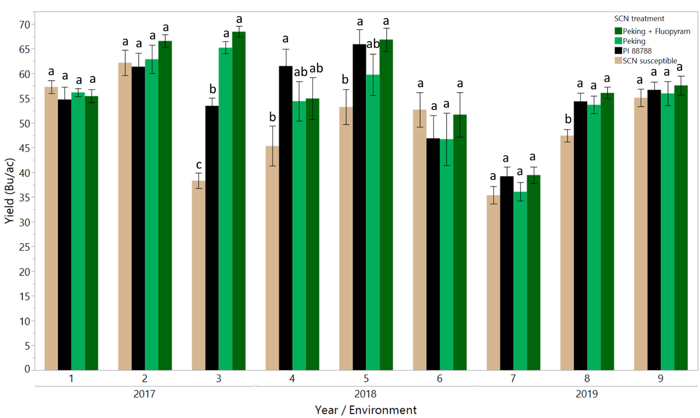
Figure 6. Yield differences by SCN treatment.

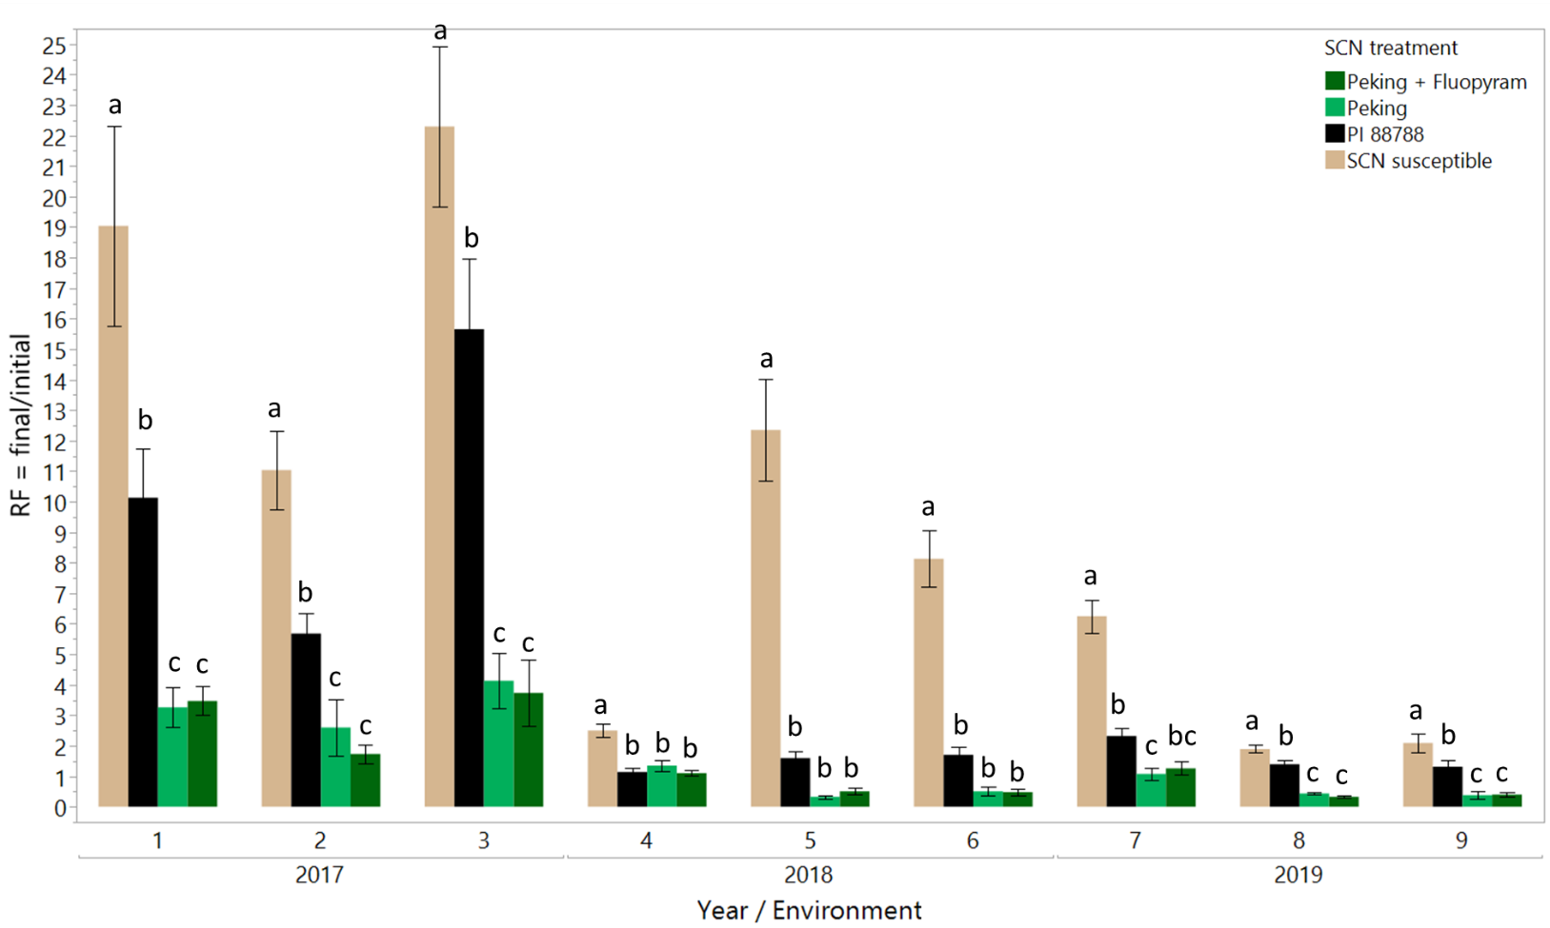
Figure 7. Reproduction factor differences by SCN treatment.

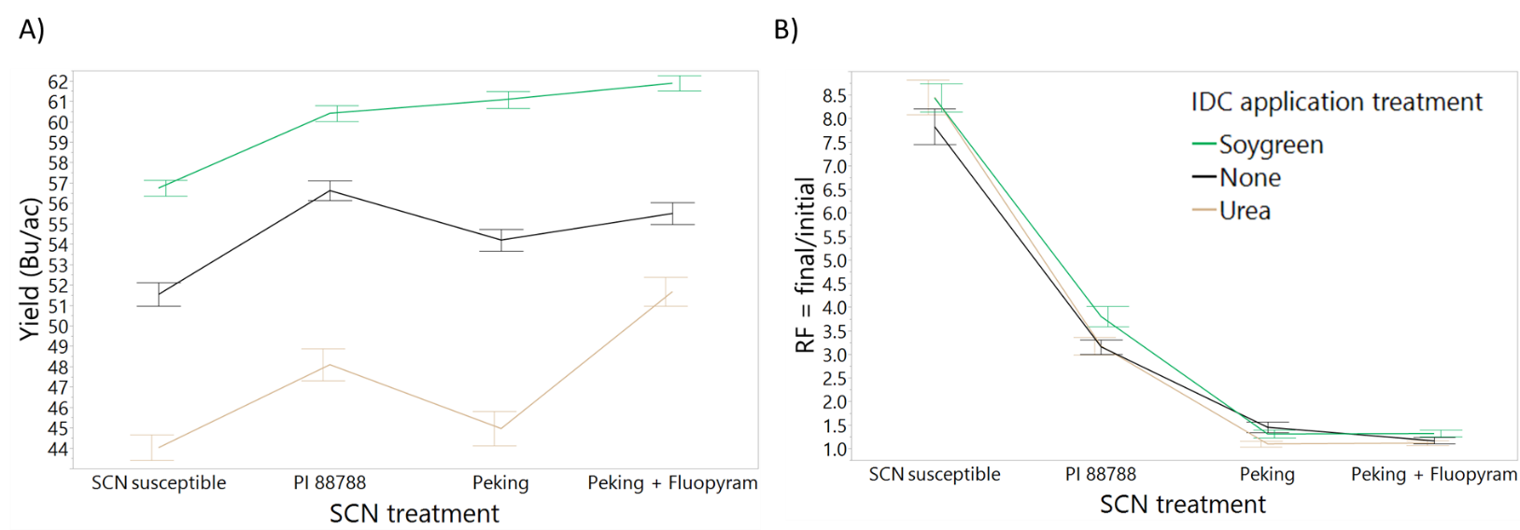
Figure 8. IDC and SCN interaction on yield and reproduction factor.

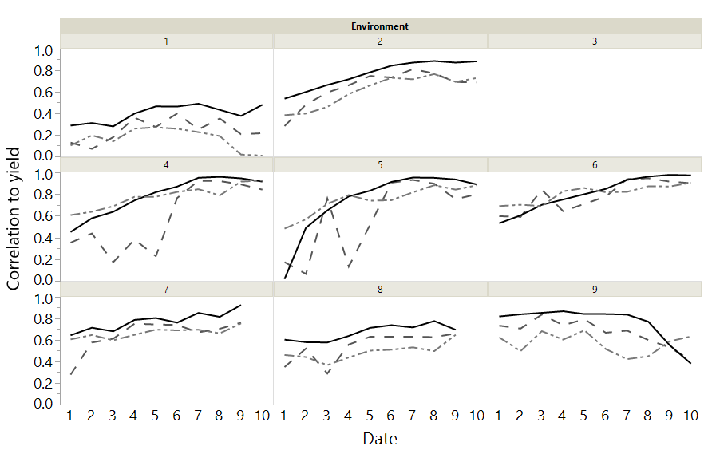
Figure 9. Correlations between UAS data, Crop Circle data, and Visual score data to yield across time in each environment.

Tables
Table 1. Cultivar descriptions. A total of six cultivars were used in this study. Iron deficiency chlorosis (IDC) tolerance, soybean cyst nematode (SCN) resistance, and maturity group data was provided by the seed company.
Cultivar | Seed Company | IDC Tolerance Rating | IDC Tolerance Class | SCN Resistance | Maturity Group
S14-J7 | Syngenta | 2 | Tolerant | Susceptible | 1.4
PB-1611R2 | Prairiebrand | 5 | Susceptible | Susceptible | 1.6
AG1733 | Asgrow | 2 | Tolerant | PI 88788 | 1.7
AG14X7 | Asgrow | 5 | Susceptible | PI 88788 | 1.4
NuTech 7169 | NuTech seed | 4 | Tolerant | Peking | 1.6
NuTech 7186 | NuTech seed | 6 | Susceptible | Peking | 1.8

Table 2. Soil chemical properties and SCN beginning of season counts. A total of nine environments were used in this study distributed throughout 6 different counties in Minnesota. The soils series and taxonomic class information of each field was collected using the Web soil survey. Soil pH, available nutrients, electrical conductivity, calcium carbonate equivalent, and organic matter were analyzed in a soil testing lab. Nematode egg counts per 100 CC of soil reported below consist of the average of four replications of initial season egg counts at each of the nine environments. Soil samples were also analyzed for HG type using Peking and PI 88788 indicator lines. The female index (FI) was calculated by dividing the mean number of females that developed on an indicator line by the mean number of females on the susceptible check multiplied by 100.
Environment | County in Minnesota: | Soil Series: | Taxonomic class: | Planting Date | pH | Fe (mg/kg soil) | EC (mmhos/cm) | CCE (%) | OM | Olsen-P (mg/kg soil) | K (mg/kg soil) | Mn (mg/kg soil) | Zn (mg/kg soil) | Cu (mg/kg soil) | Nematodes (eggs/100CC) | Peking FI (±) | PI 88788 FI (*, ±)
1 | Swift | Quam silty clay loam | Fine-silty | 06/02/17 | 7.9 | 8.1 | 0.5 | NA | 6.8 | 16 | 189 | 5.5 | 1.3 | 1.4 | 422 | 1.7 | 18.7*
2 | Swift | Bearden-Quam | Fine-silty | 06/02/17 | 7.7 | 7.8 | 1.4 | NA | 4.9 | 25 | 432 | 10.6 | 4.9 | 1.6 | 1,700 | 3.9 | 6.3
3 | Redwood | Normania loam | Fine-loamy | 05/16/17 | 7.1 | 35.3 | 0.5 | NA | 5.6 | NA | 228 | 21.5 | 2.9 | 1.1 | 1,619 | 14.8± | 13.6±
4 | Swift | Bearden-Quam | Fine-silty | 05/22/18 | 7.7 | 8.5 | 1.0 | 7.53 | 6.1 | 7 | 360 | 9.5 | 4.2 | 1.1 | 2,169 | 3.9 | 10.9*
5 | Renville | Harps clay loam | Fine-loamy | 05/24/18 | 7.8 | 9.3 | 1.3 | 14.33 | 6.1 | 16.5 | 181 | 10.1 | 2.5 | 1.4 | 756 | 0.6 | 8.4
6 | Chippewa | Bearden-Quam | Fine-silty | 05/16/18 | 7.7 | 8.5 | 1.4 | 8.41 | 7.4 | 20 | 288 | 8.6 | 2.7 | 1.5 | 1,269 | 2.1 | 22.7*
7 | Redwood | Canisteo | Fine-loamy | 06/08/19 | 7.7 | 11.53 | 2.3 | 13.59 | 5.4 | NA | 254 | 5.49 | 3.58 | 1.16 | 935 | 6.2 | 16.5*
8 | Yellow Medicine | Canisteo | Fine-loamy | 06/04/19 | 7.6 | 15.59 | 2.1 | 5.4 | 4.4 | NA | 267 | 3.25 | 5.06 | 1.11 | 4,753 | 1.9 | 58.5*
9 | Swift | Bearden-Quam | Fine-silty | 06/02/19 | 7.7 | 12.64 | 1.2 | 2.65 | 4.1 | 15 | 227 | 4.67 | 6.28 | 1.16 | 3,338 | 2.6 | 16.5*
* = female index greater than 10 on PI 88788, HG type 2
± = female index greater than 10 on both Peking and PI 88788, HG type 1.2

Table 3. Yield differences across 9 environments.
 | Environment
Source: | 1 | 2 | 3 | 4 | 5 | 6 | 7 | 8 | 9
IDC application treatment | NS | *** | NS | *** | *** | *** | *** | ** | NS
IDC Tolerance | NS | NS | NS | *** | *** | *** | NS | NS | NS
IDC application treatment*IDC Tolerance | NS | NS | NS | NS | NS | *** | * | NS | ***
SCN treatment | NS | NS | *** | * | *** | NS | * | *** | NS
IDC application treatment*SCN treatment | NS | NS | NS | NS | NS | NS | NS | NS | NS
IDC Tolerance*SCN treatment | *** | * | NS | NS | NS | ** | NS | ** | *
IDC application treatment*IDC Tolerance*SCN treatment | NS | NS | NS | NS | NS | NS | NS | NS | NS
*= significant at p < 0.05
**= significant at p<0.01
***=significant at p<0.001

Table 4. Reproduction Factor differences across 9 environments.
 | Environment
Source: | 1 | 2 | 3 | 4 | 5 | 6 | 7 | 8 | 9
IDC application treatment | NS | NS | NS | NS | * | NS | NS | NS | NS
IDC Tolerance | NS | NS | NS | NS | NS | NS | NS | NS | *
IDC application treatment*IDC Tolerance | NS | NS | NS | NS | NS | NS | NS | NS | NS
SCN treatment | *** | *** | *** | *** | *** | *** | *** | *** | ***
IDC application treatment*SCN treatment | NS | NS | NS | NS | *** | NS | NS | NS | NS
IDC Tolerance*SCN treatment | NS | NS | NS | NS | NS | * | NS | NS | NS
IDC application treatment*IDC Tolerance*SCN treatment | NS | NS | NS | NS | NS | NS | NS | NS | NS
*= significant at p < 0.05
**= significant at p<0.01
***=significant at p<0.001

Table 5. Slope coefficient for yield by visual severity score across ten dates and nine environments, reported in kg/ha. For every one point increase in visual severity score, there was, on average, a corresponding point decrease in yield in kg/ha.
 | Environment
Date: | 1 | 2 | 3 | 4 | 5 | 6 | 7 | 8 | 9 | Average:
1 | -65 | -348 | - | -654 | -738 | -642 | -322 | -344 | -400 | -390
2 | -119 | -327 | - | -660 | -577 | -674 | -266 | -272 | -305 | -356
3 | -65 | -301 | - | -727 | -780 | -729 | -261 | -223 | -427 | -439
4 | -140 | -367 | - | -822 | -950 | -826 | -275 | -302 | -433 | -514
5 | -179 | -451 | - | -911 | -881 | -931 | -272 | -468 | -607 | -588
6 | -185 | -503 | - | -932 | -838 | -925 | -279 | -492 | -464 | -577
7 | -194 | -511 | - | -1072 | -966 | -1058 | -297 | -494 | -472 | -633
8 | -249 | -608 | - | -902 | -1059 | -988 | -280 | -536 | -546 | -646
9 | -18 | -616 | - | -1066 | -1047 | -971 | -528 | -758 | -722 | -716
10 | -9 | -706 | - | -1112 | -1195 | -992 | -- | -- | -796 | -802

