Project Number: | #2020-162-0126
Project Title: | Development and Commercialization of Advanced High Oleic Varieties for Michigan
Organization: | Michigan State University
Principal Investigator Name: | Dr. Dechun Wang
National Soybean Checkoff Research Database https://www.soybeanresearchdata.com/ (public website funded by USB). Please include a non-technical summary along with your project status. The non-technical summary will be published to the website. If a non-technical summary is not provided, the contents of this entire report will be published.

Project Status - What key activities were undertaken and what were the key accomplishments during the life of this project? Please use this field to clearly and concisely report on project progress. The information included should reflect quantifiable results (expand upon the KPIs) that can be used to evaluate and measure project success. Technical reports, no longer than 4 pages, may be included in this section.
During this fiscal year, over 50,000 F2 progeny seeds derived from crosses of non-GMO high oleic parents with high yielding parents were tested for oleic contents with NIRS and over 10,000 progeny seeds were selected and planted in the greenhouse. Over 10,000 F3 or F4 progeny plants were grown in the greenhouses in the 2019-2020 winter and samples of the seeds from these plants were analyzed using gas chromatography and KASP DNA markers associated with resistance to SCN and phytophthora root rot. Over 1,500 F4 or F5 progeny plants were selected with the desired oleic, linolenic, and saturated fatty acid composition and disease resistance marker genotypes. These selected lines were evaluated in the field in plant-row plots in 2020.

From the 2019 preliminary yield trials and advanced yield trial, 53 high oleic lines were tested with five commercial yield checks in an advanced yield trial at six locations. Based on the data from four locations harvested prior to this report, five high oleic lines yielded over 90% of the check mean, with the highest at 98% of the check mean and these lines were not statistically different in yield from the highest yield check (see the table below). The highest yielding high oleic line E19689 also appears agronomically attractive (see the picture following the table).
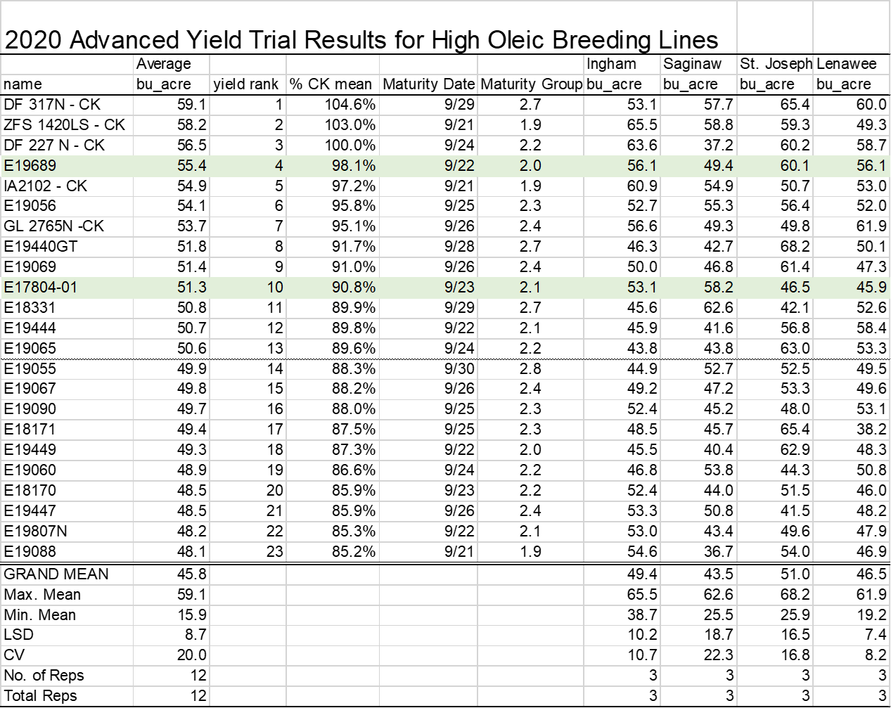
Note: data for only the top 23 entries are shown; the highlighted lines are the highest yield high oleic lines in 2020 (E19689) or in the past (E17804-1) in the trials.

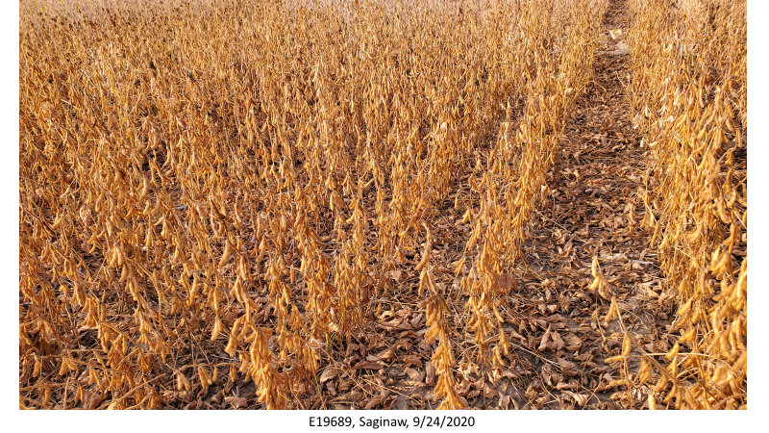

One hundred thirty high oleic lines were tested in preliminary yield trials at three locations. Two of the three locations were harvested prior to this report.

Based on 2019 advanced yield trial data, ZFS has chosen one high oleic line E17804-1 for seed increase in 2020 for commercial production. Three hundred pounds of breeder seeds were planted by a seed production company in 2020 to produce seeds for commercial production in 2021. ZFS has also chosen five new high oleic line for potential commercialization depending on 2020 advanced yield trial data. Seeds of these five lines were increased in the field in 2020 to be used as breeder seeds of potential commercial increases in 2021.

Did this project meet the intended Key Performance Indicators (KPIs)? List each KPI and describe progress made (or not made) toward addressing it, including metrics where appropriate.
•1 or 2 high yielding, non-GMO, high oleic MSU germplasm lines (MG II and/or MG III) will be ready for commercial production through ZFS by 2020
We complete this KPI. ZFS has chosen one high oleic line for seed increase in 2020 for commercial production.

•Five non-GMO, high oleic MSU lines will be tested in 2020 commercial variety trials.
We complete this KPI. ZFS has also chosen five new non-GMO, high oleic MSU lines for testing potential commercialization.

•Over 250 additional non-GMO, high oleic lines will be tested in various pre-commercial yield trials in 2020
This KPI was exceeded. We conducted over 1,000 non-GMO, high oleic lines in various pre-commercial yield trials in 2020.

Expected Outputs/Deliverables - List each deliverable identified in the project, indicate whether or not it was supplied and if not supplied, please provide an explanation as to why.
•1 or 2 high yielding, non-GMO, high oleic MSU germplasm lines (MG II and/or MG III) will be ready for commercial production through ZFS by 2020
ZFS had a pilot commercial production of one MSU high oleic soybean variety by 10 growers in 2019. Due to contamination with GMO seeds in the winter nursery in Argentina, the seeds from 2019 production were not used in 2020. Instead, ZFS decided to increase the seed domestically in the 2020 summer using 300 lbs of pure breeder seeds from MSU.

•Five non-GMO, high oleic MSU lines will be tested in 2020 commercial variety trials
Four non-GMO, high oleic MSU lines have been testing for potential commercialization in 2020. The report will be published online https://varietytrials.msu.edu/soybean/.

•Over 250 additional non-GMO, high oleic lines will be tested in various pre-commercial yield trials in 2020
This deliverable was exceeded. The total sum of single row yield plots, preliminary yield trial, advanced yield trials, and commercial yield trials exceeds this metric.

Describe any unforeseen events or circumstances that may have affected project timeline, costs, or deliverables (if applicable.)
N/A

What, if any, follow-up steps are required to capture benefits for all US soybean farmers? Describe in a few sentences how the results of this project will be or should be used.

Michigan State University and Zeeland Farm Services will build a licensing agreement for specific non-GMO, high oleic soybean varieties developed through this grant. Once the varieties are licensed from MSU, ZFS will be able to contract farmers to grow these varieties and purchase the grain with bushel premiums for the non-GMO, high oleic traits. Further funding can be used to continue developing improved non-GMO, high oleic soybean varieties, as well as speeding up commercialization through winter seed increases.
List any relevant performance metrics not captured in KPI’s.
N/A
Non-technical summary:

