 | Project Number: | 2020-172-0150
 | Project Title: | Developing and Disseminating a Comprehensive and Sustainable  Management Program for Foliar Diseases of Soybean
 | Organization: | Southern Illinois University Carbondale
 | Principal Investigator Name: | Ahmad M. Fakhoury
 | National Soybean Checkoff Research Database https://www.soybeanresearchdata.com/ (public website funded by USB). Please include a non-technical summary along with your project status. The non-technical summary will be published to the website. If a non-technical summary is not provided, the contents of this entire report will be published.
 | Project Status - What key activities were undertaken and what were the key accomplishments during the life of this project? Please use this field to clearly and concisely report on project progress. The information included should reflect quantifiable results (expand upon the KPIs) that can be used to evaluate and measure project success. Technical reports, no longer than 4 pages, may be included in this section.
The goal of this six-state program is to develop cost-effective and sustainable management options for major foliar diseases of soybean. This will be accomplished by gaining a better understanding of the biology of foliar diseases to optimize disease management strategies, identify disease-resistant varieties, and assist in the development of resistant germplasm. These efforts will provide immediate-term benefits and long-term solutions to minimize the risks of soybean foliar pathogens and to help ameliorate the 10–15% of yield losses caused by any one of the major foliar diseases. The specific objectives are: 1-Characterize Cercospora sojina and Cercospora flagellaris population diversity and race structure; 2-Conduct extensive monitoring for fungicide-resistant strains of C. sojina, C. flagellaris, and Septoria glycines as well as develop and adapt fungicide application strategies accordingly; 3-Study the impact of fungicide application on pod and seed diseases and its effect on the associated fungal community; 4-Identify sources of resistance and develop resistant varieties and elite germplasm for C. sojina; 5-Determine the effect of soybean vein necrosis virus (SVNV) on plant productivity and evaluate soybean germplasm for resistance to SVNV and thrips; and 6-Integrate research results and communicate disease management recommendations to farmers and stakeholders.

Following are key activities as well as key accomplishments listed by objective:

Objective 1 - Characterize Cercospora sojina and Cercospora flagellaris population diversity and race structure –

- Cercospora leaf blight (CLB) was historically thought to be caused exclusively by Cercospora kikuchii in the U.S. From a collection of >700 pathogen isolates from 10 soybean-producing states, we found that C. flagellaris is the predominant pathogen associated with CLB in the U.S., followed by C. sigesbeckiae. This finding is crucial to identify genetic resistance to CLB.
- Comparative genomics of 25 C. flagellaris isolates collected from 10 different states revealed at least four distinct genetic lineages of the pathogen in the U.S. Differences among these four lineages indicated possible signatures of interspecific hybridization. This suggests that C. flagellaris arose from crosses between distinct species of fungal pathogens, which provides it an evolutionary ‘shortcut’ to overcome host resistance.
- Unlike many foliar soybean pathogens, C. flagellaris was found to have a broad host range among dicots, including many weed species associated with soybean production. Additionally, a molecular marker closely associated with resistance to strobilurin fungicides was common among C. flagellaris isolates, including samples collected from non-soybean hosts a considerable distance away from commercial soybean production fields.
- Based on survey data and comparative genomics, C. sigesbeckiae is less commonly associated with CLB than C. flagellaris and is also evolving more slowly.
- Regarding frogeye leaf spot (FLS), we used an association mapping approach to identify regions of the C. sojina genome that correlated with the pathogen’s race. This led to the discovery of two regions of the C. sojina genome that are strongly associated with different races.
- Rcs3 of soybean has provided durable resistance against all known races of C. sojina and is considered the ‘last bastion’ of host resistance to frogeye leaf spot. We have identified five naturally-occurring strains of C. sojina that are capable of infecting soybean cultivar Davis (the original source of Rcs3) at consistent, albeit low, levels.
- Significant progress was made to develop a C. cf. flagellaris - Arabidopsis thaliana pathosystem as a proxy for Cercospora leaf blight so that novel resistance genes (R-genes) can be screened rapidly. Utilizing A. thaliana as a proxy for soybean will help advance the fundamental understanding of molecular mechanisms underpinning CLB. Equally or even more importantly, this proxy pathosystem will save significant amounts of time and money when developing novel transgenic resistance for CLB.
Objective 2 - Conduct extensive monitoring for fungicide-resistant strains of C. sojina, C. flagellaris, and Septoria glycines and develop and adapt fungicide application strategies accordingly -

A uniform foliar fungicide trial was established to evaluate different fungicide products for their control of frogeye leaf spot across multiple states. This trial has been ongoing for multiple years now, and a preliminary meta-analysis has been conducted to: i) determine the most efficacious products for management of frogeye leaf spot; ii) determine if efficacy is declining across years; and iii) determine the probability of achieving a profitable yield return with a foliar fungicide application. The meta-analysis is continuing with additional data from new products; below are results from a preliminary analysis based on the currently available data.

A meta-analysis of 10 fungicide treatments (including the nontreated check) was conducted to determine efficacy against frogeye leaf spot. Data was collected from field trials from 8 states across multiple growing seasons. The preliminary analysis shows that the QoI fungicide, pyraclostrobin (PYRA), was not effective in reducing frogeye leaf spot severity compared to the check (Fig. 1)., but that when multiple fungicide active ingredients from different chemistry classes were applied, frogeye leaf spot severity decreased.
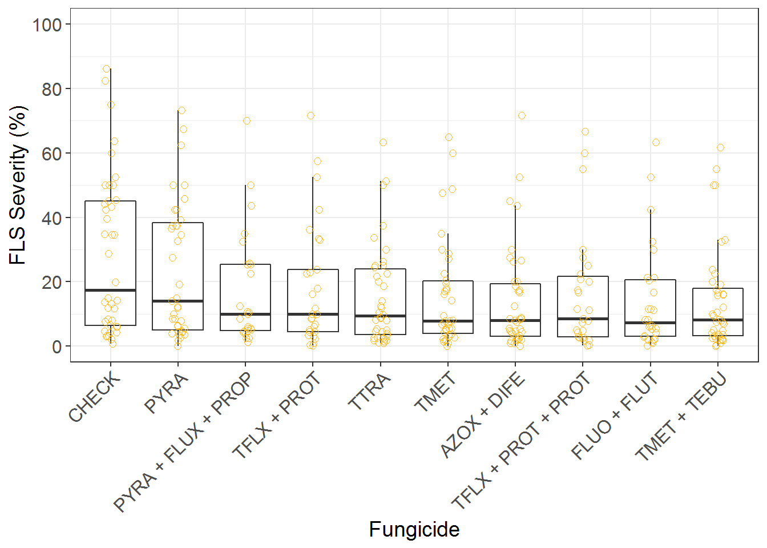
Fig. 1. Effect of different fungicide treatments on frogeye leaf spot severity. Data were collected from field trials conducted in 8 states across multiple growing seasons.

Through preliminary meta-analysis, we also evaluated the efficacy of 5 products over time from 2015 to 2019. This preliminary analysis showed that efficacy of triazole and benzimidazole fungicides are decreasing over time, which suggests that resistance to these chemistries may be building in C. sojina. This decline in efficacy was especially apparent in trials conducted in southern states.

A probability matrix was developed based on soybean price, fungicide and application costs, and yield response data from the field trials conducted. This matrix shows that there is a very low likelihood of a profitable yield response when applying pyraclostrobin alone (Fig. 2). However, the likelihood of a profitable application of tetraconazole or fluoaxostrobin + flutriafol occurred under some scenarios.

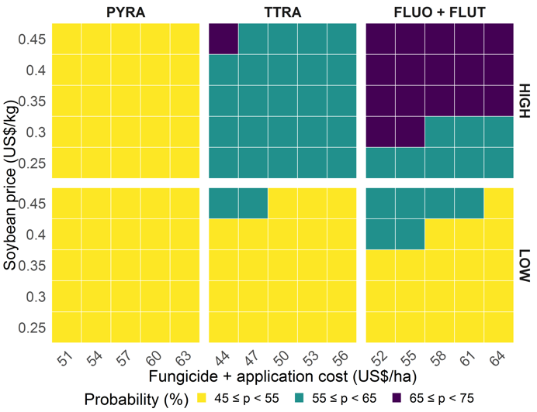
Fig. 2. Matrix showing the probability of a profitable fungicide application, based on soybean price, fungicide + application costs, and yield response data from field trials.

Isolates of C. sojina have been collected from multiple soybean-growing states, and thus far, QoI-resistant isolates have been confirmed in 19 states. Most recently, QoI-resistant C. sojina isolates were confirmed in Michigan, Minnesota, and Nebraska (Neves et al. 2020). Figure 3 shows the distribution of QoI-resistant C. sojina isolates detected. Note that some counties in Iowa have been confirmed in Dr. Daren Mueller’s lab, but this map has not yet been updated to reflect those additional Iowa counties.
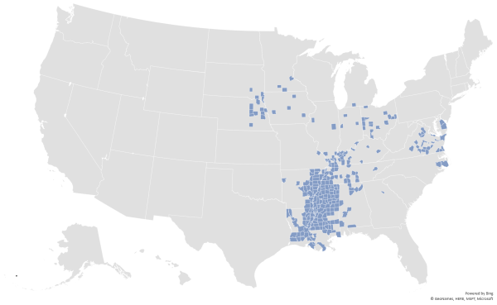
Fig. 3. Distribution of QoI-resistant Cercospora sojina isolates detected from 2010 to 2019. Note that additional surveys have indicated more counties in Iowa with QoI-resistant C. sojina isolates than what this map shows. In total, 19 states have been confirmed to have QoI-resistant C. sojina isolates.

In an effort to begin monitoring sensitivity of C. sojina isolates to SDHI fungicides, a baseline sensitivity to the SDHI fungicide pydiflumetofen was determined. To determine the baseline sensitivity, 89 C. sojina isolates that had never been exposed to SDHI fungicides were used to determine the effective concentration of pydiflumetofen that inhibited C. sojina by 50% (EC50). This baseline sensitivity will be used to determine if shifts in sensitivity are occurring in isolates collected from fields where SDHI fungicides have been sprayed.

Isolates of the Septoria brown spot pathogen, Septoria glycines, have been found to have resistance to QoI fungicides in Illinois, Iowa, Kentucky, and Tennessee. So far, isolates from 25 different counties in these states have been found to be resistant to QoI fungicides. Through DNA sequencing, we were able to determine that the mutation responsible for QoI fungicide resistance in these S. glycines isolates is the G143A mutation. PCR primers were developed that can be used as a diagnostic tool to determine the presence of the G143A mutation in S. glycines. Research is still being conducted to determine if QoI-resistant S. glycines isolates are present in other states.

Objective 3 - Study the impact of fungicide application on pod and seed diseases and its effect on associated fungal community -

In the past years, soybean growers experienced high levels of visual seed damage that led to significant penalties at the grain elevator. The seed damage was not limited to Arkansas, but it was observed in several soybean-producing states. IN 2018, high levels of damaged seed were observed in a regional Cercospora leaf blight cultivar test planted at Marianna and Kibler, AR. Besides rating these tests for foliar disease, seed samples were collected from each plot and assayed for visual seed damage and for seed infection. The infected seed plated showed high levels of infection by Phomopsis longicolla and Cercospora flagellaris. Seed infection by P. longicolla ranged from 0 to 46% and by C. flagellaris from 3 to 41% in Kibler. At Marianna, P. longicolla ranged from 9 to 76% and by C. flagellaris from 2 to 37%. There was also distinction between early and late maturity groups (ranging from 4.1 to 5.7), showing that total percentages of damaged seed, purple seed, seed infected by P. longicolla, and seed infected by C. flagellaris were greater in early than late maturity group cultivars.

Objective 4 - Identify sources of resistance and develop resistant varieties and elite germplasm for C. sojina -

In the past three years, the following was achieved in the Kantartzi’s lab:
- Thirty one advanced breeding lines were evaluated for resistance to C. sojina in four different environments (two years, two locations) and identified five resistant lines with high crop potential (SIU18-2935, SIU18-3125, SIU18-6442, SIU18-6513, and SIU18-6521).
- Three RIL populations having Forrest as a common susceptible parent were developed.
- An advanced breeding population (Forrest x SIU17-3131) was phenotyped and genotyped, revealing multiple lines with resistance to multiple C. sojina races.
- Two QTLs associated with resistance to C. sojina were identified through greenhouse phenotyping and genotyping with the Illumina BARCSoySNP6K Bead Chip.
- Two additional soybean populations (‘Saluki 4313’ x Forest and ‘Saluki 4910’x Forest) were advanced and assessed under field conditions during the summer.
- Efforts to develop new genetic combinations using lines developed by R. Mian and A. Mengistu (PI398989, PI416943, PI424488A, PI494851, and PI92710) as well as other plant introductions (PI471938, PI96169B, and PI96171) were successful (we obtained seed from three crosses between PI471938 and Saluki 4910 as well as from five crosses between PI494851 and Saluki 4910).

Objective 5 - Determine the effect of soybean vein necrosis virus (SVNV) on plant productivity and evaluate soybean germplasm for resistance to SVNV and thrips –

- Selected soybean genotypes were resistant to SVNV-infected and non-SVNV-infected thrips. Antixenosis resistance to thrips SVNV-infected and non-SVNV-infected for SVNV was detected in plant introductions (PIs) 171451, 229358, 423901-2, 572237 and 604464, while cultivars like Williamsfield Illini, Williams 82, and soybean a soybean breeding lines with Rag (Resistance to Aphis glycines) genes, were preferred by thrips. Results from treatments with SVNV-infected and non-SVNV-infected thrips were highly correlated (r = 0.704; P < 0.001).
- Soybean thrips decimate soybean plants. Seedlings of cv. Williamsfield Illini were infested with SVNV-infected thrips at growth stages V1 and V5 in insect-proof cages and compared to non-infested plants. At 4 weeks after infestation, most of the plants infested at growth stage V1 were dead, and plants infested at growth stage V5 were severely dwarfed compared to non-infested controls (Figures 4A-C).
- Soybean genotypes differ in response to SVNV. Soybean genotypes were infested with SVNV-infected thrips to detect resistance to SVNV. Systemic SVNV infections were detected in Williamsfield Illini, genotypes with Rag1/Rag2, Rag2 and PI 417136. Local SVNV infection was found only in PI 171451. Symptoms included chlorosis on inoculated leaves, rugosity and stunting compared to controls (Figure 4D-G). The systemic and local infection of the SVNV-infected genotypes was verified by dot blots immunobinding assay of the bottom and top trifoliolates when plants flowered.
- Soybean genotypes differ in response to SVNV. Soybean genotypes were infested with SVNV-infected thrips to detect resistance to SVNV. Systemic SVNV infections were detected in Williamsfield Illini, genotypes with Rag1/Rag2, Rag2 and PI 417136. Local SVNV infection was found only in PI 171451. Symptoms included chlorosis on inoculated leaves, rugosity and stunting compared to controls (Figure 4D-G). The systemic and local infection of the SVNV-infected genotypes was verified by dot blots immunobinding assay of the bottom and top trifoliolates when plants flowered.
Figure 4. Soybean plants inoculated with soybean thrips SVNV-infected and non-SVNV-infected for SVNV. (A) Williamsfield Illini without thrips infestation, (B) infested with SVNV-infected thrips at growth stage V5, and (C) infested with SVNV-infected thrips at growth stage V1. (D) PI 417136 infested with SVNV-infected thrips at growth stage V1, (E) PI 171451 infested with SVNV-infected thrips at growth stage V1, (F) PI 417136 infested with SVNV-infected thrips at growth stage V1, (G) Same plant as F, showing strong rugosity and systemic spread of SVNV infection towards the top of the plant.
- Monitoring thrips through the suction trap network. Soybean thrips were monitored thorough Suction Trap Network (https://suctiontrapnetwork.org). Samples collected weekly through the 2020 season and shipped to USDA-ARS in Urbana, were evaluated for flower thrips “Frankliniella occidentalis” and soybean thrips “Neohydatothrips variabilis” the latter most important for transmission of SVNV. Additional samples through the end of October are still being processed. Thrips samples has been stored in 95% ethanol in a freezer set at -20℃ for further use.
- Viral genomes found in soybean thrips captured in suction traps - To determine which other viruses are associated with soybean thrips, a metatranscriptome of soybean thrips collected by the Midwest Suction Trap Network during 2018 was analyzed. The analysis of contigs assembled from the metatranscriptome data revealed a remarkable diversity of virus-like sequences. Of the 181 virus-like sequences identified, 156 were novel and associated primarily with taxa of arthropod-infecting viruses, but sequences similar to plant and fungal-infecting virus taxa also were identified. Sequences represented 12 previously described arthropod viruses including SVNV, eight viruses reported from Hubei province in China, six previously described viruses, and seven novel plant viruses. Identification of virus sequences previously reported from China indicated the potential movement of insect-infecting viruses through insects across continents and geographical barriers. The presence of diverse populations of plant viruses within soybean thrips suggests they feed on and acquire viruses from multiple host plant species that could be transmitted to soybean. Assessment of the virome of soybean thrips provides us, for the first time, with information on the diversity of viruses present in thrips.
OBJECTIVE 6 – Integrate research results and communicate disease management recommendations to farmers and stakeholders –

Results were summarized in quarterly reports and were distributed to the research and agricultural communities through scientific papers, extension publications posted on CPN, as well as presentations at scientific and farmer meetings.
 | Did this project meet the intended Key Performance Indicators (KPIs)? List each KPI and describe progress made (or not made) toward addressing it, including metrics where appropriate.
Following are the different KPIs listed by objective and the progress made toward addressing them:

OBJECTIVE 1 - Characterize Cercospora sojina and Cercospora flagellaris population diversity and race structure:

This basic research objective develops into a KPI by which pathologists will be better able to characterize these two Cercospora pathogen species, which will elucidate control measures that more precisely target these species. Ultimately, breeders will have a race scheme by which to better match genetic sources of resistance to the diversity (pathogenicity) within each species.

OBJECTIVE 2 - Conduct extensive monitoring for fungicide-resistant strains of C. sojina and Septoria glycines and develop and adapt fungicide application strategies accordingly:

The overall KPI for this objective helps growers and crop advisors make more informed decisions on how to better manage the use of fungicides to control foliar diseases of soybean. Also, recommendations were developed to avoid fungicide resistance that can cost producers millions of dollars in wasted applications.

Objective 3 – Study the impact of fungicide application on pod and seed diseases and its effect on associated fungal community:

KPI for this objective included providing a list of soybean cultivars characterized by their resistance or susceptibility to FLS, CLB, PSS and Phomopsis seed decay; determining the effects of fungicides on seed infection and the development of purple seed stain; establishing a baseline resistance against fungicide chemistries for these diseases; and determining the effect of the chemistries on the natural fungal population of soybean pods and seeds.

OBJECTIVE 4 - Identify sources of resistance and develop resistant varieties and elite germplasm for C. sojina and C. flagellaris:

The overall KPI for this objective will benefit public and private breeders that will be able to incorporate genetic resistance for FLS and CLB, and thereby avoid yield losses due to these diseases.

OBJECTIVE 5 - Determine the effect of Soybean Vein Necrosis Virus (SVNV) on yield and evaluate soybean germplasm for resistance to thrips and SVNV:

The overall KPI of this objective will benefit growers and crop advisors that are affected by SVNV, by being able to equate the level of severity of visual symptoms with potential yield loss and to discover sources of soybean resistance to SVNV and/or thrips. This will allow growers to make more informed decisions about the need and potential for control measures, and thereby apply control practices where most needed and avoid unnecessary insecticide treatments.

OBJECTIVE 6 – Integrate research results and communicate disease management recommendations to farmers and stakeholders:

Data from objectives 1 – 5 of the project was analyzed, compiled, and communicated to the target audience of this proposal, including soybean producers, researchers, extension agents, and crop advisors. The goal of the proposed work is to provide producers with cost-effective and sustainable management options to minimize losses incurred from foliar diseases.

 | Expected Outputs/Deliverables - List each deliverable identified in the project, indicate whether or not it was supplied and if not supplied, please provide an explanation as to why.
The following expected deliverables were listed in the project:

- Public dissemination of information (genetic and genomic data) and biological resources (defined pathogen strains) to accelerate breeding efforts as well as fundamental research on these pathogens – (supplied).
- Foundational knowledge for the future development of transgenic resistance – specifically, pathogen gene targets – if conventional breeding cannot keep up with the pace of pathogen evolution - (supplied).
- Advanced breeding lines and cultivars with genetic resistance to contemporary races of pathogens causing CLB and FLS - (supplied).
- Identify genes or gene variants unique to specific races of C. sojina and C. flagellaris. The information generated will help develop more efficient variety screening programs for breeders that rely more on the use of molecular markers. This will alleviate the current need in breeding programs for extensive phenotyping using plant differentials, which is a very time consuming and labor-intensive process - (supplied).
- Complete an initial survey of strobilurin-fungicide-resistant strains of C. sojina, C. flagellaris, and S. glycines across the participating states - (supplied).
- Update fungicide recommendations to management of C. sojina and C. flagellaris in consideration of fungicide- resistant strains - (supplied).
- Provide an estimate of the effect of SVNV incidence on yield and evaluate soybean germplasm for resistance to thrips and SVNV - (supplied).
- Integrate research results and communicate disease management recommendations to producers, researchers, extension agents, and crop advisors - (supplied).

Describe any unforeseen events or circumstances that may have affected project timeline, costs, or deliverables (if applicable.)
The ongoing Covid-19 pandemic initially impacted the project timeline given operational restrictions that were implemented at some of the participating institutions. But arrangements were made, and for the most part, the participating researchers were able to adapt to those limitations.

What, if any, follow-up steps are required to capture benefits for all US soybean farmers? Describe in a few sentences how the results of this project will be or should be used.
Results should continue being communicated with farmers, stakeholders and the scientific community through multiple channels, including the Crop Protection Network (CPN), USB’s communication team, and local/regional media groups. This includes fact sheets and fungicide-resistant soybean pathogen maps that will be updated to show the distribution of fungicide-resistant strains in the U.S.

List any relevant performance metrics not captured in KPI’s.
The research completed in this project complements data generated through research funded by MSSB and several QSSBs. It particularly aligns with a USB-MSSB funded project “Enhanced Pest Control Systems for Mid-South Soybean Production”. The two projects use distinct yet complementary strategies to study and manage Cercospora flagellaris.

Non-technical summary:

