**Determining suitable planting date and soil temperature for enhanced growth and yield of soybean under no-till semi-arid condition**

**(Technical Report – 2020/21)**

Gautam Pradhan*, Jerald Bergman, and James Staricka

NDSU Williston Research Extension Center, Williston, ND 58001

*Corresponding author: gautam.pradhan@ndsu.edu

**Situation statement**

Planting date plays a crucial role in the performance and success of a field crop. Early or late planting may decrease grain yield and quality of a crop due to increased biotic (insect, disease, weed), and abiotic (frost, drought, and high temperature) stress. Kandel (2013) noted that soybean is susceptible to frost and prolonged exposure to near-freezing conditions in the spring and fall, and recommended that soybean be planted in North Dakota and Northwestern Minnesota when the soil temperature is >50°F. Western North Dakota has a cool semi-arid climate with annual precipitation of <15 inches, which is at least 5 inches lower than the eastern part of the state. In this part of the state, the last spring freeze may occur in May and the first fall freeze in September. Thus, there is a need of determining optimal soybean planting dates and soil temperature for the western part of North Dakota that provide optimum growing period, decrease chances of frost and/or drought damage, and enhance grain yield.

**Objectives of the research project**

The overall goal of the project is to enhance soybean growth and yield under no-till semi-arid conditions of western North Dakota by finding suitable planting date and soil temperature. The secondary objectives are to determine the effect of planting date on soybean growth, physiology, and yield and find out whether variety and seed treatment affect the effects of planting date on those traits.

**Description of the research conducted**

Two glyphosate tolerant soybean varieties were seeded at Williston Research Extension Center (103.7397705°W 48.1337712°N), Williston, North Dakota. A GPS based autosteered seven rows no-till plot seeder was used that maintained a row to row distance of seven inches. The treatments comprised of seven planting dates (‘pd’: 2nd, 8th, 15th, 22nd, and 29th of May, and 5th and 11th of June 2020) as main plots; two varieties (‘v’: ‘ND17009GT’ and ‘ND18008GT’) as subplots, and two seed treatments (‘st’: Treated with fungicide Obvious @ 6.4 oz/100 lb seed and Untreated as control) as sub-sub plots. Varieties ND17009GT and ND18008GT were developed by the Soybean Breeding Program at North Dakota State University and the relative maturity of these varieties is 00.9 and 00.8, respectively. The soil temperature data at 4” depth was recorded throughout the growing period. At maturity, plant height was recorded, biomass was collected, and the crop was harvested using a plot combine. Soybean grain protein and oil content were estimated using InfratecTM 1241 Grain Analyzer. The data were analyzed using Proc GLIMMIX Procedure and means were separated at *p = 0.05* (Littell et al. 2006).

**Findings**

2020 was an extreme drought year. We received annual precipitation of seven inches (from October 1st, 2019 to September 30th, 2020), which was half of the precipitation compared to an average of the last 63 years. This drought stress adversely affected soybean growth and yield. Also, this year, the first fall killing freeze occurred on September 8th, 2020, a month earlier than in 2019 (Fig. 1), which killed all the plants seeded in June of 2020. So, here we are presenting biomass, yield, yield components, and quality data from plots seeded in May only.

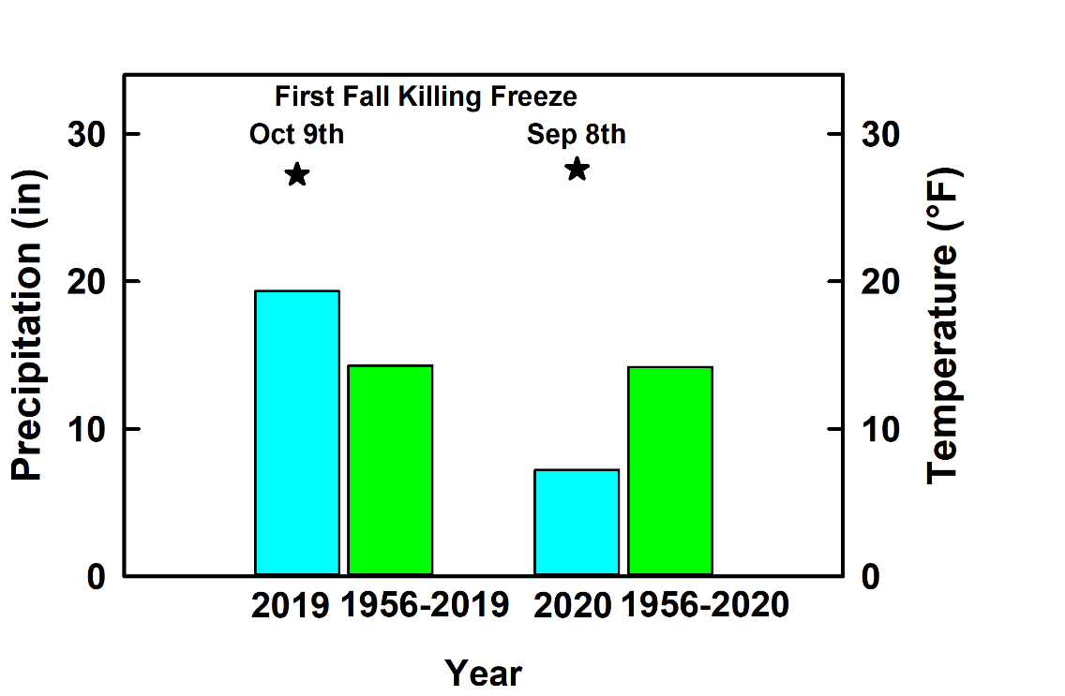

***Figure 1. Precipitation and first fall killing freeze date and temperature. Bars denote precipitation and stars indicate temperature data.***

The planting dates, emergence date, corresponding days to emerge, and soil temperature at 4” depth during emergence are given in Table 1.

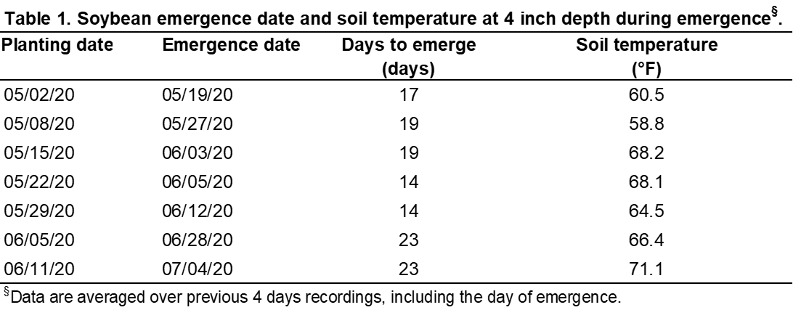

There was a significant effect of planting date on plant height. Averaged across other treatments, soybean seeded from May 2nd to 22nd, 2020 was about 18” tall. The plant height decreased significantly when planting was delayed to May 29th and the height dropped sharply when seeded in June (Table 2).

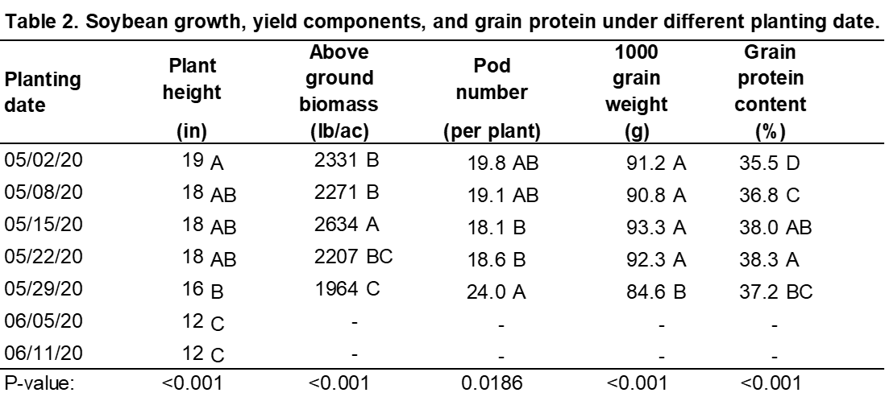

There was a significant effect of planting date and variety on above ground biomass. When averaged across other treatments, soybean planted on May 15th produced the highest amount of biomass and one planted on May 29th had the lowest biomass (Table 2). The variety ND17009GT produced about 7% more lb/ac of biomass compared to the variety ND18008GT (Table 3).

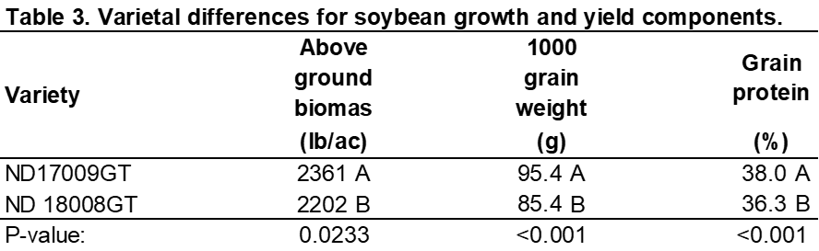

There was a significant effect of planting date on pod numbers. Soybean planted on May 29th had the highest number of pods per plant and those planted on May 15th and 22nd had the lowest number of pods per plant (Table 2). There was no effect of planting date, variety, and seed treatment on grain number per plant and test weight. The average grain number per plant and test weight recorded across all treatments was 40 and 57 lb/bu, respectively. There was a significant effect of planting date and variety on thousand grain weight. The average thousand grain weight of Soybean seeded on and before May 22nd was about 92 g which decreased by 8% when planting was delayed to May 29th (Table 2). The thousand grain weight of ND17009GT was 95.4 g, which was 11.7 % higher than that of ND18008GT (Table 3).

There was a significant effect of planting date (*p<0.001*), variety, and pd×v on grain yield. (Figure 2A). The average grain yield of the trial was 10 bu/ac. The season long drought mentioned above caused such a massive decline in yield. Soybean planted in June could not produce an economic yield as a result of the combined stress of drought and early first killing freeze. Averaged across seed treatment, when soybean was seeded from May 2nd to May 22nd, ND17009GT and ND18008GT yielded about 11.4 bu/ac and 10.1 bu/ac of grain, respectively. When planting was delayed to May 29th, the yield of ND17009GT decreased by 45% and that of ND18008GT decreased by 24%.

There was a significant effect of planting date (*p<0.001*), variety, and pd×v on grain oil content (Figure 2B). Averaged across seed treatment, ND17009GT and ND18008GT had about 22.85 % grain oil content when the crop was seeded on and before May 8th. When planting was delayed, the oil content started decreasing in ND17009GT, and the decrease was substantially higher when soybean was planted at the end of May. In the case of ND18008GT, a significant decrease in oil content was observed only when planting was delayed to May 29th.

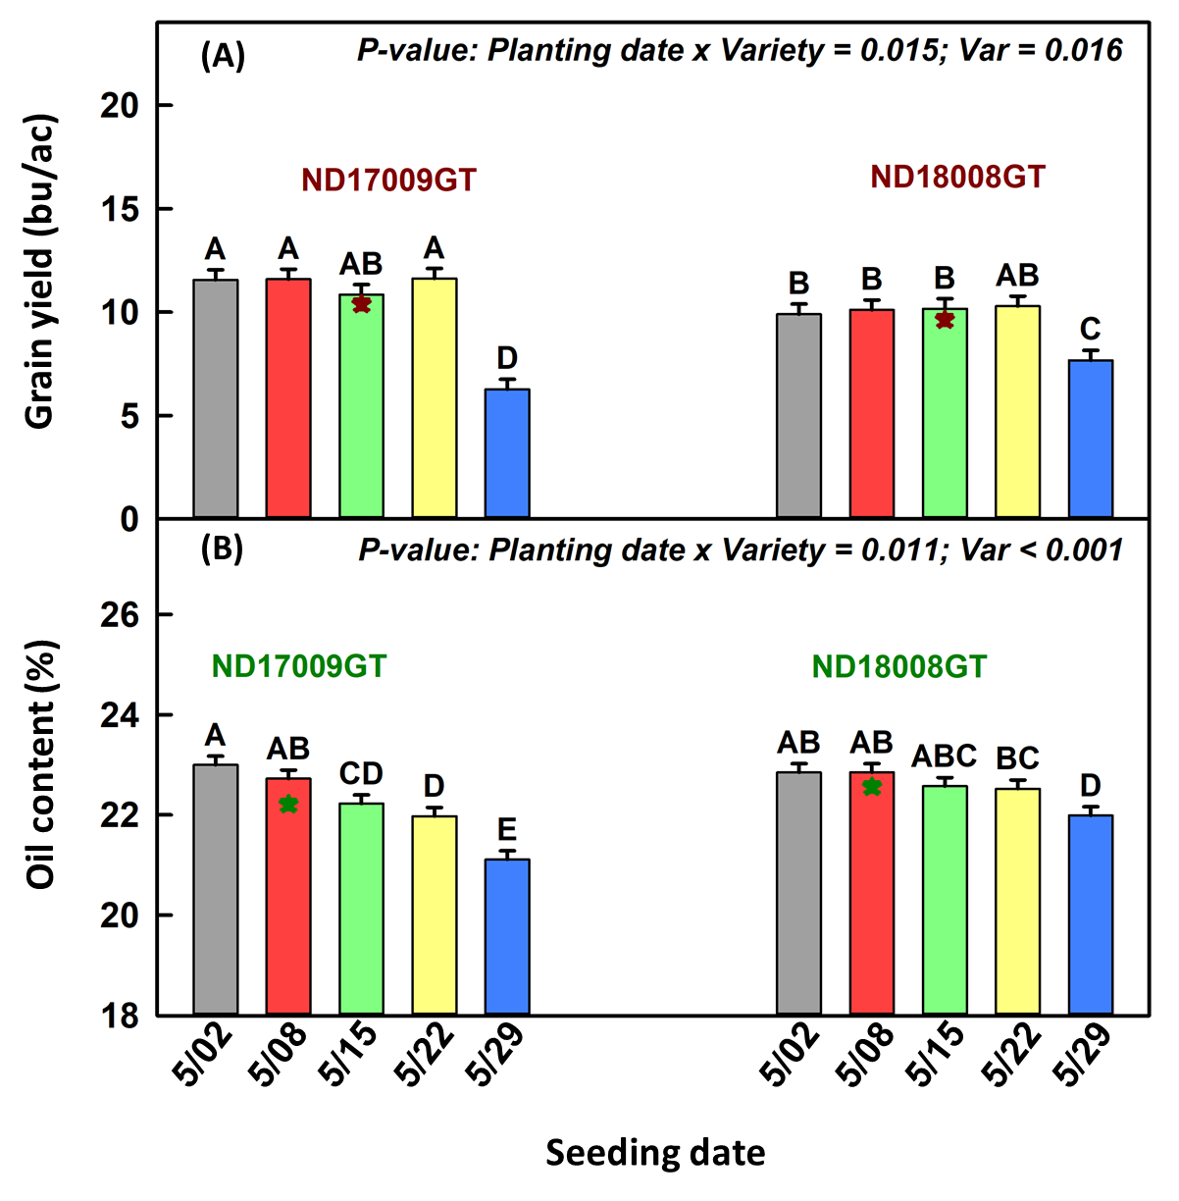

***Figure 2. Differential responses of soybean varieties to planting date for (A) grain yield and (B) oil content. ★ represents varietal yield/oil content averaged across the planting date and seed treatment.***

Averaged across variety and seed treatment, soybean seeded on May 15th and 22nd had the highest grain protein content (~38%), which declined by 1 to 2.7% when the crop was seeded earlier or later in the month (Table 2). Averaged across other treatments, variety ND17009GT had 1.8 % more grain protein content than the variety ND18008GT (Table 3).

**Summary/recommendations to North Dakota soybean Farmers and industries**

The outcomes of this project showed that under no-till dryland conditions of western North Dakota, a season long drought may result in a massive decline in soybean yield irrespective of the date of planting. The average trial yield of 10 bu/ac compared to 30 bu/ac in the previous year (2019) showed the magnitude of the devastating effect of drought on soybean. The study also showed that under drought conditions if planting is delayed to May 29, soybean yield may become as low as 6-7 bu/ac; and if the combined effect of early fall killing freeze and drought occur, planting in June may result in zero economic yields.

**Publications**

**Gautam P. Pradhan,** James Staricka, and Jerald W. Bergman. 2020. Determining Soybean Planting Date and Soil Temperature for the No-till Semiarid Conditions of Western North Dakota. In: 2020 Agricultural Research Update Regional Report No. 26. NDSU WREC and MSU EARC. p. 69.

**Acknowledgments**

We acknowledge the financial support of the North Dakota Soybean Council. Mention of trademark or proprietary product does not constitute a guarantee or warranty of the product by North Dakota State University and does not imply its approval to the exclusion of other products which may also be suitable.