**Soil Health and Agriculture Research Extension (SHARE) Farm Research Projects in Mooreton, ND and Logan Center, ND**

2021 Technical Report

Submitted to the North Dakota Soybean Council

Principal Investigators:

Abbey Wick, Caley Gasch, Aaron Daigh, Marisol Berti, Frank Casey, Greg Endres, Mike Ostlie, and Naeem Kalwar

North Dakota State University

June 30th 2021

**1. Introduction**

The Soil Health and Agriculture Research Extension (SHARE) Farm project started with the original location in Mooreton, ND (2013) and expanded to a second location in Logan Center, ND (2019). Each site is unique in soil type, crop rotation and climatic challenges. Both SHARE Farms provide opportunities for field-scale, long-term research associated with goals originally assigned to the project by commodity council members. Field-scale research means that cooperating farmers are heavily involved in each project, using their equipment to seed and manage and harvest the location. Research is then conducted by NDSU, within this framework, using sampling and analytical approaches suited to the field variability associated with the projects. Long-term sites have high value when assessing how a combination of soil health management approaches can be used to achieve on-farm goals. After all, soil health does not change quickly and issues, such as salinity found at both sites, can take time to remediate. Multiple faculty members from NDSU’s main campus and Research Extension Centers have come together to assess systems at each SHARE Farm location. This allows us to make science-based recommendations to farmers interested in adopting soil health building practices that can be relatively high risk and require specification to each system.

**2. Objectives and Deliverables**

**2.1. Objectives**

1. Evaluate field-scale soil moisture and temperature under no-till and conventional tillage practices
2. Evaluate field-scale cover crop establishment in each part of the rotation, yield and soil dynamics under (a) no-till/cover crop and (b) conventional tillage/no cover crop treatments
3. Evaluate changes in soil properties under (a) no-till/cover crop and (b) conventional tillage/no cover crop treatments.

**2.2. Project Deliverables**

* Data-supported information to be shared using Extension media development (print and online) and activities (field days, workshops, Café Talks)
* Academic publications and presentations (state, regional, and national meetings)

**3. Methods**

Research activities (treatment installations, data collection, field information) were coordinated with farmer cooperators at each location, making it seamless for research activities. Each site was monitored for soil temperature and moisture at multiple soil depths and on a near continuous basis (Objective 1). Additionally, soil temperature and moisture were periodically measured along transects at each site to determine field evenness and variability across space within each tillage treatment. Crop emergence and yields and cover crop establishment and biomass will be measured at both sites (Objective 2). Each site has also been sampled for soil health parameters as a baseline and will continue to be monitored each year for salinity (Objective 3). Prior to freeze-up in 2021, the Mooreton SHARE Farm will be sampled one last time for soil health parameters and across the field to complete the study.

The experimental design is similar for both sites, facilitating comparisons across management systems within a field-scale framework. At both sites, the majority of each field is managed under no-till with cover crop. At the Mooreton site, “conventional” tillage strips (fall chisel plow and spring field cultivation) have been in place for four growing seasons. Strips are replicated three times in the tiled portion of the field, as well as three times in the free draining part of the field. Due to wet field conditions in fall 2019, vertical tillage was required in spring 2020 to correct equipment ruts in the non-tile drained portion of the field. At the Logan Center site, three replicate conventional tillage strips (high speed disk in spring 2019 and 2020, followed by fall chisel plowing 2020 and spring field cultivation 2021) were established at the field’s inception. At both locations, these strips traverse the entire length of the field, capturing a range of soil and crop conditions. Sampling and monitoring of crop and soil properties occurs at established locations distributed across the fields and spanning the management system treatments. This design provides data that can be analytically handled in two ways: (1) properties can be compared across treatments (t-test, ANOVA), or (2) as spatially explicit observations and properties that span gradients (maps, regressions).

**4. Results**

Due to the long-term nature of this project, final results and conclusions will not be drawn until the completion of the study. However, yearly data still provides valuable insight into crop stand, yield, soil temperature, and soil moisture differences between the no-till and cover crop treatments.

**4.1. Soil Temperature and Water Content**

**4.1.1 Soil Temperature**

In the no-till treatments, surface residue helps to insulate the soil against extreme daily temperature fluctuations, especially at the 2 in depth. Overall, no-tilled soils also exhibited lower average temperatures at both 2 and 6 in depths compared to the conventionally tilled treatments [Figure 4.1, 4.2, and 4.3], helping to prevent heat induced plant stress. For example, on June 4th, 2021 at Logan Center, the soil temperature 2 in. deep was 31℃ (87℉) in the tilled treatment and 28℃ (82℉) in the no-till.

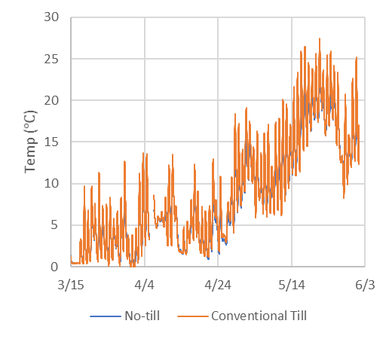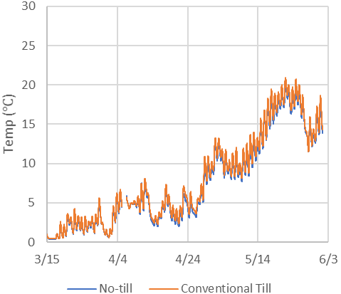

Figure 4.1. Soil temperature in the no-till versus conventionally tilled systems at 5 cm (left) and 15 cm (right) at the Mooreton site in the tile drained treatment.

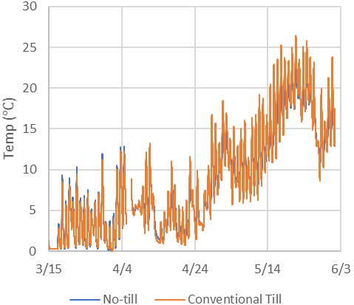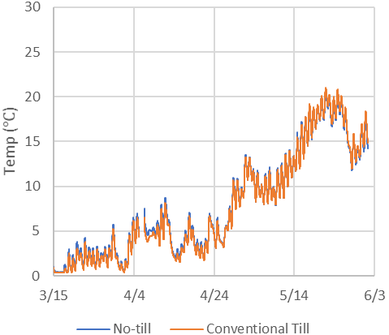

Figure 4.2. Spring soil temperature in the no-till versus conventionally tilled systems at 5 cm (left) and 15 cm (right) at the Mooreton site in the undrained drained treatment.

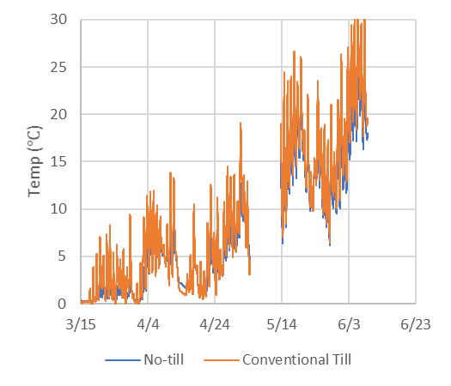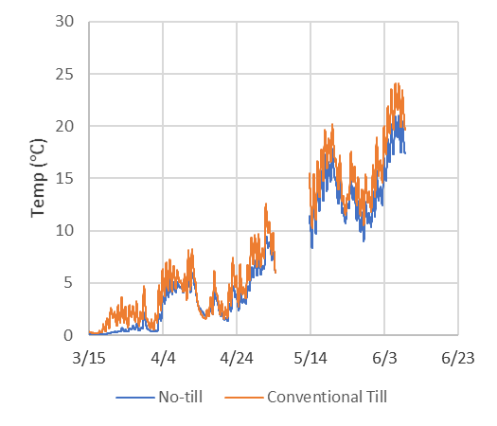

Figure 4.3. Soil temperature in the no-till versus conventionally tilled systems at 5 cm (left) and 15 cm (right) at the Logan Center Site.

**4.1.2. Volumetric Water Content**

The no-till systems generally have a higher volumetric water content compared to the tilled systems, most notably at the 2 in. depth.

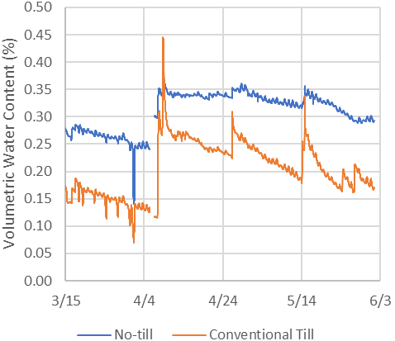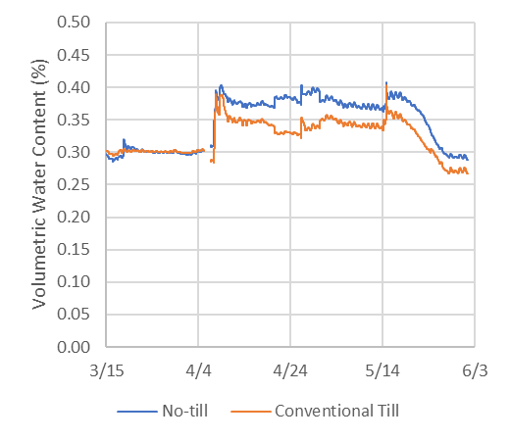

Figure 4.4. Volumetric water content of the soil in no-till versus conventionally tilled systems at 5 cm (left) and 15 cm (right) at the Mooreton site in the tile drained treatment.

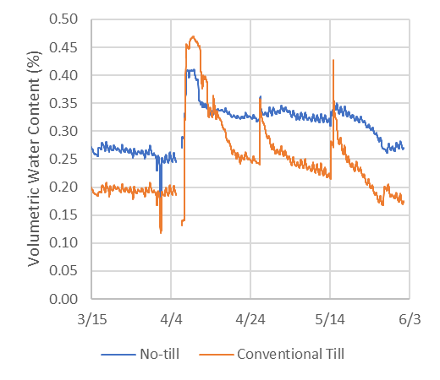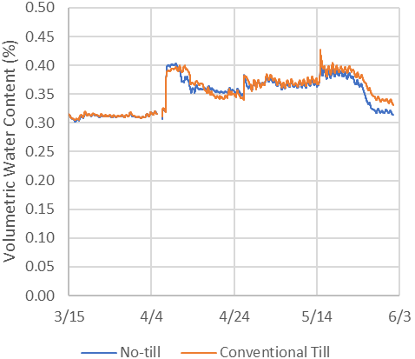

Figure 4.5. Spring volumetric water content of the soil in no-till versus conventionally tilled systems at 5 cm (left) and 15 cm (right) at the Mooreton site in the undrained treatment.

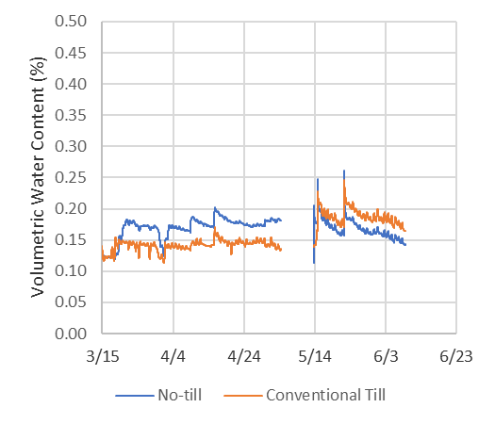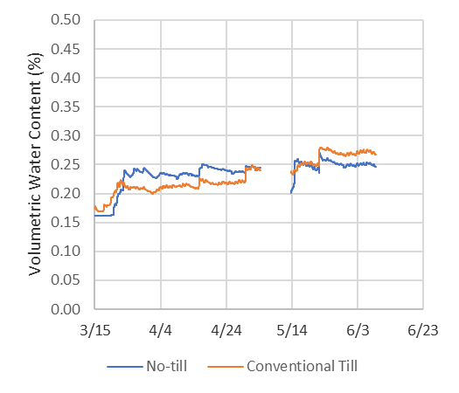

Figure 4.6. Spring volumetric water content of the soil in no-till versus conventionally tilled systems at 5 cm (left) and 15 cm (right) at the Logan Center site.

**4.2. Fertility**

Yearly soil samples were taken at each site to a depth of 48 inches. Since each field received the same amount and source of fertilizer, when this study is concluded the soil sample data will be used to draw conclusions regarding nutrient cycling and loss in no-till versus conventionally tilled treatments, along with tile-drained versus undrained treatments.

|  |  |  |  |  |  |  |  |  |  |  |
| --- | --- | --- | --- | --- | --- | --- | --- | --- | --- | --- |
| Table 4.1. Mean soil sample data for North (tile drained) and South (undrained) locations at the Mooreton site. | | | | | | | | | | |
|  | **Side of field** | | | | | | | | | |
|  | **North** | **North** | **North** | **North** | **North** | **South** | **South** | **South** | **South** | **South** |
| **Sample Depth (in)** | **0-6** | **6-12** | **12-24** | **24-36** | **36-48** | **0-6** | **6-12** | **12-24** | **24-36** | **36-48** |
| NO3-N (lb/a) | 8.07 | 2.87 | 5.87 | 7.20 | 8.13 | 5.60 | 2.30 | 18.80 | 39.40 | 30.40 |
| P (ppm) | 16.93 |  |  |  |  | 11.10 |  |  |  |  |
| K (ppm) | 471.27 |  |  |  |  | 428.20 |  |  |  |  |
| EC_1:1 (mS/cm) | 0.51 | 0.92 | 1.24 | 1.71 | 1.93 | 0.58 | 1.10 | 1.65 | 2.30 | 2.15 |
| pH1:1 | 6.86 | 7.29 | 7.87 | 8.11 | 8.13 | 6.51 | 7.31 | 7.93 | 8.02 | 8.03 |
| **Saturated paste analysis** |  |  |  |  |  |  |  |  |  |  |
| ECe (mS/cm) | 0.52 | 1.23 | 1.75 | 2.53 | 3.35 | 0.78 | 1.38 | 2.40 | 3.64 | 3.94 |
| pHe | 6.57 | 6.92 | 7.49 | 7.78 | 7.75 | 6.39 | 6.97 | 7.52 | 7.66 | 7.65 |
| Cl (ppm) | 6.40 | 8.27 | 10.93 | 16.27 | 24.27 | 79.80 | 56.80 | 46.40 | 45.60 | 45.20 |
| SO4-S (ppm) | 139.40 | 724.80 | 1098.40 | 1847.00 | 2550.80 | 253.80 | 783.90 | 1834.80 | 2994.00 | 3168.00 |
| Ca (ppm) | 42.48 | 102.24 | 128.39 | 217.45 | 273.73 | 74.30 | 116.88 | 202.40 | 315.20 | 342.00 |
| Mg (ppm) | 36.43 | 122.91 | 178.89 | 249.72 | 325.65 | 51.92 | 101.23 | 208.43 | 378.27 | 393.14 |
| Na (ppm) | 29.43 | 92.69 | 150.53 | 217.73 | 294.76 | 46.19 | 110.31 | 205.12 | 316.92 | 330.82 |
| K (ppm) | 11.07 | 9.53 | 9.40 | 9.20 | 14.67 | 12.40 | 10.20 | 10.40 | 12.30 | 15.50 |

|  |  |  |  |  |  |
| --- | --- | --- | --- | --- | --- |
| Table 4.2. Mean soil sample data for the Logan Center site. | | | | | |
| **Sample Depth (in)** | **0-6** | **6-12** | **12-24** | **24-36** | **36-48** |
| NO3-N (lb/a) | 5.24 | 3.40 | 3.64 | 3.54 | 4.52 |
| P (ppm) | 12.28 |  |  |  |  |
| K (ppm) | 264.68 |  |  |  |  |
| EC_1:1 (mS/cm) | 0.56 | 0.51 | 0.59 | 0.68 | 0.73 |
| pH1:1 | 7.65 | 7.81 | 8.06 | 8.28 | 8.28 |
| **Saturated paste analysis** |  |  |  |  |  |
| ECe (mS/cm) | 0.89 | 0.75 | 0.83 | 0.93 | 1.10 |
| pHe | 7.42 | 7.52 | 7.70 | 7.89 | 7.90 |
| Cl (ppm) | 10.88 | 8.16 | 11.36 | 15.17 | 11.65 |
| SO4-S (ppm) | 152.84 | 106.68 | 108.32 | 150.42 | 206.52 |
| Ca (ppm) | 133.88 | 87.55 | 76.44 | 70.62 | 92.15 |
| Mg (ppm) | 53.43 | 50.00 | 55.59 | 56.24 | 66.33 |
| Na (ppm) | 51.37 | 52.97 | 77.96 | 111.66 | 134.12 |
| K (ppm) | 8.40 | 4.00 | 3.88 | 3.63 | 4.48 |

**4.3. Soil Salinity**

The most notable difference in soil salinity occurred at the Mooreton site with the tile drained versus undrained portion of the field differing drastically. At the conclusion of this study, yearly EC maps will be compared to draw conclusions regarding the impact of soil health practices on soil EC and salinity.

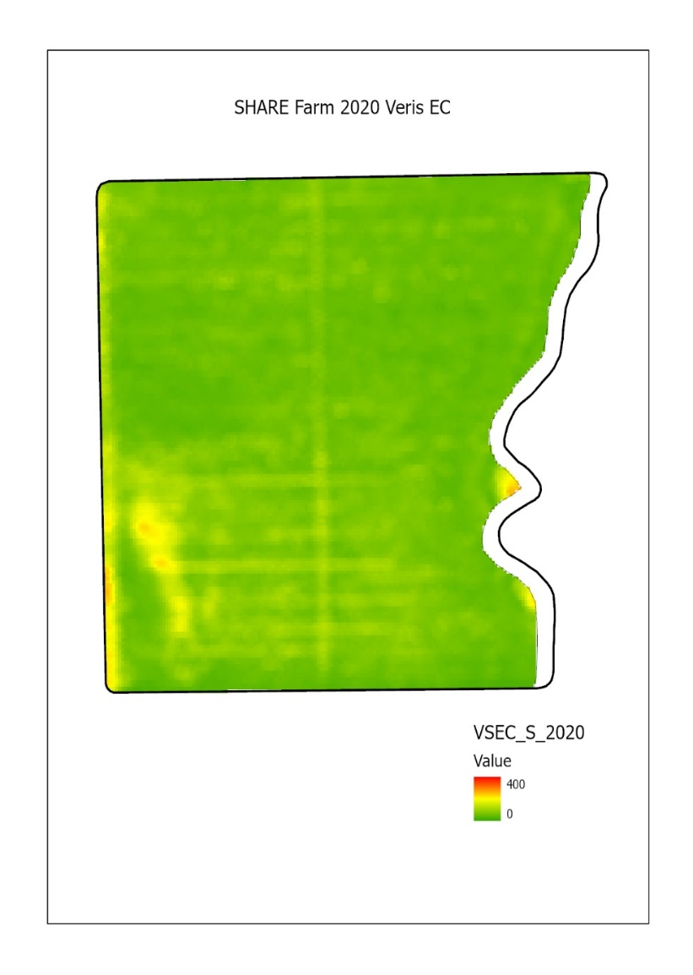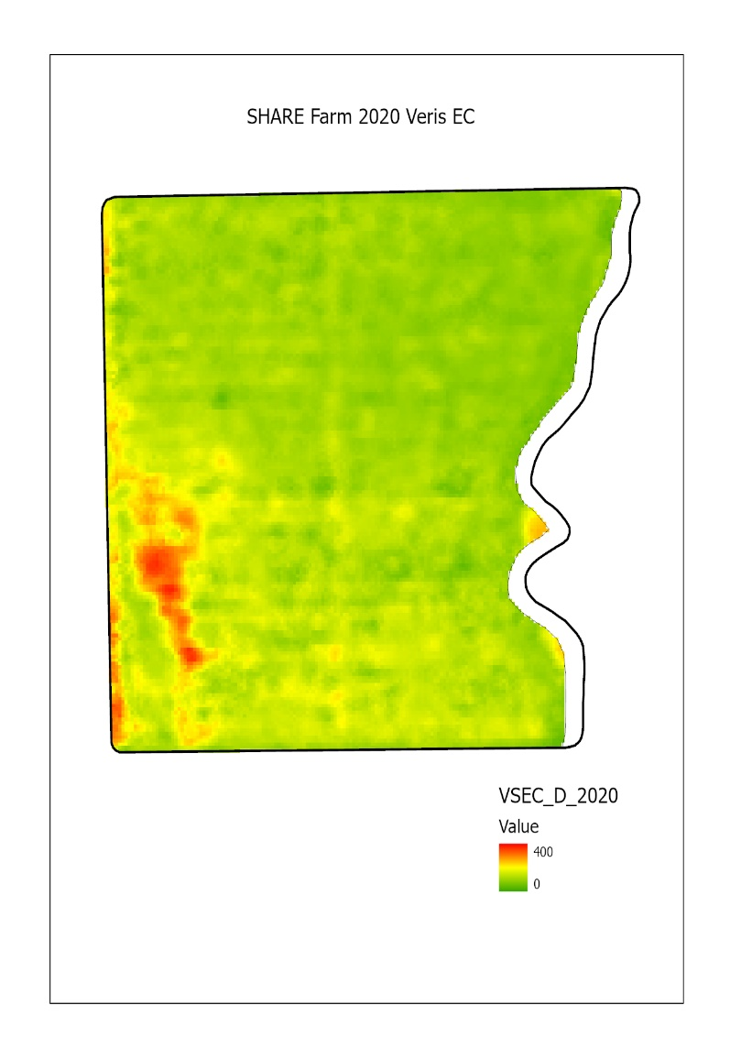

Figure 4.7. Veris EC maps from the Mooreton site at 0-1 ft (left) and 0-6 ft (right) depths.

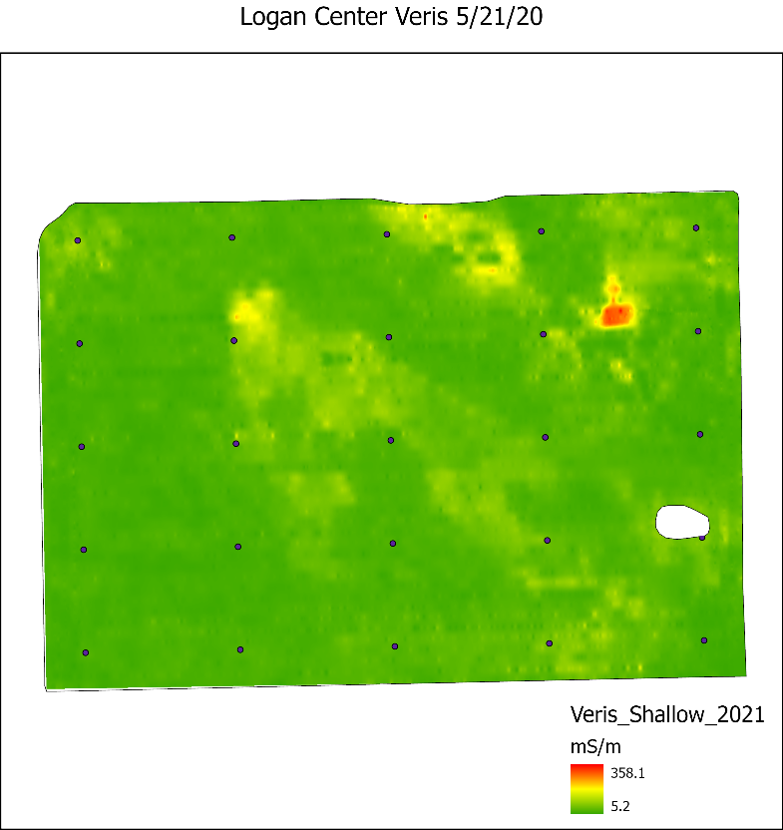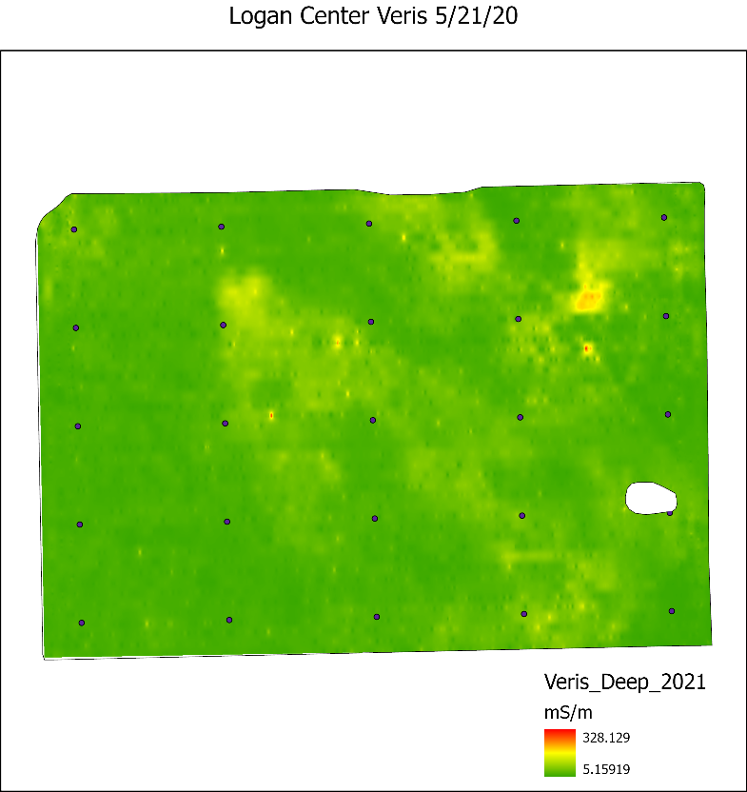

Figure 4.8. Veris EC maps from the Logan Center site at 0-1 ft (left) and 0-6 ft (right) depths.

**4.4. Water Table Management**

Water level and composition was monitored only at the Mooreton site. When the water composition data was averaged for 2020-2021, the groundwater in the tile drained portion of the field had lower levels of EC and Na–lessening potential sodic/saline soil problems.

|  |  |  |  |
| --- | --- | --- | --- |
| Table 4.3. Water quality averaged across the seven north wells and eight south wells for 2020-April 2021. | | | |
|  | | **North wells (Tile drained)** | **South wells (Undrained)** |
|  | -----------ppm----------- | | |
| EC | | 2.92 | 4.06 |
| pH | | 7.67 | 7.67 |
| NO3-N | | 21.81 | 18.83 |
| SO4 | | 1455.86 | 1894.88 |
| Cl | | 88.75 | 130.12 |
| K | | 4.09 | 7.15 |
| Na | | 199.18 | 305.00 |
| Mg | | 273.21 | 384.25 |
| Ca | | 222.18 | 317.97 |
| TOC | | 7.94 | 9.19 |
|  | ------------m------------ | | |
| Depth to groundwater | | 1.31 | 0.80 |

**4.5. Cover Crop Productivity**

A cover crop was seeded at both sites, though the timing, species, and seeding practice differed. Oats were broadcast onto the soybeans prior to leaf-drop at the Mooreton location; however, conditions prevented the oats from germinating. At the Logan Center site 60 lbs/ac of Rye, 2 lbs/ac radish, 2 lbs/ac winter camelina were interseeded into the standing corn on June 30th 2020. The cover crops at Logan Center established nicely and the rye overwintered well and had a strong presence in the spring. Cover crop biomass in fall 2020, prior to frost-kill averaged 435.5 lbs/ac of dry matter, rye biomass in spring 2021, prior to termination, was 187.8 lbs/ac.

**4.6. Crop Productivity**

At the Mooreton site, a significant difference was noted between the soybean yield in the tile drained versus the undrained portion of the field [Figure 4.9 and Table 4.5]. Differences were also noted between the tillage treatments with the no-tilled treatments resulting in a statistically significant difference at the Logan Center site [Table 4.6] and a non-statistically significant difference at the Mooreton site.

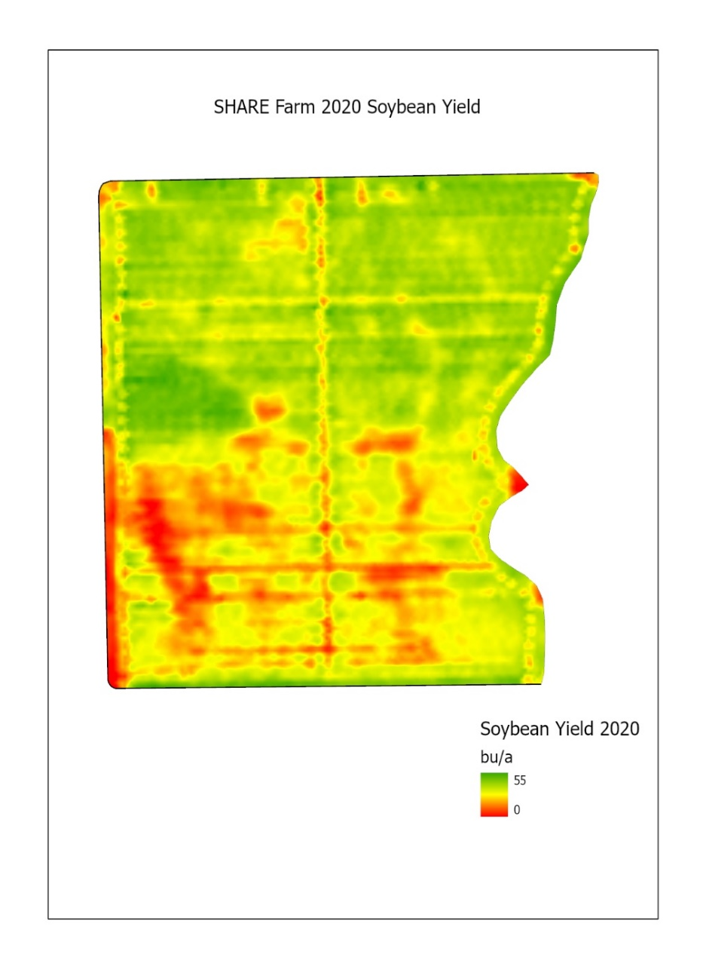

Figure 4.9. Map of Mooreton site showing 2020 soybean yield. A yield difference can be easily seen between the tile drained (North) and undrained (South) portion of the field.

|  |  |  |  |  |
| --- | --- | --- | --- | --- |
| Table 4.5. 2020 Soybean yields at the Mooreton site | | | | |
| **Drainage** | **Tile Drained (North)** | | **Undrained (South)** | |
| **Tillage System** | **Conventional Till** | **No-Till** | **Conventional Till** | **Vertical Till** |
| Yield (bu/ac) | 39.78 | 38.82 | 25.49 | 26.21 |

|  |  |  |
| --- | --- | --- |
| Table 4.6. 2020 Corn grain yield at Logan Center Site | | |
| **Tillage System** | **Conventional Till** | **No-Till** |
| Yield (bu/ac) | 158 | 145 |

**5. Conclusions**

Although more data will be collected in the coming months and years, several conclusions can be, tentatively, drawn from the past year of data:

* Tile-drainage can help to reduce soil salinity.
* Soil temperature is, on average, lower and has less daily fluctuation in no-tilled as compared to conventionally tilled systems.
* No-till systems help to increase soil volumetric water content under most conditions.
* No-till systems have a slightly lower or non-significant yield differences compared to conventionally tilled systems.

Past research has shown soil water and temperature dynamics with tillage practices are different (with differences being more predominate in coarser textured soils at other locations in the study by Daigh and minimal in the high clay soils at the SHARE Farm in Mooreton). This is important for farmers adopting soil health building practices to consider. The coarser textured soils at the SHARE Farm in Logan Center could have greater differences in temperature and moisture conditions and subsequent crop yield response for the tillage treatments. Experience at Mooreton has also indicated that cover crop establishment is highly dependent on current crop, timing and seeding method. We anticipate that this research will continue to provide guidance on when and how best to incorporate cover crops into these crop rotations. Based on previous research, we also do not expect crop yields to be reduced by these soil health building practices. Lastly, we have already started to observe soil health changes at the Mooreton site. We expect that these improvements in soil structure and drainage and the reduction of salinity will continue and be shown in the final year of soil sample collection and analysis. Based on these experiences, we expect the Logan Center soils to improve in structure and salinity reduction within the first three years of the project.