**Identifying Effective Cover Crops for Management of Soybean Cyst Nematode**

TECHNICAL REPORT

NORTH DAKOTA SOYBEAN COUNCIL

JUNE 2021

Dr. Guiping Yan, Principal Investigator, Dept. Plant Pathology, NDSU

Soybean cyst nematode (SCN; *Heterodera glycines*) is one of the biggest yield-reducing biotic factors for soybean production in North Dakota (ND). It is an obligatory sedentary endo-parasitic nematode that can cause up to 30% yield loss without obvious above-ground symptoms. Many leguminous crops and weed species are also infected by SCN which may serve as the alternative host for nematode survival and population increase. Continuous use of the single source of resistance against SCN causes rapid development of virulent populations. Non-host cover crops have been included in integrated management strategy for sustainable management of this nematode pest. Those cover crops could suppress the nematode reproduction through different mechanisms by affecting the biology of nematode.

Several studies have demonstrated the suppressive effect of cover crops on plant-parasitic nematodes such as root-knot nematode (*Meloidogyne* spp.), root-lesion nematodes (*Pratylenchus penetrans*), sugar beet cyst nematode (*Heterodera schachtii*), and potato cyst nematode (*Globodera* spp.). Effective cover crops may reduce SCN populations via three possible mechanisms, such as non-host cover crops stimulating SCN eggs hatching in the absence of a host, releasing toxic biochemical compounds, and acting as trap crops arresting the life cycle without allowing further development. Many cover crops were evaluated in ND for their hosting and population reduction ability against SCN in greenhouse and microplot conditions. Non-host cover crops were found to effectively reduce nematode populations from infested field soil but their interaction with SCN and the possible effects on SCN biology have not been well studied. The specific objectives of this study were to 1) evaluate the effects of ten cover crop species/cultivars on hatching of soybean cyst nematode juveniles; and 2) evaluate the effects of ten cover crop species/cultivars on the penetration of soybean cyst nematode juveniles.

To achieve the objectives, soil samples were collected from a SCN-infested field in Richland County, ND based on our previous work. The initial nematode population density of SCN was determined by extracting nematodes from soil and subsequently counting them under a microscope. The initial nematode population density was 1,877 per cone-tainer and each cone-tainer had 100 cm3 of naturally infested soil.

Ten cover crops species/cultivars including, alfalfa (cv. Bullseye), daikon radish (Eco-till), faba bean (Petite), foxtail millet (Siberian), oilseed radish (Concorde, Control, and Image), red clover (Allington), turnip (Purple top), and white mustard (Master) were evaluated for their effect on hatching and penetration of SCN. Common rotation crop corn (DKC44-13) was included for comparison, and SCN susceptible soybean (Barnes) and unplanted naturally infested soil (fallow) were used as controls (Table 1). All the entries were planted in 2 sets using cone-tainers with naturally infested soil. Treatments were arranged in completely randomized design each with four replicates and grown in a growth chamber maintained at 27oC (Figure 1). Plants were harvested 15 and 30 days after planting (DAP). Roots were gently separated from the soil and washed before they were stained with food coloring dye to visualize nematodes inside the plant roots (Figure 2). Newly formed white females on the surface of plant roots were also washed along with remaining soil before root staining. Soil from each cone-tainer was processed to extract SCN cysts and juveniles which were later quantified under the microscope. Extracted cysts were then crushed to release eggs and then counted. Juveniles in soil and inside the roots 15 DAP were used to determine the hatching ability of SCN for each treatment and nematodes inside the roots 15 DAP were used to evaluate the effect of cover crops on penetration by SCN juveniles.

Only turnip supported the reproduction of SCN among the cover crops with average white females’ number of 5 after 30 days of planting showing poor hosting ability as found in our previous observations. Soybean (Barnes) showed a highly susceptible reaction to SCN with average white females 248 after 30 days of planting. The excellent reproduction of SCN on the susceptible soybean cultivar showed the conducive environment conditions in the growth chamber for nematode reproduction. Cover crops other than turnip did not support the SCN reproduction. All the tested cover crops, except turnip, had a significantly lower final SCN population 30 DAP than unplanted infested soil, indicating the suppressive nature of those cover crops to SCN compared to fallow treatment and supporting the findings of our previous experiments. Additionally, unplanted infested soil had a significantly greater SCN population than the other cover crops 15 DAP, which suggests that the suppression of nematodes by cover crops may start within the first two weeks of planting. As expected no white females were found in rotational crop corn, and it had a significantly lower final SCN population than fallow both 15 and 30 DAP.

Among the cover crops, faba bean and turnip had significantly (*P <* 0.05) higher numbers of juveniles in soil and inside the roots combined than unplanted infested soil 15 DAP suggesting greater SCN hatching than the fallow. Faba bean had statistically similar hatched juveniles to the susceptible soybean check. SCN hatching was significantly greater (*P <* 0.05) for faba bean, turnip, and red clover when compared to corn (Figure 3). Moreover, faba bean had significantly more SCN juveniles inside its roots than all other cover crops in the first 15 days which was again statistically similar to the number of juveniles present inside the roots of soybean 15 DAP (Table 2). Faba bean had more than 61% of hatched juveniles inside the roots which was greater than all the other crops used in this experiment (Figure 4). Those juveniles inside the roots of faba bean were significantly reduced 30 DAP without the formation of white females (Table 2). The juveniles seemed to draw nutrients from faba bean roots as they swollen 15 DAP but they appeared to be degenerating inside the roots 30 DAP failing to develop into adult. By comparison, inside the roots of soybean SCN juveniles developed themselves into fully developed white females 30 DAP showing compatibility with the host plant (Figure 5). Another cover crop winter rye (Dylan) had more than 43% of hatched juveniles inside its roots 15 DAP but had a statistically similar number of hatched juveniles compared to corn and unplanted infested soil. Also, winter rye was able to significantly reduce the number of juveniles inside the roots 30 DAP without supporting SCN reproduction (Table 2). These data suggest that faba bean and turnip have the potential to induce more hatching of SCN eggs than the natural hatching from the fallow soil. Additionally, it is also suggested that faba bean (Petite) has a greater potential among the tested cover crops to trap the hatched juveniles inside the roots without supporting reproduction.

Turnip and red clover, which were significantly effective for inducing SCN egg hatching as compared to corn, had less than 2% of the hatched juveniles penetrated their roots 15 DAP Similar penetration of juveniles was observed in alfalfa and foxtail millet with 2.4% and 7.3% of hatched juveniles inside the roots, respectively, in the first 15 days (Figure 4). These cover crops with very low juvenile penetration may have the potential to starve the hatched juveniles in the absence of suitable host crops which results in ultimately the death of juveniles. Cover crops from the Brassicaceae family such as daikon radish, oilseed radish, and white mustard had lower numbers of hatched juveniles as compared to the fallow, corn, and other cover crops. Similarly, juveniles inside their roots 15 DAP were significantly fewer than corn. The percentage of hatched juveniles that penetrated their roots ranged from 24.2% to 28.8% (Figure 4). They did not appear to be significantly effective for enhancing hatching as well as for allowing penetration by juveniles. As cover crops from the Brassicaceae family are known for their bio-fumigation property, their non-host reaction to SCN and significant population reductions in this experiment could be attributed to bio-fumigation but it needs to be evaluated through further experiments.

In conclusion, the population reduction of SCN by different cover crops could be due to the effect of cover crops on SCN biology through different mechanisms. Faba bean (Petite) was found to be effective to significantly induce hatching of SCN eggs and allow penetration by juveniles without supporting their reproduction. Faba bean could be utilized as a resistant trap crop to suppress SCN in infested fields. Cover crops such as red clover (Allington), alfalfa (Bullseye), and foxtail millet (Siberian) may have the potential to be utilized for SCN management by starving the hatched SCN juveniles in the absence of suitable hosts resulting in ultimately the death of juveniles. Despite showing great potential for inducing hatching by turnip (Purple top), it needs to be further evaluated in field conditions as white females were formed in its roots during the experiment. The significant effect of brassica crops on hatching and penetration of SCN could not be observed in this experiment suggesting the role of their well-known bio-fumigation property may affect SCN biology for population reduction which needs to be further investigated. The research findings are useful for farmers to select effective cover crops for managing SCN in infested fields in ND.

**Table 1.** List of cover crops and controls evaluated for their effect on hatching and penetration of soybean cyst nematode, *Heterodera glycines* in a growth chamber.

|  |  |  |
| --- | --- | --- |
| Crops (Cultivar) | Scientific Name | Family |
| Alfalfa (Bullseye) | *Medicago sativa* L. | Fabaceae |
| Corn (DKC44-13) | *Zea mays* L. | Poaceae |
| Daikon radish (Eco-till) | *Raphanus sativus* L | Brassicaceae |
| Foxtail millet (Siberian) | *Setaria italica* subspp. *Rubofructa* (L.) P. Beauv. | Poaceae |
| Faba bean (Petite) | *Vicia faba* Roth | Fabaceae |
| Oilseed radish (Concorde) | *Raphanus sativus* L | Brassicaceae |
| Oilseed radish (Control) | *Raphanus sativus* L | Brassicaceae |
| Red clover (Allington) | *Trifolium pretense* L. | Fabaceae |
| Soybean (Barnes) | *Glycine max* (L.) Merr. | Fabaceae |
| Turnip (Purple top) | *Brassica rapa subsp. rapa* L. | Brassicaceae |
| White mustard (Master) | *Sinapis alba* L. | Brassicaceae |
| Winter rye (Dylan) | *Secale cereale* L. | Poaceae |
| Unplanted infested soil (Fallow) | - | - |

**Table 2**. Average number of SCN juveniles inside the roots of cover crops and controls 15 and 30 days after planting (DAP).

|  |  |  |  |
| --- | --- | --- | --- |
| Crops | Average juveniles inside the roots | | |
| **15 DAP** | **30 DAP** |  |
| Faba bean (Petite) | 449 A | 143 B | * |
| Soybean (Barnes) | 414 A | 618 A | * |
| Winter rye (Dylan) | 144 B | 72 CD | * |
| Corn (DKC44-13) | 112 C | 12 FG | * |
| Daikon radish (Eco- till) | 86 D | 53 D | * |
| Oilseed radish (Control) | 78 D | 6 G | * |
| Oilseed radish (Concorde) | 67 DE | 14 FG | * |
| White mustard (Master) | 52 E | 69 CD | * |
| Foxtail millet (Siberian) | 24 F | 16 FG |  |
| Alfalfa (Bullseye) | 8 G | 36 E | * |
| Turnip (Purple top) | 7 G | 75 C | * |
| Red clover (Allington) | 3 G | 21 F | * |

**Average SCN juveniles inside of the roots is the mean of juveniles found inside the roots of four replications observed by root staining for each crop 15 DAP and 30 DAP. Treatments with same letters are not significantly different for average SCN juveniles inside the roots according to Tukey HSD test performed by PROC GLIMMIX at *P<*0.05. Cover crops with the asterisk (*) have significant difference between the number of juveniles inside the roots 15 and 30 DAP according to paired t-test performed by PROC GLIMMIX at *P<*0.05.

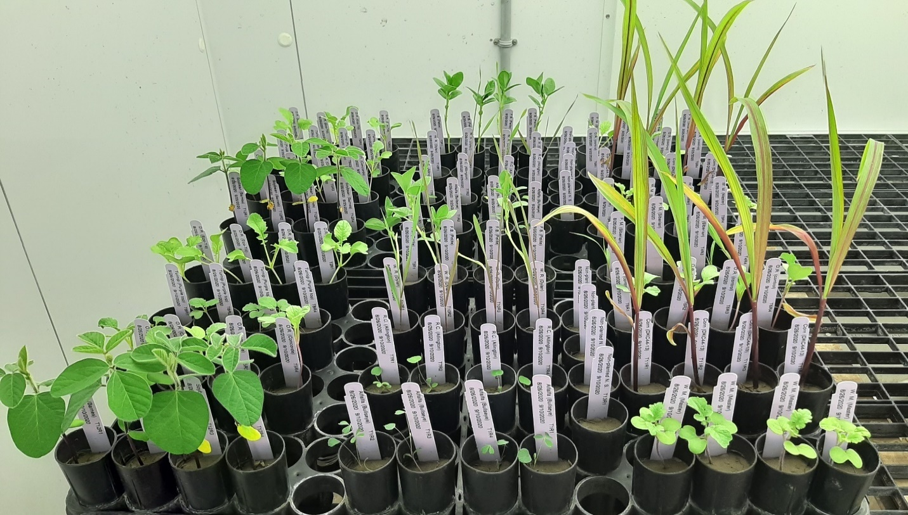

**Figure 1.** Cover crops grown in cone-tainers with naturally infested soil in a growth chamber maintained at 27oC.

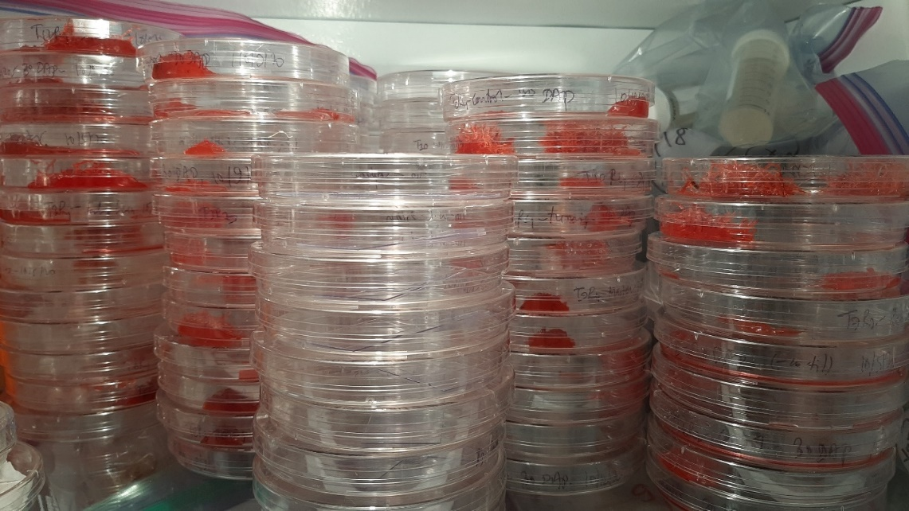

**Figure 2.** Roots of cover crops stained with 12.5% red food coloring dye for observation of nematodes inside the plant roots.

**Figure 3.** Average number of SCN juveniles hatched 15 days after planting. Average hatched SCN juveniles is the mean of juveniles found in the soil and inside the roots combined from four replications. Treatments with same letters are not significantly different for average hatched SCN juveniles according to Tukey HSD test performed by PROC GLIMMIX at *P<*0.05.

**Figure 4.** Percentage of hatched juveniles present inside the roots of cover crops and controls 15 days after planting.

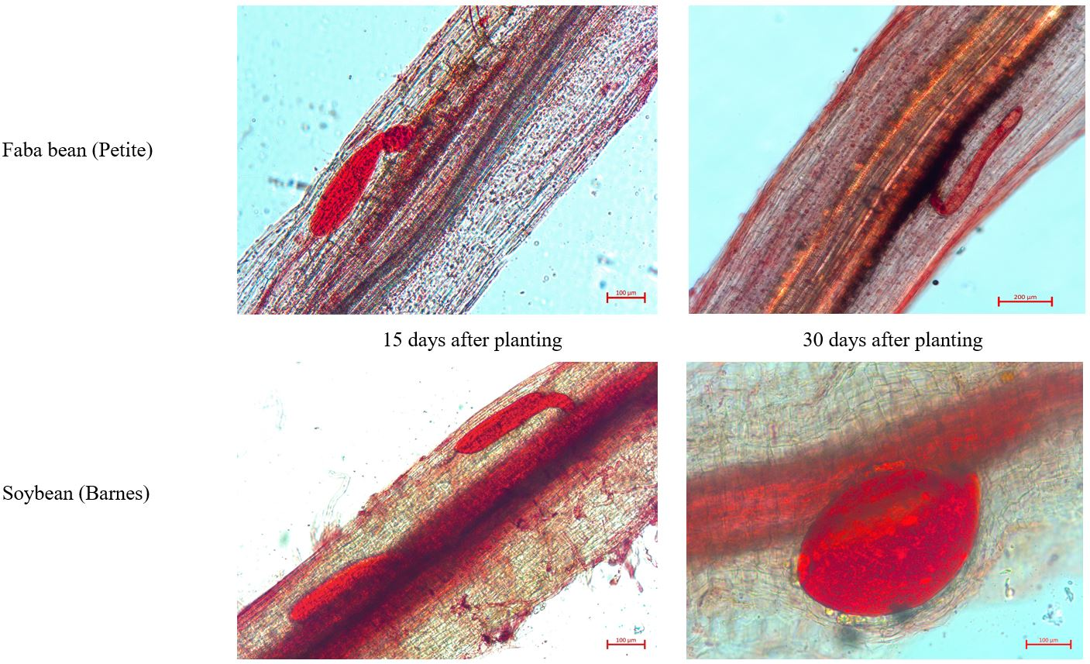

a

a

d

c

b

**Figure 5.** Plant roots of faba bean and soybean stained with red food coloring dye showing different life stages of SCN development 15 and 30 days after planting. a = swollen juveniles, b = vascular bundle, c = a degenerating juvenile, d = a fully developed white female inside root.