Soil Health and Agriculture Research Extension (SHARE) Farm Research Project in Mooreton, ND

2019-2020 Annual Report, North Dakota Soybean Council
*6 month extension granted on 7/1/2020
PIs: Abbey Wick, Caley Gasch, Aaron Daigh, Marisol Berti, Frank Casey

Objectives of the research
- Evaluate field-scale soil moisture and temperature under no-till and conventional tillage practices
- Evaluate field-scale cover crop establishment in each part of the rotation, yield and soil dynamics under (a) no-till/cover crop and (b) conventional tillage/no cover crop treatments
- Evaluate changes in soil properties under (a) no-till/cover crop and (b) conventional tillage/no cover crop treatments.

Completed work – Mooreton SHARE farm
- South half of field was harvested in spring due to it being too wet in the fall of 2019
- South half of field was vertical tilled to help reduce the issues from corn residue during planting
- Soybean was planted after corn was harvested in south half of the field
- Oat cover crop flown onto soybean in later September
  - Due to a lack of moisture throughout fall, no cover crop established and no cover crop biomass samples were taken at the end of the year.
- Monitored water table depths and water quality (Table 1)
- Soybean yield measured (Figure 1)
- Worm survey conducted (Table 2) (Figure 2)
- Soil samples at 5x5 field-wide grid were acquired after harvest
  - These samples are taken each year and analyzed for pH, EC, NO₃-N, P, and K, and saturated paste extracts for each sample are analyzed for ECe, SAR, K, Cl, and SO₄-S
- Veris EC measurements acquired post-harvest and a salinity map was generated (Figure 1)
- Conventional tillage treatments deployed with a chisel plow after soybean harvest
- Deployed soil moisture and temperature sensors after soybean harvest to record fall and spring soil moisture and temperature

Results from 2019-2020
- Lab work is still being conducted on soil samples, data from throughout the season in being compiled
- Extension program evaluations being compiled and analyzed

Work to be completed in next funding cycle
- Touch up conventional tillage treatments and plant field to wheat in spring
- Worm survey across whole field
- Follow wheat harvest with cover crop planting

Table 1. Water quality averaged across north and south wells in 2020.
 | North wells | South wells
 | ------ ppm ------
EC | 2.93 | 4.27
pH | 7.80 | 7.77
NO3-N | 22.09 | 18.19
SO4 | 1614.00 | 2158.67
Cl | 92.08 | 74.90
K | 4.62 | 7.13
Na | 224.22 | 332.56
Mg | 276.94 | 426.78
Ca | 208.17 | 330.17
TOC | 8.38 | 8.92
 | ------ m ------
Depth to groundwater | 1.23 | 0.68

Installing tile drainage seems to have helped improve ground water quality and increase the depth of the ground water. South wells continue to have higher salinity as shown by the numbers for EC, Na, Mg, and Ca.

Table 2. Soybean yields by north/south half and by chisel plow/no-till treatments
 | North | South | Average across field
 | ----------- bu/ac -----------
Chisel Plow | 39.8 | 25.5 | 32.6
No-Till | 38.8 | 26.2 | 32.5
Average across tillage treatments | 39.3 | 25.9

The major factor affecting yield seemed to be the tiling that was done on the north half of the field. The high salinity on the south half of the field is likely a major factor in the reduced yields of that half of the field.

1)
3)
2)
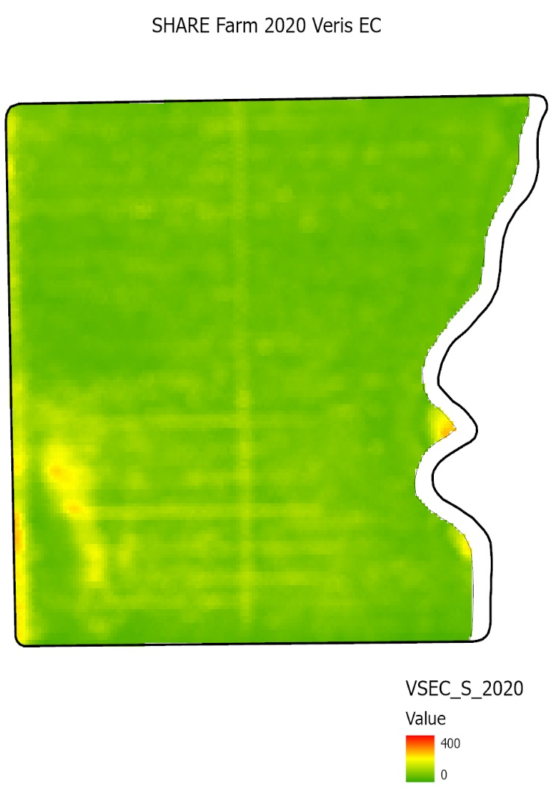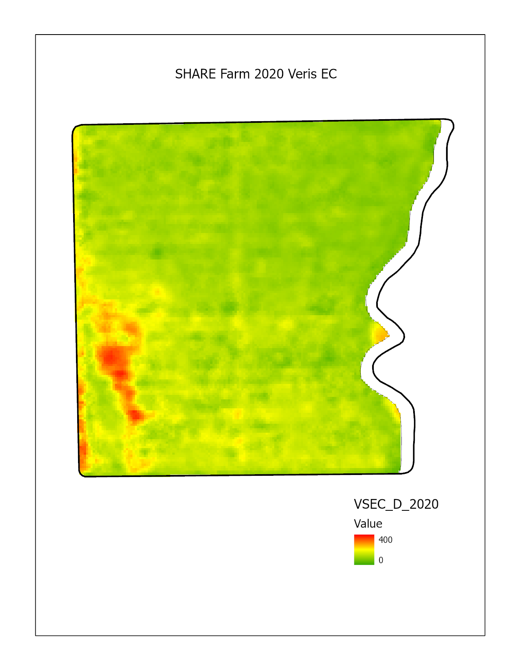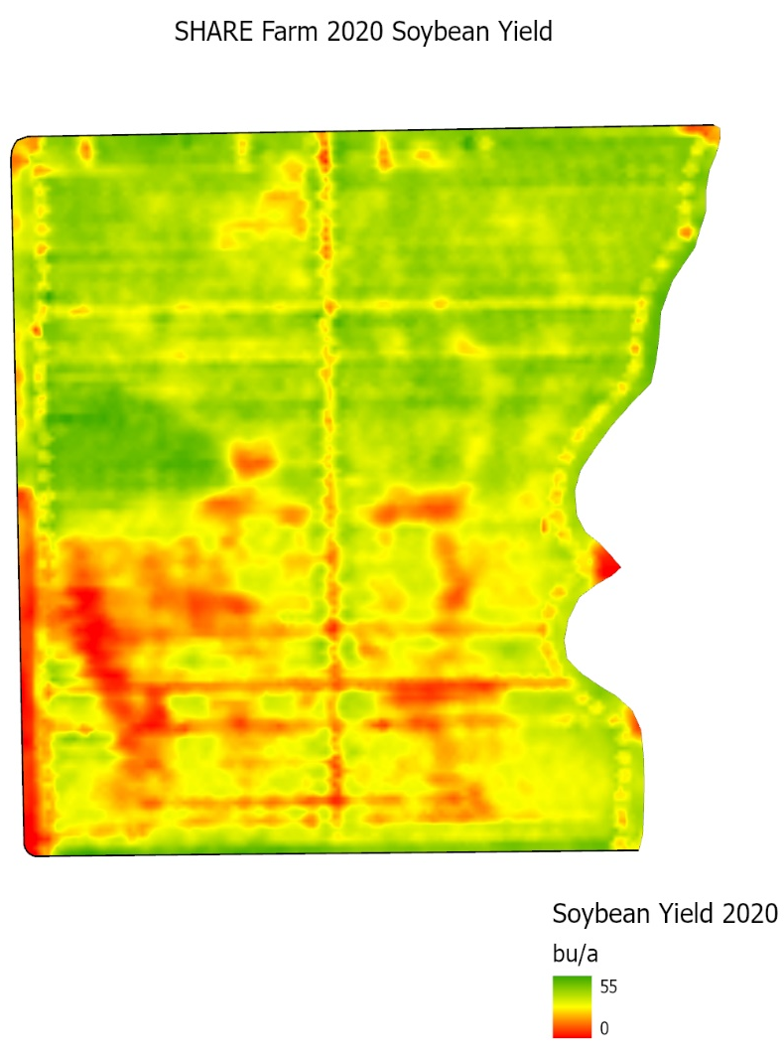

Figure 1. Veris EC maps at 1) shallow and 2) deep depths, and 3) soybean yield monitor map from 2020. The north half of the field is tile drained, the south half is untiled.

Tile draining the N half of the field seems to have helped reduce salinity and increase yield more than using no-till and covercrop practices alone

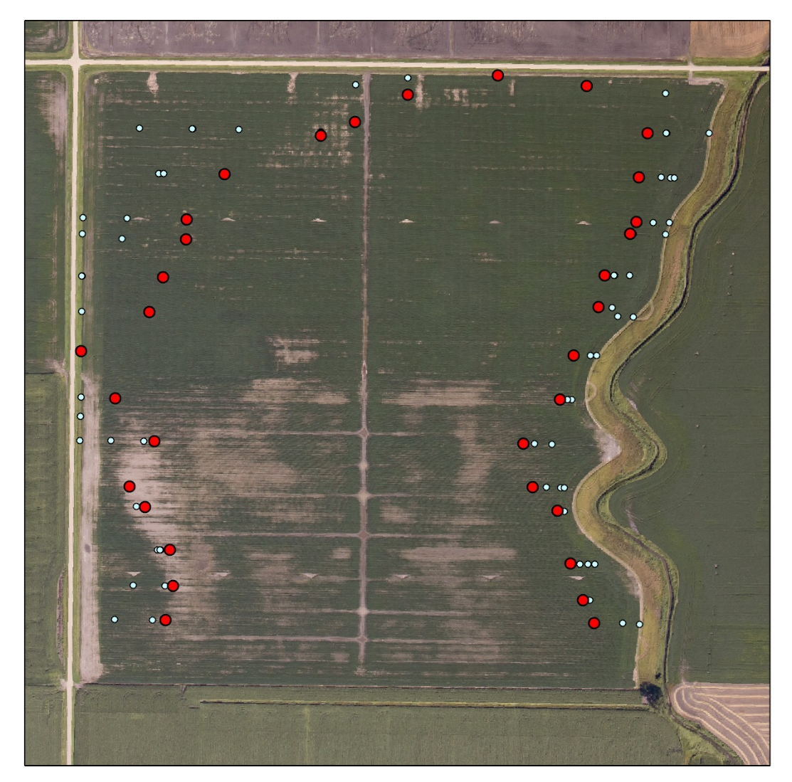
Figure 2. Worm surveys done from 2017-2020. Blue points are where worms were found in past years, moving into the field from the W, N, and E borders. Red points are how far into the field worms were found in 2020.

There seems to be major differences between tile drained (north half) and undrained (south half) movement. The high moisture conditions in 2019 and early 2020 aided tile drain worm movement, but reduced yearly movement in untiled. The NW corner in the tile drained area shows a lot of movement of worms into field. Salts seem to be reducing worm movement on the south half of the field. The east side shows a slow movement into field by earthworms. West side field entrance (west center of the field) shows slow movement of worms possibly due to compaction, NE entrance could be the same.

Data and information learned from the SHARE farm were shared at:
Workshops:

Dakota Innovation Research and Technology (DIRT) Workshop, December 8-9, 2020, Virtual Live-Hosted (Wick, 450 attendees)
Dakota Innovation Research and Technology (DIRT) Workshop, December 9-11, 2019, Fargo, ND (Wick, 225 attendees)

Soil Health Café Talks (24 held in 2020):

Soil Health Café Talk – Prevented Planting, hosts: Abbey Wick, Joe Ikley, Naeem Kalwar, Marisol Berti, June 24, 2020, Virtual (38 people; 2 hours)
Soil Health Café Talk – Prevented Planting, hosts: Abbey Wick, Joe Ikley, Naeem Kalwar, Marisol Berti, June 17, 2020, Virtual (28 people; 2 hours)
Soil Health Café Talk – Prevented Planting, hosts: Abbey Wick, Joe Ikley, Naeem Kalwar, Marisol Berti, June 10, 2020, Virtual (32 people; 2 hours)
Soil Health Café Talk – Prevented Planting, hosts: Abbey Wick, Joe Ikley, Naeem Kalwar, Marisol Berti, June 3, 2020, Virtual (34 people; 2 hours)
Soil Health Café Talk – Prevented Planting, hosts: Abbey Wick, Joe Ikley, Naeem Kalwar, Marisol Berti, May 27, 2020, Virtual (30 people; 2 hours)
Soil Health Café Talk – New Rockford, host: Mary Keena, Mike Ostlie, guest: Kevin Sedivec, March 5, 2020, New Rockford, ND (26 people; 3 hours)
Soil Health Café Talk – Wishek, host: Mary Keena, Mike Ostlie, guest: Kevin Sedivek, Marisol Berti, March 4, 2020, Wishek, ND (22 people; 3 hours)
Soil Health Café Talk – New Rockford, host: Greg Endres, guest: Abbey Wick, Dave Franzen, February 18, 2020, New Rockford, ND (22 people; 3 hours)
Soil Health Café Talk – Cooperstown, host: Luke Ressler, guest: Gerald Stokka, February 13, 2020, Cooperstown, ND (17 people, 3 hours)
Soil Health Café Talk – Langdon, host: Naeem Kalwar, guest: Joe Ikley, Lesley Lubenow, Brian Jenks, Venkata Chapara, February 12, 2020, Langdon, ND *rescheduled to March 13 because of weather (14 people, 2 hours)
Soil Health Café Talk – Drayton, host: Naeem Kalwar, guest: Tom Peters, February 11, 2020, Drayton, ND (29 people; 2 hours)
Soil Health Café Talk – Park River, host: Naeem Kalwar, guest: Abbey Wick, February 6, 2020, Park River, ND (39 people, 3 hours)
Soil Health Café Talk – Jamestown, host: Abbey Wick, guest: Greg Endres, February 3, 2020, Jamestown, ND (21 people; 4 hours)
Soil Health Café Talk – Walhalla, host: Naeem Kalwar, guest: Lesley Lubenow, Kevin Sedivec, January 30, 2020, Walhalla, ND (15 people; 2 hours)
Soil Health Café Talk – Casselton, host: Luke Ressler, guest: Aaron Daigh, January 29, 2020, Casselton, ND (25 people, 4 hours)
Soil Health Café Talk – Oakes, host: Abbey Wick, guest: Greg Endres, January 28, 2020, Oakes, ND (20 people; 3 hours)
Soil Health Café Talk – Michigan, host: Naeem Kalwar, guest: Kevin Sedivec, January 28, 2020, Michigan, ND (19 people; 2 hours)
Soil Health Café Talk – Wishek, host: Greg Endres, guest: Dave Franzen, January 23, 2020, Wishek, ND (25 people; 2 hours)
Soil Health Café Talk – Rocklake, host: Naeem Kalwar, guest: Miranda Meehan, Kevin Sedivec, January 22, 2020, Rocklake, ND (25 people, 2 hours)
Soil Health Café Talk – Crystal, host: Naeem Kalwar, guest: Miranda Meehan, Mary Keena, January 21, 2020, Crystal, ND (34 people; 2 hours)
Soil Health Café Talk – Hope, host: Abbey Wick, January 16, 2020, Hope, ND (25 people; 3 hours)
Soil Health Café Talk – Devils Lake, host: Naeem Kalwar, guest: Kevin Sedivec, January 15, 2020, Devils Lake, ND (17 people; 3 hours)
Soil Health Café Talk – Wahpeton, host: Luke Ressler, guest: Aaron Daigh, Abbey Wick, January 15, 2020, Wahpeton, ND (61 people; 2 hours)
Soil Health Café Talk – Drayton, host: Abbey Wick, guest: Joe Ikley, January 14, 2020, Drayton, ND (20 people; 3 hours)

Soil Health Podcasts – Field Check:
Soil Sense: Field Check Podcast, Season 1, 12 Episodes released weekly with different guests, Host: Tim Hammerich (43,549 plays as of 9/13/20, plus an additional 10,000 reached with radio broadcast on Ag News 890 Farm Talk with Mick Kjar)
Decades of Soil Health Building Practices, Kerry Swindler (farmer, Mott, ND), Abbey Wick (NDSU), August 31
Understanding Soil Biology, Sam Banerjee (NDSU), Paul Temple (farmer, UK), August 24
Infiltration During Intense Rain Events, Aaron Daigh (NDSU), Bill Spiegel (farmer, KS), August 17
Managing the Complexities of Adding a New Crop, David Ripplinger (NDSU), Jocelyn Velustik (Independent Crop Consultant, SK), August 10
Getting Started with Cover Crops, Abbey Wick (NDSU), Jason Hanson (Rock and Roll Agronomy), August 3
Hybrid Rye, Steve Zwinger (NDSU), Luke Struckman (Ottowa, ON, Canada), July 27
Fertility for No-Till Corn, Dave Franzen (NDSU), Kyle Geske (farmer, Enderlin, ND), July 20
Tradeoffs of Planting Green, Lee Briese (Centrol Crop Consulting), Nathan Neameyer (farmer, Rolla, ND), July 13
How to Revive Nutrient Depleted Forage Ground, Kevin Sedivec (NDSU), Clay Conry (cow/calf operator South Dakota), July 6
Cutworms in Soybeans Planted Green into Cover Crop, Jan Knodel (NDSU), Chris Prochnow (Agassiz Seed and Supply), June 22
Considering Crop Rotation when Selecting Cover Crops, Andrew Friskop (NDSU), Brian Kenner (farmer, Maddock, ND), June 22
Cereal Rye for Kochia Control and Dicamba Update, Joe Ikley (NDSU), Jason Hanson (Rock and Roll Agronomy), June 15

Videos Produced with ND Soybean Council Logo:
Buetow, R., A.F. Wick. 2020. Managing Low pH Soils, DIRT Workshop 2020, Extension Education Video, InHouse Productions, https://www.youtube.com/watch?v=nZbiRieu1jg&list=PLkmGaTzxww1Gr7WTNoG7mcusYnftOKtxa&index=30

Wick, A.F. 2019. Winter Camelina. AgWeek TV Soil Health Minute, Fargo Communications Production, https://www.youtube.com/watch?v=B1J83URX3OQ

Wick, A.F. 2019. Comparing Warm and Cool Season Grasses. AgWeek TV Soil Health Minute, Fargo Communications Production, https://www.youtube.com/watch?v=a1X6DvjB8KQ

Wick, A.F. 2019. Cover Crops on Prevented Plant. AgWeek TV Soil Health Minute, Fargo Communications Production, https://www.youtube.com/watch?v=vkciX3Pu-mw

Wick, A.F. 2019. Soil Sense Podcast Release. AgWeek TV Soil Health Minute, Fargo Communications Production, https://www.youtube.com/watch?v=VR739G95tFs

Wick, A.F. 2019. Nitrogen Release Study. AgWeek TV Soil Health Minute, Fargo Communications Production, https://www.youtube.com/watch?v=pJfY9WD6PSM

Wick, A.F. 2019. Cover Crops for Prevent Plant and Grazing. AgWeek TV Soil Health Minute, Fargo Communications Production, https://www.youtube.com/watch?v=Z2BACUDQUqM

Wick, A.F. 2019. What’s to Come in the Soil Health Minute. AgWeek TV Soil Health Minute, Fargo Communications Production, https://www.youtube.com/watch?v=fm_d-GnzWo8

Wick, A.F. 2019. Soil Health Café Talks Cover a Wide range of Topics, AgWeek TV Soil Health Minute, Fargo Communications Production, https://www.youtube.com/watch?v=9fpkps3Skq0

