Sustainable Production and Economic Performance of Farming Hybrid Catfish in an In-Pond Raceway System
Years 1 – 4: Growth performance and economic analysis of hybrid Ictalurus punctatus, ♀ x blue catfish, I. furcatus, ♂ and channel catfish Ictalurus punctatus produced in In Pond Raceway Systems -IPRS plus tilapia Oreochromis niloticus

Terry Hanson, Jesse Chappell, Leticia Fantin¹
¹School of Fisheries, Aquaculture and Aquatic Science, Auburn University (SFAAS-AU)
203 Swingle Hall, Auburn, AL 36849, USA

Abstract

The performance and profitability of hybrid (channel catfish, Ictalurus punctatus, ♀ x blue catfish, I. furcatus, ♂) and channel catfish (Ictalurus punctatus) raised in IPRS and Tilapia (Oreochromis nilotica) grown in cages were evaluated. For this four-year trial, a floating IPRS unit, called a “grow-out” unit, was placed into each of four 0.4 ha ponds. In year 1, Ponds B1 and B2 had 64 m³ IPRS units place into them, and ponds B3 and B4 had 45 m³ units. Each pond had a total of 3 HP of aeration: a 1.5 HP blower for the IPRS unit, plus a 1.5 HP blower for the in-pond water mover-destratification unit. First-year production of hybrid catfish fed fingerlings a 32% crude protein (CP) diet. In year 2, the same IPRS units were used, and to improve the system an additional 1.0 HP aerator was added to each pond and Channel catfish (Ictalurus punctatus) fingerlings were stocked into IPRS units and fed a 40%, 36% and 32% CP diet. In year three hybrid catfish were grown and, an additional “stocker generator”, a smaller floating IPRS unit 14 m³ was placed into each of four 0.4 ha ponds next to the existing “grow-out” units. Also, an additional 1.0 HP aerator was added to each pond bringing the total to 5.0 HP per pond and were fed a 32% crude protein diet. In year four, the last year of study an additional floating tilapia cage (36 m³) was placed into 2 of the 4 ponds (B2 and B4) with no aeration. There was a total of 5 HP of aeration in each pond. Hybrid catfish fingerlings for the growout units (B1, B2, B3 and B4) came from the third-year’s project “stocker generator”. Catfish were fed a 32% CP feed and tilapia were not fed and allowed to grow through ingestion of phytoplankton only. Water quality parameters had acceptable ranges for all trials. The total production from 2016 to 2019 surpassed quantities produced in conventional catfish pond production systems. Costs of production varied among raceways and were influenced by survival and FCR. Tilapia increased total production by 11%, with no additional feeding. Enterprise budget fixed and variable costs were developed using actual investment and production data. Economic and accounting profit was calculated. The latter may be closer to what adopters of this technology would actually encounter. Economic enterprise budgets indicated negative net returns for combined catfish + tilapia and catfish only production; but tilapia only production had a positive net return. Accounting results (net return calculated without the value of non-cash inputs) demonstrated that IPRS was profitable with hybrid catfish in the first, third and fourth years of production but was not profitable with channel catfish in the second year of production.

Introduction
Channel Catfish Ictalurus punctatus and hybrid catfish (channel catfish, Ictalurus punctatus, ♀ x blue catfish, I. furcatus, ♂), representing more than half of the total U.S. aquaculture production (USDA, 2004). The catfish industry accounts for approximately 68% of the total freshwater aquaculture production in the Unites States (NMFS, 2015). However, after a steady 20-year growth from the 1980s to the 2000s, catfish production has decreased by 54% from its peak in 2003 (Hanson and Sites, 2015). Farm-raised catfish processed during August 2019 totaled 29.2 million pounds round weight, down 6% from August of 2018. Farm-raised catfish processed during January 2019 totaled 29.3 million pounds round weight, up 18% from January 2018 (Hanson, 2019).
Watershed ponds are harvested by seining and despite being relatively land and labor intensive, pond production can be efficient and profitable if production levels are increased through techniques that maintain adequate water quality (Boyd and Tucker, 1998). The overall land and labor required with these traditional techniques are considered large when associated with the overall yield. Production in traditional catfish ponds ranges from 4500–5500 kg⁻¹ ha of catfish with a maximum of 7000 kg⁻¹ ha (Brune, 1991; USDA, 2006).
However, today, many farms in Alabama produce more than 10,000 kg/ha, and the amount of aeration provided is not adequate to consistently maintain minimum dissolved oxygen (DO) concentrations above 3mg/L (Boyd and Hanson, 2010). Auburn University began research on floating, in-pond raceways in the late 1990s in an attempt to develop a new methodology that could be installed in existing ponds (Masser, 2004). The basic floating, in-pond raceway consisted of a floating raceway stocked with catfish fingerlings. Airlift pumps circulated pond water through the culture unit (Hawcroft, 1994; Bernardez, 1995). However, producers (Brown et al., 2014) have not adopted the use of in-pond raceways.
Catfish farming must become more efficient to remain profitable and sustainable. This new approach to fish culture attempted to reduce production costs by intensifying production. Thus, the goal of this study was to evaluate the growth performance and economic efficiency of hybrid catfish (channel catfish, Ictalurus punctatus, ♀ x blue catfish, I. furcatus, ♂) and channel catfish (Ictalurus punctatus) raised in IPRS units.

Material and Methods
The economic analysis of fish production in In-Pond Raceways Systems (IPRS), was calculated for the first year using hybrid catfish (channel catfish, Ictalurus punctatus, ♀ x blue catfish, I. furcatus, ♂) second year using channel catfish (Ictalurus punctatus), third year using hybrid catfish (channel catfish, Ictalurus punctatus, ♀ x blue catfish, I. furcatus, ♂) and fourth year using hybrid catfish (channel catfish, Ictalurus punctatus, ♀ x blue catfish, I. furcatus, ♂) + tilapia (Oreochromis niloticus). For this economic comparison, four independent experiments were carried out in a total 1.6 ha pond area at the E.W. Shell Fisheries Center, Auburn, Alabama. For the trials, four large floating IPRS units were placed into each of four 0.4 ha ponds (B1, B2, B3 and B4), with each growing fingerling fish to foodsize. The growout IPRS raceways in ponds B1 and B2 were 63.6 m³ (4.9 m wide, 10.7 m long and 1.2 m water depth), and 45.3 m³ (3.1 m wide; 12.2 m long and 1.2 m water depth) in ponds B3 and B4.

Trials
Fingerlings for both trials were obtained through each experiment were purchased from commercial suppliers (channel catfish from Harvest Select Farm Inverness, MS; hybrid catfish from Jubilee Farms, Inc., Indianola, MS).

- Year 1- Hybrid catfish (channel catfish, Ictalurus punctatus, ♀ x blue catfish, I. furcatus, ♂) were stocked in March 2016 and averaged 41 g and were raised for 270 days. Each pond had a total of 3 HP of aeration: a 1.5 HP blower for the IPRS unit, plus a 1.5 HP blower for the in-pond water mover-destratification unit.
- Year 2- The same IPRS units were used, and to improve the system an additional 1.0 HP aerator was added to each pond totaling 4.0 HP aerator. Channel catfish (Ictalurus punctatus) were stocked in April 2017 and averaged 41 g and were raised for 217 days.
- Year 3- An additional “stocker generator”, a smaller floating IPRS unit 14 m³ (1.8 m x 5.8 m x 1.30 m) was placed into each of four 0.4 ha ponds next to the existing “grow-out” units. Also, an additional 1.0 HP aerator was added to each pond bringing the total to 5.0 HP per pond. Hybrid catfish, mean weight 31 g, were stocked into IPRS units in April 2018 and in the “stocker generator”, 29 g hybrid fingerlings were stocked in July 2018 and fed a 32% CP.
- Year 4- The last year of study, an additional floating tilapia cage (36 m³, 4.26 m x 7.16 m x 1.20 m) was placed into 2 of the 4 ponds (B2 and B4) with no aeration. There was a total of 5.0 HP of aeration in each pond. Hybrid catfish fingerlings for the growout units (B1, B2, B3 and B4) came from the third-year’s project “stocker generator” and weighted 292 g (transferred to the growout unit in February of 2019). The stocker generator unit was stocked on June 2019 with 28 g and the tilapia (120 g) were stocked in July 2019.

Water Quality Parameters
Dissolved oxygen, temperature (YSI Pro 20i) and pH (YSI EcoSense^{R} pH 10A) were measured twice a day, at 8 am and at 4 pm. Other pond water parameters (total ammonia, chloride, CO₂, nitrite, secchi disk, alkalinity and hardness were monitored twice a month using a Lamotte water quality Test kit.

Fish Feeding
During year one fish were fed a 32% crude protein floating commercial catfish pellet (4 to 6 mm) for the entire 270-day crop cycle. In the second year of production, fish were fed a 40% crude protein floating commercial catfish pellet (4 to 6 mm) for 47 days, a 36% crude protein floating commercial catfish pellet (4 to 6 mm) for 64 days and a 32% crude protein floating commercial catfish pellet (4 to 6 mm) for 106 days, totaling 217 days. In the third-year fish were fed a 32% crude protein floating commercial catfish pellet (4 to 6 mm) for 228 days (growout) and 143 days (stocker). In the fourth-year, hybrid catfish were fed a 32% crude protein floating commercial catfish pellet (4 to 6 mm) for 186 days (growout) and 142 days (stocker), tilapia were not fed and allowed to grow through ingestion of phytoplankton only. In all trials fish were fed twice a day depending upon water temperature. Each feeding event lasted for 5 to 10 minutes, until near satiation of fish was met.

Production parameters
Total production (final biomass) was the total weight harvested in the pond after the entire production cycle in the first and second year of production in each raceway. Final average weight (FW) was determined by weighing 200 individual fish per raceway. Biomass gain (BG) was calculated subtracting the Total harvested (FB) minus Weight stocked (WS). Feed conversion ratios (FCR) for each raceway were calculated by dividing the amount of feed fed by biomass gained (FCR = Feed intake/BG). Standing crop (kg/m³) was calculated by the total harvest (kg) in each raceway divided by the raceway’s volume (m). Standing crop (kg/ha) calculated by the total harvest (kg) in each raceway divided by the pond area (ha); Average feeding rate (kg/ha/day) was calculated by the total feed fed in each raceway divided by the pond area (ha) and the total production days; Specific growth rate SGR (g/fish/day) was calculated by dividing the biomass gained by the total number of production days.; Survival (%) = [(final number of fish x 100)/Initial number of fish].

Economic Parameters
Economic analysis included an estimation of the IPRS cost of producing food-sized hybrid catfish (years 1, 3 and 4), stocker-sized hybrid catfish (years 3 and 4), food-sized channel catfish (year 2), and tilapia (year 4). Standard farm management techniques were used to develop enterprise budgets for comparative analyses between raceways and year of production (Engle 2010, Kay et al. 2016). Because IPRS are relatively new, the budget analysis was conducted on a raceway cell-by-cell basis to show detailed results and variability of these systems. Net returns and breakeven prices were then calculated for each comparison. Enterprise budget fixed and variable costs for all trials were developed using standardized input/output prices (Table 1), actual investment (Table 2) and production data. We considered the costs associated with operating the IPRS over a 12-month period as we did with the traditional farm. Many of the investment items will be used for many years and this is accounted for in the annual depreciation value.
Specific parameters measured for calculating total production costs included quantity and price of fish sold and quantity and price of purchased inputs, specifically feed, fingerlings, chemicals, electricity, fuel, harvest/transport, management/labor, and interest on operating costs (Engle 2010, Kay et al. 2016). Fixed costs included depreciation on capital items (pond and raceway construction, electrical lines) and on machinery and equipment, land taxes, and interest on capital and equipment/machinery loans (Brown et al. 2014). In our economic analysis, fixed costs were divided by four (the number of raceways units) to provide the fixed cost for an individual raceway and for use in individual raceway budget development.
Feed costs were calculated based on the bulk feed price for the year and quantity of feed fed for each raceway. Catfish sale prices were calculated using an average of 2016, 2017 and 2018 prices for each catfish category size (small, premium and large) given by the processor.
Direct meter readings of electrical energy usage were taken on a regular basis during the study days and were extrapolated to 12 months of IPRS production for the additional comparisons. However, the electrical energy cost differed between the IPRS (US$ 0.070 per kilowatt-hour [kWh]) and the traditional farm because the IPRS continuously used energy during on- and off-peak periods.
After variable and fixed expenses were subtracted from the gross receipts, a net return above all costs was calculated for each raceway. As suggested by Roy et al. (2019), all receipt and expenditure data from each production cycle were condensed into line-item categories and summarized into raceway enterprise budgets that calculated sales, itemized variable costs, income above variable cost (an indicator of short-term profitability), fixed costs, total costs, and net return above all costs (an indicator of long-term profitability).
In this study the profit was calculate in two ways. The economic profit and accounting profit, where the first was calculated using the monetary value of all inputs, including opportunity costs for non-cash item, and the second was calculated without the value of non-purchased or non-cash inputs (don’t include the value of the services of inputs owned by the business firm) as described by Hyman (1991). An economic profit of zero is considered good as all costs are included for owner-manager, owner-labor and non-cash costs and depreciation. Comparatively, an accounting profit does not include any non-cash costs and its value should be positive, as the remainder is the actual amount the owner-manager earns from the enterprise.

Results
Water Quality
In years 1 and 2, water quality remained acceptable throughout each production cycle in the raceway (Table 3); and, except for DO data, water quality analysis is not yet completed for years 3 and 4. For years 1 - 4, dissolved oxygen concentrations were often low in the early morning hours during summer months in all ponds. However, inside the raceways, oxygen was seldom below 3 mg L⁻¹ (Figure 1). Dissolved oxygen close to 2 mg L⁻¹ inside the raceways were registered a few days when dissolved oxygen in the open pond water declined to values around 1 mg L⁻¹. During the first year of hybrid catfish production, pond B3 had the lowest oxygen levels and in the second year of study (channel catfish production) ponds B1 and B4 had lower oxygen levels. Maximum levels of total ammonia nitrogen (TAN) were 1.8 mg L⁻¹ in pond B4 and as high as 8.0 mg L⁻¹ in Pond B2 (first year of production) and 1.5 mg L⁻¹ in pond B4 and as high as 6.0 mg L⁻¹ in pond B1 (second year of production). During the first year producing hybrids, fish were exposed to the highest concentration of unionized ammonia (N-NH = 1.66 mg L⁻¹) in pond B1, since the afternoon water pH in that pond often reached values around 9.0 and 9.5 due to the presence of dense phytoplankton blooms. It did not occur in the channel catfish production (second year).
In pond B2, despite the high total ammonia levels, toxic ammonia levels were not a concern at all, since phytoplankton blooms did not become established in that pond to cause pH to increase (afternoon pH ranged from 7.0 to 8.0 in pond B2). Nitrite concentrations in all ponds remained well below the 7 mg L⁻¹ LC₅₀ -96h determined for channel catfish. Nonetheless, pond preparation protocol included the application of salt (NaCl) to prevent nitrite toxicity of fish. In year 1, chloride levels in pond water ranged from 100 to 300 ppm for all ponds, and in year 2 chloride levels in pond water ranged from 160 to 480 ppm.

Growth Performance
Catfish yield ranged from 13,666 to 16,502 kg ⁻¹ ha in the first year of production (hybrid catfish) with average feeding rates ranging from 72 to 90 kg/ha/day (Table 4). The yield for the second year of production ranged from 8,515 to 11,120 kg ⁻¹ ha (channel catfish) with the average feeding rates ranging from 65 to 89 kg/ha/day (Table 4). Hybrid catfish yield ranged from 10,963 to 13,193 kg ⁻¹ ha for foodsize fish (growout) and 3,540 to 4,388 kg ⁻¹ for stocker production in the third year of production (Table 5). Average feeding rates ranged from 80 to 91 kg/ha/day for growout and 35 to 40 kg/ha/day for stocker production. The yield for the fourth year of hybrid catfish production ranged from 13,472 to 15,799 kg ⁻¹ ha (growout) and 3,083 to 4,790 kg/ha/day for stocker production (Table 6), plus 2,157 to 2,192 kg/ha/day for tilapia (Table 7). Average feeding rates ranged from 124 to 152 kg/ha/day for growout, 30 to 45 kg/ha/day and tilapia received no feed ration.
In the first year, the average hybrid catfish at harvest weight ranged from 671 to 817 g (270 days of production). In year 2, the average channel catfish weight at harvest ranged from 525 to 990 g (217 days of production). In year three, the average hybrid catfish harvest weight ranged from 564 to 661 g (228 days of production). In year 4, the average hybrid catfish weight at harvest ranged from 580 to 894 g (186 days of production).
A sequence of bacterial infections in the first and second year of study (first Flavobacterium columnare, second Edwardsiella ictaluri) caused losses of fish in all raceways. By applying potassium permanganate baths (at 6 ppm for 30 minutes) to control the fin rot and by suspending feeding after the onset of Edwardsiella infection, a major loss of fish was prevented. Nonetheless, 25 % of the hybrid catfish were lost in the IPRS in pond B2, the one most affected during the Flavobacterium and Edwardsiella outbreaks (year 1) and 33% of the channel catfish were lost in B4 (second year of production). Survival rates were better in the first year of production compared to the second year. In the second year, channel catfish showed lower resistance to the disease outbreaks than hybrid catfish in year one.
Fortunately, fish were still small at the onset of those infections, causing minor losses of biomass (in both years of production). Also, noteworthy is the much-reduced cost of these treatments in smaller raceways compared to treating entire pond volumes. The disease outbreaks, probably affected the FCR - feed conversion ratio (FCR range: 1.78 - 2.40) in the second year of production (mainly in pond B4). FCR in the second year of production ranged from 1.50 to 1.64 (Table 4). No major disease outbreak or losses occurred in years 3 and 4.

Economic parameters
Economic enterprise budgets indicated negative net returns to catfish production in year 1 (hybrid catfish), year 2 (channel catfish), year 3 (hybrid growout and stockers), and year 4 (hybrid growout and stockers) trials in IPRS systems located in 0.4 ha ponds. The economic break-even price to cover the variable and fixed costs in the first year ($2.90 to $3.06 kg ⁻¹), second year ($4.78 to $5.94 kg ⁻¹), third year ($3.01 to $3.87 per kg⁻¹) and fourth year ($2.21 to $3.13 per kg⁻¹ + $4.91 to $5.08 per kg⁻¹ for tilapia). Catfish production costs in the IPRS are higher than the price paid by the processing plant (average of $2.39 kg⁻¹) (Table 7). The lowest total costs to produce catfish was $2.90 kg⁻¹ (B3) for the IPRS in the first year of production and $2.66 kg⁻¹ (B1) in the second year of production. The IPRS had elevated fixed costs due to the capital, equipment, and machinery costs associated with the raceways and electrical items. The total capital costs were the same for the first and second year of production ($78,040). However, the total equipment and machinery costs were $32,612 in year 1, $42,212 in year 2, $58,962 in year 3 and $60,962 in year 4 (Table 2).
Costs of production varied among raceway and were influenced by survival and FCR. The lower survival rates and the higher FCR were found in pond B2 and B4 in the second year of production and resulted in the highest cost kg ⁻¹ of channel catfish produced ($5.94 and $5.32 respectively).
Accounting results (net return calculated without the value of non-cash inputs) demonstrated that IPRS was profitable with hybrid catfish in the first, third and fourth years of production but was not profitable with channel catfish in the second year of production (Table 7). The accounting break-even price to cover the variable and fixed costs in the first year ($1.65 to $1.71 per kg ⁻¹), second year ($2.66 to $3.18 per kg ⁻¹), third year ($1.83 to $2.23 per kg⁻¹) and fourth year ($1.65 to $1.96 per kg⁻¹ + $4.23 to $4.42 per kg⁻¹ for tilapia). The price paid by the processing plant (average of $2.39 kg⁻¹) was higher than the accounting cost of production.
Feed, labor (for feeding, water quality monitoring, maintenance, harvest, other), fingerlings and other variable inputs comprised 70 to 73% of all costs in the first year, 67 to 70% in the second year, 65 to 70% in year three and 73 to 81% in year 4.

Discussion
The use of the IPRS allows for more control of the production cycle by confining cultured fish into a smaller volume of water compared to a traditional pond that facilitates feeding, chemical treatment, and inventory control, but also compounds risk due to high biomass densities involved (Roy and Brown 2016). Because fish are confined to raceway cells that are easily crowded and harvested, labor costs are substantially reduced compared to harvesting larger traditional levee or watershed ponds (Brown et al. 2011, 2014). Better IPRS results were shown in Roy et al. (2019) research with hybrid catfish produced in 45.9 m³ IPRS where they harvested 7,771 kg per raceway (in 10 months) with a survival rate of 92%.
Feed conversion ratios (FCR) for catfish in IPRS was improved (1.5 to 2.4) compared to FCRs reported in commercial catfish farms (up to 2.8). The IPRS also provided a constant and effective water circulation in the pond, disrupting physical and chemical stratification of pond water. This IPRS aspect improves dissolved oxygen levels throughout the water column and near the pond bottom, speeding up the decomposition of organic wastes at a rate that makes it possible to maintain adequate water quality even at an overall higher feeding rate. The same effect is thought to occur in highly aerated catfish ponds (at 25 to 35 HP/ha of aeration), a strategy some farmers have started adopting to increase catfish production in static ponds producing from 14,000 to 19,000 kg/ha, compared to 4,500 to 9,000 kg/ha in conventional catfish ponds under 7 to 15 HP/ha of aeration.
The trials shows that IPRS systems are not economically profitable when hybrid or channel catfish are produced in 0.4 ha ponds under these research conditions. However, economic net returns include non-cash, opportunity, risk costs, are used for comparing alternative investment opportunities, whereas accounting profit excludes those costs, and is appropriate when exploring IPRS additions to existing operations. For instance, when existing farm businesses already own the land, have ponds, electrical lines, and much of the required machinery and equipment, then using an accounting profitability would be correct for comparing alternatives. Accounting profitability is positive in most years and for most pond crop cycle in this research program. However, initial costs for infrastructure (raceways, electrical) is expensive and must be included and if they can be spread out over greater production, then fixed costs per unit of fish produced would be lower. If initial investments could be reduced, more kg per raceway (stocking more fish and improving the systems usage), and selling produced fish to a niche market for a higher price, the IPRS could be economically profitable.
The reason that the accounting and economic profits are still not profitable in the second year of production is because results are related to the biomass harvested (linked to survival and FCR) of each raceway. In the second year with channel catfish production, there was a lower final biomass, lower survival rate and less efficient FCR compared to the first year of hybrid catfish production. Similar results were found in the Roy et al. (2019) catfish study.
Aquaculture growers, particularly smaller-scale growers, often prefer to target specialty markets because prices frequently are higher. Specialty marketing is a choice to produce a high-quality product to capture a high price in markets willing to pay for higher quality (Engle, 2010).

References
Bernardez, R.G., 1995. Evaluation of an in-pond raceway system and its economic feasibility for fish production. M.S. Thesis, Department of Fisheries and Allied Aquacultures, Auburn University, Alabama.
Boyd, C.E., Hanson, T.R., 2010. Dissolved-oxygen concentration in pond aquaculture. Global Aquaculture Advocate 13 (1), 40–41.
Boyd, C.E., Tucker, C.S., 1998. Pond Aquaculture Water Quality Management. Kluwer Academic Publishers, Boston, MA.
Brown, T. W., J. A. Chappell, and C. E. Boyd. 2011. A commercial-scale, in pond raceway system for Ictalurid catfish production. Aquacultural Engineering 44:72–79.
Brown, T.W., Hanson, T.R., Chappell, J.A., Boyd, C.E. Wilson Jr, D.S. 2014. Economic Feasibility of an In-Pond Raceway System for Commercial Catfish Production in West Alabama, North American Journal of Aquaculture, 76:1, 79-89, DOI: 10.1080/15222055.2013.862195
Brune, D. E., C. Tucker, M. Massingill, and J. Chappell. 2012. Partitioned aquaculture systems. Pages 308–340 in J. H. Tidwell, editor. Aquaculture production systems. Wiley–Blackwell Scientific Publications, Ames, Iowa.
Brune, D.E., 1991. Pond aquaculture. In: Timmons, M.B. (Ed.), Engineering Aspects of Intensive Aquaculture. Natural Resources, Agriculture, and Engineering Service Publication NRAES-49. Natural Resources, Agriculture, and Engineering Service, New York, pp. 118–130.
Engle, C.R. 2010. Aquaculture Economics and Financing - Management and Analysis. Wiley-Blackwell, 1st ed. Ames, Iowa. ISBN 978-0-8138-1301-1
Hanson, T. 2019. January 2019 Processing up 18 percent from January 2018. Catfish Processing – January 2019. The Catfish Journal, March/April 2019, Vol 33, number 2.
Hanson, T.R. and D. Sites. 2015. "2014 U.S. Catfish Database." Department of Agricultural Economics, Mississippi State University, April.
http://www.agecon.msstate.edu/whatwedo/budgets/docs/catfish2014.pdf [Accessed December 9, 2019].
Hawcroft, B.A., 1994. Development and evaluation of an in-pond raceway and waste removal system. M.S. Thesis, Department of Fisheries and Allied Aquacultures, Auburn University, Alabama.
Hyman, D.N. 1994. Microeconomics. The business firm – A prologue to the theory of market supply. 3rd edition, ISBN 0-256-11806-X. Chapter 8.
Kay, R. D., W. M. Edwards, and P. A. Duffy. 2016. Farm management. 8th edition. McGraw-Hill, New York, New York.
Masser, M.P., 2004. Cages and in-pond raceways. In: Tucker, C.S., Hargreaves, J.A. (Eds.), Biology and Culture of Channel Catfish. Elsevier, New York, pp. 530–545.
Roy, L. A. and T. W. Brown. 2016. In-pond raceway systems: are they a good alternative for U.S. catfish farmers? Arkansas Aquafarming 33:6–7.
Roy, L.A., Hanson, T.R., Bott, L.B., Chappell, J.A. 2019. Production and Economic Comparison of Single Versus Multiple Harvests of Hybrid Catfish in a Commercial In-pond Raceway System in West Alabama Targeting Two Market Outlets. Journal of the Southeastern Association of Fish and Wildlife Agencies 6:58–66.
Tucker, C. S., and J. A. Hargreaves. 2012. Freshwater ponds. Pages 191–244 in J. H. Tidwell, editor. Aquaculture production systems. Wiley-Blackwell Scientific Publications, Ames, Iowa.
USDA - United States Department of Agriculture. 2004. Catfish production. USDA, National Agriculture Statistics Service. Available: http://usda01.library.cornell. edu/usda/nass/CatfProd//2000s/2004/CatfProd-02-05-2004.pdf.
USDA - United States Department of Agriculture. 2006. 2005 Census of Agriculture. United States Department of Agriculture, Washington, DC.
NMFS (National Marine Fisheries Service), 2015. Fisheries of the United States 2014. NMFS, Office of Science and Technology, Silver Spring, Maryland. Available: https://www.st.nmfs.noaa.gov/Assets/commercial/fus/fus14/documents/FUS2014.pdf

Table 1 Per-unit charge or cost used in the development of IPRS enterprise budgets 2016 and 2017
Description | Unit | Cost ($) per unit
Fish price
Catfish Fingerlings | each | 0.19
Harvest-size fish price | kg
Small <0.454 kg | kg | 2.27
Premium: 0.454 - 1.82 kg | kg | 2.40
Large >1.82 kg | kg | 1.55
Feed
40% crude protein | metric ton | 1,050
36% crude protein | metric ton | 948
32% crude protein | metric ton | 474
Chemicals
Lime, agricultural | metric ton | 50.00
Lime, hydrated | kg | 0.62
Salt | metric ton | 135.00
Copper sulfate (or $2.87/kg) | 22.68-kg bag | 65.00
Rotenone | L | 13.00
Formalin, (or $2.11/liter) | 208 L drum | 440
Diquat | L | 3.00
Potassium permanganate | kg | 11.63
Fuel
Gasoline off-road price for agriculture | L | 0.72
Diesel price off-road | L | 0.79
Electricity, per KWhr at off-peak rate | KW-hour | 0.09
Other
Insurance | ha | 2.53
Miscellaneous expenses | cycle | 200.00
Bird netting for 2 raceways | roll | 163.00

Table 2. Investment for 1.6 ha (Four B-ponds - In Pond Raceway Systems) producing hybrid catfish Ictalurus punctatus, ♀ x blue catfish, I. furcatus, ♂ in the first year and channel catfish Ictalurus punctatus in the second year, third year producing hybrid catfish and fourth year producing hybrid catfish plus tilapia Oreochromis niloticus
 |  |  |  |  |  | Maintenance |  | Depreciation
Items | US$ /unit | Qty | Sub total | Useful life (yr) | Deprec. ($/yr) | (%) | US$ | B1 | B2 | B3 | B4
Capital Items
Land | 800 | 4.8 | 3,840 | 20 |  | 3% | 115
Pond | 1,550 | 4 | 6,200 | 20 | 248 | 3% | 186 | 62 | 62 | 62 | 62
RW B1 and B2  (4.9 x 10.7 x 1.2 m = 63 m³) | 25,000 | 2 | 50,000 | 20 | 2,375 | 3% | 1,500 | 1,188 | 1,188
RW B3 and B4  (3.0 x 12.2 x 1.2 m = 44 m³) | 6,000 | 2 | 12,000 | 12 | 950 | 5% | 600 |  |  | 475 | 475
Electrical line for RW | 6,000 | 1 | 6,000 | 15 | 360 | 2% | 120 | 90 | 90 | 90 | 90
Subtotal |  |  | 78,040 |  | 3,933 |  | 2,521 | 1,340 | 1,340 | 627 | 627
Machinery and Equipment
Generator 20 KVA plus transfer switch | 4,570 | 1 | 4,570 | 15 | 244 | 3% | 137 | 61 | 61 | 61 | 61
*Propane tank for backup generator | 1,200 | 1 | 1,200 | 15 | 64 | 3% | 36 | 16 | 16 | 16 | 16
Electrical line for WM | 6,000 | 1 | 6,000 | 15 | 360 | 2% | 120 | 90 | 90 | 90 | 90
1.0 HP blowers for water movers | 880 | 4 | 3,520 | 3 | 880 | 3% | 106 | 220 | 220 | 220 | 220
1.5 HP blower’s raceway units | 1,200 | 4 | 4,800 | 3 | 1,200 | 3% | 144 | 300 | 300 | 300 | 300
Water mover units | 2,500 | 4 | 10,000 | 12 | 792 | 3% | 300 | 198 | 198 | 198 | 198
Baffle fencing and floats | 200 | 4 | 800 | 5 | 152 | 3% | 24 | 38 | 38 | 38 | 38
Extra diffuser grids | 120 | 4 | 480 | 10 | 46 | 3% | 14 | 11 | 11 | 11 | 11
Boardwalks - Raceways B1 and B2 | 104 | 12 | 1,242 | 10 | 124 | 3% | 37 | 62 | 62
Subtotal |  |  | 32,612 |  | 3,861 |  | 918 | 996 | 996 | 934 | 934
TOTAL 2016 |  |  | 110,652 |  | 7,794 |  | 3,440 | 2,336 | 2,336 | 1,561 | 1,561
Extra diffuser grids | -120 | -4 | -480 | -10 | -46 | -3% | -14 | -11 | -11 | -11 | -11
1.5 HP blowers for water movers (added) | 1,200 | 4 | 4,800 | 3 | 1,200 | 3% | 144 | 300 | 300 | 300 | 300
Water mover units (added) | 1,200 | 4 | 4,800 | 12 | 380 | 3% | 144 | 95 | 95 | 95 | 95
Subtotal |  |  | 9,600 |  | 1,580 |  | 288 | 395 | 395 | 395 | 395
TOTAL 2017 |  |  | 119,772 |  | 9,329 |  | 3,713 | 2,719 | 2,719 | 1,945 | 1,945
Boardwalks - Raceways B1 and B2 | -104 | -12 | -1,242 | -10 | -124 | -3% | -37 | -62 | -62
Small raceways B1, B2, B3, B4  (1.8 m x 5.8 m x 1.30 m = 14 m³) | 2,500 | 4 | 10,000 | 12 | 792 | 3% | 300 | 198 | 198 | 198 | 198
1.0 HP blower’s small raceway units | 900 | 4 | 3,600 | 3 | 900 | 3% | 108 | 225 | 225 | 225 | 225
New boardwalks - Raceways B1 and B2 | 1,000 | 2 | 2,000 | 10 | 200 | 2% | 40 | 100 | 100
New boardwalks - Raceways B3 and B4 | 1,200 | 2 | 2,400 | 10 | 240 | 2% | 48 |  |  | 120 | 120
Subtotal |  |  | 16,750 |  | 2,008 |  | 459 | 461 | 461 | 543 | 543
TOTAL 2018 |  |  | 136,530 |  | 11,337 |  | 4,172 | 3,180 | 3,180 | 2,488 | 2,488
Tilapia cage B2 and B4  (4.26 m x 7.16 m x 1.20 m = 36 m3) | 1,000 | 2 | 2,000 | 12 | 158 | 2% | 40 |  | 79 |  | 79
Subtotal |  |  | 2000 |  | 158 |  | 40 |  | 79 |  | 79
TOTAL 2019 |  |  | 138,530 |  | 11,494 |  | 4,212 |  | 3,180 |  | 2,567
* Installation; RW = raceway; SV = Salvage value; Qty = quantity; Deprec. = depreciation; Yr = Year.
Extra diffusers grids were only used in the first year of production (2016) and were thus removed from the 2017 portion of the investment table.

Table 3. Water quality results from hybrid catfish production in IPRS at Auburn University
 | Year 1  Hybrid catfish |  |  |  | Year 2  Channel catfish
 | B1 | B2 | B3 | B4 | B1 | B2 | B3 | B4
DO range in mg L⁻¹ | 2.2 - 9.2 | 2.4 - 9.8 | 1.9 - 9.2 | 1.8 - 9.9 | 1.4 - 16.7 | 2.5 - 13.9 | 2.3 - 13.3 | 1.5 - 13.4
Temperature °C |  |  |  |  | 13.2 -33.1 | 12.7 - 32.1 | 12.7 -32.4 | 12.8 - 32.0
Total alkalinity | 100 - 117 | 68 - 78 | 52 - 72 | 80 - 84 | 60 - 108 | 6 - 100 | 40 - 70 | 64 - 100
Total hardness | 15 - 100 | 24 - 68 | 18 - 72 | 18 - 82 | 70 - 90 | 70 - 100 | 50 - 70 | 70 - 100
pH | 7.0 - 9.5 | 7.0 - 8.0 | 7.0 - 9.0 | 7.0 - 9.5 | 7.0 - 11.0 | 7.0 - 8.0 | 7.0 - 11.0 | 7.0 - 9.0
TAN mg L⁻¹ | 4.8 | 8.0 | 4.8 | 1.8 | 6.0 | 4.0 | 4.0 | 1.5
NH₃ mg L⁻¹ | 1.66 | 0.50 | 0.34 | 0.01 | 0.03 | 0.2 | 0.03 | 0.02
NO₂- mg L⁻¹ | 1.50 | 1.50 | 1.60 | 0.80 | 0.6 | 0.8 | 0.6 | 0.6
Pond water color | Green | Light brown | Green | Green | Green | Brown | Green | Green
Secchi disk (m) | 0.12 - 0.28 | 0.35 - 0.66 | 0.16 - 0.32 | 0.15 - 0.38 | Green | Green | Green | Green
* Dissolved oxygen inside the raceway; Temperature = minimum and maximum values; Total alkalinity (range as ppm CaCO₃); Total hardness (range as ppm CaCO₃); TAN = Maximum afternoon; NH₃ = Maximum afternoon; NO₂- = Maximum afternoon; pH = Inside the raceway (afternoon range); Pond water color = Most predominant water color; Secchi disk at summer and early fall

Table 4. Growth performance of hybrid catfish (Ictalurus punctatus, ♀ x blue catfish, I. furcatus, ♂) and channel catfish (Ictalurus punctatus) produced in In-Pond Raceway Systems IPRS, years 1 and 2.
 | Year 1  Hybrid catfish |  |  |  | Year 2  Channel catfish
Ponds (0.4 ha) | B1 | B2 | B3 | B4 | B1 | B2 | B3 | B4
Production cycle (days) | 270 | 270 | 270 | 270 | 217 | 217 | 217 | 217
IPRS volume (m3) | 64.0 | 64.0 | 45.0 | 45.0 | 64.0 | 64.0 | 45.0 | 45.0
Number of fish stocked | 11,030 | 11,086 | 8,083 | 7,821 | 10,927 | 10,581 | 10,489 | 10,425
Mean weight at stocking (g) | 41.4 | 41.8 | 42.7 | 41.2 | 47.3 | 41.3 | 47.7 | 43.4
Stocking biomass (kg) | 456 | 463 | 345 | 322 | 517 | 437 | 500 | 452
Mean weight at harvest (g) | 671 | 794 | 712 | 817 | 593 | 556 | 990 | 525
Total harvested (kg) | 6,383 | 6,595 | 5,509 | 5,505 | 4,444 | 3,403 | 3,672 | 3,657
Feed fed (kg) | 9,699 | 9,817 | 8,200 | 7,733 | 7,641 | 6,693 | 5,641 | 7,697
FCR | 1.64 | 1.60 | 1.59 | 1.50 | 1.94 | 2.25 | 1.78 | 2.40
Standing crop (kg/m³) | 99.8 | 103.1 | 122.4 | 121.5 | 69.5 | 53.2 | 81.7 | 81.3
Standing crop (kg/ha) | 15,971 | 16,502 | 13,774 | 13,666 | 11,120 | 8,515 | 9,188 | 9,151
Avg. feeding rate (kg/ha/day) | 90.5 | 91.6 | 76.5 | 72.1 | 88.0 | 77.1 | 65.0 | 88.7
SGR (g/fish/day) | 2.35 | 2.81 | 2.45 | 2.93 | 2.51 | 2.37 | 4.34 | 2.22
Survival (%) | 86 | 75 | 97 | 84 | 88 | 87 | 93 | 67
*FCR = feed conversion ratio; SGR = specific growth rate;

Table 5. Growth performance of grow-out and stocker generation of hybrid catfish (Ictalurus punctatus, ♀ x blue catfish, I. furcatus, ♂) produced in In-Pond Raceway Systems IPRS, year 3.
Year 3
Hybrid Catfish
Ponds (0.4 ha) | Grow-out |  |  |  |  | Stocker
 | B1 |  | B2 | B3 | B4 | B1 | B2 | B3 | B4
Production cycle (days) | 228 |  | 228 | 228 | 228 | 143 | 143 | 143 | 143
IPRS volume (m³) | 64.0 |  | 64.0 | 45.0 | 45.0 | 14.0 | 14.0 | 14.0 | 14.0
Number of fish stocked | 8,714 |  | 8,657 | 8,603 | 8,592 | 14,000 | 14,159 | 14,147 | 14,735
Mean weight at stocking (g) | 31.8 |  | 30.4 | 30.9 | 32.2 | 25.9 | 28.6 | 30.9 | 30.9
Stocking biomass (kg) | 277 |  | 263 | 266 | 277 | 362 | 404 | 437 | 455
Mean weight at harvest (g) | 625 |  | 602 | 661 | 564 | 201 | 123 | 133 | 234
Total harvested (kg) | 4,512 |  | 5,137 | 5,277 | 4,385 | 1,416 | 1,710 | 1,755 | 1,603
Feed fed (kg) | 7,321 |  | 8,298 | 7,363 | 7,722 | 2,004 | 2,296 | 2,335 | 2,255
FCR | 1.73 |  | 1.70 | 1.47 | 1.88 | 1.42 | 1.34 | 1.33 | 1.41
Standing crop (kg/m³) | 71 |  | 80 | 117 | 97 | 101 | 122 | 125 | 114
Standing crop (kg/ha) | 11,281 |  | 12,841 | 13,193 | 10,963 | 3,540 | 4,276 | 4,388 | 4,007
Avg. feeding rate (kg/ha/day) | 80.3 |  | 91.0 | 80.7 | 84.7 | 35.0 | 40.1 | 40.8 | 39.4
SGR (g/fish/day) | 2.60 |  | 2.50 | 2.77 | 2.33 | 1.23 | 0.66 | 0.71 | 1.42
Survival (%) | 83 |  | 99 | 93 | 91 | 50 | 99 | 93 | 47
*FCR = feed conversion ratio; SGR = specific growth rate;

Table 6. Growth performance of grow-out and stocker generation of hybrid catfish (Ictalurus punctatus, ♀ x blue catfish, I. furcatus, ♂) produced in In-Pond Raceway Systems IPRS, year 4.
Year 4
Hybrid Catfish
Ponds (0.4 ha) | Grow-out |  |  |  |  | Stocker
 | B1 |  | B2 | B3 | B4 | B1 | B2 | B3 | B4
Production cycle (days) | 186 |  | 186 | 186 | 186 | 142 | 142 | 142 | 142
IPRS volume (m³) | 64.0 |  | 64.0 | 45.0 | 45.0 | 14.0 | 14.0 | 14.0 | 14.0
Number of fish stocked | 8,222 |  | 8,317 | 8,126 | 10,203 | 9,706 | 9,797 | 9,845 | 9,549
Mean weight at stocking (g) | 295 |  | 291 | 300 | 284 | 28.8 | 28.8 | 28.8 | 28.8
Stocking biomass (kg) | 2,961 |  | 2,414 | 2,433 | 2,894 | 280 | 282 | 284 | 275
Mean weight at harvest (g) | 894 |  | 815 | 737 | 580 | 181 | 186 | 223 | 146
Total harvested (kg) | 6,320 |  | 6,087 | 5,854 | 5,389 | 1,565 | 1,634 | 1,916 | 1,233
Feed fed (kg) | 11,249 |  | 10,165 | 9,543 | 9,161 | 2,057 | 1,919 | 2,547 | 1,696
FCR | 1.78 |  | 1.67 | 1.63 | 1.70 | 1.60 | 1.42 | 1.56 | 1.77
Standing crop (kg/m³) | 98.7 |  | 95.1 | 10.1 | 119.8 | 111.8 | 116.7 | 136.9 | 88.1
Standing crop (kg/ha) | 15,799 |  | 15,218 | 14,636 | 13,472 | 3,912 | 4,084 | 4,790 | 3,083
Avg. feeding rate (kg/ha/day) | 152.8 |  | 138.1 | 129.7 | 124.5 | 36.2 | 33.8 | 44.8 | 29.9
SGR (g/fish/day) | 3.25 |  | 2.85 | 2.38 | 1.61 | 1.07 | 1.11 | 1.37 | 0.82
Survival (%) | 86 |  | 89 | 98 | 91 | 89 | 90 | 87 | 89
*FCR = feed conversion ratio; SGR = specific growth rate;

Table 7. Final production and profitability of channel and hybrid catfish in In Pond Raceway System - IPRS, over the four- year project, 2016-2019 (plus tilapia)

 | Pond
 | B1 | B2 | B3 | B4
First Year - – Hybrid (kg/ha)
Growout | 15,971 | 16,502 | 13,774 | 13,666
Economic Profit
Net return above all costs, $ | -3,822 | -3,120 | -2,463 | -2,687
Cost per kg | 3.06 | 2.98 | 2.90 | 2.96
Accounting Profit
Net return above all costs, $ | 4,775 | 5,254 | 4,457 | 4,241
Cost per kg | 1.71 | 1.67 | 1.65 | 1.69
Second Year – Channel (kg/ha)
Growout | 11,157 | 8,515 | 9,188 | 9,151
Economic Profit
Net return above all costs, $ | -10,365 | -11,875 | -8.540 | -10,503
Cost per kg | 4.78 | 5.94 | 4.79 | 5.32
Accounting Profit
Net return above all costs, $ | -946 | -2,503 | -804 | -2,681
Cost per kg | 2.66 | 3.18 | 2.68 | 3.18
Third Year – Hybrid (kg/ha)
- Growout | 11,281 | 12,841 | 13,193 | 10,963
- Stocker | 3,540 | 4,276 | 4,388 | 4,007
Total | 14,821 | 17,117 | 17,581 | 14,970
Economic Profit
Net return above all costs, $ | -8,828 | -7,392 | -3,996 | -7,150
Cost per kg | 3.87 | 3.46 | 3.01 | 3.63
Accounting Profit
Net return above all costs, $ | 1,004 | 2,474 | 4,342 | 1,213
Cost per kg | 2.21 | 2.01 | 1.83 | 2.23
Fourth Year - Hybrid + tilapia (kg/ha)
- Growout | 15,799 | 15,218 | 14,636 | 13,472
- Stocker | 3,912 | 4,084 | 4,790 | 3,083
- Tilapia | - | 2,192 | - | 2,157
Total | 19,625 | 21,494 | 19,426 | 18,712
Economic Profit
Net return above all costs, $
Catfish + Tilapia | - | 536 | - | -4,585
Catfish | -5,534 | -649 | -3,941 | -5,395
Tilapia | - | 1,186 | - | 809
Cost per kg – Catfish + Tilapia | - | 2.49 | - | 2.89
Cost per kg - Catfish | 3.13 | 2.21 | 2.96 | 2.60
Cost per kg – Tilapia | - | 4.91 | - | 5.08
Accounting Profit
Net return above all costs, $
Catfish + Tilapia | - | 10,705 | - | 4,024
Catfish | 4,369 | 8,671 | 4,490 | 2,200
Tilapia | - | 2,033 |  | 1,824
Cost per kg – Catfish + Tilapia | - | 1.92 |  | 2.24
Cost per kg - Catfish | 1.88 | 1.65 | 1.88 | 1.96
Cost per kg – Tilapia | - | 4.23 |  | 4.42
*Economic was calculated using the monetary value of all inputs, including opportunity costs for non-cash item. *Accounting profit was calculated without the value of non-purchased or non-cash inputs (don’t include the value of the services of inputs owned by the business firm)

Year 1
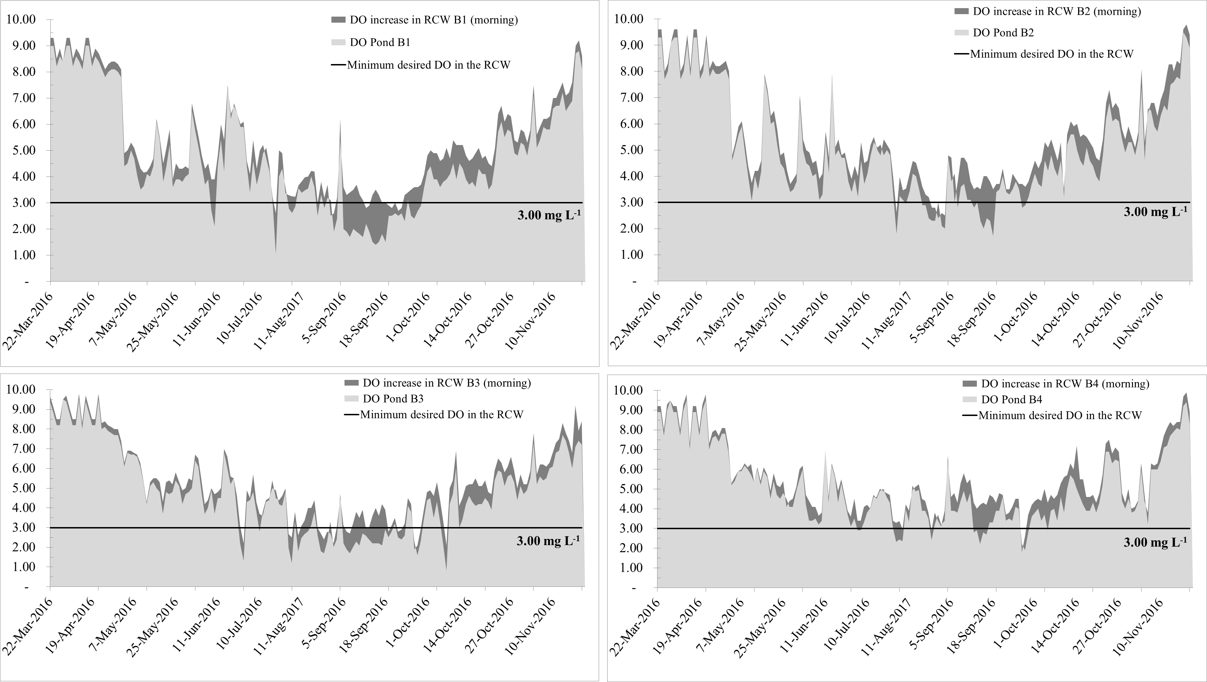
Year 2
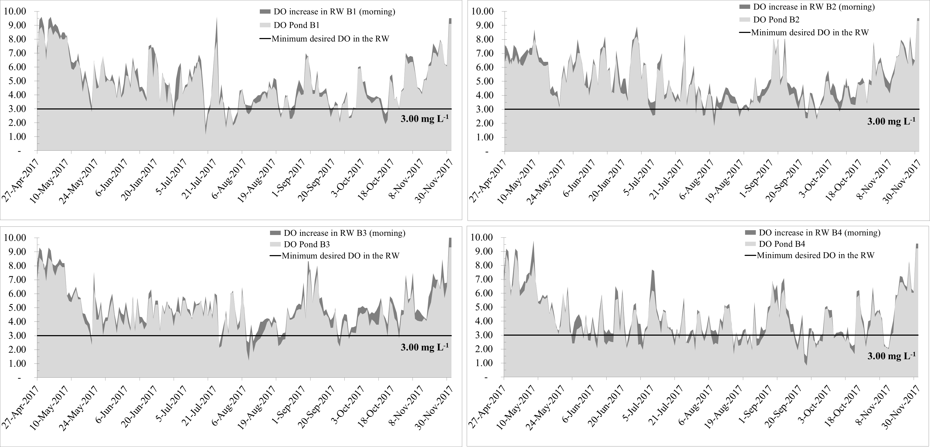

Year 3
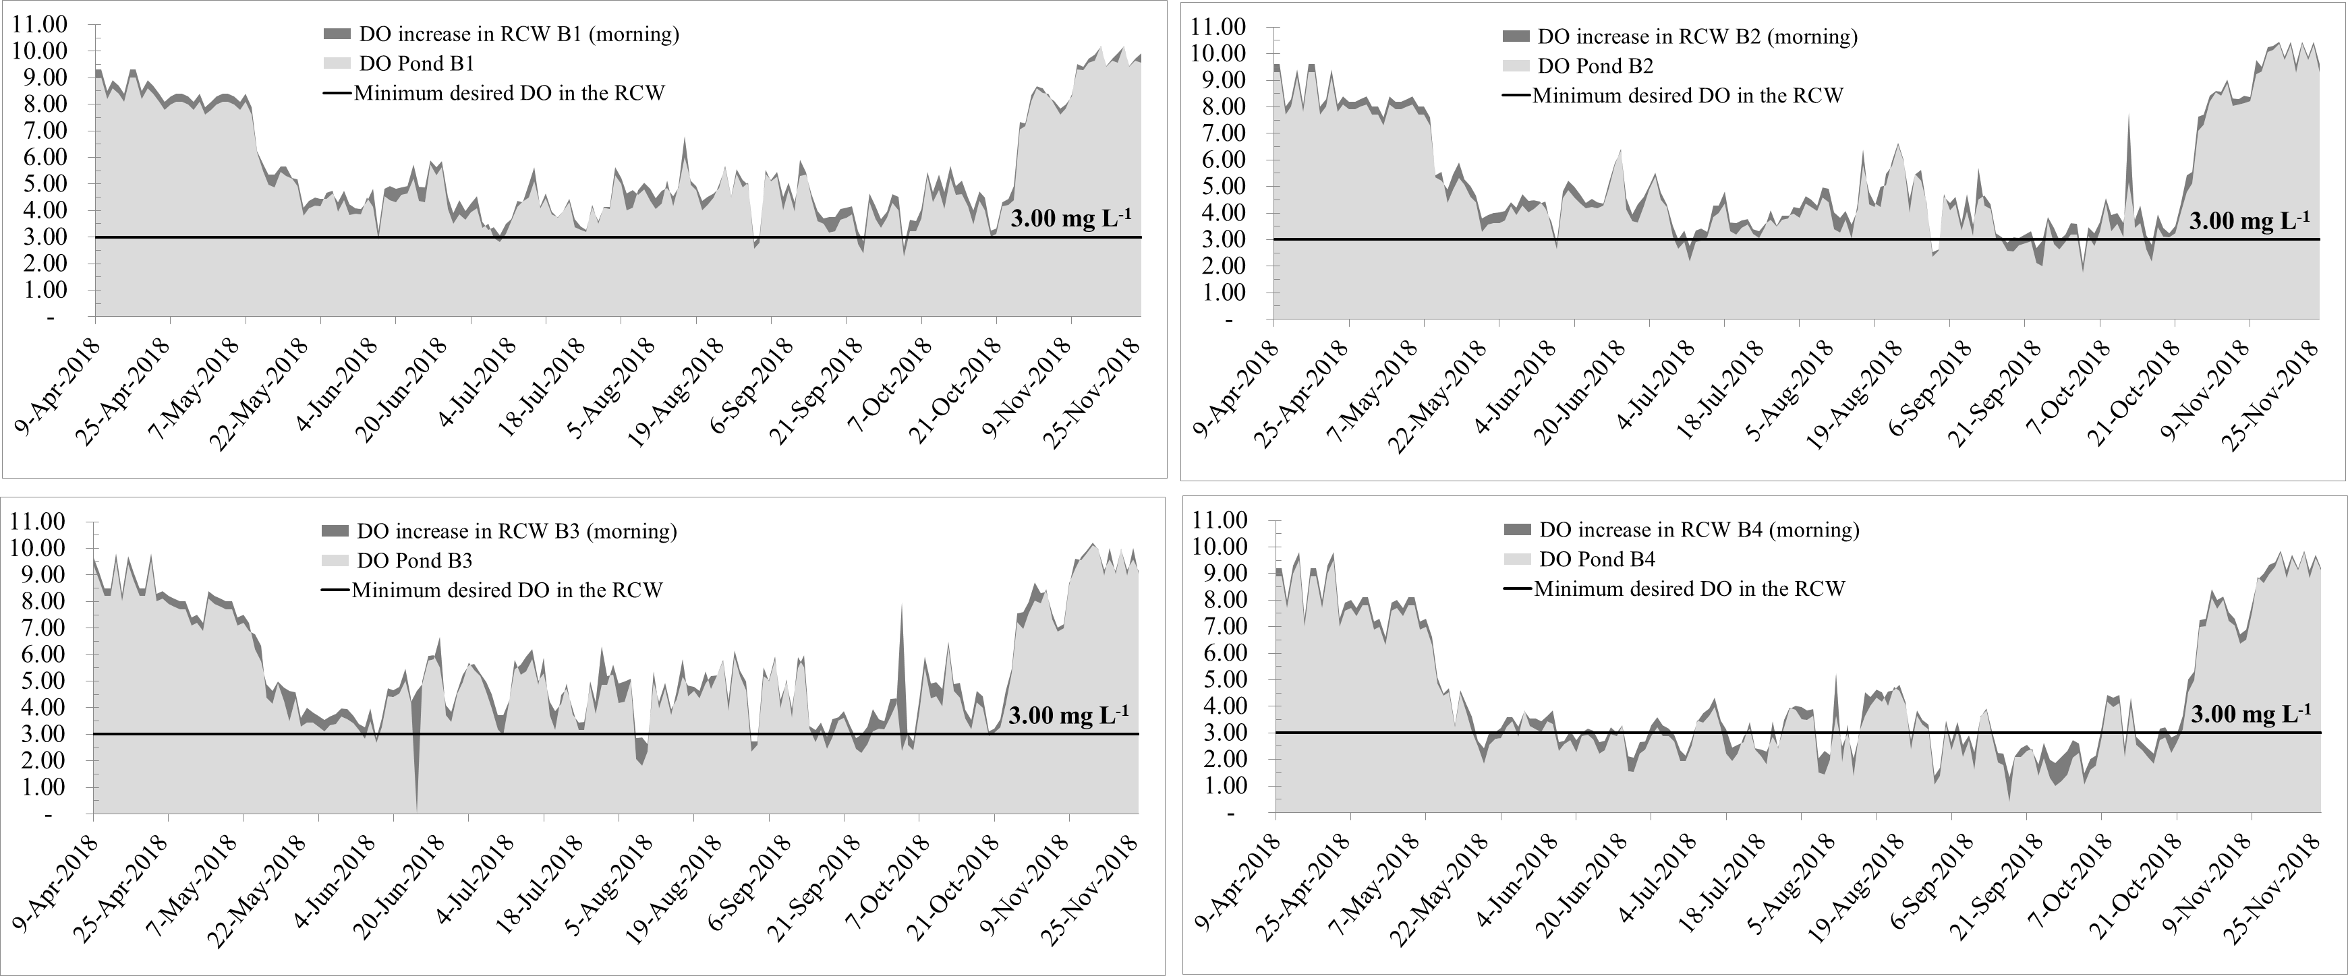
Year 4
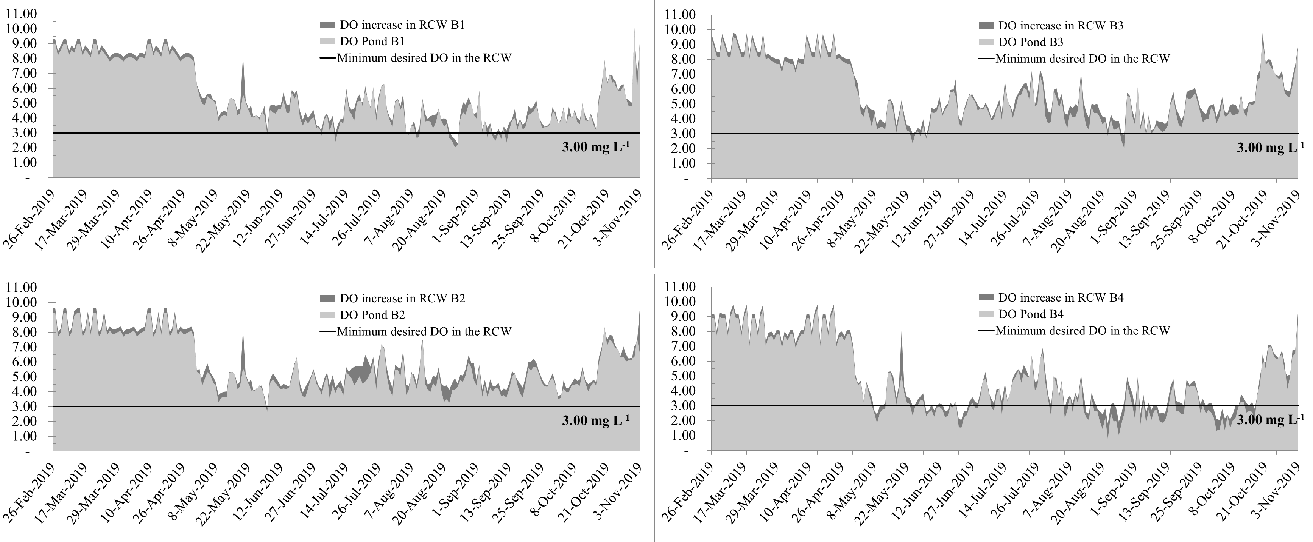
Figure 1. Illustration of the early morning dissolved oxygen concentration in the pond (light grey) and inside the raceway (dark grey) in pond B1, B2, B3 and B4 (Year 1, 2, 3 and 4). The dark grey above the light grey area indicates how much oxygen the aeration device added to the water at the entrance of the raceway, keeping dissolved oxygen levels inside the raceway above 3 mg L⁻¹ (minimum desired level) and seldom below 2 mg L⁻¹, even when pond DO approached values close to 1 mg L⁻¹.

