2021 Final Progress Reports for On-farm Soybean Potassium Project
Project Title: Evaluating the effects of Potassium Fertilizer on the Yield and Productivity of On-farm Soybean Production.
Prepared by: IDOWU, Ayodeji Peter
Principal Investigator (PI): Dr. Bhupinder Farmaha
Background:
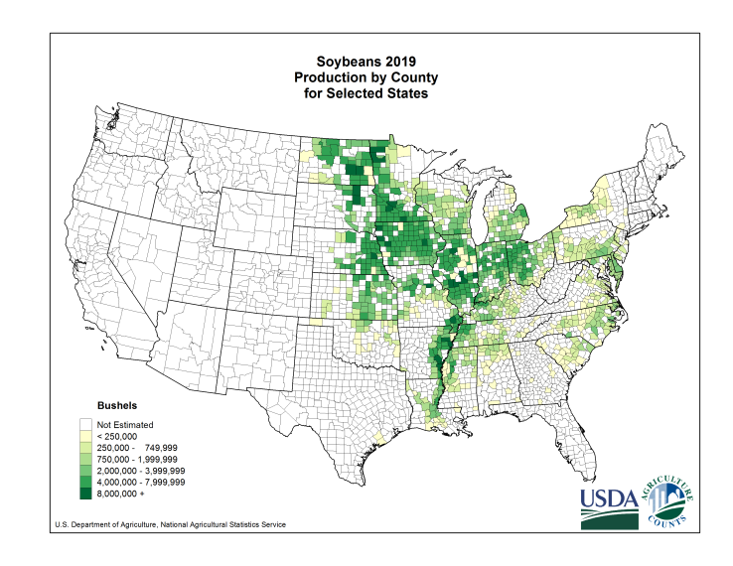
Potassium (K) is an essential nutrient for soybean (Glycine max L) growth and development. Potassium deficiency can lead to low soybean seed yield (Stammer and Mallarino, 2018). Adequate K fertilization has been shown to increase the seed yield (Heckman and Kamprath, 1995; Parvej et al., 2015). However, the effect of K fertilization on seed yield has not always been positive, even on sandy Coastal Plain soils with low soil-test K (STK) (Evanylo, 1991; and Woodruff and Parks, 1980). While Parvez et al. (2015) found an effect of K application on seed yield, Fernandez et al. (2009) did not while Ebelhar and Varsa (2000) and Farmaha et al. (2011) found a linear decrease in seed yield with an increase in K fertilizer rate. Therefore, evaluating soybean yield response to fertilizer-K application across on-farm sites is needed. In 2021, we conducted five on-farm and two on-station trials. We have yet to analyze the 2021 results. However, 2021 datasets will not be adequate to make changes to Clemson’s recommendations as more years of data are needed, including other soil types, cropping systems, and environments. Additional information will help us to ascertain the residual and cumulative effects of fertilizer-K applications in the region.
Completed Tasks:
The test plots were harvested using a 2-row calibrated plot combine (shown below) while preliminary analysis on soybean yield and productivity will be conducted using raw weights of the harvested grains from the two middle rows. Composite soil samples from three sampling depths (0-4, 4-12, and 12-24 inches, respectively) were collected randomly from the test plots after harvesting. A portion of the collected soil samples will be used for soil health assessment. Similarly, we will use part of the collected soybean grains (picture below) as well as the trifoliate leave samples from each field to analyze nutrient uptakes and nutrient use efficiency.
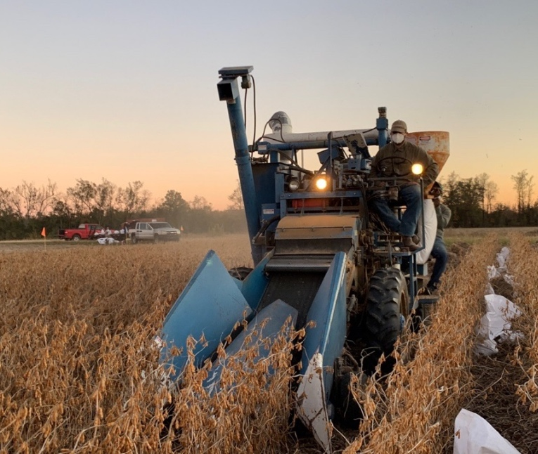Almaco two-row plot combine | 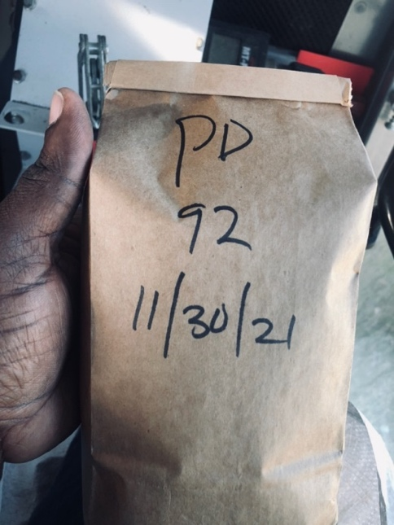A 600 g Soybean Grain Sample

The table below summarizes the management practices of the stakeholders and the field activities from all the selected sites.
Producer | Dean Hutto | Joe Alvin | Wes Woodard | Pee Dee REC | EREC | Racheal Sharp
Management | Dryland | Dryland | Dryland | Irrigated | Irrigated | Dryland & Irrigated
Nearest City | Providence | Edgefield | Darlington | Darlington | Blackville
County | Orangeburg | Edgefield | Florence | Florence | Barnwell | Allendale
Planting date
Baseline Soil Sampling date | 05/27/21 | 05/20/21 | 07/28/21 | 06/26/21 | 05/20/21 | 06/07/21
Fertilizer Application date | 06/28/21 ~ 06/29/21 | 07/06/21 | 08/02/21 | 07/07/21 | 07/06/21
Harvesting date | 11/15/21 | 11/17/21 | 11/29/21 | 11/30/21 | 12/28/21 | 12/15/21
End of Season Soil Sampling | 01/19/22 | 01/10/22 | 12/29/21 | 01/11/22 |  | 01/04/22 ~ 01/05/22
Challenges/Difficulties:
We could not complete all field activities by December due to unfavorable weather conditions, machinery breakdown, holidays, and the recent spikes in COVID-19. However, we could finish the harvest of the last field by the third week of January and complete soil sampling. However, we have yet to analyze soil and seed samples. At the next board meeting, we will present results from yield data.
Expected Outputs:
Results from these studies will provide detailed information to refine Clemson’s potassium fertilizer recommendations to optimize soybean yields and improve farm profitability. Results will be compiled, published, and made available for stakeholders and recommended for other soybean producers across the southern state of the United States of America. We will share the yield results at the next board meeting.

