2021 Final Progress Reports for On-farm Soybean Broiler Litter Project
Project Title: Evaluating the Effects of Broiler Litter on the Soybean Productivity and Soil Health Through On-farm Trials.
Prepared by: IDOWU, Ayodeji Peter
Principal Investigator (PI): Dr. Bhupinder Farmaha
Background:
The recent hikes in fertilizer price, especially major chemical fertilizers required to manage and maintain crop yield and productivity, have left farmers with no other options than continuous search for alternative, low-cost fertilizers while maintaining or improving crop productivity and enhancing soil health. Broiler litter is a low-cost fertilizer source provides that can solve this problem. However, research regarding its management practices in the southern region of the US is underreported. Compared to inorganic fertilizer, broiler litter s often have out-yielded inorganic chemical fertilizers due to its rich source of mineral nutrients (primary nutrients but secondary and micronutrients) that are readily available for crop usage (UGA 2013 Cooperative Extension Article). Broiler litter also increases soil aggregate stability, soil water infiltration and reduces P transport potentials due to surface runoff and erosion (Wortmann and Shapiro, 2008) by adding organic matter to the soil (Lin et al., 2016).
Local research on broiler litter is needed to develop management practices regarding its application rates in the southeastern region of the USA (Georgia, Mississippi, Alabama, Arkansas, and North Carolina), where two-third of broiler production in the USA comes from (Lin et al., 2016). Even though the effects or impacts of broiler litter application could go beyond one cropping season depending on many factors as suggested by Wortmann and Shapiro (2008), not many research or publications have been published or documented to support this claim.
Results from 2021 studies show that broiler litter can increase soybean yield, though this yield response to broiler litter application varied across sites. Therefore, additional research is required to ascertain broiler litter's residual and cumulative effects.
Completed Tasks:
The test plots were harvested using a 2-row calibrated plot combine (shown below), while preliminary analysis on soybean yield and productivity will be conducted using raw weights of the harvested grains from the two middle rows. Composite soil samples from three sampling depths (0-4, 4-12, and 12-24 inches, respectively) were collected randomly from the test plots after harvesting. A portion of the collected soil samples will be used for soil health assessment, nutrient availability, and concentrations, including heavy metals build-up with different broiler litter applications. At the same time, the resulting data will be compared with that of the baseline samples earlier collected. Similarly, we will use part of the collected soybean grains (picture below) as well as the trifoliate leave samples from each field to analyze the total nitrogen content, nutrients uptake, and nutrient use efficiency as well as the total nutrients removed from the soil and other parameters relating to evaluation of plant-soil nutrient analysis.
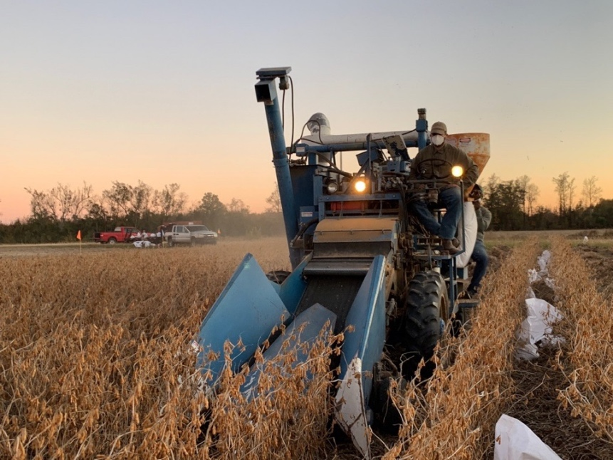Almaco two-row plot combine | 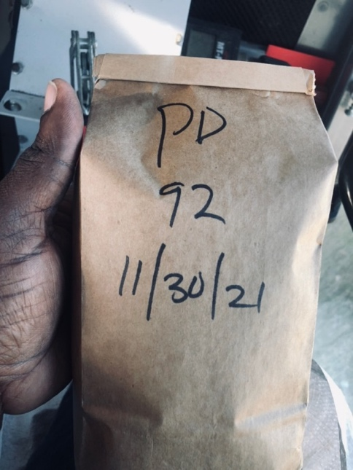A 600 g Soybean Grain Sample

The table below summarizes the management practices of the stakeholders and the field activities from all the selected sites.
Producer | Dean Hutto | Joe Alvin | Wes Woodard | Pee Dee REC | EREC | Racheal Sharp
Management | Dryland | Dryland | Dryland | Irrigated | Dryland | Dryland & Irrigated
Nearest City | Providence | Edgefield | Darlington | Darlington | Blackville
County | Orangeburg | Edgefield | Florence | Florence | Barnwell | Allendale
Planting date
Baseline Soil Sampling date | 05/27/21 | 05/20/21 | 07/28/21 | 06/26/21 | 05/20/21 | 06/07/21
Fertilizer Application date | 06/28/21 ~ 06/29/21 | 07/06/21 | 08/02/21 | 07/07/21 | 07/06/21
Harvesting date | 11/15/21 | 11/17/21 | 11/29/21 | 11/30/21 | 12/28/21 | 12/15/21
End of Season Soil Sampling | 01/19/22 | 01/10/22 | 12/29/21 | 01/11/22 |  | 01/04/22 ~ 01/05/22
Challenges/Difficulties:
We could not complete all field activities by December due to unfavorable weather conditions, machinery breakdown, holidays, and the recent spikes in COVID-19. However, we could finish the harvest of the last field by the third week of January and complete soil sampling. However, we have yet to analyze soil and seed samples. At the next board meeting, we will present results from yield data.
Expected Outputs:
At the end of this research, our findings will provide detailed information about how much broiler litter is needed to optimize soybean yield and whether it varies among sites. All results will be compiled, published, and made available for stakeholders and recommended for other soybean producers across the southern region of the USA.

