**SC Soybean Board Final Report**

**General Information**

**Principal Investigator(s) Name(s):** Michael Plumblee and Jeremy Greene  
**Organization:** Clemson University

**Date: 1/17/2022**

**Quarter: Final**

**Proposal Information**

**Title:** Evaluation of Soybean Insecticide Wash-off Intervals for Maximizing Pesticide Efficacy

**Amount Expended to Date: $8,149**

**Project Summary**

*Soybean farmers in South Carolina typically spend between 5 and 20% of their total annual input cost on pesticides. With the unpredictable weather, commodity price, and pest infestations that SC Soybean farmers have experienced over the last decade, timeliness and effectiveness are critical in maximizing overall profits. Because some common soybean insecticide labels do not provide rain fast intervals following application, this research aims to develop recommendations to define the rain-free period to maximize pesticide efficacy and residual control.*

*Treatments consisted of Bifenthrin (Brigade 2EC) being sprayed at a full rate of 6.4 oz/acre. Simulated rainfall (irrigation) was then applied to specific plots immediately following application to 30 minutes, 1-1.5 hours, 3-4 hours, 6-7 hours, and 24 hours after application.* *An untreated control was included for comparison purposes as well as plots receiving no simulated rainfall for at least 24 hours. The insect species that were counted include kudzu bug, three-cornered alfalfa hopper, stink bugs, soybean looper, velvet bean caterpillar, grasshoppers, and others. Sweep net sampling was conducted prior to and after pesticide applications are made to monitor control.*

***Stinkbugs:***

*Soybean plots were swept with a sweep net at various intervals after insecticide and wash-off treatments were applied, all insects caught in the sweep net were counted in the lab. Since stinkbug is a common pest that soybean farmers deal with each year, we analyzed the results based on stinkbug in this portion of the trial. From these results we observed significant differences between treatments at each sampling timing, however, the most significant impact was a result of where Bifenthrin was applied and where it was not. (Figures 1, 2, and 3). Among the insecticide-treated plots control remained similar regardless of when the insecticide was washed off after application. Furthermore, water applied alone (0.3” of simulated rainfall per plot) did not impact stinkbug populations. Based on these results, we can conclude that in 2021 we achieved excellent stinkbug control even when simulated rainfall was applied immediately following a Bifenthrin application, allowing pesticide applicators more flexibility when applying these products and better understanding their efficacy if a rain event should follow. We did note that stinkbug populations in this trial did not build to threshold levels until very late in the growing season, due to the insects moving into the soybeans so late, yield results may vary in a year where stinkbug pressure occurs earlier in the season.*

***Other Insects:***

*Additionally, several other insects were evaluated in this trial to determine if product efficacy was reduced due to wash-off intervals. When analyzing all caterpillar pests that were caught in the sampling nets, no significant differences were observed among all treatments both sprayed and untreated with insecticide. Again, we hypothesize that this was a result of low pest populations in the field. Kudzu bugs were also analyzed and displayed a similar result to the caterpillar pests where no differences in kudzu bug numbers were revealed regardless of treatment.*

***Yield:***

*Ultimately, without seeing drastic differences in insect numbers from the sampling timings we hypothesized that significant yield differences would also be unlikely. Upon harvest, we confirmed our hypothesis that no significant yield differences were observed in this trial among treatments regardless of wash-off interval timing or whether an insecticide was applied or not. (See Figure 4). Plots that never received an insecticide application season-long still resulted in a soybean yield of 50 to 60 bushels/acre.*

**Key Performance Indicators**

The KPIs for this research helped determine if specific soybean insecticides have reduced efficacy on control soybean pests when exposed to different simulated rainfall events at the field scale. These results could alter how soybean farmers apply pesticides to ensure that they maximize efficacy and profitability reducing the likelihood of having a product failure. The key performance indicator will be to define the simulated rainfall interval in which pesticide efficacy was not altered for soybean pesticides. From our results, we determined that in 2021, wash-off intervals did not influence product efficacy among stinkbugs, lepidopteran pests, or kudzu bugs. Challenges that were faced in this research that could have influenced the KPIs measured would have been the overall pest pressure in the natural landscape where the trial was conducted, resulting in non-yield limiting pest populations.

**Next Steps**

*The next steps of this project would be to evaluate wash-off intervals among insecticides within a year where pest pressure is yield-limiting and occurs earlier in the growing season. From there, we aim to publish these results in an Extension report/bulletin, on the new SC Crops Blog and begin sharing with soybean growers across the region at local, regional, and national meetings. This research has already been presented at the 2021 SC Corn and Soybean Grower’s Meeting held in Santee, SC on Dec. 8th, 2021.*

**Additional Information**

*See the figures below that contain results from the 2021 research presented above.*

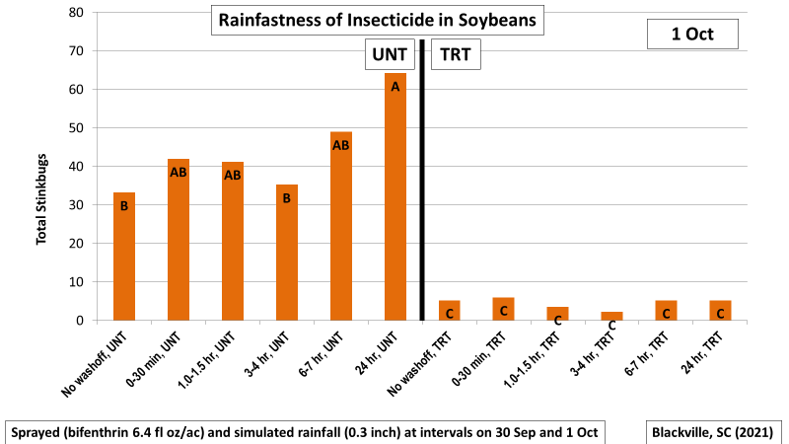

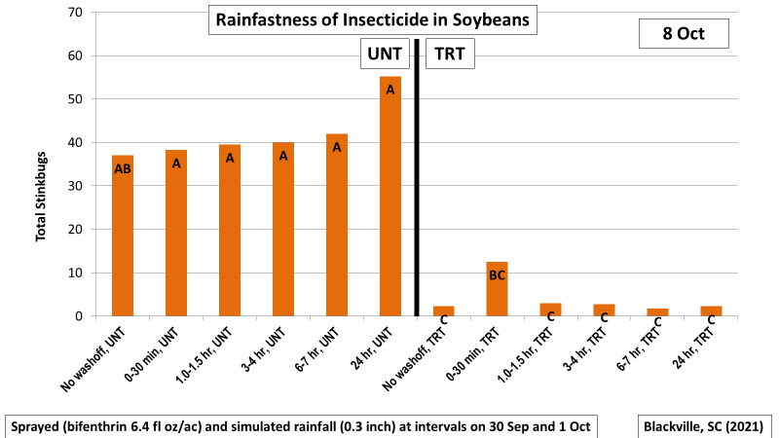

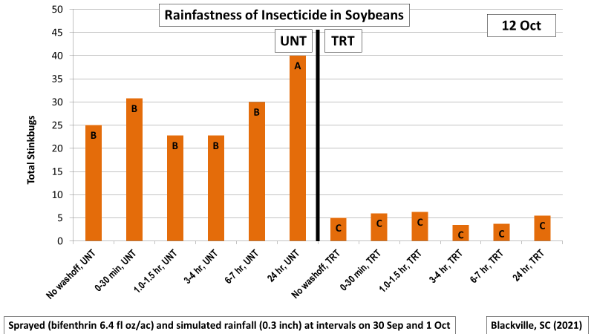

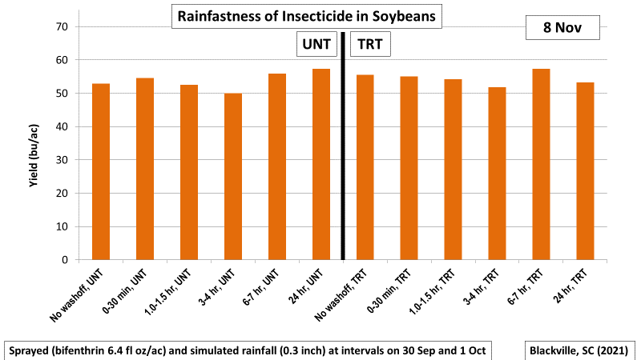

Prior to submission, reports should be saved as a pdf document using the following naming convention; 2022Date(MMDD)_(PI Last Name)_(Abbreviated Proposal Title)_Final.