**2021 Pennsylvania Soybean Board Research Project Final Report**

**Soybean Response to Nitrogen and Sulfur Rate and Timing of Fertilizer Application**

**Project period:** 3/1/21 – 2/28/22

**Project Leader:**

Charles White, Assistant Professor and Extension Specialist, Soil Fertility and Nutrient Management, Department of Plant Sciences, Penn State

**Project Overview:**

The primary goal of this project was to determine whether soybean yield and quality were responsive to sulfur fertilization in the soybean year or previous corn year in a soybean-corn rotation. We used plots which were fertilized with ammonium sulfate, gypsum, poultry litter, or elemental S as their sulfur source in 2020, the corn year of the rotation. We determined the depth distribution of the sulfur applied in 2020 from the different S sources prior to soybean planting in 2021, and monitored soybean rooting depth to identify when plants could access the S deep in the soil profile. We also determined if there was an interactive effect between nitrogen and sulfur fertilization on soybean yield and quality, since S is often applied as ammonium sulfate.

To achieve these goals, we used in-season plant tissue sampling, shallow soil sampling (8” depth), deep soil sampling (32” depth), and grain sampling to evaluate crop performance and soil nutrient storage. We compared the nutrient uptake of the plants in the different treatments and used the Penn State Ag Analytical Services Laboratory (AASL) interpretive nutrient levels for plant tissue samples to determine the nutritional status of the crop (low, normal, high, excessive). We compared the levels of S available throughout the growing season in the different treatments using the shallow soil samples. We also monitored soybean rooting depth and how it relates to the distribution of S throughout the soil profile. This research will allow Pennsylvania soybean growers to make more economical decisions about the timing of S fertilization in soybean-corn rotations.

**Activities to Date (December 2020 – March 2022)**

In 2020 we conducted an experiment to demonstrate the effectiveness of different S containing fertilizers in corn at the Russell E Larson Agricultural Research Center. Sulfur was applied at a rate of 40 lbs per acre using gypsum, ammonium sulfate (AMS), elemental S, and poultry litter, while four No S check plots were maintained. We chose this site for the experiment in 2021 since it would be rotated to soybeans and included No S check plots which we could treat with S in 2021 (Figure 1). The plots were 25’ x 15’. Four replications of this design were included in the experiment.

After corn harvest in 2020, deep soil samples (32” depth) were taken from each of the plots in December to evaluate the distribution of S throughout the soil profile. Prior to soybean planting in 2021, deep soil samples were taken again in May to assess the degree to which S had been retained in the soil profile against leaching. We also took deep soil samples after soybean harvest in November 2021 to determine residual S distribution in the soil profile after two growing seasons. We performed Mehlich III extractions on these samples and analyzed the extracts for S concentration.

Soybeans were planted on 26 May 2021 and S and N treatments were applied to their respective plots on 27 May 2021. Plots which received only S were treated with 40 lbs S per acre as gypsum, plots which received S and N were treated with 40 lbs S per acre and 35 lbs N per acre as AMS, and plots which received only N were treated with 35 lbs N per acre as urea. 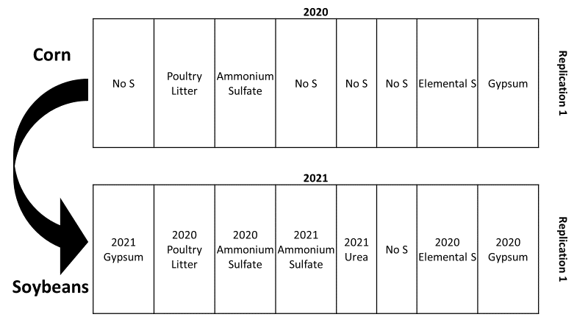

*Figure 1. Example of plot layout in 2020 and 2021. Plots which received S in 2020 did not receive S in 2021. The 2021 gypsum, AMS, urea, and No S treatments were randomly assigned to the plots which did not receive S in 2020.*

In June, whole soybean plant samples were taken from each of the plots when plants were at the V2 growth stage. Samples were dried, ground and sent to AASL for tissue nutrient analysis. Shallow soil samples (8” depth) were also collected from the plots to assess the available S. Finally, we collected deep soil samples from the borders of the plots to measure soybean rooting depth. The rooting depth samples were taken back to our laboratory and dissected to record the maximum depth of plant root growth.

Soybean trifoliates were sampled at the R1 growth stage in July. Samples were dried and ground and sent to AASL for tissue nutrient analysis. Shallow soil samples were also collected from the plots, and have been analyzed for S. We then collected deep soil samples to measure soybean rooting depth. The rooting depth samples were dissected and rooting depth measurements were made.

A third set of shallow soil samples and deep soil samples were taken when plants were at the R5 growth stage in late August. The shallow samples were analyzed for S concentration. The deep soil samples were returned to the laboratory and dissected to determine rooting depth.

At the end of the growing season soybean grain yield was measured from each of the plots. Samples of grain from each plot were collected and sent to a commercial lab to be analyzed for total S, crude protein, cysteine, and methionine. This allowed us to determine the effect of the fertility treatments on grain quality as well as yield.

**Results**

The deep soil samples collected after 2020 corn harvest, prior to 2021 soybean planting, and after 2021 soybean harvest were separated into 8” depth segments. We performed Mehlich III extractions on each depth segment and measured the S concentration in the extract using inductively coupled plasma atomic emission spectroscopy (ICP). The treatments were not significantly different at any depth at any sampling date (Figure 2). This is a surprising result, as it is stark contrast to the results found in a previous study using the same treatments and sampling approach as this study. However, we observed in both studies that the drought during the 2020 growing season inhibited S leaching into deeper soil layers, which may be partially responsible for the lack of a treatment effect between plots which received S and the No S check plots. Another possible explanation is that a history of ammonium sulfate application at the site led to Mehlich III S concentrations in the 16-24 and 24-32-inch depth segments of 42 and 62 ppm, respectively, prior to the experiment.

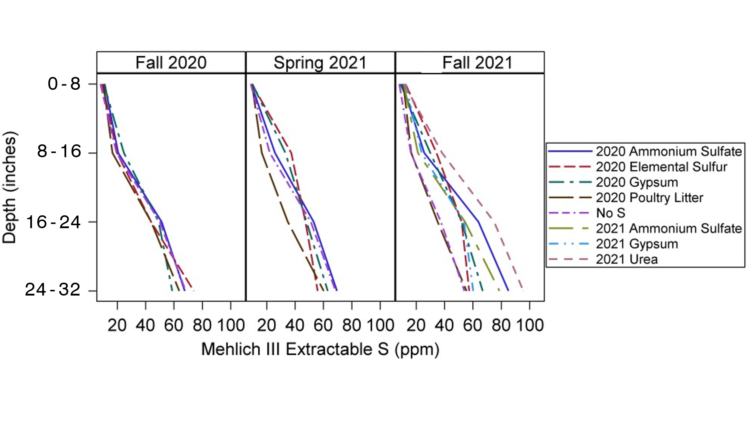

*Figure 2. Mehlich III extractable S distribution in the soil profile in Fall 2020 after corn harvest, Spring 2021 prior to soybean planting, and Fall 2021 after soybean harvest. There was not a significant treatment effect at any depth on any of the sampling dates.*

Deep soil samples collected in June, July, and August were taken to the laboratory after collection and dissected to measure rooting depth. One core was taken from the border of each replication, 4” from the soybean row, to a depth of 32”. Dissection began from the bottom of each soil core and proceeded towards the top until the first living root was identified and this was considered the maximum rooting depth. Based on the maximum observed rooting depths, at the V2 stage soybean roots reached a depth of 14”, where Mehlich 3 S concentrations ranged from 16 to 37 ppm. At the R1 stage, roots had extended to a depth of 29.5” where soil layers contained significantly greater S than the layers above and ranged from 56 to 70 ppm. At the R5 stage, roots had extended the entire 32” sampling depth, and possibly further into the subsoil. Mehlich III S concentrations in the 24-32” depth ranged from 54 to 95 ppm.

*Table 1. Observed maximum rooting depth at the V2 and R1 soybean growth stage from deep soil samples collected from the borders of the experiment.*

|  |  |
| --- | --- |
| Growth stage | Maximum Rooting Depth (inches) |
| V2 | 14 |
| R1 | 29.5 |
| R5 | 32+ |

Whole soybean plants were collected from each plot when plants were at the V2 growth stage. Twenty-five plants were clipped at the soil surface, dried, ground and sent to AASL for plant tissue nutrient analysis. The plots which received gypsum in 2021 had significantly higher tissue S concentration than any other treatment (Figure 3A). The 2021 urea treatment had significantly lower tissue S concentration than all other treatments, including the untreated plots. The 2020 elemental S was the only treatment of those which received S in 2020 that was greater than the untreated plots, likely due to the slow oxidation of elemental S fertilizer in soil, and no-till management resulting in high levels of S in the shallow soil. Surprisingly, the 2021 ammonium sulfate treatment did not result in greater tissue S concentration than the untreated plots despite receiving the same amount of S as the 2021 gypsum treatment. Perhaps the added N in the AMS treatment and urea treatment interfered with plant S uptake.

Soybean trifoliates were collected from each plot when plants were at the R1 growth stage. Twenty-five upper, fully expanded trifoliates were collected and sent to AASL for plant tissue nutrient analysis. We found higher plant tissue S concentration in the group of treatments which had received S in either year than in the group of treatments which had not (Figure 3B). These plant tissue S concentration results are consistent with those from a previous study. All treatments were within the AASL sufficiency range for S concentration, 0.21 – 0.41 % S, at both sampling dates.

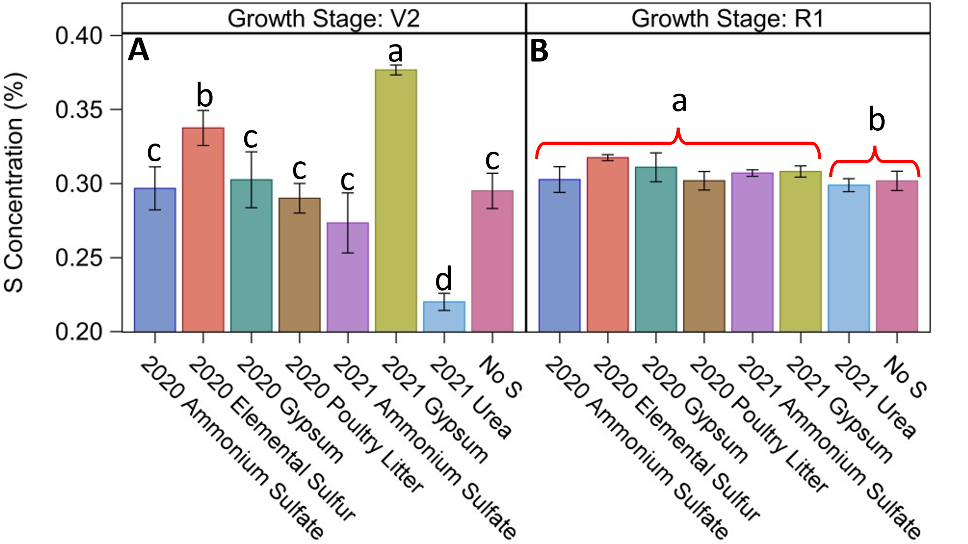

*Figure 3. S concentration in soybean plant tissue collected at the V2 (A) and R1 (B) stages of growth. Differing letters in panel A indicate significant differences at the p≤0.05 level. Differing letters in panel B indicate a significant difference between the group of treatments which received S in either year and the group of treatments which did not at the p≤0.05 level.*

Soybean grain was harvested from the center two rows of each plot in November using a small plot combine. There were no significant treatment effects on soybean grain yield (Figure 4). This finding is in agreement with that of a previous study which found no significant differences in soybean yield among these same treatments. Grain yield ranged from 62 to 70 bushels per acre at 13% moisture.

*Figure 4. Soybean grain yield from each of the eight S treatments. There were no significant differences between treatments at the p**≤0.05 level.*

Soybean grain samples were collected at the time of harvest to be analyzed for quality parameters. Samples were analyzed for crude protein, total S, cysteine and methionine concentrations. There were no significant treatment effects on crude protein, total S or methionine concentrations. Although there was not a significant treatment effect at the p≤0.05 level, the results indicated a trend for the group of treatments which received S in either year to have greater cysteine concentration than those which did not receive S (p=0.07). In our previous study, we found a similar trend of greater cysteine concentrations in grain from treatments which had received S, but in that study the effect of S was also significant for methionine concentrations. We found that there was a significant treatment effect on the cysteine:methionine ratio (Figure 5), with treatments which received S having a ratio closer to 1:1 than those which had not. This is an important finding since research has shown that broiler performance is optimized when the cysteine:methionine ratio in feed is 1:1 or 50:50.

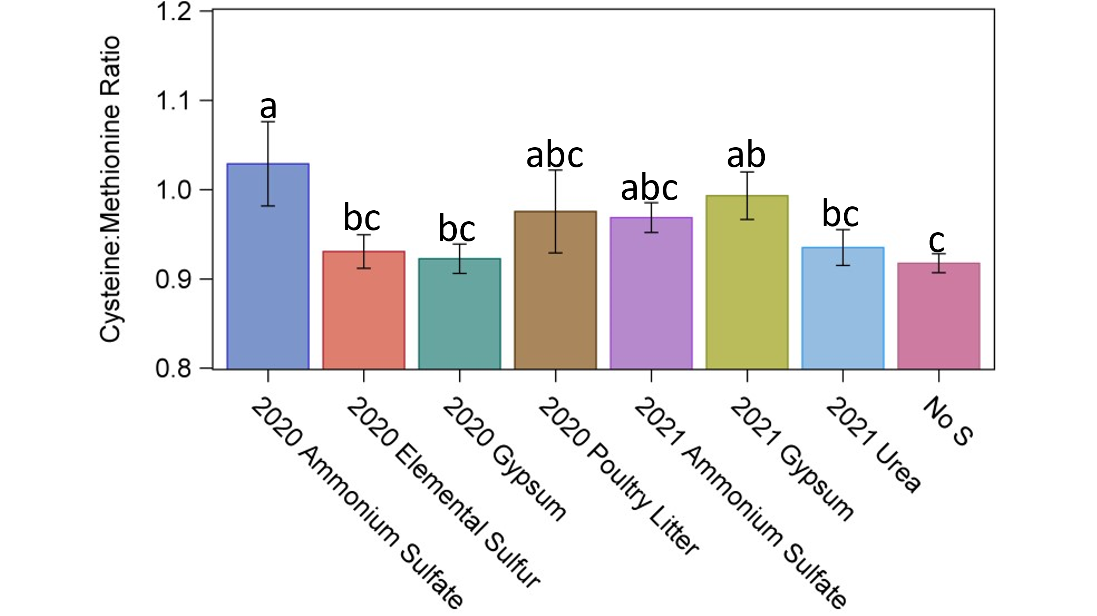

*Figure 5. Soybean grain cysteine:methionine ratio in samples collected at harvest. Differing letters indicate statistically significant differences at the p≤0.05 level. A cysteine:methionine ratio of 1.0 (i.e., 1:1 or 50:50) is ideal for animal feed.*

**Presentations, Publications, and Meetings**

Results from this study, and our previous study funded by the Soybean Board, were presented at the 2020 and 2021 Agronomy Society of America meetings. The two presentations were “Can soybeans access deep legacy sulfur?” and “Sulfur fertilizer affects soil and plant tissue S in a corn-soybean rotation”. Both presentations received positive feedback from attendees. Data and results from this study were also presented at the 2021 Pennsylvania Association of Professional Soil Scientists annual meeting in a presentation entitled “Stratification of P, C, S, and N in agricultural soils of Pennsylvania”. This presentation generated some excellent discussion among the attending soil scientists. Results from this study also were used in the creation of a new Penn State Extension fact sheet, “Sulfur fertility management for grain and forage crops” which is available to the public for free online. These results have also proven useful in answering farmers’ questions about S fertility management.