Final Report May 2021

TITLE: Assessing Management Options and Inputs for Significant Soybean Diseases in Minnesota

AUTHOR: Dean Malvick, Dept. of Plant Pathology, University of Minnesota

RESEARCH SUPPORT PERSONNEL: Crystal Floyd (Researcher)

Funding for this project was provided from the Minnesota Soybean Research and Promotion Council (MSR&PC). MSR&PC Award Number: 10-15-44-20230-7527

KEY OUTCOMES FROM THIS PROJECT
- Resistant soybean varieties and ILeVO® and Saltro® seed treatments are effective for managing sudden death syndrome (SDS)
- The resistant soybean varieties and seed treatments are effective alone and in combination (with an additive effect) to manage SDS
- Frogeye leaf spot (FLS) continues to spread across central and southern MN
- Most isolates of the FLS fungal pathogen in Minnesota appear to be resistant to the QoI (strobilurin) class of fungicides.
- The level of resistance to brown stem rot (BSR) was determined for a set of advanced breeding and existing soybean lines from the U of MN soybean-breeding program. Some varieties differed in susceptibility to the A and B types of the BSR pathogen.
- Results from this project and other information on soybean diseases have been disseminated widely via multiple means across MN, and multiple diseased soybean plant samples were diagnosed to determine the disease and management options.

INTRODUCTION: This project addresses the MSR&PC priority area of Soybean Pest Management. It focuses on the Soybean Farmers need for research into managing against yield and quality limiting effects of root and stem rots and foliar diseases. This work focuses on sudden death syndrome (SDS), brown stem rot (BSR), and frogeye leaf spot, Because these diseases are threats to soybean production in Minnesota, research was conducted to improve understanding of risk factors and disease management options.
SDS and BSR are significant soybean diseases in Minnesota and the NC Region based on USB-sponsored yield loss estimates, and are likely among the top five most important diseases in Minnesota. These diseases occur in response to favorable weather conditions and other factors. BSR occurs in most soybean production areas of Minnesota, and is a yield-limiting problem when susceptible soybean varieties are planted and weather conditions favor the disease. Crop rotations can suppress BSR. However, it is unknown how many years out of soybean are required before BSR-susceptible varieties can be produced with minimal risk.
SDS is spreading in MN and becoming more common in many areas, including west central MN and into northwestern MN where it was uncommon and where high levels of resistance in locally adapted varieties is limited or unavailable. Spread of SDS is driven in part by wet summer weather and by the time required for establishment of the SDS pathogen in fields. Seed treatments are sold for managing SDS, but they can be expensive input costs that may not pay-off with increased yields if SDS doesn’t develop.
Frogeye leaf spot (FLS) has been a significant soybean disease across the southern half of the U.S. for many years, Until recently it was uncommon in MN, but in the past few years has been increasing in distribution and severity. There is a need to understand its distribution and sensitivity to fungicides that could potentially be used to manage it.
This research produced information to improve disease management and understand risk and yield-loss for soybean. Results have been disseminated through multiple methods, including newsletters, Extension education programs, and news outlets.

OBJECTIVES
- Evaluate inputs and tactics to manage sudden death syndrome (SDS) and brown stem rot (BSR) of soybean.
- Determine distribution of frogeye leaf spot (FLS) in Minnesota and determine fungicide sensitivity for Minnesota isolates of the causal pathogen.
- Conduct extension education and diagnostic activities that address important and unusual soybean disease problems in Minnesota.

EXPERIMENTAL APPROACH AND METHODS
Objective 1A: The goal was to determine the benefits of three seed treatments (ILeVO®, Saltro®, and Heads-Up®) and resistant soybean varieties for management of SDS. Field trials were conducted at two inoculated and irrigated field locations (Rosemount and Waseca, MN) with combinations of the seed treatments and soybean varieties with different levels of SDS resistance. Plots were evaluated for the incidence and severity of SDS and for seed yield, and aerial images were taken with a drone.
Objective 1B: The goal was to evaluate soybean breeding lines and varieties for resistance to BSR. Advanced breeding and existing soybean lines from the U of MN soybean-breeding program led by Dr. Aaron Lorenz were evaluated for resistance to BSR. This research was conducted in a greenhouse under controlled conditions. Plants at the VC/V1 growth stage were inoculated in replicated studies with the two predominant types (A and B) of the BSR pathogen. BSR severity was measured at the R6 growth stage.
Objective 2: Determine the distribution of frogeye leaf spot (FLS) and resistance in the FLS pathogen to fungicides in MN. Soybean leaf samples with symptoms typical of FLS were collected from fields in five counties in south and central MN and taken to my laboratory in St. Paul. The pathogen (Cercospora sojae) was isolated from the leaves and the identity of isolates confirmed with DNA sequencing at the Univ. of Minnesota. In addition, the isolates of FLS pathogen from soybean in MN were tested in a cooperative laboratory (C. Bradley) at the Univ. of Kentucky for sensitivity to strobilurin fungicides.

RESULTS by OBJECTIVE
Objective 1A. Determine the benefits of three seed treatments and resistant soybean varieties for management of SDS. In summer 2020, replicated field studies were established at field locations in Rosemount and Waseca, MN. The studies include two commercial soybean varieties with different levels of resistance to SDS and five seed treatments (Acceleron base, ILeVO®+base, Saltro®+base, Heads-Up®+base, and untreated). The studies were planted and inoculated with the SDS pathogen in May, and plots were irrigated as needed so they received at least 1.5” of water (rain + irrigation) weekly to favor development of SDS. The studies progressed well and SDS developed in both studies. SDS incidence and severity were rated at the R5.5 and R6 growth stages and the plots were harvested for yield at maturity. Brown stem rot (BSR) also developed in the plots at Waseca, which confounded the foliar disease ratings for SDS there because the symptoms on leaves are very similar for these two common diseases.
At the Waseca field location, foliar disease index (DX) scores ranged from @42 to 66, and at Rosemount the DX scores ranged from about @2 to 66 in infested plots across the two soybean varieties and seed treatments. See the Figures and Table of results below. The SDS-resistant soybean variety had lower levels of SDS and yielded better than the more susceptible variety under SDS pressure, as expected. The ILeVO® and Saltro® seed treatments both significantly reduced SDS and increased yield relative to the untreated controls with both soybean varieties. The results demonstrate efficacy of seed treatments and variety resistance for management of SDS in the field conditions of 2020.

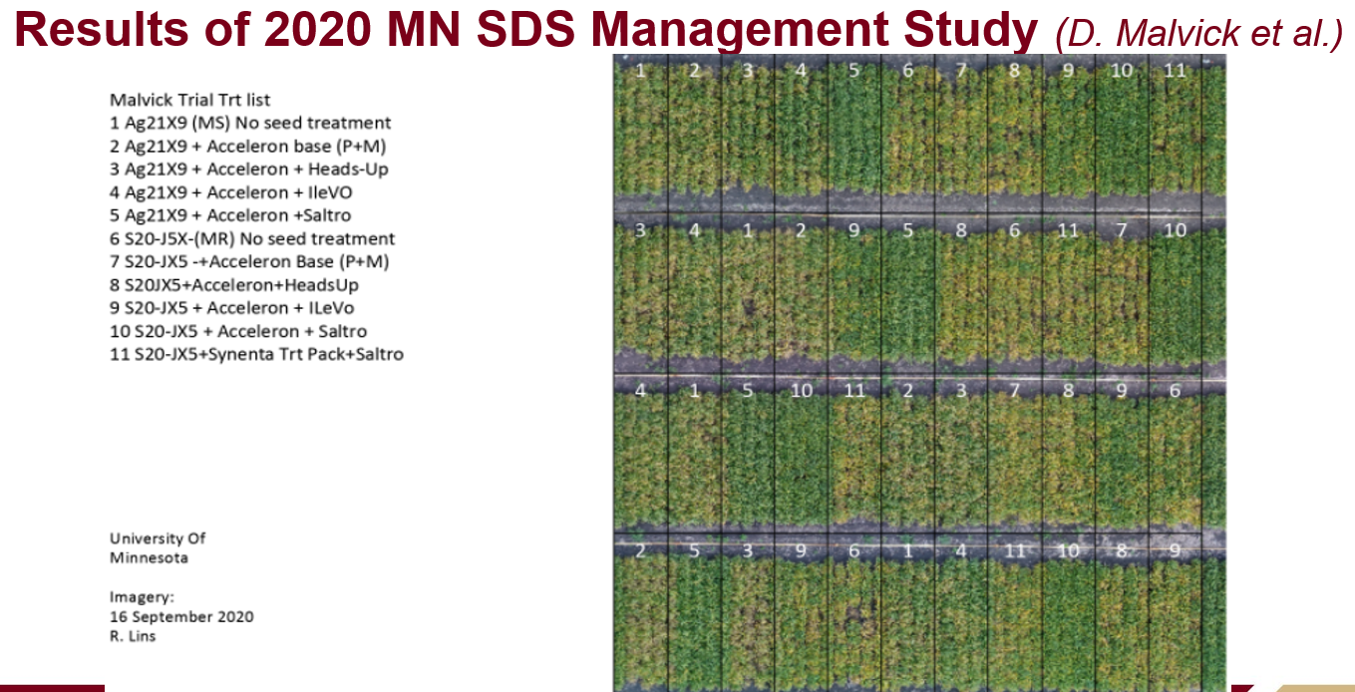

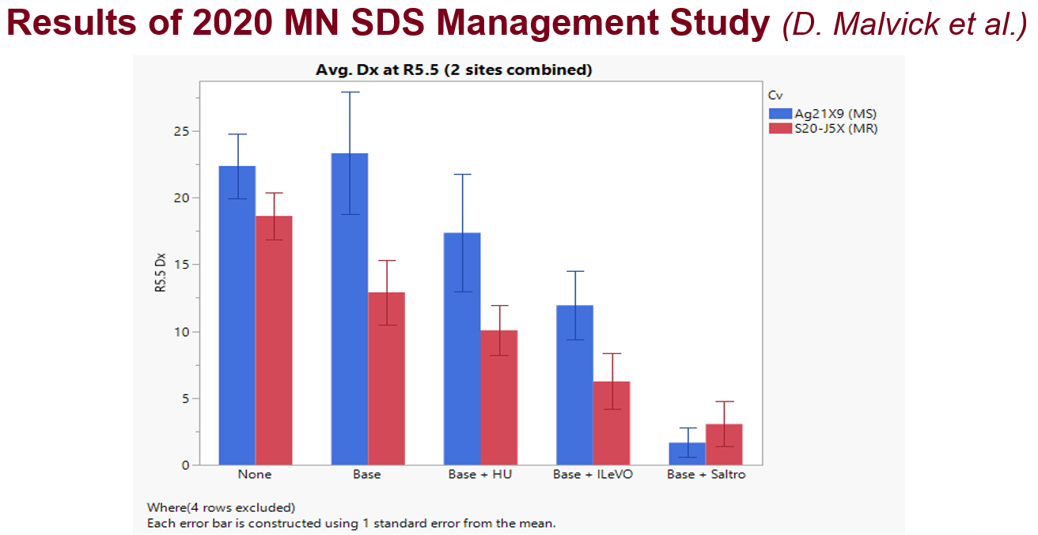

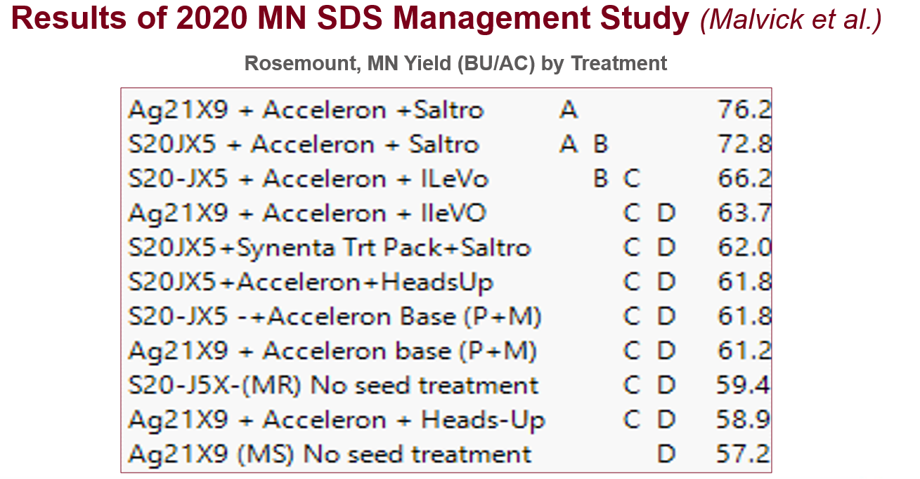

Objective 1B: Evaluate soybean breeding lines and varieties for resistance to BSR. This work was conducted in the winter of 2021 in a greenhouse in St Paul. Fifteen existing and advanced breeding lines from Dr. Aaron Lorenz (Univ. of Minnesota) were evaluated for resistance to types A and B of the BSR pathogen. In addition, Cv. Bell and Black Kato were included as resistant and susceptible controls, respectively. Stems of plants at the VC growth stage were inoculated with either type A or B of the BSR pathogen (CgA and CgB). BSR leaf symptom severity and incidence were rated 6 weeks after inoculation and internal stem symptoms severity was rated 7 weeks after inoculation. Symptoms developed in the stems, but leaf disease symptoms did not develop. Temperatures in the greenhouse reached 92F on a few days, which is high for normal BSR symptom development. Black Kato had lower stem symptoms severity than it usually does, especially with CgB. A few of the soybean lines were resistant to both genotypes, and a few appeared resistant to just Cg A (see results in Figure below).

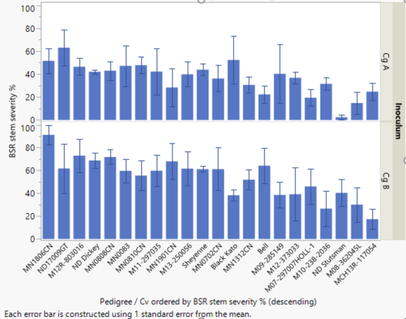

2. Determine distribution of frogeye leaf spot (FLS) in Minnesota and evaluate fungicide sensitivity for Minnesota isolates of the causal pathogen. Leaf samples with symptoms of frogeye leaf spot (FLS) were collected from eight fields in five counties (Dakota, Waseca, Redwood, Traverse, Martin) in southern and central Minnesota in 2020. The fungal FLS pathogen was isolated from the leaves and identified in my laboratory in St. Paul. FLS was common in some areas in MN again in 2021, but appeared to be less common and severe of Minnesota oveall than it was the previous two years. This was likely due by drier weather patterns in 2020. The FLS fungal pathogen (Cercospora sojae) from the leaf samples obtained from the fields in MN in 2020 were tested for QoI (strobilurin) fungicide resistance using a discriminatory dose (1ppm) laboratory assay. Of the 8 isolates from MN in 2020, 7 were resistant and one was sensitive to the fungicide.

3. Conduct extension education and diagnostic activities that address important and unusual soybean disease problems in Minnesota. Results from this project and other information on soybean diseases and their management have been disseminated via multiple phone calls, emails, blog and newsletter posts, radio interviews, interviews with ag news writers, formal extension programs and meetings, and on-line meetings with extension educators, crop consultants, farmers, and seed dealers. This has spread the information from my project broadly to farmers and their clientele and customers. In addition, we received multiple diseased soybean samples, and diagnosed them with SDS, bacterial blight, pod and stem blight, brown stem rot, Rhizoctonia root and stem rot, and frogeye leaf spot.

