Final Progress Report for “Soybean Breeding and Genetics”
Aaron Lorenz
Objectives

- Develop general-purpose (both conventional and glyphosate tolerant) and food-type soybean varieties adapted to Minnesota, and new sources of pest and disease resistance for application to Minnesota-adapted varieties.
- Continue testing public and private soybean varieties available to Minnesota soybean producers.
- Discover and develop new sources of resistance to soybean pests and diseases.

- Develop molecular markers for in-house genotyping to conduct marker-assisted selection on Phytophthora resistance.

Progress report
Objective 1
This project forms the core support of our breeding program, which is used to leverage many other funds from diverse sources, and for many projects. This final report will describe the progress made at each stage of the breeding pipeline, and end with a summary of materials transferred, licensed varieties, presentations, and publications.
- All breeding nurseries and yield trial plots were successfully planted during May and early June.
  - 38 unique parents were planted in the crossing block and 50 crosses were designed between breeding lines selected for high yield, early maturity, high protein, small seed (natto), large seed/high protein (tofu), aphid resistance, SCN resistance, Rhizoc resistance, high oleic, genetic diversity, among other traits. Nearly all crosses were successfully attempted. Harvest of F1 seeds will begin soon. This activity was reduced compared to normal because of the COVID restrictions this year.
  - The breeding nursery, where generational advancement occurs, consisted of the following numbers for each generation during the summer of 2020: 155 F2 populations (121 conv, 34 RR); 157 F4 populations (all conventional). Pod picks on all F2 populations were successfully conducted and populations were advanced to the F3 generation for planting in the Chile winter nursery. The F3 plants were pod picked in Chile and advanced to the F4 generation for planting in Saint Paul in 2021. These will form plant rows next year, and include breeding populations formed for purposes of aphid resistance, genetic diversity research, early maturity, high sucrose, SCN resistance, high oleic, high protein, and specialty seed traits such as small or large seeds.
  - F3 and F4 breeding nurseries were successfully advanced via plant pulls for planting into plant rows in 2021. Through the use of molecular markers at the single F4 plant stage, we were able to reduce the number of plant rows down to 9768. The reasons attached to breeding populations in 2020 F4/F3 nurseries included SCN resistance (both 88788 and novel sources), small/large seeds, high protein, aphid resistance, genetic diversity, modified carbohydrate, and high oleic.
  - 1984 new breeding lines were planted in preliminary yield trials (PYTs) at two locations. Lines were placed according to the maturity score in the plant row stage. Early maturing lines were planted at Crookston and Moorhead; intermediate lines were planted at Rosemount and Becker; and late lines were planted at Lamberton and Waseca. Yield, maturity, and quality data were successfully collected. A total of 304 lines performed well enough to be advanced to second year yield testing in 2021.
  - 408 breeding lines were planted in advanced yield trials at three MN locations. Early lines were planted at Crookston, Moorhead, and Shelly; intermediate lines were planted at Rosemount, Danvers, and Becker; late lines were planted at Lamberton, Westbrook, and Waseca. Data on yield, maturity, and quality were all successfully collected, except in northern MN where a very wet harvest season prevented us from harvesting some locations. One hundred and seventy lines performed well enough to advance to general regional trials and third year of testing for food-type trials in MN; All regional and advanced tests were successfully packaged and planted in 2021.
  - The 2020 regional tests were successfully conducted, including our lines and lines from regional co-operators were planted. The regional trials nearly 200 lines from the MN breeding program, plus many others from co-operators. Several lines performed well enough to be advanced to another year of regional testing. Below are highlights from some of the regional tests. A link to the complete report of the tests can be found here.
    - Northern Uniform Soybean Test MG 0: The line of most interest in this trial was M13-236028. This is a 0.7 RM line adapted to northwest MN. Over two years, it was the highest yielding line in the MG 0 Northern Uniform Soybean Tests, beating the performance check (ND Dickey) by nearly two bushels across seven environments. Greenhouse bioassays have determined it to have the Rps3a gene for Phytophthora resistance, a desired gene providing resistance to the most prevalent races. This line also has higher than average oil content, being 19.7% (on a 13% moist basis). The check variety, ND Dickey, had an oil content of 17.6%. M13-236028 will undergo purification in 2021, with breeder’s seed production expected to occur in 2022.
    - Northern Uniform Soybean Tests MG I: The most exciting lines we tested in these trials were two high oleic varieties, M07-297007HOLL-1 and M10-238-2036. M07-297007HOLL-1 (RM~1.8) is a high oleic and low linolenic variety often achieving oleic levels close to 80%, and linolenic levels less than 2%. It’s yield performance in the 2020 regional trials across 10 locations was adequate, being 95% of the best check variety. M07-297007HOLL-1 also carries strong SCN resistance, but is susceptible to Phytophthora, suggesting that a seed treatment could really benefit this line. Pure seed was increased in Puerto Rico over the winter, and approximately five acres of seed production is being grown in 2021 in Rosemount, MN by Minnesota Crop Improvement. The M10-238-2036 line is also a high oleic line but has normal linolenic levels, and overall lower oleic levels, being closer to 70%. Its RM is approximately 1.4, and yielded just one bushel less than the check closest in maturity. It is susceptible to SCN, but carries the Rps1k gene for Phytophthora resistance. Seed of this line has been multiplied many times, and at least 70 units of pure seed are currently available.
    - Northern Preliminary Soybean Tests MG I: A line to highlight in this trial is M14-151094. Its primary attribute is yield, being similar in maturity to the best check variety, but yielding almost two bushels more. This line was advanced to another year of testing, but has not reached the purification stage.
    - Northern Uniform Soybean Tests Traited Materials MG 0: These tests consist of any breeding lines with transgenic traits (e.g., herbicide resistance traits) or other specialty characteristics such as high protein. In these trials, a standout line was M13R-309021. This line carries glyphosate tolerance and yielded 94% of the commercial Asgrow check variety. This line has been advanced to another year of yield testing, and is undergoing purification in 2021 for potential breeder’s seed production in 2022.
    - Below is table of food-type and specialty lines for which breeder’s seed production was made in 2020.
Line | Market | Traits | FL/PUB/HIL | Rel. Mat. (Approx)
M10-161065 | Natto | Small seeds, Rps1c | W-G-Y | 0.9
M10-159-4007 | Natto | Small seeds, Rps1a | W-G-Y | 0.9
M11-297025 | Tofu | Large seeds (22 g/100), Rps1k | W-G-Y | 1.6
M11-297035 | Tofu | 42% pro, yld, large seeds (25 g/100), Rps1c | W-G-Y | 1.4
M12-377028 | Protein | 47% pro | W-T-L | 1.7

The following lines were transferred to Minnesota Crop Improvement in 2020 for creation of foundation seed in 2021.

Variety release
At 2020 December Crop Variety Review Committee, the Soybean Breeding Program requested permission for two releases: one germplasm germplasm release and two public releases. The document submitted to the meeting can be found in Appendix 1 at the end of this report.
The germplasm release was for M10-207102, a high protein and very early line (RM 0.0) adapted to northern Minnesota. This line will be an important breeding parent for helping to lift the protein of that region. The citation for the germplasm release publication is:
Bhusal, S., J. Orf, A. Lorenz. 2021. Registration of M10-207102 soybean germplasm: a high yielding, early maturity variety with elevated protein. J. of Plant Reg. (In press).

Germplasm transfer
It’s difficult to document the impact of the breeding program in terms of acres planted and value of seed harvested because this information is proprietary to our licensees. One way we can document impact is through examination of seed transfers and agreements signed. Below is a summary of those signed in 2020. The information of the requestor is kept confidential.
- 12 lines were transferred to private seed companies for use as parents.
- 12 lines were transferred to 5 public universities for use as parents.
- 18 lines were transferred to private companies for testing of quality and yield preceding possible licensure.
- 15 lines were transferred to other university research projects to serve as experimental materials for studies on pathology, entomology, and genetics.
Invention disclosures were filled out for 7 varieties to begin the process of licensing, or transferring lines to companies as parental stock: Soybean varieties (parents) M13-106007 (M03-172059 X A09-754003), M13-236028 (SD06-393 X M07-375020), M13-262053 (M03-172059 X LD08-12435a), M14-122031 (M08-365038 X IA1026), M14-151094 (LD08-12435a X M04-241226), M14-224050 (MN1410 X PI447003A), M14-224081 (MN1410 X PI447003A).

I spoke at a few events relevant to the breeding program:
- Soybean and Corn Plot Tours Northwest Minnesota. Aug 24, 2020. (Spoke to producers about current research activities.)
- Soybean Breeding and Genetics. May 13, 2020. Minnesota Ag Experiment Station Update.
- U.S. Food Bean Variety Breeding Program. June 10, 2020. USSEC Pan Asia Soy Food Summit and Trade Show.
- UMN Soybean Breeding and Genetics Project. Sept 25, 2020. Department of Agronomy Hayes-Phillips Award Ceremony.
- UMN Soybean Breeding and Genetics Project. Jan 6, 2021. Minnesota Ag Expo.
- University of Minnesota Soybean Breeding. March 24, 2021. NDSU Soybean Symposium.
- Developing Phenotyping Solutions Towards Optimizing Soybean Shoot Architecture. Feb. 12, 2021. Minnesota Robotics Initiative Seminar.
Publication
A publications of direct relevance to this grant was accepted in the peer-review journal Plant Phenome this last year.
Volpato, L., A. Dobbels, L. Borem, A.J. Lorenz*. 2021. Optimization of Temporal UAS-based imagery analysis to estimate plant maturity date for soybean breeding. The Plant Phenome J. (In Press).
This research project helped to develop and optimize methods for using imagery collected from unmanned aerial systems to predict date of maturity for soybean plots in a breeding program. This is important to help make the program more efficient and easy the workload of manual maturity dating in the fall. The figure below helps to outline this procedure.
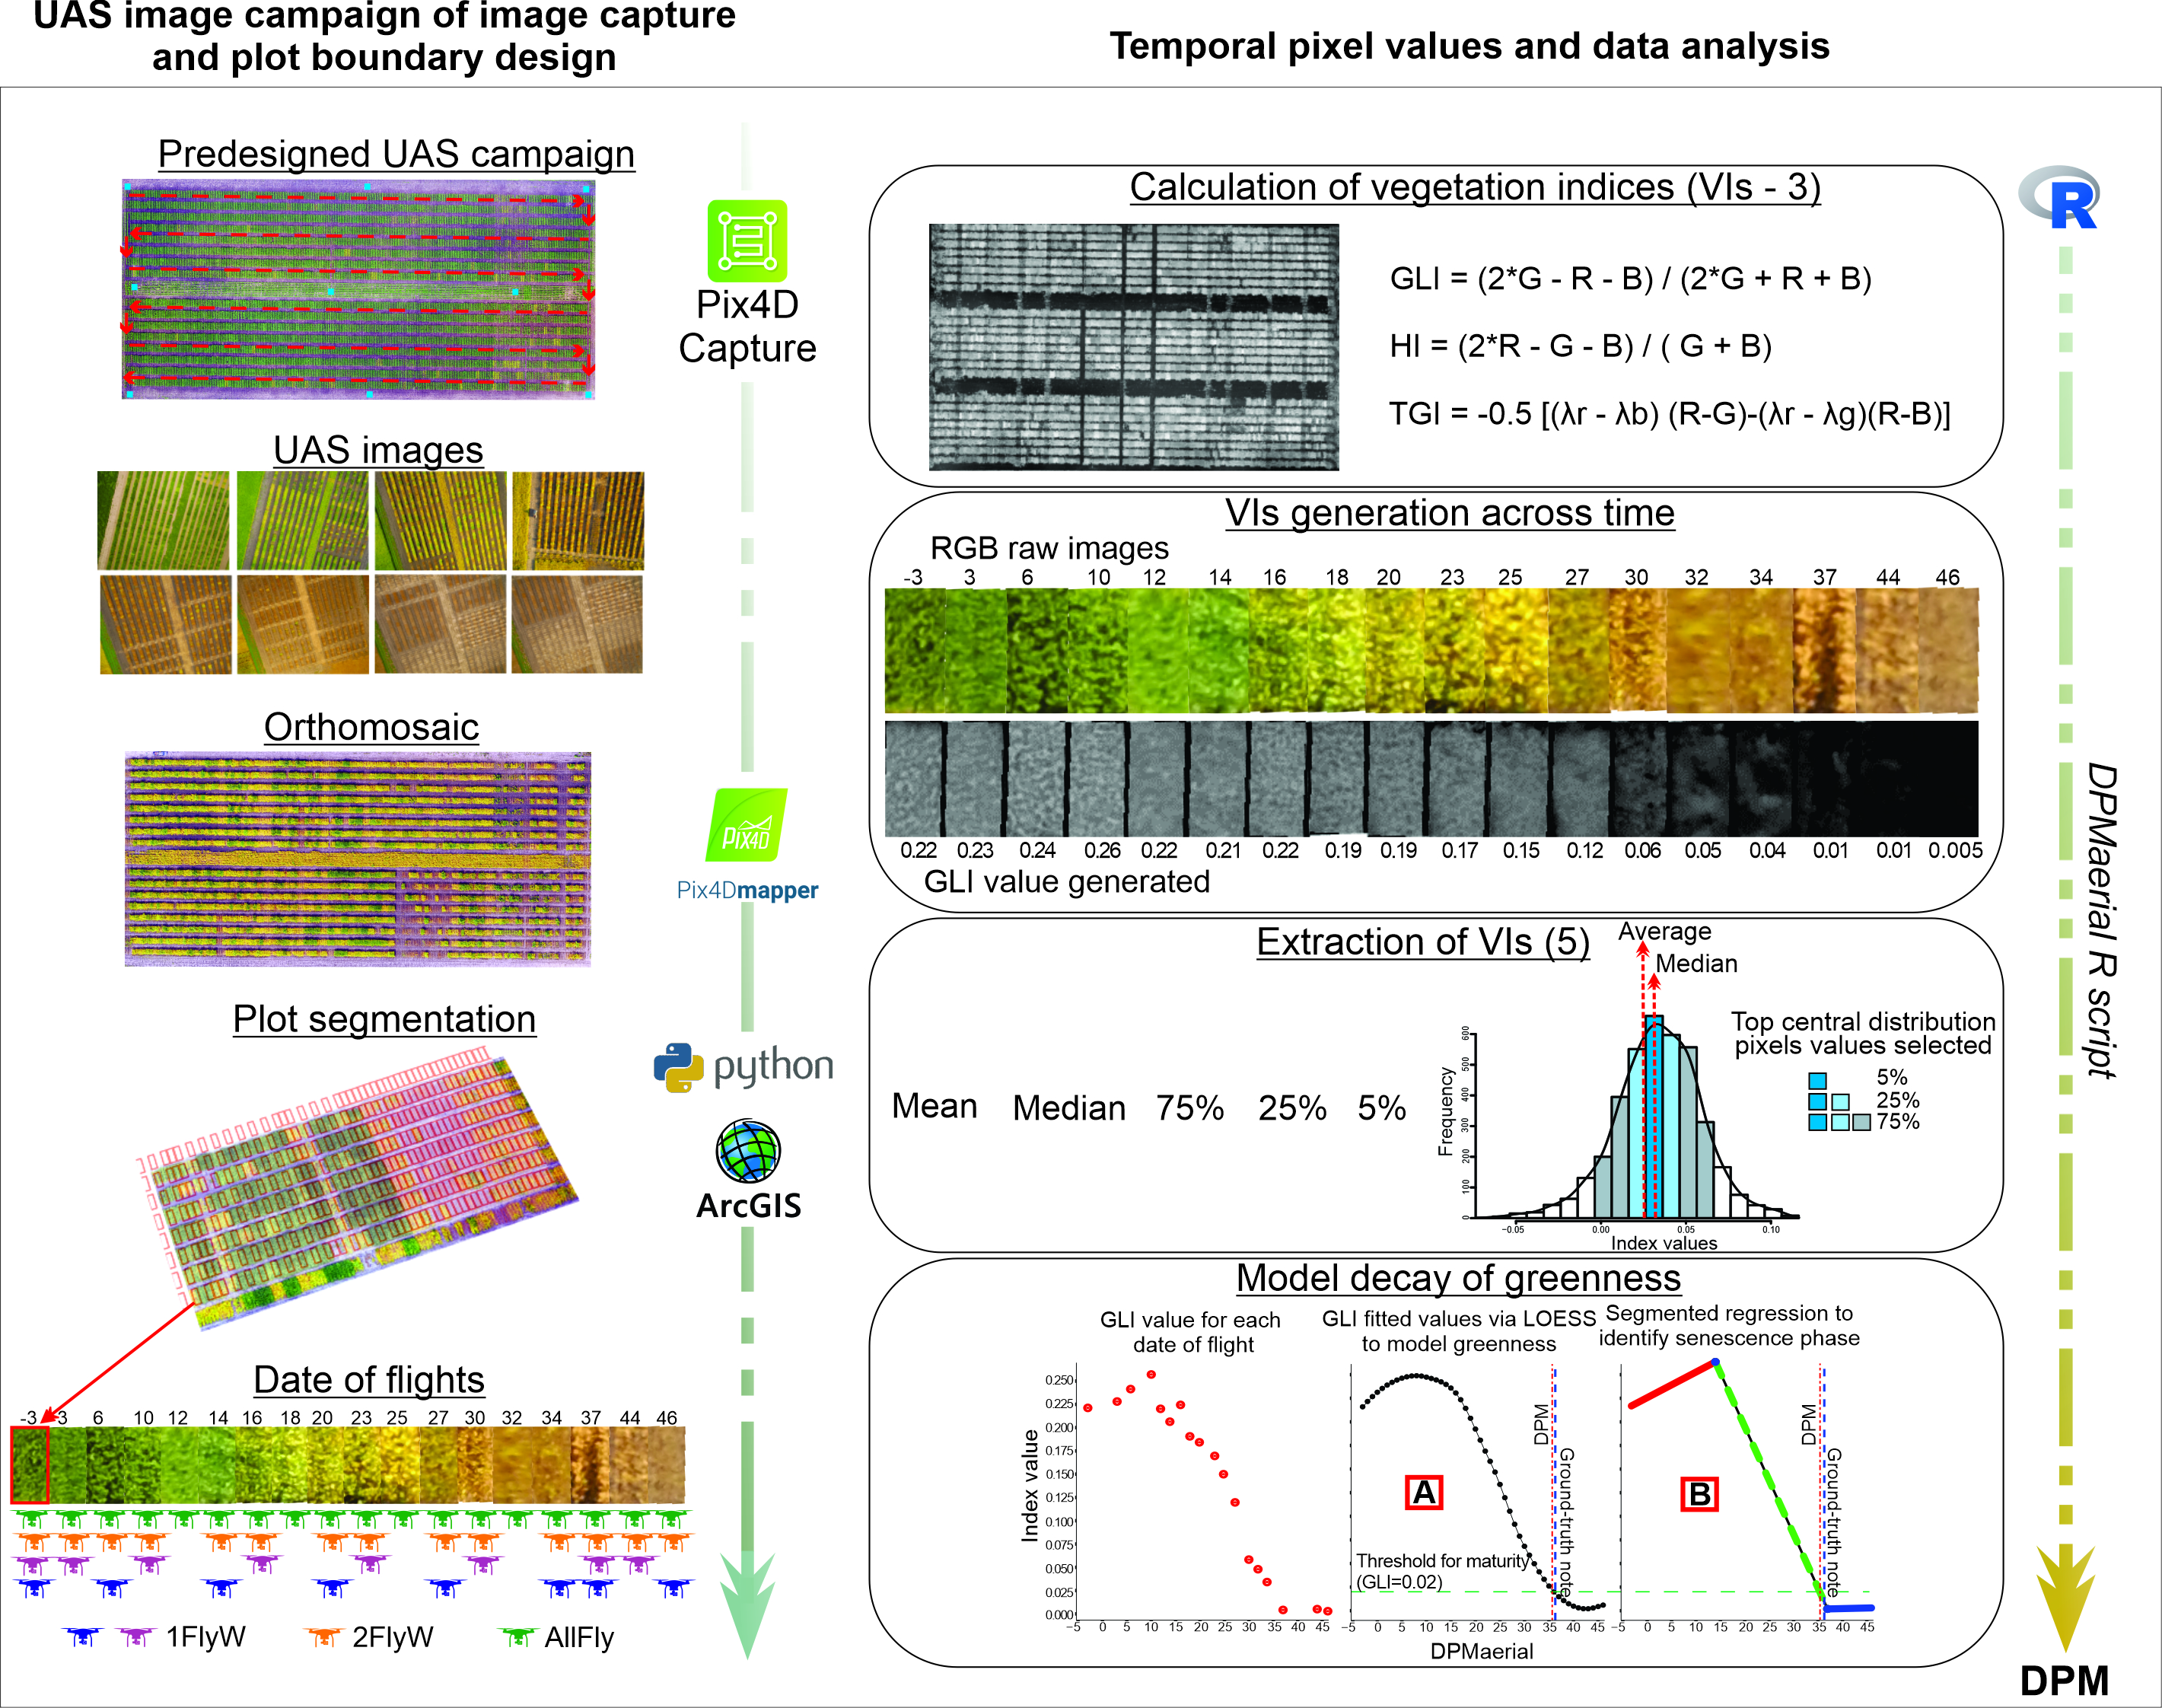

Objective 2
- An announcement was sent out to commercial seed representatives. We received 140 unique varieties that were entered into at least one of the four tests.
- Plots were planted at each of the three locations within each type of test. Staking, flower/pubescence notes, weeding, harvest, compositional analysis were all successfully completed.
- The report was created on time in November and can be found here at this link:
https://extension.umn.edu/soybean/soybean-variety-selection#variety-trials-1123611

Objective 3
- We worked with the following researchers to provide them with germplasm so they could conduct studies on pathology, entomology and biology of soybean.
  - We provided germplasm to Ford Denison for the study of nitrogen fixation.
  - We provided germplasm to Dean Malvick for the study on brown stem rot resistance
  - We provided germplasm to Shaun Curtin for the development of new gene editing methods in soybean.
  - We provided germplasm to Bob Stupar for the development of new gene editing methods in soybean.
  - We provided germplasm to Berlin Nelson (NDSU) for the study of sudden death syndrome.

Objective 4: Develop molecular markers for in-house genotyping to conduct marker-assisted selection on Phytophthora resistance.
The original plan for this research project was to use existing datasets to discover DNA markers associated with Phytophthora resistance, and then validate those markers using breeding lines and breeding populations for this the source of Phytophthora resistance has been characterized. However, during the course of this research, we learned that Corteva just began to offer a service to genotype plants using several markers perfectly tagging genes conferring resistance to Phytophthora. Rather than re-invent the wheel here, we decided to pursue a service relationship with Corteva. We negotiated and completed all required paperwork, and will start genotyping lines with these markers this coming summer. Our plan is to genotype all lines entering advanced and regional yield trials. For the first summer, we will compare the genotyping results to what we know about the expected sources of resistance. If the molecular DNA markers are highly predictive of Phytophthora resistance, then this service will save us time and resources by foregoing the greenhouse bioassay in the winter.
Appendix 1 – 2020 CVRC Report
December 14, 2020

To: Crop Variety Review Committee

From: Soybean Personnel

Subject: Soybean Proposals and Information for CVRC meeting

1. Tables 1 – 3: We are requesting permission to release M10-207102 as a germplasm on the basis of its combination of high protein, early maturity, and competitive yield. An article for the Journal of Plant Registrations has been drafted. We feel this is a good candidate for germplasm release because its yield and hila color make it unacceptable for commercialization, but its protein, earliness, and adequate seed yield may make it valuable to others as a germplasm source.

2. Tables 4 – 6: We are requesting permission to release or license M08-362045L. M08-362045L is a high yielding, SCN-resistant variety of 0.8 relative maturity. It has a black hilum and average protein content. Yield performance of M08-362045L relative to checks has been favorable. If released as a public variety the proposed names is MN0811CN.

3. Tables 7 – 9: We are requesting permission to release or license M09-285149. M09-285149 is a high yielding, SCN-resistant variety of 1.8 relative maturity. It has a buff hilum and average protein content and has Rps1c Phytophthora resistance. Yield performance of M09-285149 relative to existing UMN conventional public varieties has been favorable. If released as a public variety the proposed name is MN1807CN.

4. Lines presented in Table 10 are new lines available through MTA’s for evaluation. Seed available for further increase and/or evaluation will typically range from 1 to 3 bushels.

5. Variety Trial tables for 2020 are available at www.soybeans.umn.edu.

Table 1. Basic morphology and disease resistance characteristics of M10-207102.
Exp. Name | Reason | Rel. Mat | FL/PUB/HIL | SCN (Source) | Phyto. | Parentage
M10-207102 | Yield, pro | 0.0 | PGI | Susc. | Rps1c | M03-165068 x M04-419020
Flower: W = White, P = Purple
Pubesence: G = Grey, T = Tawny
Hilum: Y = yellow, L = Black, R = Brown, I= Imperfect Black, F = Buff

Table 2. Mean agronomic performance of M10-207102 along with an elite yield check (ND Rolette) in Northern Uniform Soybean Tests maturity group 00 during 2016-2019.
 |  |  |  | Plant | Seed | Seed | Composition
 | Yield | Maturity | Lodging | Height | Size | Quality | Protein | Oil | Meal protein
No. of Tests | 28 | 30 | 27 | 25 | 29 | 25 | 21 | 21 | 21
Strain | Bu/a | Date | Score | cm | g/100 | Score | % | % | %
ND Rolette | 53.3 | Sept 14 | 1.1 | 75.2 | 13.6 | 1.6 | 39.7 | 21.0 | 46.0
M10-207102 | 49.6 | Sept 15 | 1.1 | 67.3 | 16.9 | 1.6 | 43.5 | 18.8 | 49.1
LSD (0.05) | 2.5 | 0.9 | 0.06 | 3.1 | 0.5 | 0.3 | 5.9 | 2.9 | 0.5

Table 3. Mean agronomic performance of M10-207102 along with two elite yield checks in Northern Uniform Soybean Tests maturity group 00 during 2016-2019.
 |  |  |  | Plant | Seed | Seed | Composition
 | Yield | Maturity | Lodging | Height | Size | Quality | Protein | Oil | Meal protein | IDC
No. of Tests | 22 | 24 | 21 | 20 | 24 | 21 | 16 | 16 | 16 | 6
Strain | Bu/a | Date | Score | cm | g/100 | Score | % | % | % | score
MN0095 | 48.3 | Sept 15 | 1.1 | 72.4 | 13.4 | 1.4 | 39.7 | 21.0 | 46.3 | 2.2
ND Rolette | 50.1 | Sept 15 | 1.1 | 74.3 | 13.5 | 1.6 | 39.7 | 20.8 | 46.4 | 2.6
M10-207102 | 46.5 | Sept 16 | 1.1 | 66.1 | 16.8 | 1.6 | 43.4 | 18.5 | 50.1 | 2.7
LSD (0.05) | 2.9 | 0.9 | 0.1 | 3.6 | 0.4 | 0.3 | 6.6 | 3.5 | 0.6

Table 4. Basic morphology and disease resistance characteristics of M08-362045L.
Exp. Name | Reason | Rel. Mat | FL/PUB/HIL | SCN (Source) | Phyto. | Parentage
M08-362045L | SCN, yield | 0.8 | WGL | Resistant (PI 88788) | Susc | MN0606CN x U03-100612
Flower: W = White, P = Purple
Pubesence: G = Grey, T = Tawny
Hilum: Y = yellow, L = Black, R = Brown, I= Imperfect Black, F = Buff

Table 5. Comparison of M08-362045L to MN0810CN and ND Stutsman on the basis of yield, maturity, protein and oil in Minnesota environments. Data were from multiple-location tests in northern Minnesota in 2018-2020.

Variety | Mat. Date | Yield (bu/a) | Protein (%) | Oil (%) | Lodging | IDC
#Tests | 12 | 19 | 17 | 17 | 3 | 9
MN0810CN | Sept. 26 | 40.5 | 39.4 | 19.5 | 3.3 | 1.4
M08-362045L | Sept. 26 | 43.9 | 37.8 | 20.6 | 2.9 | 2.0
LSD (0.05) | 2.0 | 2.8 | 0.7 | 0.4 | 1.3 | 0.4

Variety | Mat. Date | Yield (bu/a) | Protein (%) | Oil (%) | Lodging | IDC
#Tests | 16 | 31 | 27 | 27 | 8 | 9
ND Stutsman | Sept. 20 | 48.1 | 38.4 | 20.6 | 1.4 | 1.3
M08-362045L | Sept. 22 | 48.6 | 38.9 | 20.9 | 1.6 | 1.8
LSD (0.05) | 1.7 | 3.0 | 0.7 | 0.3 | 0.5 | 0.4

Table 6. Comparison of M08-362045L to the regional check variety ND Stutsman in the 2018-19 Northern Regional Trials. Trials were conducted in both SCN-infested (5 environments) and non-SCN infested (6 environments) fields.
Variety | Yield (bu/a)  All | Yield (bu/a)  SCN | Yield (bu/a)  Non-SCN | Mat. date | Lod. | Plant ht. (in.) | Seed size | Seed qual. | Pro (%) | Oil (%)
#Tests | 11 | 5 | 6 | 12 | 12 | 10 | 10 | 10 | 10 | 10
ND Stutsman | 50.5 | 51.7 | 48.9 | Sept. 21 | 1.2 | 31 | 17.5 | 2.2 | 33.3 | 18.7
M08-362045L | 51.8 | 57.3 | 47.4 | Sept. 21 | 1.3 | 28 | 17 | 1.6 | 33.8 | 18.8

Table 7. Basic morphology and disease resistance characteristics of M09-285149.
Exp. Name | Reason | Rel. Mat | FL/PUB/HIL | SCN (Source) | Phyto. | Parentage
M09-285149 | Yield, SCN | 1.8 | PGF | Resistant (PI 88788) | Rps1c | MN1701CN x E06936
Flower: W = White, P = Purple
Pubesence: G = Grey, T = Tawny
Hilum: Y = yellow, L = Black, R = Brown, I= Imperfect Black, F = Buff

Table 8. Comparison of M09-285149 to current UMN conventional check cultivars on the basis of yield, maturity, protein and oil in Minnesota environments. Data were from multiple-location tests in southern Minnesota in 2017-2020.
Variety | Mat. Date | Yield (bu/a) | Protein (%) | Oil (%) | Lodging | IDC
#Tests | 32 | 41 | 40 | 40 | 12 | 14
MN1701CN | Sept. 27 | 49.0 | 39.3 | 20.4 | 2.9 | 3.0
M09-285149 | Sept. 27 | 51.2 | 39.3 | 20.4 | 2.4 | 2.6
LSD (0.05) | 0.9 | 2.8 | 0.3 | 0.3 | 0.3 | 0.5

Variety | Mat. Date | Yield (bu/a) | Protein (%) | Oil (%) | Lodging | IDC
#Tests | 40 | 54 | 50 | 50 | 12 | 18
MN1806CN | Sept. 26 | 50.4 | 40.4 | 20.7 | 2.6 | 2.1
M09-285149 | Sept. 26 | 55.6 | 39.2 | 20.5 | 2.1 | 2.5
LSD (0.05) | 0.8 | 2.3 | 0.3 | 0.2 | 0.5 | 0.4

Variety | Mat. Date | Yield (bu/a) | Protein (%) | Oil (%) | Lodging | IDC
#Tests | 35 | 59 | 56 | 56 | 13 | 18
MN1901CN | Sept. 27 | 59.0 | 39.3 | 21.7 | 2.4 | 3.1
M09-285149 | Sept. 25 | 58.3 | 39.0 | 20.7 | 2.2 | 2.5
LSD (0.05) | 0.9 | 2.5 | 0.2 | 0.3 | 0.2 | 0.3

Table 9. Comparison of M09-285149 to check varieties in the Regional SCN Tests. Data points averages across 16 SCN-infested environments.
Variety | Mat. Date | Yield (bu/ac) | Lodging (1-5) | Pro (%) | Oil (%) | Environments
MN1410 | 9/15 | 44.0 | 2.0 | 35.8 | 18.7 | 16 (2015, 2016)
IA1022 | 9/19 | 52.9 | 2.2 | 32.6 | 20.1
M09-285149 | 9/19 | 61.4 | 2.0 | 34.8 | 18.9

Table 10. New specialty and food-type lines available through MTA’s for evaluation.
Line | Market | Traits | FL/PUB/HIL | Rel. Mat. (Approx)
M10-161065 | Natto | Small seeds, Rps1c | W-G-Y | 0.9
M10-159-4007 | Natto | Small seeds, Rps1a | W-G-Y | 0.9
M11-297025 | Tofu | Large seeds (22 g/100), Rps1k | W-G-Y | 1.6
M11-297035 | Tofu | 42% pro, yld, large seeds (25 g/100), Rps1c | W-G-Y | 1.4
M12-377028 | Protein | 47% pro | W-T-L | 1.7

