Iowa Soybean Association
Interpreting the contribution of cover crops to soil health and crop productivity
1/1/2014 – 12/31/2015
Alison Robertson, Gwyn Beattie, Larry Halverson and Leonor Leandro
Department of Plant Pathology and Microbiology, Iowa State University

Accomplishments

- We developed experimental protocols for capturing microbial community information, including: (i) effective extraction methods for obtaining high quality DNA from bulk soil, root surfaces, and root tissues of corn and soybean samples, (ii) methods for consistent high-fidelity amplification of microbial bio-markers, and (iii) protocols for preparation of high-throughput sequencing libraries.
- We developed computational pipelines for analyzing and comparing the composition of microbial communities.
- These studies generated high-quality, high-throughput sequence data reflecting the composition of the bacterial communities in a large number of corn- and soybean-associated samples, providing some foundational data to begin to understand these microbiomes.
- These studies demonstrated a lack of impact of a single rotation of a cereal rye cover crop cover crop on the bacterial microbiome in the soil, rhizosphere or root of corn and soybean plants.

Project Goal

The goal was to begin to elucidate the effects of cover crops on soil health and the root microbiome to better exploit the benefits of cover crops and predict their impact on soybean yield.

Objectives

- To evaluate the impact of cover crops on the soil and root microbiome in cover crop strip trials established by the On-Farm Network.
- To evaluate the impact of cover crops on stand establishment, prevalence of diseases and root health in cover crop strip trials established by the On-Farm Network.

Materials and Methods

Cover crop strip trials were established at three locations in Iowa in Fall 2014. Two locations were at Osage (one soybean and one corn) and one was at Harlan; the cover crop at each location was cereal rye. Four plots, each comprised of adjacent strips (at least 100 ft long x 10 ft wide) with and without cover crops, were identified in each field. Four sites within each strip were GPS referenced and demarcated with flags. Disease data were collected at all three locations; microbiome data were collected at the two locations at Osage.

Objective 1. To evaluate the impact of cover crops on the soil and root microbiome in cover crop strip trials established by the On-Farm Network.

Sampling and sample processing. Soil and root samples were collected from the two Osage sites approximately two weeks after planting, with samples collected from the corn fields on May 28, 2015 and those from soybean fields on June 9, 2015. Two types of samples, bulk soil and roots (with soil attached), were collected at the GPS-flagged sites within each strip. At each flagged sampling site, two soil cores were collected approximately 5 feet from the flag and 6 inches away from the plants and were pooled; two soil cores were also collected approximately 5 feet on the other side of the flag and pooled. Root samples were similarly collected from sites on each side of the GPS-flagged sampling site. All samples were frozen immediately on dry ice and stored at -80°C. During sample processing, soil attached to the plant roots was removed by washing and collected to represent the rhizosphere microbiomes, and the roots were washed extensively to remove residual external microbes and were used as the source of the endophytic microbiomes, referred to here as the root microbiomes. Overall, we collected a total of 192 samples from the corn field at Osage (64 bulk soil samples, 64 rhizosphere samples and 64 endophytic samples) and another 192 from the soybean field at Osage.

DNA extraction and sequencing library preparation. For each of the 384 samples, total DNA was extracted and was used as a template for the amplification of bacterial taxonomic markers (16S rRNA genes) while introducing unique index tags for sample identification. We combined the amplified products into a single library for Illumina MiSeq sequencing, assessed it for quality, and had the library sequenced at the University of Minnesota Genome Center.

Sequencing summary. After stringent filtering and trimming, a total of 5,277,035 reads were generated and assigned to the 384 samples. This yielded a high level of sequencing depth for each sample, namely 3,379 to 46,757 reads per sample. The median sequence length was 285 bp. Clustering these reads into groups based on a >97% sequence identity threshold suggested the presence of >10,000 bacterial species.

Results

The cover crop did not detectably affect bacterial diversity in the soil, rhizosphere or root samples. The endophytic (root) microbiomes harbored fewer bacterial species (<500) than the soil or rhizosphere microbiomes (generally >2,000). The rhizosphere and root microbiomes generally exhibited higher bacterial diversity for corn than soybean (Fig. 1A), with the latter dominated by bacteria belonging to Bradyrhizobium spp. despite sampling the soybean plants prior to the appearance of root nodules. In both corn and soybean fields, the bacterial diversity in the soil, rhizosphere and root samples were similar in strips planted with a cover crop as in those without a cover crop (Fig. 1B).

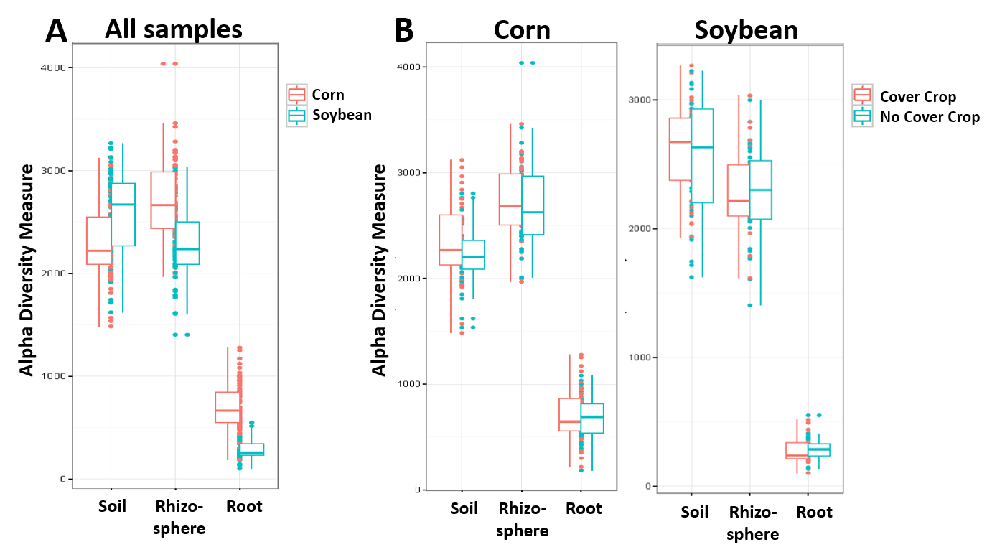
Fig. 1. Bacterial diversity (alpha-diversity) observed (A) when all samples were compared, and (B) when comparisons were made separately within the corn and soybean samples. Data are shown as box plots that show a box with the median framed by the first and third quartiles, and as dots representing individual samples.

The crop species strongly influenced the composition of the rhizosphere and root microbiomes. The soil, rhizosphere, and root samples contained distinct bacterial communities (Fig. 2A). Whereas the bacterial communities in the bulk soil samples were similar in the corn and soybean fields, the rhizosphere microbiomes on corn could be distinguished from those on soybean, and the root microbiomes on the two species were noticeably distinct (Fig. 2B).

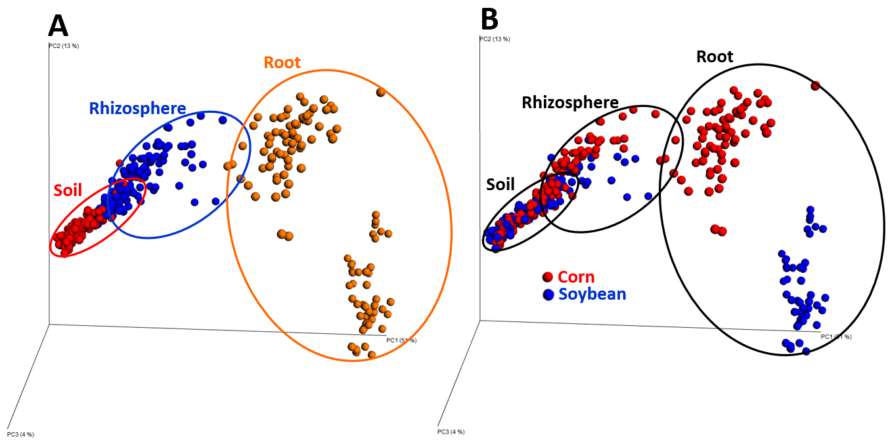

Fig. 2. Effect of (A) sample type and (B) crop species on the bacterial community composition of the samples.

The cover crop did not detectably affect bacterial community composition in the soil, rhizosphere or roots on either plant species. Although the soil, rhizosphere, and root samples harbored distinct bacterial communities on each of the crop species, the communities were not detectably affected by the planting of the cover crop (Fig.3)
. 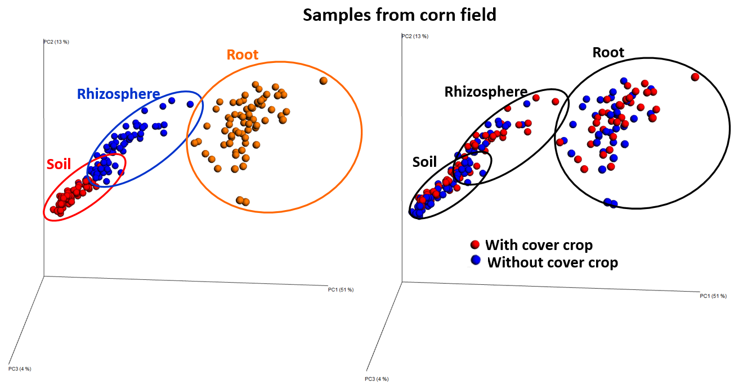

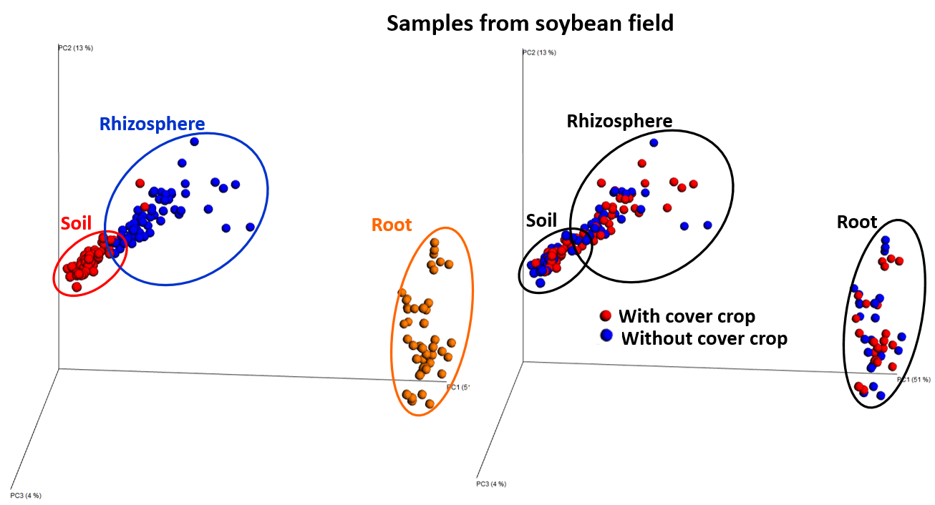
Fig. 3. Effect of the sample type and presence of the cover crop on bacterial community composition on samples from the corn field as analyzed separately from those in the soybean field.

Objective 2. To evaluate the impact of cover crops on stand establishment, prevalence of diseases and root health in cover crop strip trials established by the On-Farm Network.

Soybean and corn stands were evaluated in each strip of all three fields approximately two weeks after planting. No difference in stand was detected between strips that had and had not been planted to cover crops (treatment effect) (P>0.05). Similarly, seedling disease was not observed in any strip in any of the fields. Root rot severity was assessed on seedlings collected from each strip in each field and no treatment effects were detected (P>0.05). At approximately growth stage R5, strips within the soybean fields were assessed for sudden death syndrome (SDS), and again, SDS was not observed within the fields and no treatment effect was detected (P>0.05). SDS was observed in the compacted areas (edges and entrances) of the fields but at a very low incidence and severity.

Conclusions and Future plans

The bacterial communities in the corn- and soybean-associated samples examined were not detectably altered by a single winter planting of cereal rye. The composition of these communities, however, showed differences that correlated with crop species and sample origin, illustrating that the methods and resulting data were of sufficient power and quality to detect differences; and the data provide a strong foundation for beginning to understand these complex assemblages of organisms.

Although the results did not provide evidence that cover crops affect soil and root microbiomes, they do not exclude the possibility that multiple years of cover crop plantings are required to promote detectable shifts in these communities. They also do not exclude the possibility that the fungal communities experienced shifts associated with the cover crops after a single year of cover cropping; our studies in other projects have indicated that fungal communities are a more sensitive indicator of treatment effects than bacterial communities. We have prepared fungal DNA libraries from the 384 samples for sequencing and have these in storage until we can find funds to have them sequenced¹. Similarly, we anticipate that the cover crop strip trials will continue at the Osage and Harlan sites; this will enable us to build on this foundational data to evaluate the impact of multiple years of cover crops on microbiomes when we procure future funding for these studies.

Our analyses of the bacterial community sequence data are on-going. We are (1) completing the statistical analyses of this dataset, (2) combining this dataset with others that we acquired using similar techniques on corn and soybean at other field sites, (3) probing these combined datasets using network inference analysis tools to identify positive and negative associations among bacterial species and identify keystone species under distinct treatments, and (4) characterizing bacterial-fungal associations using the datasets that we have thus far, but will expand these if we can get the fungal community sequences funded for the samples collected here.

Finally, although a single planting of cereal rye in the winter prior to planting corn or soybean did not affect stand establishment or disease incidence or severity, we were not able to rigorously evaluate this impact due to the absence of detectable disease pressure at these field sites in 2015.

¹ Due to the failure of the MiSeq instrument at ISU to generate acceptable data, we changed our sequencing provider to the University of Minnesota Genome Center, which successfully sequenced our bacterial library samples. This modification involved paying a higher rate than expected for this activity, which precluded having sufficient funds for the fungal community sequencing. We are currently exploring other options to get these sequence data.

Deliverables
- Community profiles of root microbiomes of soybean and corn planted after a cover crop of cereal rye or left fallow; this activity was completed.
- Community profiles of root microbiomes of soybean and corn planted over multiple years; this activity was not completed due to funding provided for only one year.
- Effect of cereal rye cover crop on (i) disease incidence and severity (seedling diseases, SDS, foliar diseases), and (ii) root health; this activity was completed, although more data must be collected under conditions of disease pressure.

Publications and presentations
None yet.

