Kansas Soybean Commission Report of Progress
Principal Investigators: Kraig Roozeboom, Agronomy Extension
Eric Adee, Agronomy KRV Experiment Field
Bryson Haverkamp, Agronomy Graduate Assistant
Title: Agronomic Maximization of Soybean Yield and Quality
Amount of Funding: $9,280
Department Head: Gary Pierzynski, Agronomy
Progress Report: Fourth Quarter (Jan 1 to March 31 2015)

Objectives:
- Determine the best yield-protecting or yield-enhancing product or combination of the newest products to increase soybean yields using the maximum yield concept of “SOYA” = Systematic Optimization of Yield-enhancing Applications. Products and systems will be evaluated for utility both on a large-scale regional basis as well as within specific production environments.

Inputs and input systems did not affect plant density at either growth stage or on survival rates at any location. Plant density at R8 ranged from 246,100 to 357,700 plants ha⁻¹ across all locations. De Bruin and Pedersen (2008b) found that 95% of maximum yield was achieved with a range of 157,300 to 290,800 plants ha⁻¹, which is similar to final plant densities at all three locations in this study.
Inputs had an effect on height at all three locations but differences were minimal, ranging from 5 to 10 cm. The defoliant treatment typically had one of the shortest plant heights at all locations and would be expected given that it burned the soybean leaves, setting these plots back. However, the SOYA + D treatment had an inconsistent effect, having the shortest height at one location and one of the tallest heights at another. Inputs also affected lodging at Scandia, but all scores were less than 2 on a 1 (no lodging) to 5 (80-100% lodging) scale and differed by only 0.55. Regression analysis found a linear relationship between plant height and lodging at all locations but low r-square values of 0.14 at Manhattan (Pr. > F = <0.001), 0.04 at Rossville (Pr. > F = 0.04), and 0.28 at Scandia (Pr. > F = <0.001) were observed. On average, a 1 cm increase in plant height led to a 0.025 increase in lodging score.
Inputs affected seed mass with differences ranging from 0.6 to 0.7 g 100 seeds⁻¹ at Rossville and Scandia (Table 1.1). At Rossville seed mass was increased over the UTC by 3.3% with the SOYA minus foliar fungicide, 3.8% with the defoliant, nitrogen, and SOYA minus foliar fungicide and insecticide, 5.1% with the SOYA plus defoliant, and 5.2% with the SOYA treatments. None of the SOYA input systems were significantly different from each other at Rossville, but removal of inputs, in general, decreased seed mass compared to the main SOYA treatment. Similar results were seen at Scandia with seed mass being increased over the UTC by 2.6% with the fungicide plus insecticide seed treatment, 2.8% with the foliar fungicide, 3.0% with the SOYA minus foliar fungicide, 3.1% with the SOYA minus nitrogen, 3.3% with the foliar fungicide and insecticide, and 3.8% with the SOYA plus defoliant treatments. Once again, none of the SOYA input systems were significantly different than the main SOYA treatment. Other studies evaluating foliar fungicide alone have documented an increase in seed mass (Henry et al., 2011; Swoboda and Pedersen, 2009). In the current study, foliar fungicide had an inconsistent effect on seed mass, being one of the worst treatments at Rossville and one of the best treatments at Scandia for this parameter.
The use of inputs affected yield at Rossville only (Table 1.1). At this location yield was increased over the UTC by15.8% with the defoliant, 16.4% with the SOYA minus nitrogen, 16.5% with the nitrogen, 19.8% with the SOYA minus foliar fungicide, 24.5% with the SOYA, and 25.9% with the SOYA plus defoliant treatments. Similar to seed mass at Rossville, removal of inputs reduced yield compared to the main SOYA input system. All of the SOYA input systems increased yield over the UTC except for the SOYA minus foliar fungicide and insecticide, with this treatment being significantly less (-396 kg ha⁻¹) than the SOYA plus defoliant treatment. The treatment with the least yield at Rossville was the fungicide plus insecticide seed treatment although it was not significantly different than the UTC. A possible reason for the response of yield to the inputs at Rossville may be due to the high incidence of SDS (Table 1.8). Treatments with lower SDS DX ratings typically had some of the greatest yields (r = -0.51, Pr. > F = <0.001).
Table Error! No text of specified style in document..1. Effect of inputs on seed mass, yield, and sudden death syndrome (Fusarium virguliforme; SDS) disease index (DX) ratings at locations in Kansas during 2012 to 2014.
 | Seed Mass |  |  | Yield |  |  | SDS DX†
Treatment | Manhattan | Rossville | Scandia | Manhattan | Rossville | Scandia | Rossville
 | ———— g 100 seed⁻¹———— |  |  | ————yield kg ha⁻¹———— |  |  | 1 - 100
Untreated Control | 15.6 | 13.5 d‡ | 14.9 de | 4105 | 2758 ef | 4028 | 12.64 abc
Bio-Forge | 15.4 | 13.8 bcd | 15.1 bcde | 4123 | 2773 ef | 4088 | 9.10 abcde
Fungicide (F) Seed Treatment (ST) | 15.6 | 13.6 cd | 14.8 e | 3717 | 2813 ef | 3888 | 11.78 abc
F + Insecticide (I) ST | 15.7 | 13.7 cd | 15.3 abc | 3940 | 2710 f | 4127 | 14.24 ab
F + I + LCO ST + Foliar LCO | 15.9 | 13.5 d | 14.9 de | 4075 | 3088 bcde | 3929 | 6.20 cde
Foliar Fertilizer | 15.6 | 13.9 abcd | 15.1 abcde | 4168 | 2922 def | 3823 | 3.33 de
Defoliant (D) | 15.7 | 14.0 abc | 14.8 de | 4046 | 3194 abcd | 4203 | 2.25 e
Foliar F | 16.2 | 13.9 abcd | 15.3 abc | 3669 | 2956 cdef | 3763 | 14.58 a
Foliar I | 15.9 | 13.7 cd | 14.8 e | 3918 | 2993 cdef | 3728 | 10.49 abcd
Foliar F + I | 16.1 | 13.7 cd | 15.4 ab | 3807 | 3004 cdef | 4066 | 12.06 abc
Nitrogen (N) | 15.9 | 14.0 abc | 15.0 cde | 3912 | 3213 abcd | 3645 | 13.91 ab
SOYA | 15.8 | 14.2 a | 15.4 ab | 3843 | 3435 ab | 3889 | 8.82 abcde
SOYA + D | 16.1 | 14.2 ab | 15.4 a | 3779 | 3472 a | 4136 | 2.82 de
SOYA – N | 15.7 | 13.7 cd | 15.3 abc | 4003 | 3210 abcd | 3844 | 5.72 cde
SOYA – F | 15.9 | 14.0 abc | 15.3 abc | 3839 | 3305 abc | 4058 | 6.78 bcde
SOYA – (F+I) | 15.8 | 14.0 abc | 15.2 abcd | 4091 | 3076 bcdef | 4163 | 9.17 abcde
Pr > F | 0.30 | 0.02 | <0.001 | 0.73 | <0.001 | 0.55 | 0.007
†DX, disease index, is calculated by taking disease incidence (DI) times disease severity (DS) divided by nine. DX has a scale from 0 (no disease) to 100 (all plants dead at or before R6). Source: Southern Illinois University Carbondale.
‡ Values within a column followed by the same letter are not significantly different at P ≤ 0.05.
- Evaluate the interaction of these yield-enhancing products with next generation high-yielding varieties and current varieties, under both aggressive and standard soybean management practices to better understand how management interacts with variety choice.

Varieties responded differently to input system for some yield determining factors (e.g. plant density and lodging), but yield components and yield responded similarly regardless of input system.
The effect of input system on plant density differed with variety at Scandia for both growth stages and Rossville at R8. At Scandia, the UTC had the greatest density for three varieties, SOYA had the greatest density for two varieties, and SOYA – Foliar F had the greatest density for the last variety at both V2-V3 and R8. The same trend was found at Rossville at the R8 plant density but with the input systems having the greatest density with different varieties. Variety also affected plant density at Manhattan at both growth stages and Rossville at V2-V3. At Manhattan, P93Y92 and P94Y23 had the lowest plant density at both growth stages, but AG3431 and AG4033/4130 had the greatest plant density at both growth stages. P94Y23 had the lowest density at Rossville at V2-V3, but P93Y92 had the greatest density. Overall, plant densities ranged from 257,584 to 374,091 plants ha⁻¹ at R8 and were within or greater than the De Bruin and Pedersen (2008) range of 157,300 to 290,800 plants ha⁻¹ needed to achieve 95% of maximum yield. Variety and input system had no effect on survival.
Variety had an effect on lodging scores at all three locations but this response depended upon input systems at Manhattan. At Manhattan, the UTC had the least amount of lodging for five of the six varieties, but SOYA and SOYA – foliar F had the most lodging for three of the varieties. For AG3431, the SOYA – foliar F input system had a 0.2 lower lodging score then the UTC and SOYA. AG4232 had the greatest lodging score averaging 3.0 in the SOYA and SOYA – foliar F input systems but other than this variety, lodging scores were low ranging from 1 to 1.9 on a 1 to 5 scale. Variety also impacted lodging scores at Rossville and Scandia and did not depend on input system. AG4232 had the greatest lodging at both locations, having an increase in lodging score above the next closest variety by 0.29 at Rossville and 0.37 at Scandia.
Variety and input system affected multiple yield components and yield, but variety response was similar regardless of input system (Tables 2.1 – 2.3). Variety affected pods plant⁻¹ at Rossville and Manhattan, and input systems had an effect at Rossville (Table 2.1). At Manhattan and Rossville, AG4232 had the greatest pods plant⁻¹ followed by AG4033/4130 at Rossville and AG4033/4130 and AG3431 at Manhattan. Although the response was not significant at Scandia, AG4232 also had the greatest pods plant⁻¹. AG4232 was one of the latest maturing varieties used in the study and would have had a slightly longer reproductive duration compared to the earlier-maturing varieties. This could have led to the increase in pods plant⁻¹ observed here. However, P94Y23 is similar in maturity to AG4232 and typically had some of the least pods plant⁻¹. At Rossville, the SOYA input system had 4.2 more pods plant⁻¹ than the UTC. Although response to input system was not significant at Manhattan and Scandia, the SOYA input system had the greatest pods plant⁻¹ at these two locations. Variety influenced pods m⁻² at all three locations (Table 2.1). At the three locations, AG4232 had the greatest number of pods m⁻², and P93Y92 and P94Y23 usually had the least pods m⁻².
Variety and input systems did not impact seeds plant⁻¹ (Table 2.2). Varieties did have an effect on seeds pod⁻¹ at one location. At Manhattan, P94Y23 and P93Y92 had the greatest seeds pod⁻¹. Input system did not affect seeds pod⁻¹ at any of the locations. Responses of all varieties were similar for seeds m⁻², but input systems inconsistently affected this parameter at Rossville and Scandia. At Rossville, the SOYA input system had the greatest number of seeds m⁻² with 220 more seeds than the SOYA – foliar F system and 154 more seeds than the UTC. At Scandia, the UTC had an increase in seeds m⁻² of 198 above the SOYA system and 200 above the SOYA – foliar F system.
Variety affected seed mass at all three locations and input system affected the same parameter at Manhattan and Scandia (Table 2.3). In general, P94Y23 and P93Y92 had the greatest seed mass while AG4232 had the lowest seed mass at all three locations. At Manhattan and Scandia, the SOYA input system resulted in greater seed mass than the UTC but was similar in seed mass to the SOYA – foliar F. Although a significant response was not seen at Rossville, the SOYA input system resulted in the greatest seed mass, similar to the responses at Manhattan and Scandia.
Although variety affected most of the other soybean growth parameters measured, variety had no impact on yield (Table 2.3). Input system influenced yield at Rossville, where the SOYA input system increased yield by 285 kg ha⁻¹ over the UTC and 387 kg ha⁻¹ over SOYA – foliar F. Input systems at Manhattan and Scandia were inconsistent in their effect on yield.

Table 2.Error! No text of specified style in document.. Effect of variety and input system on pod number at three locations in Kansas during 2012 to 2014.
 | Pod Number
Treatment | Manhattan | Rossville | Scandia | Manhattan | Rossville | Scandia
 | ————— pods plant⁻¹ ————— |  |  | ————— pods m⁻² —————
Variety
AG3431 | 34.5 b | 38.8 d† | 45.9 | 1215 bc | 1208 b | 1374 abc
AG4033/4130‡ | 35.8 b | 48.3 b | 42.4 | 1265 b | 1407 a | 1252 c
AG4232 | 42.2 a | 53.8 a | 47.2 | 1417 a | 1527 a | 1498 a
CH3303R2 | 30.9 c | 43.3 c | 45.6 | 1085 cd | 1207 b | 1439 ab
P93Y92 | 31.2 c | 40.6 cd | 41.2 | 1000 d | 1226 b | 1301 bc
P94Y23 | 30.9 c | 42.0 cd | 45.7 | 991 d | 1111 b | 1286 c
Input System (IS)§
UTC | 33.1 | 42.2 b | 44.0 | 1111 | 1232 | 1332
SOYA | 34.9 | 46.4 a | 45.2 | 1180 | 1311 | 1383
SOYA – FF | 34.8 | 44.7 ab | 44.7 | 1194 | 1300 | 1360
Var. x IS, Pr>F | 0.09 | 0.31 | 0.20 | 0.77 | 0.22 | 0.18

Table 2.2 Effect of variety and input system on seed number at three locations in Kansas during 2012 to 2014.
 | Seed Number
Treatment | Manhattan |  | Rossville |  | Scandia | Manhattan | Rossville | Scandia | Manhattan | Rossville | Scandia
 | ———— seeds plant⁻¹ ———— |  |  |  |  | ———— seeds pod⁻¹ ———— |  |  | ————— seeds m⁻² —————
Variety
AG3431 | 67.7 | 89.2 |  | 91.9 |  | 2.03 cd† | 2.33 | 2.34 | 2343 | 2688 | 2570
AG4033/4130‡ | 68.1 | 92.4 |  | 93.2 |  | 1.96 cd | 1.95 | 2.46 | 2359 | 2518 | 2537
AG4232 | 73.9 | 107.3 |  | 94.8 |  | 1.82 d | 2.10 | 2.15 | 2468 | 2786 | 2753
CH3303R2 | 65.5 | 97.0 |  | 88.0 |  | 2.22 bc | 2.24 | 2.21 | 2252 | 2588 | 2588
P93Y92 | 72.3 | 89.6 |  | 84.7 |  | 2.35 ab | 2.25 | 2.23 | 2289 | 2584 | 2539
P94Y23 | 77.3 | 98.6 |  | 99.6 |  | 2.54 a | 2.41 | 2.49 | 2372 | 2564 | 2659
Input System (IS)§
UTC | 72.6 | 93.7 |  | 96.4 |  | 2.27 | 2.27 | 2.43 | 2360 | 2592 b | 2740 a
SOYA | 68.9 | 101.9 |  | 89.5 |  | 2.06 | 2.26 | 2.25 | 2310 | 2746 a | 2542 b
SOYA – FF | 70.9 | 91.4 |  | 90.2 |  | 2.13 | 2.11 | 2.27 | 2372 | 2526 b | 2540 b
Var. x IS, Pr>F | 0.75 | 0.61 |  | 0.19 |  | 0.85 | 0.75 | 0.91 | 0.85 | 0.90 | 0.60
† Values within a column with different letters are significantly different at P ≤ 0.05.
‡ AG4130 planted in 2012 and 2013. AG4033 planted in 2014.
§ UTC, untreated control; SOYA – FF, SOYA minus foliar fungicide.

Table 2.3 Effect of variety and input system on seed mass and yield at three locations in Kansas during 2012 to 2014.
 | Seed Mass |  |  | Yield
Treatment | Manhattan | Rossville | Scandia | Manhattan | Rossville | Scandia
 | ————— g 100 seed⁻¹ ————— |  |  | ————— kg ha⁻¹ —————
Variety
AG3431 | 16.5 cd† | 14.7 b | 15.1 b | 3861 | 3924 | 3870
AG4033/4130‡ | 16.3 d | 14.6 b | 14.7 c | 3859 | 3674 | 3742
AG4232 | 15.5 e | 14.4 b | 14.4 d | 3788 | 4001 | 3953
CH3303R2 | 17.2 ab | 14.7 b | 15.0 b | 3853 | 3782 | 3886
P93Y92 | 16.8 bc | 15.8 a | 16.1 a | 3853 | 4065 | 4089
P94Y23 | 17.4 a | 15.6 a | 15.9 a | 4126 | 4003 | 4248
Input System (IS)§
UTC | 16.4 b | 14.9 | 15.0 b | 3853 | 3847 b | 4133
SOYA | 16.7 a | 15.1 | 15.3 a | 3845 | 4132 a | 3895
SOYA – FF | 16.8 a | 14.9 | 15.2 a | 3973 | 3745 b | 3866
Var. x IS, Pr>F | 0.64 | 0.27 | 0.53 | 0.70 | 0.94 | 0.35
† Values within a column with different letters are significantly different at P ≤ 0.05.
‡ AG4130 planted in 2012 and 2013. AG4033 planted in 2014.
§ UTC, untreated control; SOYA – FF, SOYA minus foliar fungicide.

- Evaluate the interaction of the “SOYA” treatments with plant population to better understand the impact of aggressive management on minimum required seeding rates and to broaden and verify minimum seeding rate recommendations determined in the project “Agronomy Limitations of Soybean Yield and Seed Quality in the US”.

Soybean response to changes in seeding rate was similar regardless of input system for all growth and yield parameters at all locations. Therefore, parameter responses to input systems and regression analysis of each parameter response to seeding rate were examined independently.
Input system did not affect plant density, emergence, establishment, or survival at any of the locations. The SOYA input system decreased lodging score by 0.06 at Scandia, but all lodging scores were low, with the highest being 1.16 on a scale of 1 (no lodging) to 5 (80-100% lodging). The SOYA input system consistently increased seed mass by an average of 0.4 g (100 seeds)⁻¹ over the UTC across the three locations. Because input systems contained several components, it is unclear which product had the greatest impact on seed mass. Studies looking at fungicide (Henry et al., 2011; Swoboda and Pedersen, 2009), insecticide (Henry et al., 2011), and nitrogen (Ruiz Diaz et al., 2009; Salvagiotti et al., 2009) have found inconsistent effects on seed mass, and studies looking at newer growth promotor products focused on their effect on yield (Staton and Boring, 2012; Voight et al., 2012). Evaluation of inputs in another experiment in this current study did not identify one product that consistently increased seed mass, but the SOYA input systems tended to have greater seed mass. Rossville was the only location where input system improved yield. As mentioned for the experiment evaluating inputs, a possible explanation for this yield increase may the higher SDS levels present in the UTC compared to the SOYA input system at this location. The UTC and SOYA systems produced comparable yields at Manhattan and Scandia.
Linear regression analysis found growth parameters that had a significant linear response to seeding rate but quadratic and cubic regression analyses were non-significant. As might be expected, plant density at V2-V3 and R8 responded linearly to seeding rate at all locations. For each additional 100,000 seeds ha⁻¹, plant density increased by an average of 74,667 plants ha⁻¹ at V2-V3 and 62,667 plants ha⁻¹ at R8 across all three locations (Figure 3.1a and 3.1b). Linear regression accounted for an average of 73% of the V2-V3 and 63% of the R8 plant density variability. Although plant density continued to increase as seeding rate increased, a previous study conducted in Iowa (De Bruin and Pedersen, 2008) found that final plant densities needed to achieve 95% of maximum yield ranged from 157,300 to 290,800 plants ha⁻¹ indicating that our seeding rates were sufficient for achieving maximum yield.
Negative linear responses to seeding rate were found for emergence at Manhattan, establishment at Manhattan and Scandia, and survival at Rossville and Scandia. For every 100,000 seeds ha⁻¹ increase, emergence decreased by 2.0% at Manhattan (Figure 3.1c), establishment decreased by an average of 4.2% at Manhattan and Scandia (Figure 3.1d), and survival decreased by an average of 4.5% at Rossville and Scandia (Figure 3.1e). Oplinger and Phillbrook (1992) found a similar response of survival to seeding rate. Lodging had a linear response to seeding rate at Manhattan with a lodging score increase of 0.074 for every additional 100,000 seeds ha⁻¹ (Figure 3.1f), but overall lodging scores were low.
Seed mass responded linearly to seeding rate at Manhattan with a 0.21 g (100 seeds)⁻¹ decrease in seed mass for each increase of 100,000 seeds ha⁻¹ (Figure 3.1g). A similar response in seed mass to seeding rate has been documented by other studies (Elmore, 1998; Ethredge et al., 1989), but another study has documented an increase in seed mass as seeding rate increased (De Bruin and Pedersen, 2008). Although the linear response at Manhattan was highly significant (Pr > F = <0.001), seeding rate accounted for less than 10% of the variability in the seed mass data. Board et al. (1999) found, that among primary traits, seeds m⁻² had the greatest effect on yield along with pod plant⁻¹ while seed mass did not have as big of an effect on yield.
Yield had a linear response to seeding rate at all three locations, but the fit of the model was as good or better with a linear-plateau model. Similar seeding rates were required to maximize yield at Rossville and Scandia (297,261 and 305,859 seeds ha⁻¹, respectively (Figure 3.1h). Both locations also had similar yields at this point with Rossville yielding 3,235 kg ha⁻¹ and Scandia yielding 3,374 kg ha⁻¹. At Manhattan, a higher seeding rate of 379,658 seeds ha⁻¹ was needed to reach the plateau, but a greater yield of 3,762 kg ha⁻¹ was achieved at Manhattan. The seeding rates found in this study to achieve maximum yield are in line with current University recommendations. In Kansas, 322,910 seeds ha⁻¹ is recommended to maximize yield potential (Kok et. al., 1997) and at least 322,898 seeds ha⁻¹ is recommended in Indiana (Robinson and Conley, 2007).
Yield had a significant relationship with R8 plant density at all three locations when a non-linear model was used. This model accounted for a large percentage of the variability in the data with an average r-squared value of 0.96 across all locations. Figure 3.2 shows the yield response to R8 plant density as well as the plant density required to achieve 95% and 99% of the maximum yield at each location. Rossville and Scandia acted similarly with 95 and 99% of maximum yield attained at 106,990 and 164,470 plants ha⁻¹ at Rossville and 115,221 and 177,122 plants ha⁻¹ at Scandia. Manhattan needed a greater R8 plant density to attain 95 and 99% maximum yield at 230,441 and 350,244 plants ha⁻¹. Rossville and Scandia required plant densities less than the range reported by DeBruin and Pedersen (2008b) where 95% maximum yield was achieved with 157,300 to 290,800 plants ha⁻¹, but Manhattan was within this range. If average establishment rates are taken into account for each location, a seeding rate of 437,338 seeds ha-1 at Manhattan, 241,868 seeds ha⁻¹ at Rossville, and 253,031 seeds ha⁻¹ at Scandia were needed to achieve the plant density required to attain 99% of the maximum yield. These seeding rates are within 55,000 seeds ha⁻¹, on average, of the seeding rates found previously that attained maximum yield using the linear plateau model. Also using these seeding rates, Rossville and Scandia are below, and Manhattan is above the current University recommendations of 322,910 and 322,898 seeds ha⁻¹ that Kansas State University and Purdue University recommend (Kok, 1997; Robinson and Conley, 2007). One possible reason for why this study found lower optimal seeding rates at two locations than those recommended by Kansas State and Purdue may be due to the less than ideal environmental conditions observed during the three years of this study, which led to lower yields.

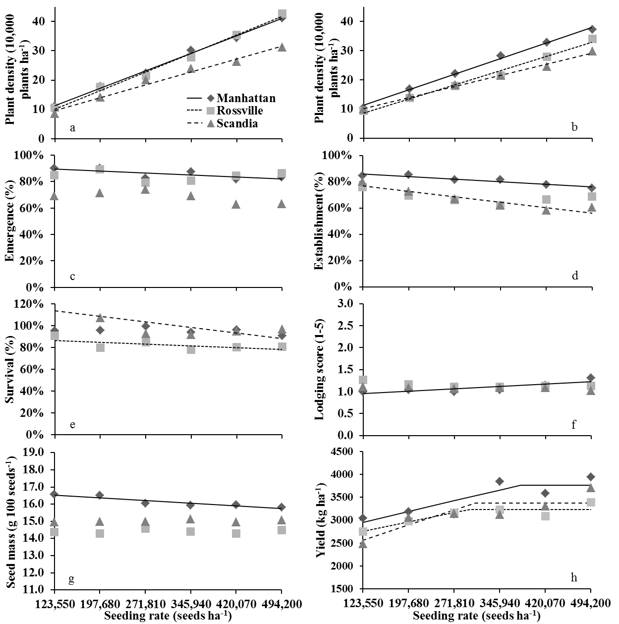
Figure 3.1 Response of multiple growth and yield parameters to seeding rate at three locations in Kansas during 2012 to 2014. Linear responses that were non-significant within each parameter are not shown.

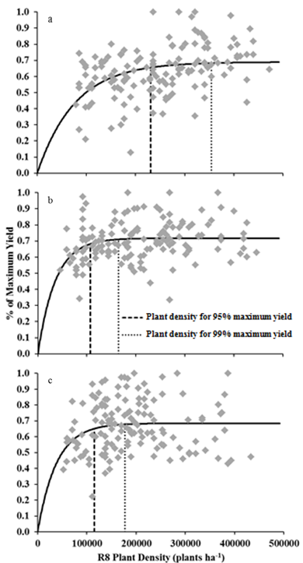
Figure 3.2 Best fit non-linear regression model [y=α(1-exp^{-βx})] curves where Y = percent maximum yield, X = R8 plant density, α is the predicted, asymptotic maximum, and β represents the responsiveness of Y as plant density increases at three locations (a – Manhattan, b – Rossville, and c – Scandia) in Kansas during 2012 to 2014. Vertical lines represent the R8 plant density required to achieve 95% and 99% of the maximum yield at each location.
- Evaluate the interaction of yield-enhancing products with different row spacings under aggressive and standard soybean management practices to better understand how management interacts with row spacing.

Seed yield responded to either row spacing or input system at three of five locations (Table 4.1). Although Manhattan was the only location to have a significant row spacing response, narrow row spacing produced the greatest yields (Table 4.1). Medium and wide row spacing were inconsistent in their effect on row spacing. The increase in yield found with narrow row spacing is consistent with other studies (DeBruin and Pedersen, 2008a; Oplinger and Philbrook, 1992). Orlowski et al. (2012) reported equal yields for medium and wide row spacing but greater yields with narrow row spacing, however, other studies found that medium row spacing generally produced yields similar to those from narrow row spacing (Pedersen and Lauer, 2003; Bertram and Pedersen, 2004). This study in combination with other studies shows that narrow row spacing (<38 cm) fairly consistently yields greater than medium and wide row spacing, but yield response from medium and wide row spacing has been inconsistent.
Seed yield response to input system was consistent across all locations with the SOYA and SOYA – FF input systems generally having the greatest yields (Table 4.1). The SOYA input system out yielded the UTC by 327 kg ha⁻¹ at KSros and 551 kg ha⁻¹ at MNwas. At both locations removing the foliar fungicide in the SOYA – FF input system had no effect on yield compared to the SOYA input system. Compared to the STFF input system, the SOYA system had a 228 kg ha⁻¹ yield advantage at KSros and 280 kg ha⁻¹ yield advantage at MNwas. At MNwas, the STFF out-yielded the UTC by 271 kg ha⁻¹ and STFF generally out-yielded the UTC at the other locations. Outside of one location, UTC was the lowest yielding system overall showing that the use of products consistently increased yield. However, given the structure of the treatments, it is impossible to determine exactly which product(s) had the greatest impact.

Table 4.1. Effects of row spacing and input system on seed yield at five locations across 2012 to 2014 in Kansas and Minnesota.
 | Location†
Treatment | KSman | KSros | KSsca | MNstp | MNwas
 | —————————————kg ha⁻¹—————————————
Row Spacing (RS)
Narrow | 4010 a‡ | 3388 | 3613 | 4485 | 4866
Medium | 3819 ab | 3166 | 3239 | 4551 | 4858
Wide | 3645 b | 3346 | 3337 | 4320 | 4695
Input System (IS)§
UTC | 3715 | 3145 b | 3240 | 4354 | 4451 c
STFF | 3697 | 3244 b | 3499 | 4443 | 4722 b
SOYA | 4068 | 3472 a | 3389 | 4562 | 5002 a
SOYA - FF | 3819 | 3339 ab | 3456 | 4449 | 5051 a
RS x IS, Pr>F | 0.42 | 0.11 | 0.84 | 0.06 | 0.71
† KSman, Manhattan, KS; KSros, Rossville, KS; KSsca, Scandia, KS; MNstp, St. Paul, MN; MNwas, Waseca, MN.
‡ Values within a column followed by the same letter are not significantly different at P ≤ 0.05.
§ UTC, untreated control; STFF, fungicide, insecticide, and nematicide seed treatment plus foliar fungicide; SOYA – FF, SOYA minus foliar fungicide.

At St. Paul, MN where an interaction between row spacing and input system occurred for yuield, the SOYA input system yielded the greatest followed by SOYA – FF, STFF, and UTC, in that order, in both medium and wide row spacing (Figure 4.1). However, in narrow row spacing, the STFF input system yielded the greatest while SOYA and SOYA – FF yielded similarly to the UTC. This contradicts our hypothesis that narrow row spacing combined with a high input system such as the SOYA and SOYA – FF would maximize yield. However, this response was only found at St. Paul, MN, and other locations did not show a similar response.
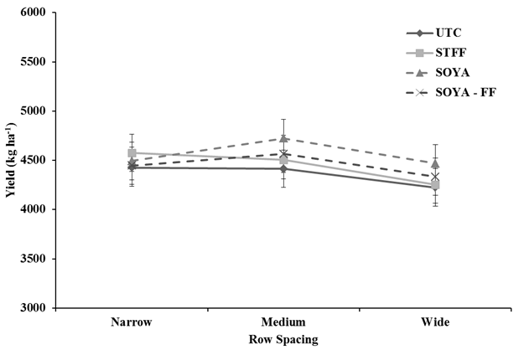
Figure 4.1 Response of yield to each input system by row spacing treatment at MNstp in 2012 to 2014. Error bars that overlap indicate treatments are not significantly different at α = 0.05.
The structure of this experiment makes it difficult to make firm conclusions regarding which input product(s) contributed to increasing yield. The objective of this study was to examine input systems and their interaction with row spacing. Our original belief was that a combination of inputs in a system could provide a synergistic occurrence that when added with narrow rows would accelerate yields past current levels. It is likely that yields beyond what were found in this study could be achieved if producers intensively managed each field and based product decisions on a field by field basis to see if a product is needed. For instance, pest levels were monitored in this study, but products were applied according to the treatment protocol, regardless of pest levels. Not only does the approach used in this study incur additional cost with a low probability of increasing yield, it has the potential to develop pest resistance if widely used (Boethel, 2004) and products, such as nitrogen, may have a negative environmental impacts (Gutierrez-Boem et al., 2004).
With the current cost of each product and custom application rates, there was an additional cost above the UTC of $130.76 ha⁻¹ with the STFF, $345.34 ha⁻¹ with the SOYA, and $289.28 ha⁻¹ with the SOYA – FF input system. Figure 4.2 shows the break-even points at different soybean market prices and the yield increase needed to cover the current cost, a 15% reduction in cost, and a 15% increase in cost of the three input systems. Averaged across all locations and years, yield increases relative to the UTC were 172 kg ha⁻¹ with the STFF, 311 kg ha⁻¹ with the SOYA, and 269 kg ha⁻¹ with the SOYA – FF input systems. At these levels of response, soybean market prices needed to cover the additional cost of these input systems would need to increase to $760 t⁻¹ or by 207% for the STFF, $1,110 t⁻¹ or by 302% for the SOYA, and $1,075 t⁻¹ or by 293% for the SOYA – FF systems. Even at MNwas, where the greatest yield increases above the UTC were found, price increases of 131% for the STFF, 171% for the SOYA, and 131% for the SOYA – FF would need to be realized to cover the additional cost of these systems. Yield gains needed at current soybean prices to cover the additional cost of the input systems are 356 kg ha⁻¹ from the STFF, 941 kg ha⁻¹ from the SOYA, and 788 kg ha⁻¹ from the SOYA – FF input systems. Given the current cost and market prices, it would not be economical for a producer to invest in additional inputs unless greater yield gains are achieved, higher market prices are realized, or a combination of both occurs.
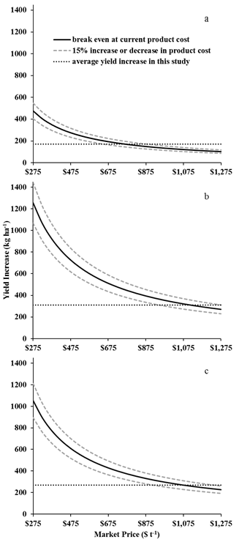

Figure 4.2. Yield increase needed to break even at different soybean market prices given product costs for each input system: a) Fungicide, insecticide, and nematicide seed treatment plus foliar fungicide, b) SOYA, and b) SOYA minus foliar fungicide.
Objective 4 Conclusions
Row spacing and input system had a positive effect on many soybean growth parameters, yield components, and yield. Narrow row spacing, in general, had the greatest fractional canopy coverage and yield across all locations but did not differ from medium and wide row spacing in most other measurements. At two of the five locations, the use of inputs in the STFF, SOYA, and SOYA – FF input system increased yield above the UTC. These input systems also had the greatest senescence NDVI duration indices, which led to an increased seed mass above the UTC at most locations. When looking at the average yield response that the STFF, SOYA, and SOYA – FF systems achieved across all locations, current product costs and soybean market prices could not justify the use of these inputs in a system. It appears that producers would be better served to use narrow rows as a means to improve the possibility of maximizing production across their farm and to evaluate current prices to see if implementing inputs in a system can be justified.

- Educate soybean producers and agronomy professionals about the best yield-protecting or enhancing product, or combinations of these products, along with the best management practices that maximize soybean yield and increase grower profitability.

Several field day presentations have been made over the three years of this project. Agronomy eUpdates are planned to share research conclusions as well as scientific journal articles for each of the research objectives. Manuscripts for Objectives 1, 2, and 3 will be developed by students at Minnesota, Wisconsin, and Kentucky. The manuscript for Objective 4 will be developed by Bryson Haverkamp and Kraig Roozeboom for submission later this year.

