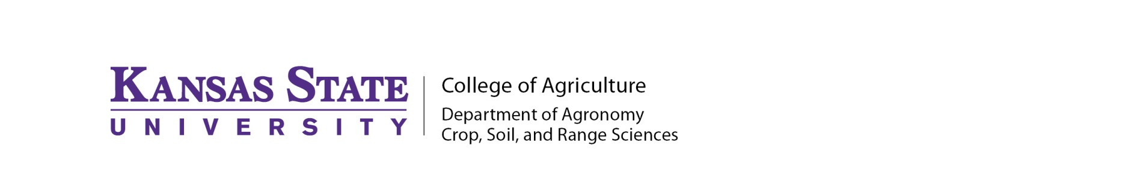

Final Report- Kansas Soybean Commission

Title: Understanding the Genetic Basis of Glyphosate Resistance in Kochia (K. scoparia)

Principal Investigator: Mithila Jugulam
Amount of funding: $26,120

Department Head: Dr. Gary Pierzynski

Progress Report: July 1, 2014- June 30, 2015

Progress towards the objectives:

- Identify homozygous glyphosate-resistant and -susceptible accessions from individually self-pollinated kochia plants.
- Perform reciprocal crosses between homozygous glyphosate-resistant and –susceptible plants to generate F₁ and F₂ progeny; and determine the response of these progeny to glyphosate.
- Quantify shikimate levels and 5-enolpyruvylshikimate-3-phosphate synthase (EPSPS) gene copy number in parental, F_{1,} and F₂ progeny expressing glyphosate resistance or susceptibility.

To understand the inheritance of glyphosate resistance in kochia, we have used two different populations of kochia from Kansas. In both these populations homozygous glyphosate-resistant and susceptible plants were identified upon screening progeny from individually self –pollinated resistant and susceptible plants (collected from field). Shikimate and enolpyruvylshikimate-3-phosphate synthase (EPSPS) gene copy number assays were performed in these plants.
Glyphosate dose-response experiments were conducted on parental and F1 progeny. The results suggests that the F1 plants from reciprocal crosses were all resistant to glyphosate suggesting that the glyphosate resistance is a nuclear trait in kochia.
Furthermore, florescent in situ bybridization analysis was performed on glyphosate-resistant and –susceptible kochia chromosomes. The results indicate for the first time that the EPSPS copies are arranged in tandem and are located close to the telomere region of the chromosomes. These results suggests that the EPSPS amplification may have occurred as a result of unequal recombination.
We have also tested kochia populations from Kansas for multiple herbicide resistance. The results suggest that these populations are at least resistant to more than 2 modes of action of herbicides. Multiple herbicide resistant kochia is a major challenge for kochia management.

